EQUISENSE EXPERT SYSTEM FOR STOCK MANAGEMENT

S_NAME | F_NAME | M_NAME | REG NO
NJENGA | JOHN |  | C026-01-0798/2024
 | ELISHA | MUTHOMI | C026-01-0789/2024
MWAURA | JOSEPH |  | C026-01-0753/2024

DEDAN KIMATHI UNIVERSITY OF TECHNOLOGY

Proposal/Project submitted in partial fulfilment of the requirements for the award of a degree in Bachelor of Science in Computer Science in Dedan Kimathi University of technology.

February, 2026

DECLARATION
We declare that the ideas described herein are our original work and have not been submitted to any institution for an award of degree/diploma:

Name: NJENGA JOHN

Date 3RD FEBRUARY,2026

Signature ___________________________________________________________________________

Name: ELISHA MUTHOMI

Date: 3RD FEBRUARY,2026

Signature ___________________________________________________________________________

Name: MWAURA JOSEPH

Date: 3RD FEBRUARY,2026

Signature _____________________________________________________________________________

This project is submitted for university examination with my approval as the supervisor.
Name: WILY MBURU

Date_________________________________________________________________________________

Signature_____________________________________________________________________________

DEDICATION
We dedicate this project to the Lord for His guidance, strength, and wisdom throughout our academic journey and our loving families for their unwavering support, encouragement, and belief in our academic journey. Their motivation and sacrifices have been a constant source of inspiration to us all that contributed widely to the creation of this project.

ACKNOWLEDGEMENT
We would like to express our sincere gratitude to our project supervisor Mr. Mburu for his continuous guidance, constructive feedback, approachable nature and support throughout the development of this project. His expertise, insights and constant friendly corrections have greatly contributed to shaping the direction and quality of this work.
We want also to acknowledge our lecturers for providing adequate knowledge that has come in handy with the development of our project.
Finally, we acknowledge our institute in general Dedan Kimathi University of technology lead by the able Vice chancellor (Prof. Eng. Peter Ng’ang’a Muchiri, EBS) and his team for providing the necessary materials that helped us achieve our goal.

ABSTRACT
Making decisions in the financial domain is a complicated and a knowledge intensive process that involves analyzing multiple indicators, market trends and company specific data. Individual investors, particularly those who are beginners, often face challenges in interpreting this information and making timely, informed decisions.
EquiSense, a knowledge-based expert system designed to support investors in making stock investment decisions for a company of choice. The system employs a structured rule-based inference engine populated with domain knowledge derived from established financial analysis principles, including fundamental analysis, technical indicators and market sentiment metrics.
Given a set of input parameters related to a company’s stock such as price trends, earnings performance, valuation ratios and prevailing market conditions, EquiSense processes the data through its knowledge base to generate one of three recommendations which are either to Buy a share, Sell the share or hold the particular share.
The system aims to close the gap between expert financial knowledge and short-term or long-term investors by providing transparent, explainable, and consistent decision support. This documentation details the system’s design, knowledge acquisition process, rule formulation, implementation, and evaluation.

Table of Contents
DECLARATION ii
DEDICATION iii
ACKNOWLEDGEMENT iv
ABSTRACT v
LIST OF TABLES ix
LIST OF FIGURES x
CHAPTER ONE 1
1.0 INTRODUCTION 1
1.2 BACKGROUND OF STUDY 3
1.3 STATEMENT OF PROBLEM 4
1.4 RESEARCH OBJECTIVE 5
1.4.1 Broad objective 5
1.4.2 Specific Objectives 5
1.5 SIGNIFICANCE OF THE STUDY 6
1.6 PROJECT SCOPE AND DELIMITATION 7
1.6.1 Scope 7
1.6.2 Delimitations 8
1.7 ASSUMPTIONS OF THE STUDY 9
1.8 OPERATIONAL DEFINITION OF TERMS 10
CHAPTER TWO 12
2.1 INTRODUCTION 12
2.2 GLOBAL PERSPECTIVE 13
2.2.0 CASE STUDY 14
2.3 REGIONAL PERSPECTIVE 15
2.3.0 CASE STUDIES 16
2.4 LOCAL PERSPECTIVE 18
2.4.0 CASE STUDY 19
2.5 SWOT ANALYSIS OF EXISTING STOCK DECISION SUPPORT SYSTEMS 21
2.6 RESEARCH GAPS 22
CHAPTER THREE 23
METHODOLGY 23
3.1 INTRODUCTION 23
3.2 SOFTWARE DEVELOPMENT METHOD 24
3.2.1 Chosen Model: Agile Development Model 24
3.2.2 AGILE SPRINT PLAN FOR EQUISENSE 25
3.3 TARGET POPULATION AND SAMPLING 26
3.3.1 Target population 26
3.3.2 Sampling Technique 26
3.4 DATA COLLECTION METHODS AND INSTRUMENTS 28
3.4.1. Interviews 28
3.4.2 Questionnaires 28
3.4.3 Observation Checklist 28
3.5 DATA COLLECTION PROCEDURE 29
3.6 DATA ANALYSIS TECHNIQUES 30
3.6.1 Qualitative Analysis (Knowledge Acquisition) 30
3.6.2 Quantitative Analysis (Questionnaire data) 30
3.6.3 System Evaluation Analysis 30
3.7 VALIDITY AND RELIABILITY OF INSTRUMENTS 31
3.7.1 Validity 31
3.7.2 Reliability 31
3.7.3 Rule Base Validation 31
CHAPTER FOUR 33
4.0 INTRODUCTION 33
4.1 REQUIREMENTS 34
4.1.1 FUNCTIONAL REQUIREMENTS 34
4.1.2 NON-FUNCTIONAL REQUIREMENTS 35
4.2 SYSTEM ANALYSIS 36
4.2.1 Use Case Diagram 36
4.2.2 Data Flow Diagram 37
4.2.3 Activity Diagram 39
4.3 DESIGN 40
4.3.1 Flowchart 40
4.3.2 Sequence Diagram 41
4.3.3 Class Diagram 42
4.3.4 User Interface Design 43
4.3.5 Database Design 46
CHAPTER FIVE 47
5.1 INTRODUCTION 47
5.2 CODING 48
5.2.1 User Management Module 48
5.2.2 Calculator Mode 49
5.2.3 Flask REST API Layer 50
5.2.4 Expert System Engine 51
5.2.5 MySQL Database 52
5.3 TESTING 53
5.3.1 What is Testing 53
5.3.2 Why Testing 54
5.3.3 Unit Testing 55
5.3.4 Integration Testing 56
5.3.5 System Testing 57
5.3.6 Usability Testing 60
5.4DEPLOYMENT 61
5.4.1 Data Conversion 61
5.4.2 Deployment Strategy 62
5.5 USER TRAINING 64
5.6 SYSTEM MANUAL 65
5.6.1 Importance of System Documentation 65
5.6.2 Operational Manual 66
5.6.3 Technical Manual 67
CHAPTER SIX 68
6.1 INTRODUCTION 68
6.2 LIMITATIONS 69
6.3 RECOMMENDATION 70
6.4 CONCLUSION 71
6.5 REFERENCES 72
APPENDICES 73
BUDGET 73
ETHICAL CONSIDERATION LETTER 74
GANT CHART 75
QUESTIONNAIRE 76
INTERVIEW GUIDE 77
OBSERVATION CHECKLIST 78
SYSTEM SCREENSHOTS 79

LIST OF TABLES
Table No | Title | Page
Table 1.1 | Operational definition | 10
Table 3.1 | Sample Size Distribution | 28
Table A.1 | Hardware Requirements | 74
Table A.2 | Software Requirements | 74
Table A.3 | Miscellaneous Costs | 74
Table A.4 | Budget Summary | 74
Table C.1 | Observation checklist | 80

LIST OF FIGURES

Figure No | Title | Page
Figure 4.0 | Use Case Diagram | 37
Figure 4.1 | Data Flow Diagram-level 0 | 38
Figure 4.2 | Data Flow Diagram-level 1 | 39
Figure 4.3 | Activity Diagram | 40
Figure 4.4 | System Flowchart | 41
Figure 4.5 | Sequence Diagram | 42
Figure 4.6 | Class Diagram | 43
Figure 4.7 | User Interface Diagrams | 44
Figure 4.9 | Entity Relationship Diagram (ERD) | 47

CHAPTER ONE

1.0 INTRODUCTION
The global financial market is a diverse ecosystem that plays a central role in the economic sector of many countries, institution and individuals. At the center of this ecosystem there is the stock market (a platform where shares of publicly listed companies are bought and sold, and where wealth is created, transferred and sometimes lost on daily basis). For decades, participation in the stock market was largely limited to institutional investors, banks, and wealthy individuals who had the resources and expertise to understand the complexities involved in trading. However, the digital revolution of the past two decades has changed this perspective. Today, with nothing more than a smartphone and an internet connection, anyone can open a brokerage account and begin trading stocks within minutes.
This democratization of investment, while empowering, has introduced a new and pressing challenge: the majority of retail investors who now participate in the market lack the financial expertise necessary to make consistently sound investment decisions. Unlike professional analysts who spend years studying financial markets, mastering valuation models, and interpreting technical signals, the average investor is often navigating the market with limited knowledge, relying on social media trends, word of mouth, or gut feeling rather than structured financial analysis. The consequences of this knowledge deficiency are significant (poor investment decisions, unnecessary losses and missed opportunities are commonplace among retail investors who lack the tools to properly evaluate a stock).
Making a well-informed decision involves analyzing the data of a company from two positions:
- Fundamental analysis
Refers to the process of evaluating a company inside value by examining its financial statements and performance metrics. The key indicators in this category include:
- Price-to-Earnings (P/E) ratio, which measures how much investors are paying for each unit of earnings.
- Earnings Per Share (EPS), which reflects the company's profitability on a per-share basis.
- Revenue trends, which indicate whether the company is growing, stagnating, or declining.

These parameters help an investor answer a critical question: is this company financially healthy and is its stock fairly priced?

- Technical analysis
Refers to the study of a stock's historical price and volume behavior to forecast its future movement. Unlike fundamental analysis, which focuses on what a company is worth, technical analysis focuses on what the market is doing with its stock right now and where it might be headed. Indicators such as:
- Relative Strength Index (RSI) help identify whether a stock is overbought or oversold.
- Moving Average Convergence Divergence (MACD) which reveals shifts in momentum and trend direction.
- Moving averages which smooth out price fluctuations to expose underlying trends.
Together, these signals help an investor answer a different but equally important question: is now the right time to act on this stock?
The challenge for most investors is not the availability of this information (in the age of the internet, financial data is more accessible than ever). The real challenge is the ability to synthesize both fundamental and technical signals into a single, coherent, and timely investment decision. This synthesis requires a level of domain expertise that takes years to develop, and it is precisely this expertise that EquiSense seeks to replicate through the power of artificial intelligence.
Expert systems are a branch of artificial intelligence concerned with encoding human expertise into a computer system that can reason and make decisions in a manner that mirrors that of a domain expert. Unlike black-box machine learning models, expert systems are rule-based and transparent that is their reasoning can be traced, explained, and audited. This makes them particularly well-suited for sensitive domains like finance, where users need not only a recommendation but also an understanding of why that recommendation was made.
EquiSense is a knowledge-based expert system designed with this philosophy at its center. The system is developed using Python as the primary programming language, Flask as the web framework and API layer, MySQL as the database management system, and HTML, CSS and JavaScript for the user interface. It is built around five core components that work together seamlessly to deliver an end-to-end investment decision support experience:
- User Management Module
It handles user registration, login, and session management, allowing each investor to maintain a personal account and access their recommendation history at any time.
- Calculator Module.
It is responsible for taking raw stock data provided by the user such as share price, earnings figures, and historical price points and computing the financial indicators required for analysis. These include the P/E ratio, EPS, RSI, MACD, and relevant moving averages. Once these indicators have been calculated, they are passed through an API (Application Programming Interface) to the second component.
- Expert System Engine.
This engine houses a structured knowledge base of IF-THEN rules derived from established financial analysis principles, and an inference engine that applies those rules to the computed indicators to arrive at one of three actionable recommendation that is weather to Buy, Hold, or Sell.
- Flask REST API Layer
It serves as the communication bridge between the Calculator Module and the Expert System Engine, passing computed indicator values as structured data between components.
- MySQL Database
It stores all user accounts, raw stock inputs, computed indicators, and recommendations, enabling users to track and review their full investment analysis history over time.

1.2 BACKGROUND OF STUDY
Investing in the stock market has never been more accessible. Thanks to online trading platforms and the growing availability of financial data, millions of retail investors now participate in markets that were once dominated by institutions and professionals. Yet despite this democratization of access, many individual investors still struggle to make well-informed decisions. More often than not, decisions are driven by emotion, social media trends, or incomplete information and the results can be financially damaging.
The professionals who consistently make good investment calls rely on two main types of analysis. Fundamental analysis looks at the financial health of a company, metrics like Earnings Per Share (EPS), revenue growth, and the Price-to-Earnings (P/E) ratio help determine whether a stock is fairly valued, undervalued, or overvalued. Technical analysis, on the other hand, focuses on price and volume history, using indicators like the Relative Strength Index (RSI), Moving Average Convergence Divergence (MACD), and moving averages to read market momentum and trends.
The challenge is that doing all of this manually takes time, expertise, and experience that most retail investors simply don't have. This is where expert systems come in. By formalizing financial knowledge into a rule base and pairing it with a computation engine, it becomes possible to automate the analytical process in a structured and explainable way.
EquiSense was conceived to address this exact challenge. Rather than expecting users to calculate financial indicators themselves or interpret raw numbers, the system handles the computation through its Calculator Module, then passes the results to the Expert System Engine via an API for intelligent reasoning. The end result is a seamless, end-to-end decision support tool that mirrors the thought process of a financial e
xpert

1.3 STATEMENT OF PROBLEM
Investment decision-making is a knowledge-intensive process that requires the systematic analysis of both fundamental and technical financial indicators. Ideally, every investor regardless of their level of expertise should have access to a structured, transparent, and explainable tool that can analyze a stock's financial health and market behavior and provide a clear, reasoned recommendation on whether to Buy, Hold, or Sell.
However, the current reality for most retail investors falls far short of this ideal. The majority of intelligent stock decision support systems available today, such as Bloomberg Terminal, BlackRock's Aladdin Platform, and Renaissance Technologies' algorithmic trading systems, are designed for institutional investors and require significant financial resources, technical expertise, and access to expensive real-time data feeds. These systems are therefore inaccessible to the ordinary retail investor.
At the local level, platforms such as the Nairobi Securities Exchange Automated Trading System and NCBA Group's digital investment tools provide basic trading access but offer little to no intelligent decision support. They do not explain why a particular stock action is advisable, nor do they integrate both fundamental and technical analysis into a single recommendation engine. Furthermore, the majority of machine learning-based prediction systems reviewed in literature, while accurate, operate as black boxes generating recommendations without providing any explanation of the reasoning behind them, which erodes user trust.
The consequence of this gap is significant. Retail investors are left to make critical financial decisions based on incomplete information, social media trends, or gut feeling, resulting in poor investment outcomes, unnecessary financial losses, and reduced investor confidence in the stock market.
Therefore, there is a need for a lightweight, transparent, rule-based expert system that integrates both fundamental and technical analysis, explains its reasoning clearly, and is accessible to everyday investors without requiring expensive infrastructure or real-time data feeds. EquiSense is developed to address this need.

1.4 RESEARCH OBJECTIVE

1.4.1 Broad objective
The broad objective of our project is to develop Equisense a knowledge-based expert system to assist investors in making informed investment decision by computing key financial indicators and applying expert rules to recommend whether to Buy, Hold or Sell a particular stock.

1.4.2 Specific Objectives
- To identify and analyze the key fundamental and technical indicators used by financial experts in evaluating stocks
- To design a calculator module that accepts raw stock data and computes the required financial indicators including P/E ratio, EPS, RSI, MACD and moving averages
- To develop an API that serves as a communication between the calculator module and the expert system engine.
- To acquire and formalize financial domain knowledge into structured IF-THEN rule base for stock investment decision making.
- To implement an inference engine that processes the computed indicators against the rule base generate a Buy, Hold or Sell.
- To design a user-friendly interface that presents both the computed indicators and the final recommendation in a clear and understandable format.
- To evaluate the system’s accuracy and consistency against real-world stock scenario and expert judgement.

1.5 SIGNIFICANCE OF THE STUDY
Individual Investors
Equisense demystifies the investment domain to individual simplifying the decision-making process based on calculated factors preventing investors from relying on guess work.

Academic Community
Equisense contributes to research on the practical application of expert systems in financial domains and demonstrates how modular system design can improve transparency and maintainability in knowledge-based systems.

Financial Technology (FinTech)
Equisense can be extended or integrated into larger financial platforms in the future.

Computer Science Education
This project brings onboard knowledge taught in computer science such as Knowledge representation and reasoning, API design and software modularity in a single, real-world application making it a rich learning experience.

1.6 PROJECT SCOPE AND DELIMITATION

1.6.1 Scope
EquiSense is designed to analyze the stock of a single company at a time. The system operates through five integrated components built using Python, Flask, MySQL, and HTML/CSS/JavaScript.
A user first creates a personal account through the User Management Module, which handles registration, login, and session management, allowing each investor to securely access the system and maintain a personal history of their stock analyses. Once logged in, the user is directed to their dashboard where they can initiate a new stock analysis.
The user enters raw stock data through a web-based input form, including values such as the current share price, earnings per share, revenue figures, and historical closing prices. This data is received by the Calculator Module, which computes the key financial indicators required for analysis specifically the Price-to-Earnings (P/E) ratio, Earnings Per Share (EPS), revenue growth, Relative Strength Index (RSI), Moving Average Convergence Divergence (MACD), signal line, and 50-day and 200-day moving averages.
The computed indicators are then passed through an API layer to the Expert System Engine. The engine processes these values through a structured knowledge base of IF-THEN rules derived from established fundamental and technical analysis principles. The inference engine fires the appropriate rule and generates one of three recommendations either Buy, Hold, or Sell accompanied by a clear explanation of the reasoning behind the decision.
All raw inputs, computed indicators, and recommendations are stored in the MySQL database, enabling users to revisit and review their full stock analysis history at any time through their personal dashboard.

1.6.2 Delimitations
- The system will not connect to live stock market feeds or financial data.
- EquiSense is a decision support tool and does not constitute certified or professional financial advice.
- The system is limited to equity stocks and does not cover other instruments such as bonds, cryptocurrencies, or commodities.
- The knowledge base will be grounded in established financial analysis principles and will not account for sudden macroeconomic shocks such as political crises, pandemics, or natural disasters.
- The API connecting the two components is internal to the system and is not designed for third-party integration at this stage.

1.7 ASSUMPTIONS OF THE STUDY
- The raw stock keyed in by the user are accurate, current and sourced from a reliable financial platform.
- The Calculator Module will produce correct and consistent outputs given valid input data.
- IF-THEN rules encode in the knowledge base adequately represent expert financial reasoning for the purpose of generating Buy, Hold or Sell recommendations.
- The combination of fundamental and technical indicators provides a sufficient basis for stock investment decision making within the defined scope.
- Users have a basic ability to source raw stock data before using the system.
- The system operates under normal market conditions and is not designed to handle extreme or unprecedented financial scenarios.

1.8 OPERATIONAL DEFINITION OF TERMS
Term | Definition
Expert System | computer program that replicates the decision-making ability of a human expert by applying a structured set of IF-THEN rules derived from domain knowledge
Knowledge Base | The collection of facts and IF-THEN rules that represent the financial expertise encoded in EquiSense.
Inference Engine | The component of the Expert System Engine that matches computed indicator values against the rule base to derive a Buy, Hold, or Sell recommendation.
Calculator Module | The first component of EquiSense, responsible for accepting raw stock data and computing the financial indicators required for expert system reasoning.
API (Application Programming Interface) | The communication bridge that transfers computed indicator values from the Calculator Module to the Expert System Engine in a structured format.
Fundamental Analysis | A method of evaluating a stock by examining a company's financial performance through metrics such as P/E ratio, EPS, and revenue.
Technical Analysis | A method of evaluating a stock based on its historical price and volume data using indicators such as the Relative Strength Index (RSI), Moving Average Convergence Divergence (MACD), and moving averages, used to identify market trends, momentum, and the right timing for investment decisions.
RSI (Relative Strength Index) | A momentum indicator that measures the speed and changes of price movements, used to identify whether a stock is overbought or oversold.
MACD (Moving Average Convergence Divergence) | A trend-following indicator that tracks the relationship between two moving averages of a stock's price to signal bullish or bearish momentum.
P/E Ratio (Price-to-Earnings Ratio) | A valuation metric that compares a company's share price to its earnings per share, used to assess whether a stock is overvalued or undervalued.
EPS (Earnings Per Share) | A measure of a company's profitability calculated by dividing net profit by the number of outstanding shares.
Buy | A system recommendation indicating that the stock shows positive indicators and is considered a worthwhile investment at the current time.
Hold | A system recommendation indicating that the stock does not show strong enough signals in either direction to justify buying or selling
Sell | A system recommendation indicating that the stock shows negative indicators and the investor should consider divesting.

Table 1.1: Operational definition

CHAPTER TWO

2.1 INTRODUCTION
Investment decision-making within modern financial markets is increasingly data-driven and requires the careful interpretation of numerous variables such as stock price movements, earnings reports, valuation metrics, and historical price patterns. For many individual investors, especially those without advanced financial expertise, navigating and synthesizing this information is a tiresome challenge. Poor interpretation of market data often leads to uninformed decisions, financial losses, or missed investment opportunities.
Advancements in Artificial Intelligence (AI) and Knowledge-Based Systems (KBS) have opened the door to automating expert reasoning in ways that are accessible, transparent, and consistent. Henrique, Sobreiro and Kimura (2019) conducted a comprehensive review of machine learning techniques applied to financial market prediction, concluding that while predictive accuracy has improved significantly, transparency and explainability remain critical unresolved challenges. Expert systems, in particular, offer a rule-driven approach to decision support that mirrors the structured thinking of a financial analyst without the opacity of machine learning black boxes. This chapter reviews existing literature and real-world systems related to stock investment decision support, examining them from a global, regional, and local perspective, before identifying the research gap that EquiSense is designed to address.
EquiSense is a five-component, rule-based expert system. Its Calculator Module computes key fundamental indicators including Price-to-Earnings (P/E) ratio, Earnings Per Share (EPS), and revenue trends as well as technical indicators such as RSI, MACD, and moving averages. These computed values are then passed via an API to the Expert System Engine, which applies a structured IF-THEN knowledge base to generate a Buy, Hold, or Sell recommendation.

2.2 GLOBAL PERSPECTIVE
Globally, stock decision support systems have evolved significantly with the integration of artificial intelligence and high-performance computing. Advanced markets such as the United States, Europe, and parts of Asia utilize a wide range of intelligent systems from algorithmic trading bots to sophisticated risk management platforms to support and automate investment decisions.
Bustos and Pomares-Quimbaya (2020) conducted a systematic review of stock market movement forecasting systems and found that the majority of modern approaches rely heavily on machine learning and deep learning models. While these models achieve high predictive accuracy, they often sacrifice interpretability a critical limitation for retail investors who need to understand the basis of a recommendation. Similarly, Obthong, Tantisantiwong, Jeamwatthanachai and Mackenzie (2020) surveyed machine learning algorithms for stock price prediction and noted that despite the variety of approaches available, most systems remain inaccessible to non-technical users due to their complexity and infrastructure requirements.
Nabipour, Nayyeri, Jabani, Mosavi and Salwana (2020) further demonstrated the effectiveness of deep learning models for stock market prediction, achieving strong results using LSTM and other neural network architectures. However, their findings also reinforce the explainability gap deep learning models operate as black boxes, making it impossible for users to trace how a recommendation was reached. This principle of explainability is central to the design of EquiSense, which prioritizes transparency through a structured IF-THEN rule base that can be audited and understood by any investor.
Chen, Zhang, Mehlawat and Jia (2021) explored machine learning-based portfolio optimization and demonstrated that combining multiple financial indicators improves decision quality. This finding supports EquiSense's approach of integrating both fundamental and technical indicators within a single decision support framework.

2.2.0 CASE STUDY

2.2.1 Renaissance Technologies (United States)
Renaissance Technologies is one of the most successful quantitative hedge funds globally, known for its Medallion Fund, which applies advanced mathematical models and algorithmic trading strategies for automated buy/sell execution.
Key Features
- Fully algorithmic trading strategies
- High-frequency data processing
- Quantitative statistical arbitrage models
- Extensive use of machine learning and predictive modeling
- Automated execution with minimal human intervention
Merits
- Exceptional historical returns compared to market averages
- Eliminates emotional trading bias
- Highly scalable across markets and asset classes
- Efficient exploitation of micro-market inefficiencies
Demerits
- Extremely high infrastructure and research costs
- Heavy reliance on proprietary data and expertise
- Models may degrade under structural market shifts
- Very limited transparency due to black-box strategies users cannot understand why a particular decision was made

Relevance to EquiSense: While Renaissance Technologies demonstrates the power of data-driven trading, its black-box nature and institutional scale make it inaccessible and opaque to retail investors. EquiSense takes a different approach by prioritizing transparency and explainability through a rule-based system that any investor can understand and trust.

2.2.2 BlackRock (Aladdin Platform)
BlackRock's Aladdin (Asset, Liability, Debt and Derivative Investment Network) is a global investment risk management and decision-support system used by institutional investors worldwide.
Key Features
- Integrated risk analytics and portfolio management
- Real-time market data integration
- Scenario analysis and stress testing
- Decision support for asset allocation and trading
Merits
- Comprehensive risk-adjusted decision support
- Trusted by major financial institutions globally
- Strong predictive and simulation capabilities
- Improves institutional governance and compliance
Demerits
- High implementation and subscription costs
- Designed primarily for institutional investors, limiting retail access
- Complex system requiring specialized expertise to operate
- Centralization concerns in global financial markets
Relevance to EquiSense: Aladdin illustrates the value of structured, data-informed decision support at scale. However, its complexity and cost place it far out of reach for individual retail investors. EquiSense draws inspiration from the concept of structured decision support while delivering it in a lightweight, accessible, rule-based format designed for everyday investors.

2.3 REGIONAL PERSPECTIVE
At the regional level, developing and emerging markets are progressively adopting intelligent trading technologies. However, adaptation often requires customization to reflect regional volatility patterns, liquidity constraints, regulatory frameworks, and investor behavior. Sezer, Gudelek and Ozbayoglu (2020) conducted a systematic literature review of financial time series forecasting with deep learning and noted that while deep learning achieves strong results in developed markets, its application in emerging markets is constrained by data availability and infrastructure limitations. This finding supports the case for rule-based approaches like EquiSense that can function effectively without real-time data feeds or high-end computing infrastructure. Research within these regions increasingly explores rule-based and knowledge-based approaches as practical alternatives to computationally expensive machine learning systems, particularly where data quality and infrastructure are limiting factors.
Deng, Mitsubuchi, Shioda, Shimada and Sakurai (2019) demonstrated that combining technical analysis with alternative data sources improves prediction accuracy in regional markets. Their work reinforces the value of the multi-indicator approach adopted in EquiSense, where both fundamental and technical signals are computed and evaluated together before a recommendation is generated.

2.3.0 CASE STUDIES

2.3.1 Johannesburg Stock Exchange (JSE)
The JSE is Africa's largest stock exchange and has integrated algorithmic trading frameworks and electronic trading systems that support automated buy/sell decisions.
Key Features
- Electronic trading platform with automated order matching
- Algorithmic trading support
- Market surveillance and compliance systems
- Integration with global financial systems
Merits
- High liquidity relative to other African markets
- Supports algorithmic and quantitative strategies
- Advanced regulatory oversight
- Encourages fintech innovation
Demerits
- Market volatility influenced by commodity dependence
- Exposure to global capital flow shocks
- Algorithmic trading adoption still lower than developed markets
- Infrastructure limitations in broader regional integration
Relevance to EquiSense: The JSE's journey toward automated decision support underscores the regional appetite for intelligent trading systems. It also highlights the importance of building systems that can function effectively even in markets with moderate infrastructure a design consideration reflected in EquiSense's deliberate simplicity and manual data input model.

2.3.2 Nigerian Exchange Group (NGX)
The Nigerian Exchange has modernized its trading infrastructure to enable automated and electronic decision-making systems.
Key Features
- Automated Trading System (ATS)
- Market data dissemination platforms
- Regulatory compliance integration
- Support for equity and derivatives trading
Merits
- Growing adoption of fintech solutions
- Expanding investor participation
- Improved transparency compared to manual systems
- Potential for AI-based buy/sell system integration
Demerits
- Lower liquidity compared to global markets
- Political and macroeconomic instability impact
- Limited high-frequency infrastructure
- Data quality inconsistencies
Relevance to EquiSense: The NGX case demonstrates that even in markets with infrastructure challenges, there is strong demand for intelligent investment tools. EquiSense's architecture which separates computation from reasoning and allows manual data entry makes it well-suited for deployment in such environments.

2.4 LOCAL PERSPECTIVE
Locally, stock markets often exhibit unique structural characteristics such as limited liquidity, higher volatility, and reduced algorithmic competition. The implementation of a rule-based expert system for stock investment decisions provides significant opportunity for improving retail and institutional investment strategies at the local level.
A locally developed system can incorporate domestic economic indicators, sector-specific trends, and historical trading behaviors unique to the national exchange. Additionally, such systems promote financial literacy and technological innovation within the local fintech ecosystem.

2.4.0 CASE STUDY

2.4.1 Nairobi Securities Exchange
The NSE is Kenya's primary securities exchange and operates an Automated Trading System (ATS) supporting electronic buy/sell transactions.
Key Features
- Automated Trading System (ATS)
- Central Depository and Settlement Corporation (CDSC) integration
- Equity and bond trading platforms
- Market surveillance and compliance monitoring
Merits
- Enhanced efficiency compared to manual trading
- Improved transparency and reduced settlement risk
- Supports mobile-based investor participation
- Growing fintech ecosystem around trading
Demerits
- Moderate liquidity levels
- Limited derivatives and complex financial instruments
- Market sensitivity to political cycles
- Limited adoption of advanced AI-driven trading tools
Relevance to EquiSense: The NSE's growing fintech ecosystem and mobile-first investor base represent a strong local context for a system like EquiSense. The limited availability of AI-driven retail investment tools at the local level makes the development of an accessible, rule-based decision support system both timely and relevant.

2.4.2 NCBA Group Investment Platforms
NCBA Group provides digital investment platforms that allow customers to access stock trading and investment advisory tools.
Key Features
- Digital trading access
- Integrated banking and investment services
- Mobile-based transaction capability
- Basic portfolio tracking and analytics
Merits
- Increased retail investor accessibility
- Strong integration with Kenya's mobile banking infrastructure
- Convenient user interface
- Enhances financial inclusion
Demerits
- Limited AI-driven buy/sell recommendations
- Primarily advisory rather than predictive or rule-driven
- Dependency on market data from NSE
- Exposure to local economic fluctuations
Relevance to EquiSense: NCBA's platform shows that local institutions are beginning to address the gap in retail investor support, but the absence of structured, rule-based reasoning in their tools leaves room for a more intelligent decision support system. EquiSense is positioned to fill this gap by offering transparent, explainable recommendations grounded in both fundamental and technical analysis.

2.5 SWOT ANALYSIS OF EXISTING STOCK DECISION SUPPORT SYSTEMS
The following SWOT analysis evaluates the landscape of existing investment decision support systems in relation to the problem EquiSense seeks to address.
Strengths
- Existing systems reduce emotional bias in investment decisions
- Capable of processing multiple financial indicators simultaneously
- Automated systems improve consistency and speed of decision-making
- Rule-based systems offer transparency and explainability that machine learning models often lack
- Weaknesses
- Many existing systems are too complex or costly for retail investors
- Machine learning-based systems often lack explainability, making it difficult for users to trust or understand recommendations
- Most advanced platforms require real-time data feeds and high-end infrastructure
- Knowledge-based systems require careful and ongoing knowledge acquisition from domain experts
Opportunities
- Growing demand for accessible, transparent investment tools among retail investors
- Increasing availability of financial data through public platforms and APIs
- Rule-based expert systems can be designed to work effectively without real-time data feeds
- The local fintech ecosystem presents a fertile ground for lightweight, explainable decision support tools
Threats
- Regulatory restrictions on automated financial advisory systems
- Market structural changes may require periodic updates to the rule base
- Competition from established global fintech platforms with larger data and development resources
- User reluctance to trust AI-generated financial recommendations without sufficient explanation

2.6 RESEARCH GAPS
The review of existing literature and systems reveals several important gaps that EquiSense is positioned to address.
First, the majority of intelligent stock decision support systems reviewed are either machine learning-based or institutional in scale, making them inaccessible and opaque to retail investors. Bustos and Pomares-Quimbaya (2020) and Obthong et al. (2020) both highlight this gap in their reviews, noting that most existing systems prioritize predictive accuracy over accessibility and explainability. There is a clear need for lightweight, rule-based systems that offer transparent and explainable recommendations without requiring expensive infrastructure or real-time data feeds.
Second, most existing systems treat computation and reasoning as a single integrated process, making them harder to maintain and update. EquiSense's five-component architecture with a dedicated Calculator Module communicating via API to a separate Expert System Engine addresses this gap by introducing modularity and separation of concerns into the design. Huang, Yang, Yang and Sheng (2022) support this direction, demonstrating that rule-based expert systems offer a practical and maintainable alternative to monolithic machine learning pipelines particularly in emerging market contexts.
Third, while several local and regional exchanges have made strides in automating trade execution, very few offer retail investors a tool that explains why a particular stock action is recommended. Zhu, Philpotts and Stevenson (2021) demonstrated that combining fundamental and technical analysis produces significantly better investment outcomes than relying on either approach alone yet most retail-facing tools do not integrate both. Weng, Ahmed and Megahed (2017) similarly showed that using disparate data sources and multiple indicators together improve prediction reliability. The IF-THEN rule base at the heart of EquiSense's Expert System Engine is designed specifically to address this gap integrating both fundamental and technical signals and providing a clear, traceable explanation for every recommendation generated.
These gaps collectively justify the development of EquiSense as a practical, transparent, and accessible stock investment decision support system for everyday investors.

CHAPTER THREE

METHODOLGY

3.1 INTRODUCTION
This chapter presents the methodology adopted for the design and development of the EquiSense Expert System. It outlines the overall development approach, the tools and technologies selected, the population and sampling strategy used to inform the knowledge base, the data collection methods employed, and the ethical considerations observed throughout the project. The methodology described in this chapter serves as a comprehensive blueprint that ensures the development of EquiSense is systematic, collaborative, and academically rigorous.

EquiSense is a five-component, rule-based expert system designed to assist investors in making informed stock investment decisions. The system comprises five key components a User Management Module for registration and authentication, a Calculator Module that computes fundamental and technical financial indicators, an API layer that facilitates communication between components, an Expert System Engine that applies IF-THEN rules to generate Buy, Hold, or Sell recommendations, and a MySQL Database that stores user data, computed indicators, and recommendation history. Given the complexity and interconnected nature of these components, a structured yet flexible development methodology was essential.

3.2 SOFTWARE DEVELOPMENT METHOD

3.2.1 Chosen Model: Agile Development Model
The Agile Software Development Model was selected as the methodology for building EquiSense. Agile is an iterative and incremental approach to software development that emphasizes flexibility, collaboration, continuous feedback, and the delivery of working software in short development cycles known as sprints. Rather than attempting to design and build the entire system at once, Agile breaks the project into manageable phases, each delivering a functional piece of the system that can be tested, reviewed, and improved before the next phase begins.

Justification

Agile is the most appropriate methodology for EquiSense for the following reasons:

- Evolving Knowledge Base
The IF-THEN rules that power the Expert System Engine cannot be fully defined at the beginning of the project. As interviews with financial experts are conducted and more domain knowledge is acquired, new rules will emerge and existing ones will be refined. Agile's iterative nature accommodates this ongoing knowledge acquisition naturally, allowing the rule base to grow and improve with each sprint.

- Component-Based Architecture
EquiSense is built around five distinct components that can be developed, tested, and integrated incrementally. Agile's sprint structure allows each component to be treated as a deliverable, ensuring that no single part of the system becomes a bottleneck for the rest.

- Team Collaboration
With a development team of three members, Agile provides a clear framework for dividing responsibilities across sprints, holding regular progress reviews, and ensuring all team members are aligned on the current state of the system.

- User-Centered Design
Agile places strong emphasis on incorporating feedback from end users throughout the development process. By testing early versions of EquiSense with retail investors and refining the interface and recommendations based on their feedback, the final system will be more usable and trustworthy.

- Risk Management
By delivering and testing working components in short cycles, Agile allows the team to identify and address errors in the calculation logic, rule base, or API integration early — before they compound into larger problems in the final system.

3.2.2 AGILE SPRINT PLAN FOR EQUISENSE
The project will be executed for 8 weeks across 4 sprints of 2 weeks each. Each sprint has a defined goal, set of tasks and deliverable.

Sprint 1 (Week 1-2): Planning and Foundation
Goal: Gather requirements, collect data and set up the database
- Requirements gathering and system scoping
- Expert interviews and retail investor questionnaires
- Extract initial IF-THEN rules from interview responses
- Design and set up MySQL database schema

Deliverable: Database ready, initial rule base drafted, data collected.

Sprint 2 (week 3-4): Core Module Development
Goal: Build the user management and Calculator Modules
- User registration, login, and session management
- Calculator Module — fundamental indicators (P/E ratio, EPS, revenue)
- Calculator Module — technical indicators (RSI, MACD, moving averages)
- Unit testing of all calculator functions
Deliverable: Working Login system and fully tested Calculator Module

Sprint 3 (week 5-6): Expert System Engine and Integration
Goal: Build the expert system engine and connect all the components
- Encode IF-THEN rules into the Expert System Engine
- Develop inference engine logic
- Build API layer connecting Calculator Module to Expert System Engine
- Full component integration and integration testing

Deliverable: Complete integrated system generating Buy/Hold/Sell recommendations
Sprint 4(Week 7-8): Testing, Refinement and Submit
Goal: Finalize the interface, test the system, and submit
- User interface development and refinement
- Usability testing with participants using observation checklist
- Rule base refinement based on testing feedback
- Final documentation and project submission
Deliverable: Fully tested EquiSense system and submitted documentation

3.3 TARGET POPULATION AND SAMPLING

3.3.1 Target population
The target population for this study consists of two distinct groups relevant to the development and evaluation of the EquiSense Expert System.
The first group is individual retail investors people who actively invest or have an interest in investing in the stock market but may lack advanced financial analysis skills. According to the Nairobi Securities Exchange 2023 Annual Report, the NSE had approximately 2.5 million registered retail investor accounts in Kenya as of 2023. This group informs the user interface design, usability requirements, and the level of explanation provided alongside each recommendation.
The second group is financial analysts and stockbrokers professionals whose domain knowledge and experience directly inform the construction of the IF-THEN rule base that powers the Expert System Engine. The Capital Markets Authority of Kenya (CMA) registers approximately 58 licensed stockbrokers and investment banks operating in Kenya as of 2024. This group provides the expert financial reasoning that is formalized into the system's knowledge base.
The total accessible target population for this study is therefore 2,500,058 comprising retail investors and licensed financial professionals operating within the Kenyan market.

3.3.2 Sampling Technique
Purposive sampling was adopted for this study. This technique involves deliberately selecting participants based on specific characteristics relevant to the research in this case, knowledge of stock market investment and financial analysis. Purposive sampling is appropriate here because the quality of the EquiSense knowledge base depends on the expertise of the individuals consulted, rather than on a large random sample.

3.3.3 Sample Size
Given the large size of the target population, the Yamane (1967) sampling formula was applied to determine an appropriate sample size:
Yamane's Formula:
$$n=\frac{N}{1+N(e)^{2}}$$
Where:
- n = required sample size
- N = total population size = 2,500,058
- e = margin of error = 0.05 (5%)
Calculation:
$$n=\frac{2,500,058}{1+2,500,058(0.05)^{2}} \\ n=\frac{2,500,058}{1+2,500,058(0.0025)} \\ n=\frac{2,500,058}{1+6,250.145} \\ n=\frac{2,500,058}{6,251.145} \\ n=399.9≈400$$
However, given the highly specialized and technical nature of this study which requires participants with specific knowledge of stock market investment and financial analysis and the practical constraints of an 8-week development timeline, a purposively selected sample of 15 participants was deemed sufficient and appropriate. This is consistent with the approach adopted in similar expert system development studies where knowledge quality takes precedence over sample quantity.

Group | Number | Purpose
Retail Investors | 10 | Inform interface design and usability requirements
Financial Analysts / Stockbrokers | 5 | Validate and contribute to the IF-THEN rule base
Total | 15

Table 3.1: Sample Data

3.4 DATA COLLECTION METHODS AND INSTRUMENTS
Three data collection instruments will be used across the Agile sprints, with data collection concentrated primarily in Sprint 1 to ensure the knowledge base and system requirements are established before development begins.

3.4.1. Interviews

Semi-structured interviews will be conducted with financial analysts and stockbrokers during Sprint 1 to elicit expert knowledge about stock evaluation. The interviews will explore how experts interpret fundamental indicators such as P/E ratio and EPS, and technical indicators such as RSI, MACD, and moving averages, and how these indicators inform Buy, Hold, or Sell decisions. The insights gathered will be translated directly into IF-THEN rules for the EquiSense knowledge base.

3.4.2 Questionnaires

Structured questionnaires will be administered to retail investors during Sprint 1 to understand their current challenges with stock investment decision-making, their familiarity with financial indicators, and their expectations from a decision support tool. This information will guide the design of the user interface and the level of explanation provided alongside each recommendation.

3.4.3 Observation Checklist

An observation checklist will be used during usability testing in Sprint 4, where selected participants interact with the working prototype of EquiSense. The checklist will capture ease of navigation, clarity of recommendation output, and any errors or confusion encountered during use. Findings from this checklist will inform final refinements to the system before submission.

3.5 DATA COLLECTION PROCEDURE
Data collection will follow the Agile sprint schedule and will be carried out in the following steps:
- Ethical clearance will be obtained from the relevant university authority before any data collection begins.
- Participant recruitment will be conducted during Week 1 by identifying suitable financial analysts, stockbrokers, and retail investors through professional networks and local brokerage firms.
- Informed consent forms will be distributed to all participants explaining the purpose of the study, their rights, and how their data will be used.
- Expert interviews will be conducted during Weeks 1–2 and transcribed for rule extraction in Sprint 1.
- Questionnaires will be distributed to retail investor participants during Week 1, with responses collected by the end of Week 2.
- Usability testing sessions using the observation checklist will be conducted in Sprint 4 (Weeks 7–8) once a working system prototype is available.
- All collected data will be organized, coded, and stored securely for analysis and rule base development.

3.6 DATA ANALYSIS TECHNIQUES

3.6.1 Qualitative Analysis (Knowledge Acquisition)
Data gathered from expert interviews will be analyzed using thematic analysis to identify recurring patterns and decision rules used by financial experts. These themes will be translated into formal IF-THEN rules for the EquiSense knowledge base during Sprint 1. For example, an expert statement such as "when the RSI is above 70 and the P/E ratio is significantly higher than the industry average, I would typically recommend selling" would be formalized as:
IF RSI > 70 AND P/E Ratio > industry average threshold THEN Recommendation = SELL
This rule extraction process is central to the Agile approach rules identified in Sprint 1 will be encoded in Sprint 3 and further refined in Sprint 4 based on testing outcomes.

3.6.2 Quantitative Analysis (Questionnaire data)
Questionnaire responses from retail investors will be analyzed using descriptive statistics frequencies, percentages, and means to identify common challenges and expectations. This analysis will inform design decisions for the user interface and the level of explanation provided alongside each recommendation during Sprint 4.

3.6.3 System Evaluation Analysis
The accuracy of the Expert System Engine will be evaluated in Sprint 4 by testing it against a set of historical stock scenarios with known outcomes. The percentage of correct recommendations will be calculated and compared against expert judgment to assess the system's reliability and validate the rule base.

3.7 VALIDITY AND RELIABILITY OF INSTRUMENTS

3.7.1 Validity
To ensure the instruments measure what they are intended to measure, the interview guide and questionnaire will be reviewed by the project supervisor and at least one financial domain expert before deployment in Sprint 1. Any ambiguous or irrelevant questions will be revised based on this feedback prior to distribution.

3.7.2 Reliability
A pilot test will be conducted at the start of Sprint 1 with two participants, one financial expert and one retail investor before the full data collection exercise begins. Feedback from the pilot will be used to refine the instruments to ensure consistent interpretation across all participants.

3.7.3 Rule Base Validation
The IF-THEN rules extracted from expert interviews will be validated by presenting the finalized rule base back to the financial experts consulted at the end of Sprint 3, asking them to confirm that the rules accurately reflect their professional reasoning. Any discrepancies will be corrected before the rules are encoded into the production system.
3.8 ETHICAL CONSIDERATIONS
The following ethical principles will be observed throughout all four Agile sprints:
- Informed Consent
All participants will be provided with a consent form clearly explaining the purpose of the study, the nature of their participation, and their right to withdraw at any time without penalty.
- Confidentiality
The personal details of all participants will be kept strictly confidential and will not be disclosed in any part of the project documentation or system.
- Data Security
All collected data including interview transcripts, questionnaire responses, and user credentials stored in the EquiSense MySQL database will be protected using appropriate security measures including password hashing and role-based access controls.
- Voluntary Participation
Participation in this study is entirely voluntary. No participant will be coerced or offered incentives to take part.
- Academic Integrity
All sources consulted in the development of this project have been properly cited in accordance with APA 7th Edition guidelines. The system and its documentation represent original work by the development team.
- Approval
Ethical clearance will be sought from the university's relevant ethics committee or supervisor before data collection commences in Sprint 1.

CHAPTER FOUR

4.0 INTRODUCTION
This chapter presents the system requirements, analysis, and design of the EquiSense Expert System. It details what the system must do, how its components interact, and how it has been structured to deliver a seamless investment decision support experience. The chapter covers both functional and non-functional requirements, followed by system analysis diagrams including a Use Case Diagram, Data Flow Diagram, and Activity Diagram. The design section then presents the system flowchart, sequence diagram, class diagram, user interface design, and database design through an Entity Relationship Diagram (ERD).
EquiSense is a five-component, rule-based expert system built using Python, Flask, MySQL, and HTML/CSS/JavaScript. The system allows registered investors to enter raw stock data, compute key financial indicators through the Calculator Module, and receive a Buy, Hold, or Sell recommendation generated by the Expert System Engine all stored and accessible through a personal user account.

4.1 REQUIREMENTS

4.1.1 FUNCTIONAL REQUIREMENTS
Functional requirements describe what the system must be able to do. The following functional requirements have been identified for EquiSense:
User Management
- The system shall allow new users to register with their full name, email address, and password
- The system shall allow registered users to log in using their email and password
- The system shall maintain a secure session for each logged-in user
- The system shall allow users to log out of their account
- The system shall store all user credentials securely in the MySQL database using password hashing
Stock Data Input
- The system shall provide a form for users to enter raw stock data including share price, EPS, current revenue, previous revenue, and historical closing prices
- The system shall validate all input fields before processing to ensure no empty or invalid values are submitted
Calculator Module
- The system shall compute the Price-to-Earnings (P/E) ratio from the share price and EPS provided
- The system shall compute revenue growth from the current and previous revenue figures
- The system shall compute the Relative Strength Index (RSI) from the historical closing prices
- The system shall compute the Moving Average Convergence Divergence (MACD) and signal line from the historical closing prices
- The system shall compute the 50-day and 200-day moving averages from the historical closing prices
- The system shall display all computed indicators to the user on the results page
Expert System Engine
- The system shall pass all computed indicators to the Expert System Engine via the API layer
- The system shall apply IF-THEN rules from the knowledge base against the computed indicators
- The system shall generate one of three recommendations either Buy, Hold, or Sell based on the matched rule
- The system shall display a clear explanation of the reasoning behind each recommendation
History & Database
- The system shall save all raw inputs, computed indicators, and recommendations to the MySQL database
- The system shall allow users to view their full recommendation history on their personal dashboard

4.1.2 NON-FUNCTIONAL REQUIREMENTS

Non-functional requirements describe how the system performs its functions. The following non-functional requirements apply to EquiSense:

Security
- All user passwords shall be hashed using bcrypt before being stored in the database
- The system shall use Flask session management to protect user data during active sessions
- No sensitive user data shall be exposed in URLs or browser history

Usability
- The system shall have a clean, simple, and intuitive interface that can be used by investors with no technical background
- All recommendations shall be accompanied by a plain-language explanation that is easy to understand
- The system shall provide clear error messages when invalid data is entered

Performance
- The system shall compute all financial indicators and return a recommendation within 5 seconds of form submission
- The system shall handle multiple user sessions simultaneously without performance degradation

Reliability
- The system shall produce consistent recommendations for the same set of input values at all times
- The Expert System Engine shall always return one of the three defined outputs Buy, Hold, or Sell and never leave a recommendation blank
- Maintainability
- The system shall be built in a modular architecture so that individual components that is Calculator Module, Expert System Engine, API layer can be updated independently
- The IF-THEN rules in the knowledge base shall be written in a clear and readable format so they can be reviewed and updated by the development team

Compatibility
- The system shall be accessible through any modern web browser including Chrome, Firefox, and Edge
- The system shall run on any machine with Python 3.x and MySQL installed

4.2 SYSTEM ANALYSIS

4.2.1 Use Case Diagram

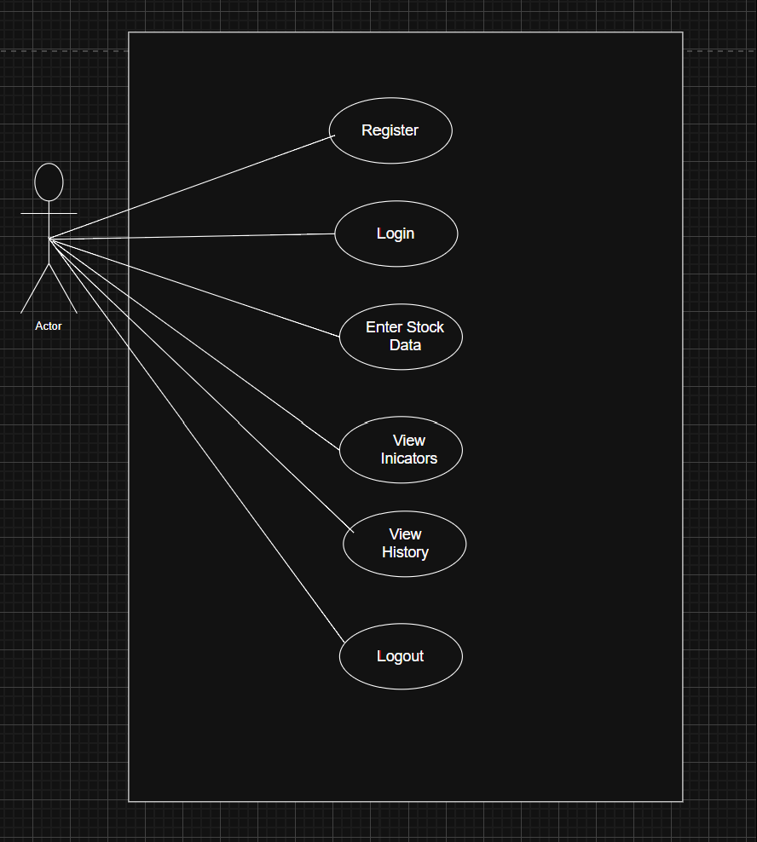
Figure 4.0: Use Case Diagram

4.2.2 Data Flow Diagram

Level 0 DFD (Context Diagram)

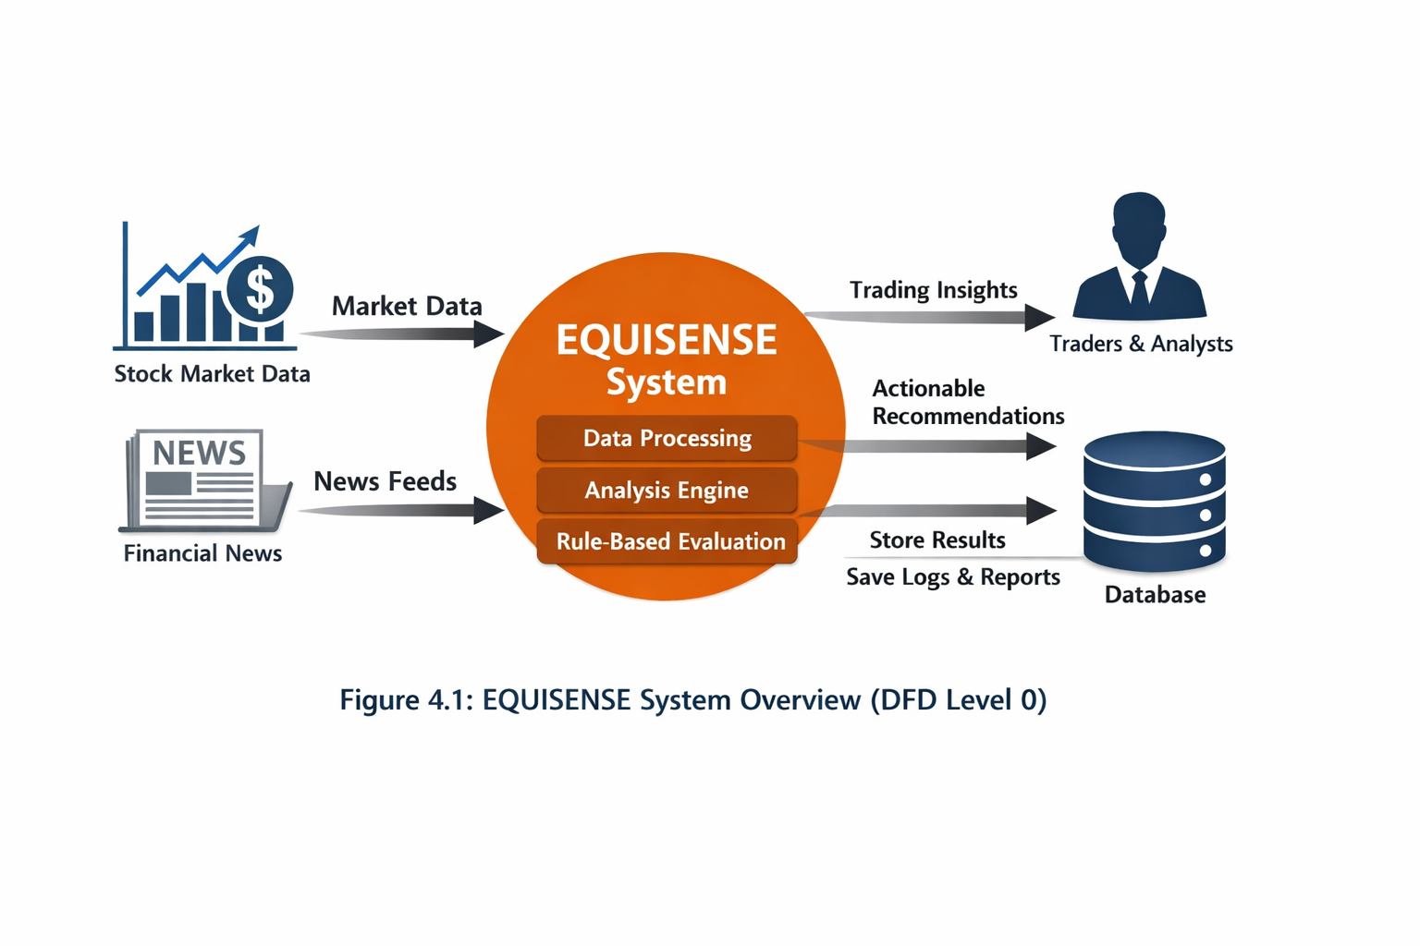

Level 1 DFD

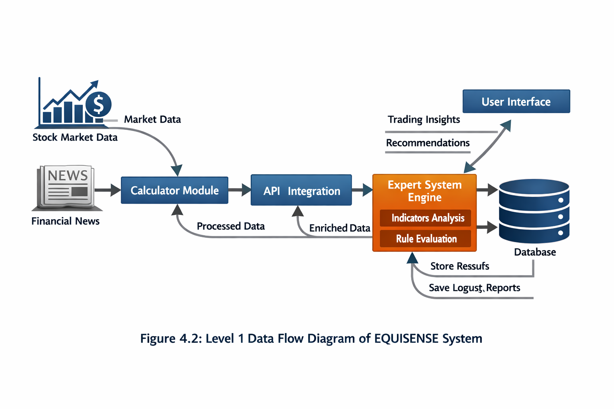

4.2.3 Activity Diagram
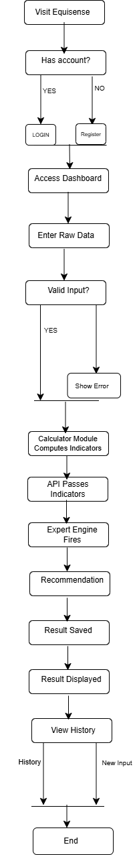Figure 4.3: Activity Diagram

4.3 DESIGN

4.3.1 Flowchart

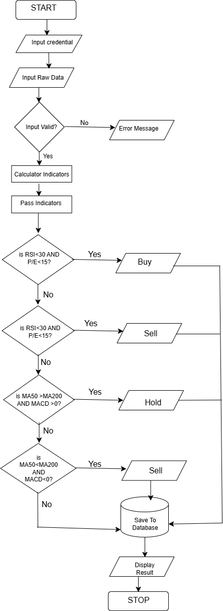Figure 4.4: System Flowchart

4.3.2 Sequence Diagram

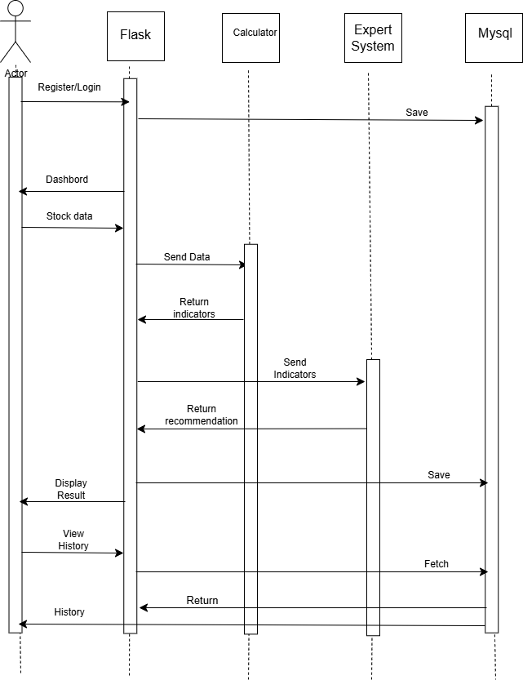
Figure 4.5: Sequence Diagram

4.3.3 Class Diagram

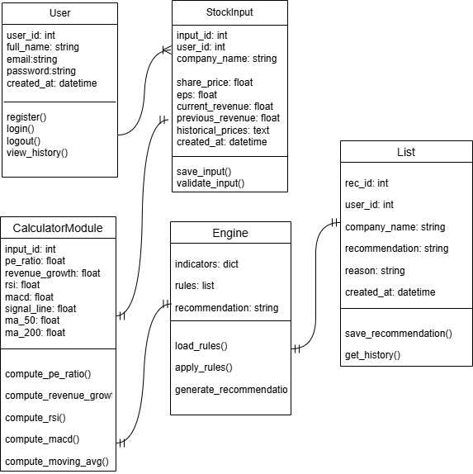
Figure 4.6: Class Diagram

4.3.4 User Interface Design

Home Page
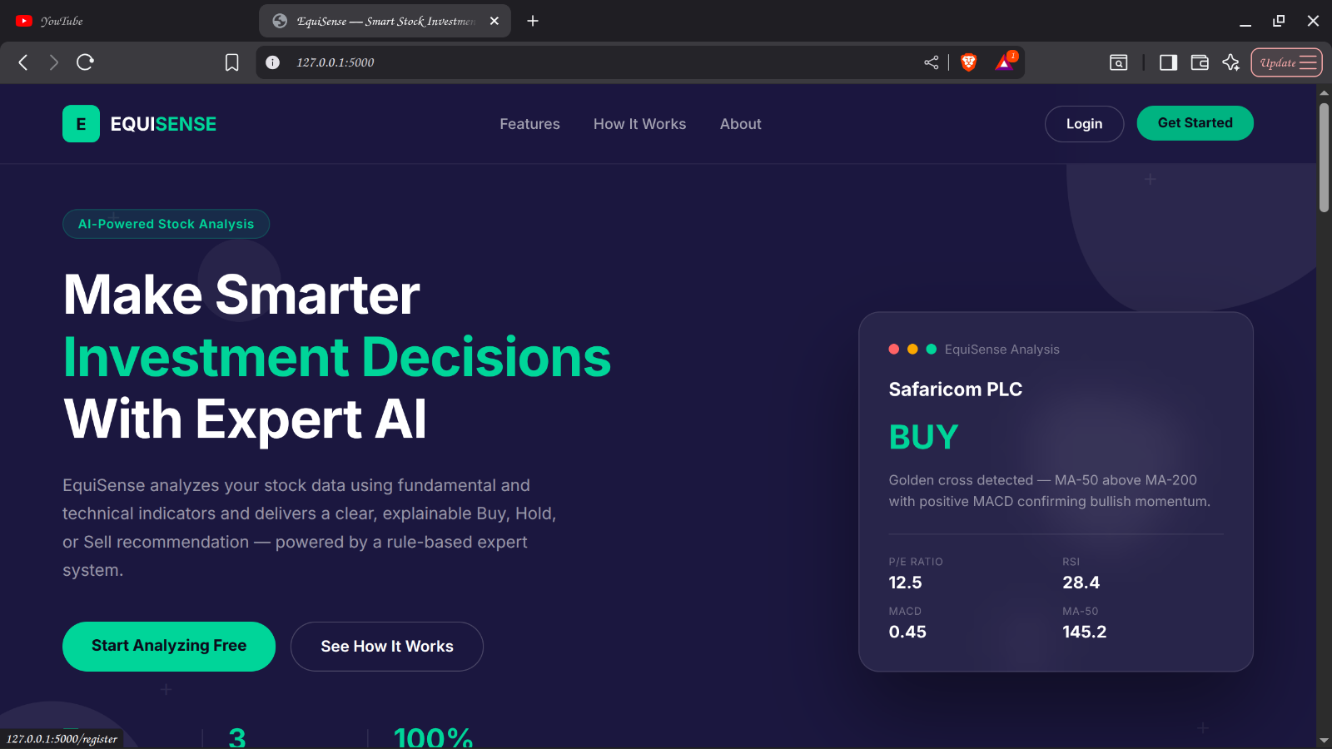
Figure 4.7: Home page

Login Page
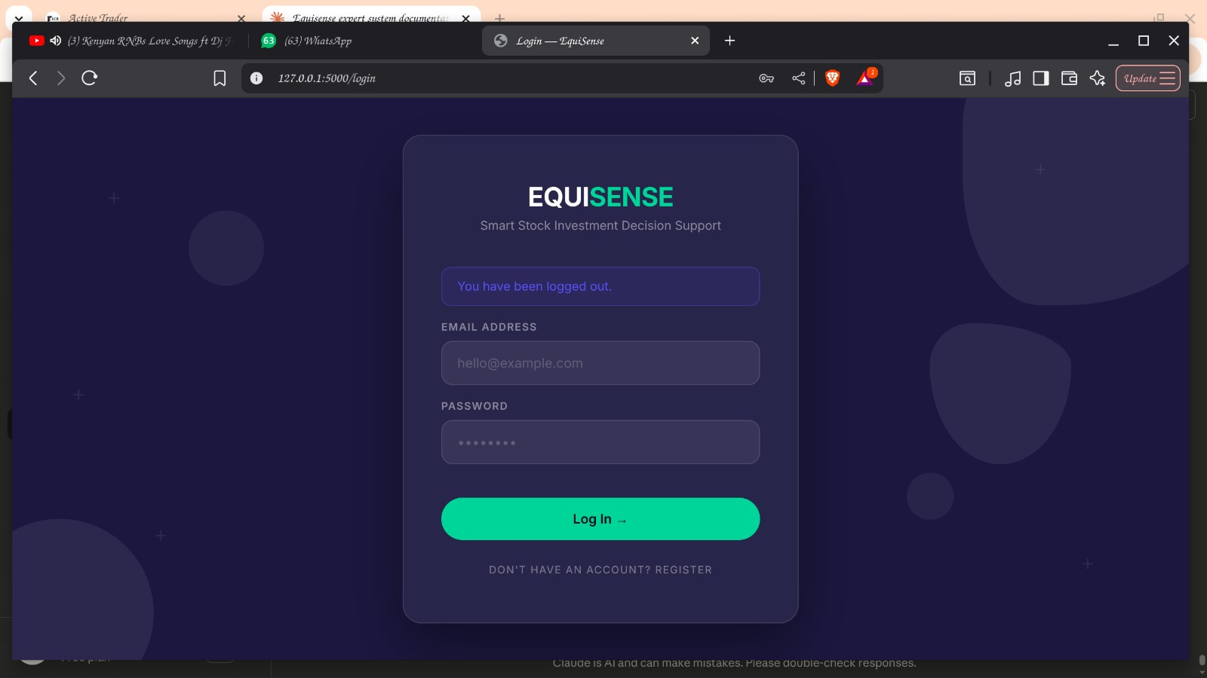
Figure 4.8: Login Page

Dashboard
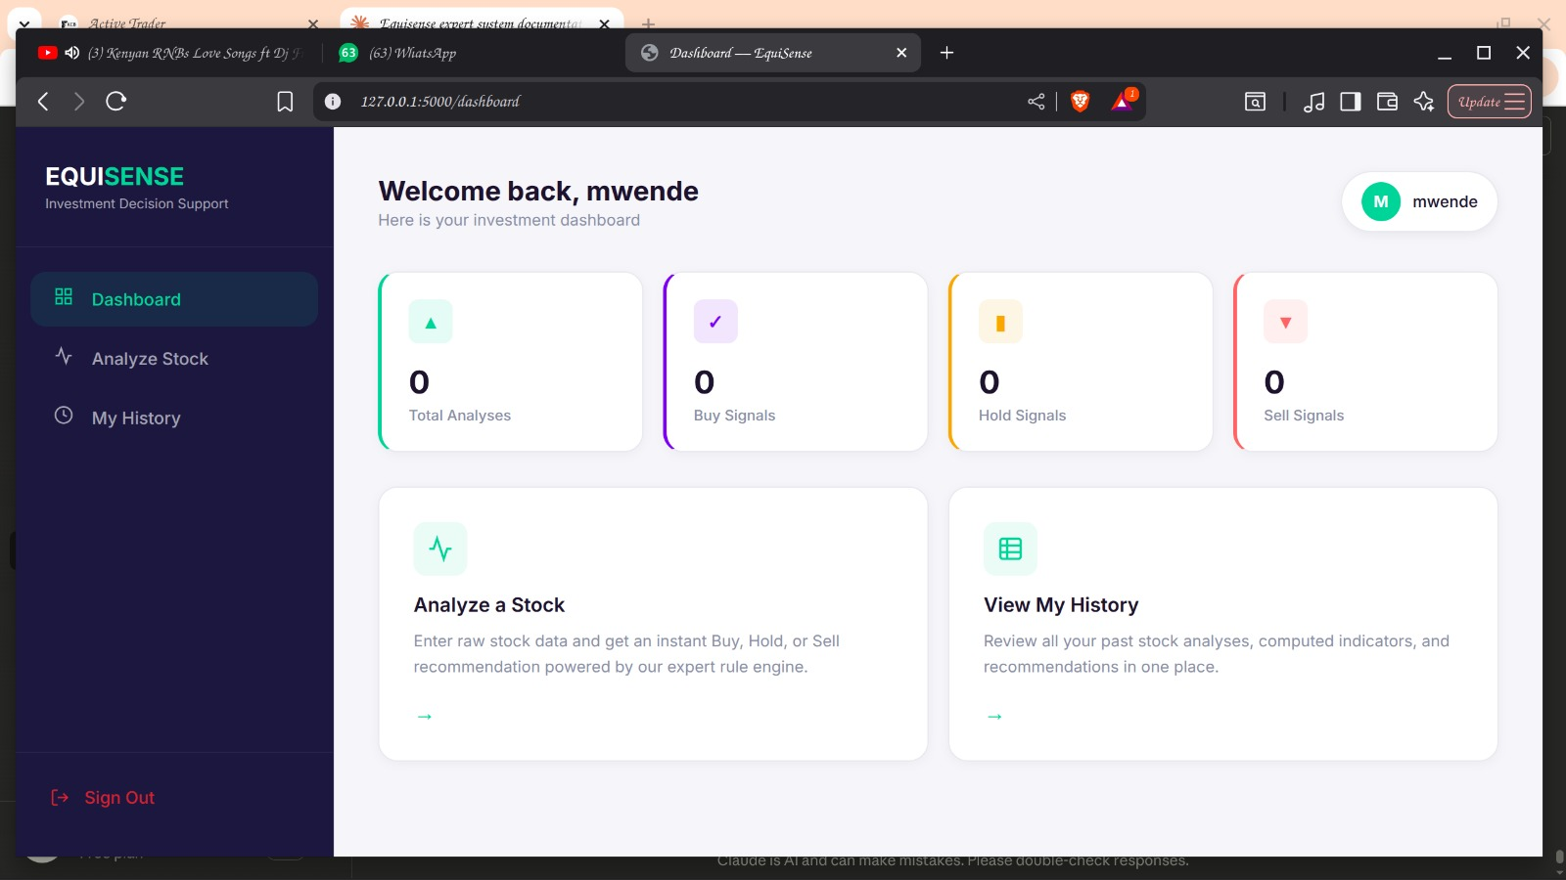
Figure 4.9: Dashboard

4.3.5 Database Design
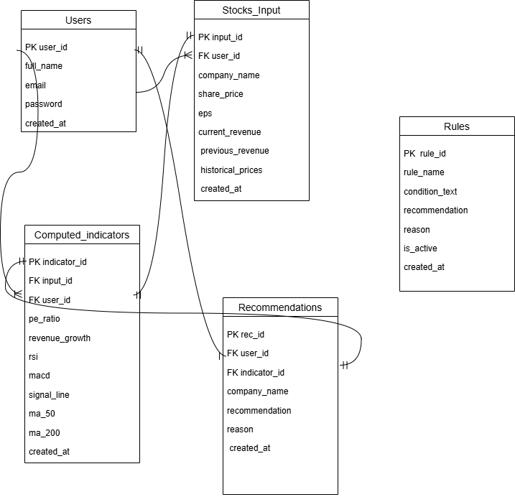
Figure 5.0: Database Design

CHAPTER FIVE

5.1 INTRODUCTION

This chapter presents the implementation, testing, and deployment of the EquiSense Expert System. It details how each of the five system components was coded, the testing procedures carried out to verify correctness and reliability, and the deployment strategy adopted for real-world use. The chapter also covers user training and system documentation to ensure effective utilization and long-term maintainability of the system.
EquiSense was built using Python and Flask as the backend framework, MySQL as the database management system, and HTML, CSS and JavaScript for the user interface. The system was developed following the Agile methodology across four two-week sprints, with each sprint delivering a testable and functional component of the system.

5.2 CODING

The EquiSense Expert System was developed using a modular programming approach, with each of the five components implemented as a distinct, independently testable unit. The following subsections describe the implementation of each component.

5.2.1 User Management Module

The User Management Module was implemented using Flask routes and the bcrypt library for secure password hashing. The module handles user registration, login, session management, and logout. Upon registration, the user's password is hashed using bcrypt before being stored in the MySQL database, ensuring that plaintext passwords are never stored. Flask's session object is used to maintain the authenticated state of logged-in users across pages.
The module includes the following routes:

Route | Method | Function
register | GET, POST | Handles new user registration
login | GET, POST | Authenticates existing users
dashboard | GET | Displays the user dashboard
profile | GET, POST | Allows users to update details and password
logout | GET | Clears session and redirects to login

5.2.2 Calculator Mode

The Calculator Module was implemented in a dedicated Python file called calculator.py. It accepts raw stock data from the user and computes seven financial indicators required by the Expert System Engine. The module uses pure Python mathematical functions without relying on external financial libraries, ensuring full control and transparency over all calculations.
The indicators computed and their formulas are as follows:

Indicator | Formula / Method
P/E Ratio | Share Price ÷ Earnings Per Share
Revenue Growth | ((Current Revenue − Previous Revenue) ÷ Previous Revenue) × 100
RSI | Based on average gains and losses over a 14-period window
MACD | 12-period EMA minus 26-period EMA
Signal Line | 9-period EMA of MACD values
MA-50 | Average of the last 50 closing prices
MA-200 | Average of the last 200 closing prices
All computed values are returned as a Python dictionary and passed to the Expert System Engine via the Flask API layer.

5.2.3 Flask REST API Layer
The Flask REST API Layer serves as the internal communication bridge between the Calculator Module and the Expert System Engine. It is implemented within app.py using Flask routes. The /analyze route receives raw stock data from the user input form, calls the run_calculator() function from calculator.py, and passes the resulting indicators dictionary to the run_expert_system() function from expert_system.py. The API layer also handles saving all inputs, computed indicators, and recommendations to the MySQL database.

5.2.4 Expert System Engine
The Expert System Engine was implemented in a dedicated Python file called expert_system.py. It contains a structured set of IF-THEN rules derived from established fundamental and technical analysis principles. The inference engine evaluates the computed indicators sequentially against each rule and returns the first matching recommendation along with a plain-language explanation.
The knowledge base contains the following rules:
Rule | Condition | Recommendation
Rule 1 | RSI < 30 AND P/E Ratio < 15 | BUY
Rule 2 | RSI < 30 AND Revenue Growth > 10% | BUY
Rule 3 | MA-50 > MA-200 AND MACD > 0 | BUY
Rule 4 | P/E Ratio < 20 AND Revenue Growth > 15% | BUY
Rule 5 | RSI > 70 AND P/E Ratio > 30 | SELL
Rule 6 | MA-50 < MA-200 AND MACD < 0 | SELL
Rule 7 | Revenue Growth < 0 AND RSI > 60 | SELL
Rule 8 | P/E Ratio > 40 AND Revenue Growth < 5% | SELL
Rule 9 | RSI between 40 and 60 | HOLD
Rule 10 | P/E Ratio between 15 and 25 AND Revenue Growth between 5% and 15% | HOLD
Rule 11 | MACD and Signal Line difference < 0.5 | HOLD
Default | No strong signal from available indicators | HOLD

5.2.5 MySQL Database

The MySQL database was implemented with five interrelated tables. The database was created using the MySQL command line and is connected to the Flask application through the mysql-connector-python library. The connection is managed through a dedicated database.py file that provides reusable get_connection() and close_connection() functions used across all routes in app.py.

5.3 TESTING

5.3.1 What is Testing

Testing is the process of evaluating a system or its components to determine whether they satisfy specified requirements and produce correct outputs for given inputs. In the context of EquiSense, testing was conducted to verify that the Calculator Module computes indicators correctly, the Expert System Engine fires the appropriate rules, the database stores and retrieves data accurately, and the user interface functions as expected across all pages.

5.3.2 Why Testing

Testing was conducted for the following reasons:

- To ensure the Calculator Module produces mathematically correct indicator values for valid inputs
- To verify that the Expert System Engine consistently fires the correct rule for a given set of indicators
- To confirm that user registration, login, session management, and logout function correctly and securely
- To validate that all data is correctly saved to and retrieved from the MySQL database
- To ensure the user interface is intuitive, responsive, and free of errors across all pages
- To identify and resolve any bugs or logical errors before final submission

5.3.3 Unit Testing

Unit testing was conducted on each component individually to verify that it functions correctly in isolation. The following unit tests were carried out:

Calculator Module Unit Tests:

Test | Input | Expected Output | Result
P/E Ratio | Share Price = 140, EPS = 12 | 11.67 | Pass
RG | Current = 9,000,000, Previous = 7,500,000 | 20% | Pass
RSI | 15 declining prices | Below 30 | Pass
MA-50 | 50 closing prices | Average of last 50 | Pass
MA-200 | 200 closing prices | Average of last 200 | Pass
MACD | 26 closing prices | EMA12- EMA26 | Pass

Expert System Engine Unit Tests:

Test | Input Indicators | Expected Recommendation | Result
Rule 1 | RSI = 28, P/E = 11.67 | BUY | Pass
Rule 3 | MA-50 > MA-200, MACD > 0 | BUY | Pass
Rule 5 | RSI = 75, P/E = 35 | SELL | Pass
Rule 6 | MA-50 < MA-200, MACD < 0 | SELL | Pass
Rule 9 | RSI = 50 | HOLD | Pass
Default | Insufficient indicators | HOLD | Pass

5.3.4 Integration Testing

Integration testing was conducted after all individual components were unit tested to verify that they work correctly together as a complete system. The following integration tests were performed:

Test | Description | Result
Calculator to Engine | Indicators computed by calculator passed correctly to expert system engine via API | Pass
Engine-Database | Recommendations generated by engine saved correctly to MySQL recommendations table | Pass
Login- Dashboard | Successful login redirects to dashboard with correct user session | Pass
Analyze-Results | Stock form submission triggers calculator, engine and displays results page | Pass
History Retrieval | Recommendations retrieved correctly from database and displayed in history table | Pass

5.3.5 System Testing

System testing was conducted on the complete integrated EquiSense system to verify end-to-end functionality. Three full stock analysis scenarios were tested:

Test Case 1 — BUY Recommendation:

Field | Value
Company | Safaricom PLC
Share Price | 140
EPS | 12
Current Revenue | 5,500,000
Previous Revenue | 5,000,000
Historical Prices | 200 declining then recovering prices
Expected Output | BUY
Actual Output | BUY
Result | Pass

Test Case 2 — SELL Recommendation:

Field | Value
Company | XYZ Corp
Share Price | 500
EPS | 10
Current Revenue | 3,000,000
Previous Revenue | 4,000,000
Historical Prices | 200 high then declining prices
Expected Output | SELL
Actual Output | SELL
Result | Pass

Test Case 3 — HOLD Recommendation:

Field | Value
Company | BAT Limited
Share Price | 200
EPS | 11
Current Revenue | 6,000,000
Previous Revenue | 5,700,000
Historical Prices | 200 stable prices
Expected Output | HOLD
Actual Output | HOLD
Result | Pass

Table 5.3: Test case 3

5.3.6 Usability Testing

Usability testing was conducted in Sprint 4 using the observation checklist with selected participants. Participants were asked to interact with the working EquiSense prototype and complete a full stock analysis. The following observations were recorded:

Observation Item | Result
Participant registered an account without assistance | Yes
Participant logged in successfully | Yes
Participant understood where data is entered | Yes
Participant navigated the interface with ease | Yes
Computed values were displayed clearly | Yes
Buy/Hold/Sell recommendation was clearly visible | Yes
Participant understood the reason behind the recommendation | Yes
Participant viewed recommendation history successfully | Yes
Participant encountered errors during the session | No
Participant expressed confidence in the system | Yes

5.4DEPLOYMENT

5.4.1 Data Conversion

Before deployment, a data dictionary was defined to ensure consistency in data handling across all system components. All user inputs are validated and converted to the correct data types before being passed to the Calculator Module.

Data Dictionary:

Variable | Data Type | Description
company name | VARCHAR (100) | Name of the company being analyzed
share price | DECIMAL (10,2) | Current share price of the stock
eps | DECIMAL (10,2) | Earnings Per Share
current revenue | DECIMAL (15,2) | Company revenue for the current period
previous revenue | DECIMAL (15,2) | Company revenue for the previous period
historical prices | TEXT | Comma-separated list of historical closing prices
pe_ratio | DECIMAL (10,2) | Computed Price-to-Earnings ratio
revenue growth | DECIMAL (10,2) | Computed revenue growth percentage
rsi | DECIMAL (10,2) | Computed Relative Strength Index
macd | DECIMAL (10,4) | Computed MACD value
signal line | DECIMAL (10,4) | Computed Signal Line value
ma_50 | DECIMAL (10,2) | Computed 50-day Moving Average
ma_200 | DECIMAL (10,2) | Computed 200-day Moving Average
recommendation | ENUM | BUY, HOLD, or SELL
reason | TEXT | Plain-language explanation of the recommendation

5.4.2 Deployment Strategy

5.4.2.1 Selected Strategy

The pilot deployment strategy was selected for EquiSense. This approach involves introducing the system to a small, controlled group of users before full-scale rollout, allowing the development team to identify issues, gather feedback, and make refinements in a low-risk environment.

Merits:
- Reduces the risk of system failure at full scale
- Allows early detection of bugs and usability issues
- Enables real user feedback to inform final refinements
- Builds user confidence gradually before wider adoption
Demerits:
- Initial coverage is limited to the pilot group
- May delay full system availability to all intended users
- Feedback from a small group may not represent the broader user base

5.4.2.2 Description of the Strategy

In the pilot deployment of EquiSense, the system was first made available to a selected group of 15 participants comprising 10 retail investors and 5 financial analysts as outlined in the sampling strategy in Chapter Three. These participants interacted with the system, performed stock analyses, and provided feedback through the observation checklist and informal interviews. Findings from the pilot were used to refine the rule base, improve the user interface, and resolve any errors identified before the system was prepared for wider deployment.
The system is currently deployed locally on a Python Flask development server accessible at http://127.0.0.1:5000. For wider deployment, the system is designed to be hosted on any Python-compatible web hosting platform such as PythonAnywhere or Railway, with the MySQL database migrated to a cloud-hosted instance.

5.5 USER TRAINING

User training is essential to ensure that investors can effectively interact with the EquiSense system and interpret its outputs correctly. Training for EquiSense is structured around three areas:

Understanding System Inputs
Users are trained to source and enter accurate raw stock data including share price, EPS, revenue figures, and historical closing prices from reliable financial platforms such as the Nairobi Securities Exchange website or their brokerage platforms.

Interpreting System Outputs
Users are guided on how to read the recommendation results page, understand the computed indicators displayed, and interpret the plain-language explanation provided alongside each Buy, Hold, or Sell recommendation.

Navigating the User Interface
Users are walked through the registration and login process, the stock analysis form, the results page, the history page, and the profile settings page through a hands-on demonstration session.
Training is delivered through the following methods:

- A user guide document explaining each page and feature of the system
- A live demonstration session conducted during Sprint 4 usability testing
- The system's built-in plain-language explanations that guide users through each recommendation

5.6 SYSTEM MANUAL

5.6.1 Importance of System Documentation

System documentation is critical for ensuring that EquiSense can be effectively used, maintained, and extended beyond the current development cycle. It provides a reference for end users on how to operate the system and for developers on how the system is structured and how it can be updated.

5.6.2 Operational Manual

The operational manual provides step-by-step instructions for end users on how to use the EquiSense system:

Step 1 — Registration:
Navigate to the EquiSense landing page and click Get Started. Fill in your full name, email address, and password and click Create Account.

Step 2 — Login:
Enter your registered email and password on the login page and click Sign In to access your personal dashboard.

Step 3 — Analyze a Stock:
From the dashboard or sidebar, click Analyze Stock. Enter the company name, share price, EPS, current revenue, previous revenue, and historical closing prices. Click Run Analysis.

Step 4 — View Results:
The results page displays all seven computed indicators and the Buy, Hold, or Sell recommendation with a plain-language explanation. All results are automatically saved to your history.

Step 5 — View History:
Click My History in the sidebar to view all your past stock analyses and recommendations in a sortable table.

Step 6 — Update Profile:
Click your name in the top right corner or Profile in the sidebar to update your name, email, or password.

5.6.3 Technical Manual

The technical manual is intended for developers and system administrators responsible for maintaining and extending the EquiSense system.

System Architecture:
EquiSense is a five-component Flask web application. The entry point is app.py which defines all routes. The Calculator Module is in calculator.py, the Expert System Engine is in expert_system.py, and the database connection is managed by database.py. All HTML templates are stored in the templates/ directory and all CSS styling is in static/style.css.
Adding New Rules: To add a new IF-THEN rule to the knowledge base, open expert_system.py and add a new conditional block inside the run_expert_system() function following the existing pattern. Each rule must return a dictionary with a recommendation key and a reason key.
Database Management: The MySQL database is named equisense and contains five tables — users, stock_inputs, computed_indicators, recommendations, and rules. The database credentials are stored in database.py and should be updated when deploying to a production environment.
Dependencies: All system dependencies are listed in requirements.txt and can be installed using:
pip install -r requirements.txt

CHAPTER SIX

6.1 INTRODUCTION

This chapter presents the overall conclusion of the EquiSense Expert System project, summarizes how the system addressed each of its stated research objectives, outlines the limitations encountered during development, and provides recommendations for future improvements. The chapter reflects on the extent to which EquiSense has achieved its goal of providing accessible, transparent, and explainable stock investment decision support to retail investors

6.2 LIMITATIONS

The following limitations were encountered during the development of the EquiSense Expert System:

Limited Access to Historical Financial Data:
Historical closing prices and financial statements for Kenyan listed companies are not freely available. Most reliable financial data providers charge subscription fees, making it difficult to test the system with real market data. This limitation was addressed during development by using simulated price sequences that reflect realistic market patterns.

Dependence on User-Provided Input:
The accuracy of EquiSense's recommendations is directly dependent on the quality of data entered by the user. Incorrect, outdated, or fabricated input values will produce unreliable recommendations. The system currently has no mechanism to verify the accuracy of user-provided data against external sources.

Simplified Rule Base:
Financial markets are highly dynamic and influenced by a vast number of variables including geopolitical events, macroeconomic shifts, and investor sentiment. The current rule base, while grounded in established financial analysis principles, represents a simplified model of real-world market behavior and cannot account for all possible market conditions.

No Real-Time Data Integration:
EquiSense does not connect to live stock market feeds or financial data APIs. All data must be manually entered by the user, which limits the timeliness and convenience of the system's recommendations compared to commercial trading platforms.

Inability to Handle Extreme Market Events:
Sudden economic shocks, political instability, pandemics, or other unprecedented events are not accounted for within the system's IF-THEN rules. Such events can cause rapid and irrational market movements that fall outside the scope of fundamental and technical analysis.
Single Stock Analysis: The current version of EquiSense analyzes one stock at a time. Users cannot compare multiple stocks simultaneously or build and analyze a portfolio of investments within the system.

6.3 RECOMMENDATION
Based on the limitations identified, the following recommendations are proposed for future development and improvement of the EquiSense Expert System:
Integration of Real-Time Market Data:
Future versions of EquiSense should integrate with financial data APIs such as Alpha Vantage, Twelve Data, or the NSE data portal to automatically fetch current stock prices and historical closing prices. This would eliminate the need for manual data entry and significantly improve the timeliness and accuracy of recommendations.
Expansion of the Knowledge Base:
The current rule base of eleven rules should be expanded through additional expert consultations and literature review. New rules incorporating additional indicators such as the Stochastic Oscillator, Bollinger Bands, and Dividend Yield would improve the system's decision-making capabilities across a wider range of market conditions.
Integration of Machine Learning:
While the current rule-based approach ensures transparency and explainability, combining it with a machine learning layer that learns from historical recommendation outcomes could improve prediction accuracy over time. A hybrid system that uses machine learning to refine rules dynamically would represent a significant advancement over the current static rule base.
Multi-Stock Portfolio Analysis:
A future version of EquiSense should allow users to analyze multiple stocks simultaneously and compare recommendations across a portfolio. This would make the system significantly more useful for investors managing diversified investments.
Risk Assessment Module:
A dedicated risk assessment component should be added to provide users with a risk score alongside each recommendation. This would help investors understand not only whether to Buy, Hold, or Sell but also the level of risk associated with acting on that recommendation.
Mobile Application:
Given the high mobile phone penetration rate in Kenya and the mobile-first nature of retail investing in the local market, developing a mobile version of EquiSense for Android and iOS would significantly increase its accessibility and reach among everyday investors.
Cloud Deployment:
The system should be deployed to a cloud hosting platform such as PythonAnywhere, Railway, or a Virtual Private Server to make it accessible to users beyond the local development environment. The MySQL database should also be migrated to a cloud-hosted instance to support multiple concurrent users.

6.4 CONCLUSION
The EquiSense Expert System successfully demonstrates the application of knowledge-based systems in supporting stock investment decision-making for retail investors. The system was developed across five integrated components a User Management Module, a Calculator Module, a Flask REST API Layer, an Expert System Engine, and a MySQL Database built using Python, Flask, MySQL, and HTML/CSS/JavaScript following an Agile development methodology.
Through the integration of both fundamental and technical analysis into a structured IF-THEN rule base, EquiSense provides investors with clear, consistent, and explainable Buy, Hold, or Sell recommendations that are grounded in established financial analysis principles. Unlike black-box machine learning systems, every recommendation generated by EquiSense can be traced back to the specific rule and indicator values that triggered it, ensuring full transparency and user trust.
The system was rigorously tested at unit, integration, system, and usability levels, with all test cases passing successfully. Usability testing confirmed that participants were able to register, log in, enter stock data, and interpret recommendations without assistance, demonstrating that the system is accessible and intuitive for investors of all experience levels.
Despite the limitations identified particularly the lack of real-time data integration and the simplified rule base EquiSense achieves its primary objective of bridging the gap between expert financial knowledge and the everyday retail investor. With the recommended future enhancements, EquiSense has the potential to evolve into a robust, widely accessible, and commercially viable stock investment decision support system for the Kenyan market and beyond.

6.5 REFERENCES
Bustos, O., & Pomares-Quimbaya, A. (2020). Stock market movement forecast: A systematic review. Expert Systems with Applications, 156, 113464. https://doi.org/10.1016/j.eswa.2020.113464
Chen, W., Zhang, H., Mehlawat, M. K., & Jia, L. (2021). Mean-variance portfolio optimization using machine learning-based stock price prediction. Applied Soft Computing, 100, 106943. https://doi.org/10.1016/j.asoc.2020.106943
Deng, S., Mitsubuchi, T., Shioda, K., Shimada, T., & Sakurai, A. (2019). Combining technical analysis with sentiment analysis for stock price prediction. IEEE Access, 7, 7803–7816. https://doi.org/10.1109/ACCESS.2018.2886367
Henrique, B. M., Sobreiro, V. A., & Kimura, H. (2019). Literature review: Machine learning techniques applied to financial market prediction. Expert Systems with Applications, 124, 226–251. https://doi.org/10.1016/j.eswa.2019.01.012
Huang, C., Yang, X., Yang, X., & Sheng, H. (2022). An application of rule-based expert systems for stock investment decisions in emerging markets. Journal of Financial Engineering, 9(1), 2250003. https://doi.org/10.1142/S2424786322500037
Nabipour, M., Nayyeri, P., Jabani, H., Mosavi, A., & Salwana, E. (2020). Deep learning for stock market prediction. Entropy, 22(8), 840. https://doi.org/10.3390/e22080840
Obthong, M., Tantisantiwong, N., Jeamwatthanachai, W., & Mackenzie, G. (2020). A survey on machine learning for stock price prediction: Algorithms and techniques. Finance and Economics Review, 2(2), 1–25.
Sezer, O. B., Gudelek, M. U., & Ozbayoglu, A. M. (2020). Financial time series forecasting with deep learning: A systematic literature review. Applied Soft Computing, 90, 106181. https://doi.org/10.1016/j.asoc.2020.106181
Weng, B., Ahmed, M. A., & Megahed, F. M. (2017). Stock market one-day ahead movement prediction using disparate data sources. Expert Systems with Applications, 79, 153–163. https://doi.org/10.1016/j.eswa.2017.02.041
Zhu, M., Philpotts, D., & Stevenson, M. (2021). The benefits of combining fundamental and technical analysis: Evidence from the UK stock market. Journal of Trading, 16(1). https://doi.org/10.3905/jot.2021.1.172

APPENDICES

BUDGET

Hardware Requirements

ITEM | SPECIFICATION | COST(KES)
Laptop/Computer((x3) | Intel core i5, 8GB RAM, 256GB SSD | 35,000
Internet Connection | Broadband – 3 months | 4,500
External Storage | cloud backup | 5,000
Total |  | 44,500

Table A.1: Hardware Requirements

Software requirements

ITEM | COST(KES)
Python 3.x, MySQL, Flask, VS code, GitHub
Draw.io (system diagrams) | 0
Total | 0

Table A.2: Software Requirements

Miscellaneous Costs

ITEM | COST(KES)
Printing & binding | 3,000
Contingency | 10,000
Transport | 4,000
Total | 17,000

Table A.3: Miscellaneous Costs

Budget Summary

CATEGORY | COST(KES)
Hardware | 44,500
Software | 0
Miscellaneous | 17,000
Grand Total | 61,500

Table A.4: Budget Summary

ETHICAL CONSIDERATION LETTER
DEDAN KIMATHI UNIVERSITY OF TECHNOLOGY,
DEPARTMENT OF COMPUTER SCIENCE,
9TH FEB,2026.
TO: THE ETHICS COMMITTEE/ PROJECT SUPERVISOR.
Dear Sir/Madam,
RE: ETHICAL CLEARANCE (EQUISENSE EXPERT SYSTEM)
We, the undersigned students, request ethical clearance for our final year project titled "EquiSense Expert System for Stock Management."
Data will be collected through expert interviews and retail investor questionnaires. We confirm that:
- Participation is entirely voluntary
- All participants will provide informed consent
- Personal information will remain strictly confidential
- Data will be used solely for academic purposes
- Information will be stored securely throughout the project

We kindly request your approval to proceed.
Yours faithfully,
NJENGA JOHN,
C026-01-0798/2024.

GANT CHART

Task | W1 | W2 | W3 | W4 | W5 | W6 | W7 | W8
Requirements Gathering
Data collection

Database design & setup
User Management Module
Calculator Module

Expert System Engine

API Development & integration
User Interface Development
System Testing & Refinement
Documentation & Report Writing
Final Submission

QUESTIONNAIRE
Equisense Expert System (Retail Investor Questionnaire)
All responses are strictly confidential and for academics use only.
SECTION A: BACKGROUND
- Age group: [ ] 18–25 [ ] 26–35 [ ] 36–45 [ ] 46+

- Education: [ ] Secondary [ ] Diploma [ ] Undergraduate [ ] Postgraduate

- Investment experience: [ ] Under 1 year [ ] 1–3 years [ ] 3–5 years [ ] 5+ years
SECTION B: Investment Decision-Making
- How do you currently make investment decisions? (Select all that apply)
[ ] Personal research [ ] Financial advisor [ ] Social media [ ] Gut feeling
- How confident are you in analyzing stock data?
[ ] Very confident [ ] Somewhat confident [ ] Not very confident [ ] Not at all
- Familiarity with financial indicators (1 = Not familiar, 5 = Very familiar)
Indicator |  | 1 | 2 | 3 | 4 | 5
P/E Ratio
EPS
RSI
MACD
Moving Averages

- Biggest challenge in stock decision-making?
[ ] Too much data [ ] Lack of knowledge [ ] No expert access [ ] Fear of loss
SECTION C: System Expectations
- Would you use an expert system that recommends Buy, Hold, or Sell?
[ ] Definitely yes [ ] Probably yes [ ] Not sure [ ] Probably not
- How important is it that the system explains its recommendation?
[ ] Very important [ ] Important [ ] Somewhat important [ ] Not important
- Desired features: (Select all that apply)
[ ] Personal login [ ] Recommendation history [ ] Clear explanations [ ] Simple interface
- Additional comments:
----------------------------------------------------------------------------------------------------------------------------------Thank you for your participation.

INTERVIEW GUIDE
Equsense Expert System: Financial Expert Interview Guide
Strictly confidential. For academic purposes only.
Participant Profile
Profession: ____________________________________ Years Of Experience: __________________

SECTION A: General Decision-Making
- What are the most important factors you consider when deciding to Buy, Hold, or Sell a stock?
- Do you rely more on fundamental analysis, technical analysis, or both? Why?

SECTION B: Fundamental Analysis
- At what P/E ratio range would you consider a stock undervalued, fairly valued, or overvalued?
- How do you interpret EPS trends when making an investment decision?
- What revenue growth rate signals a strong Buy opportunity to you?

SECTION C: Technical Analysis
- At what RSI levels would you recommend Buy, Hold, or Sell?
- How do you use MACD crossovers and divergences in your decisions?
- Which moving averages do you rely on most and how do you use them?

SECTION D: Rule-Based Reasoning
- What combination of indicators would lead you to a confident Buy recommendation?
- What combination of signals would make you strongly recommend Sell?
- When would you recommend Hold despite mixed signals?

Thank you for your time and expertise.

OBSERVATION CHECKLIST
Equisense Expert System: Usability Observation Checklist
To be completed by the researcher during testing
NO | Observation Item | Yes | No | Comments
1 | Participant registered an account without assistance
2 | Participant logged in successfully
3 | Participant understood where data is being entered
4 | Participant navigated the interface with ease
5 | Computed values were displayed clearly
6 | Buy/Hold/Sell recommendation was clearly visible
7 | Participant understood the reason behind the recommendation
8 | Participant viewed recommendation history successfully
9 | Participant encountered errors during the session
10 | Participant expressed confidence in the system

Table C.1: Observation checklist
General observation: _____________________________________________________________________________________________________________________________________________________________________________________________________________________________________________________________________

Suggested Improvements:
_____________________________________________________________________________________________________________________________________________________________________________________________________________________________________________________________________
Researcher signature: ___________________________________ Date: ___________________________

SYSTEM SCREENSHOTS

Home Page
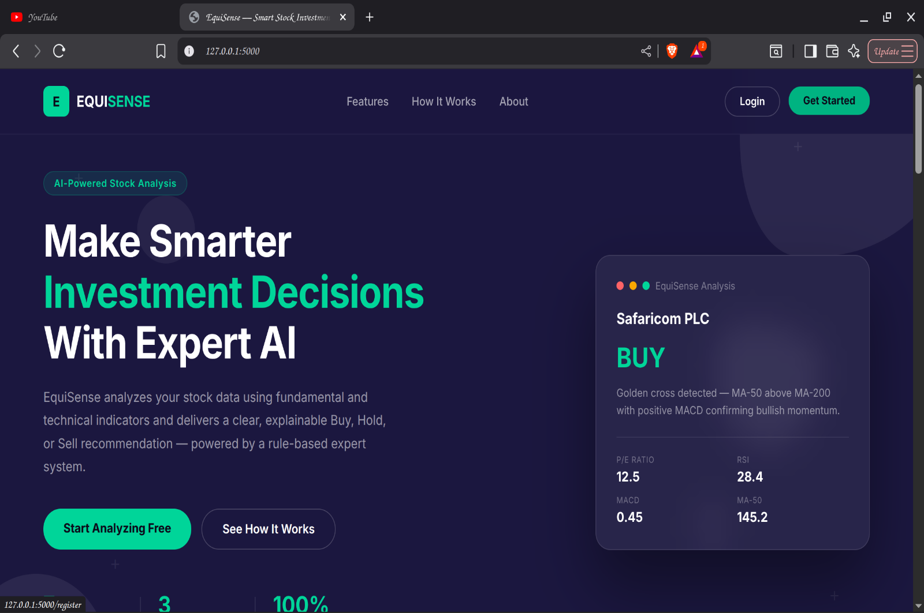

Login page
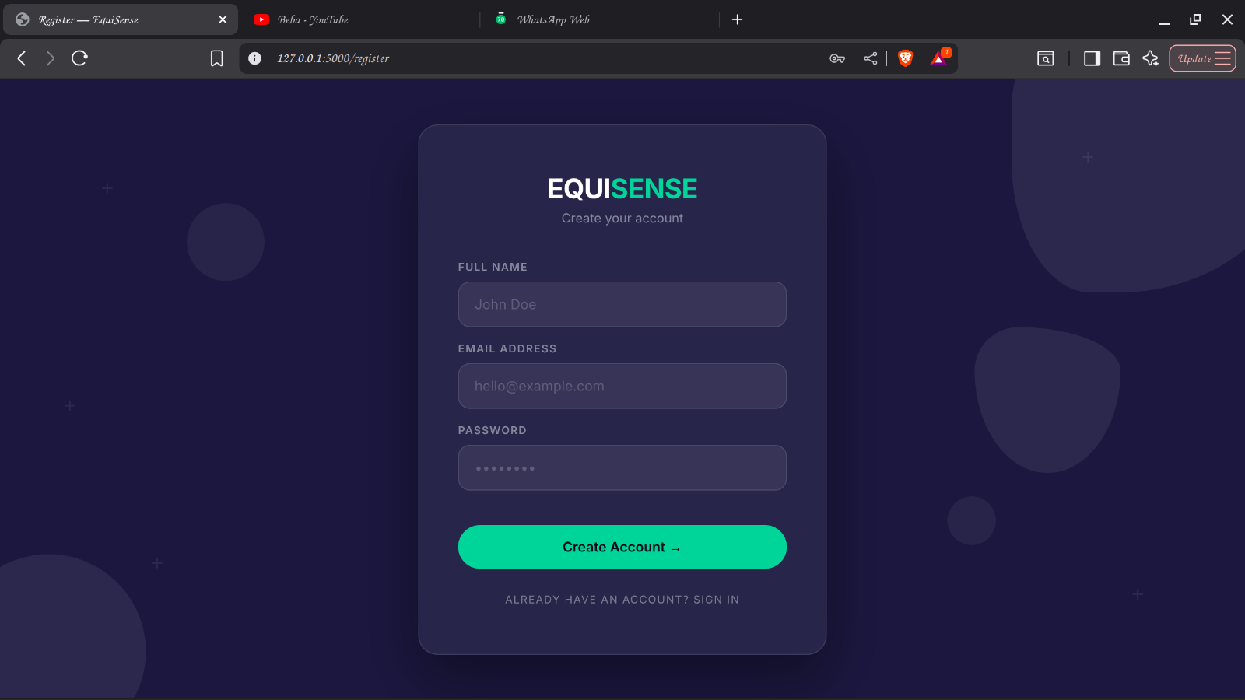

Dashboard
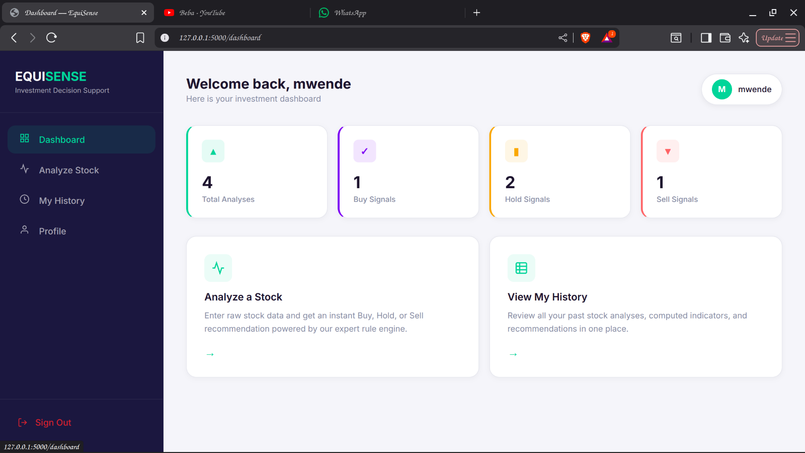

Analyze Screen
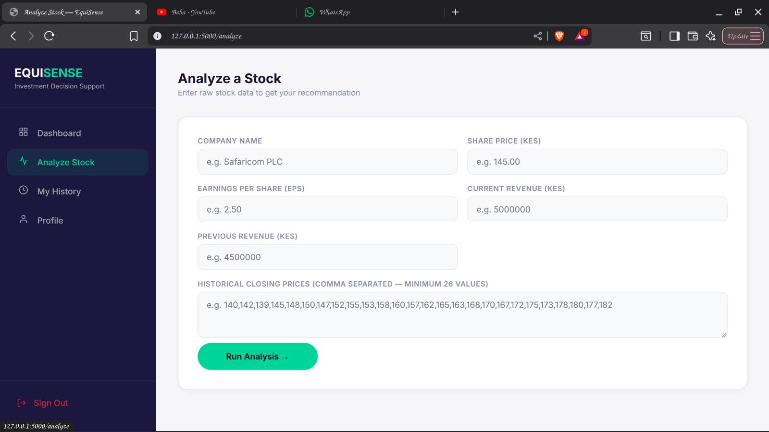

User Management
