How the Validity Formula Was Built
This note explains the AI-Native PDLC Validity Framework formula in plain language, with the equation images used in the full TTC abstract.
Weights shown in pilots are initial / placeholder, not Modus-fitted factory weights.

1. Why a formula at all?
Long autonomous agent runs do not fail mainly because a single step is hard. They fail because small per-step mistakes compound. If each step has even a 1% chance of going wrong, the chance that a 100-step trajectory stays entirely correct is already about 37%; at 300 steps it is about 5%. That compounding-error pattern is why long-horizon autonomy needs lifecycle safeguards (tests, QA, repair, review), not only a stronger model.
We needed a number that answers a different question than model benchmarks:
Does this setup—agents, context, CI, QA, repair, and review—restore trust faster than the work environment erodes it?

2. What we measure: observed validity V(t)
At each lifecycle checkpoint (for example, each agent commit), we treat validity as the share of verifier checks that currently pass:
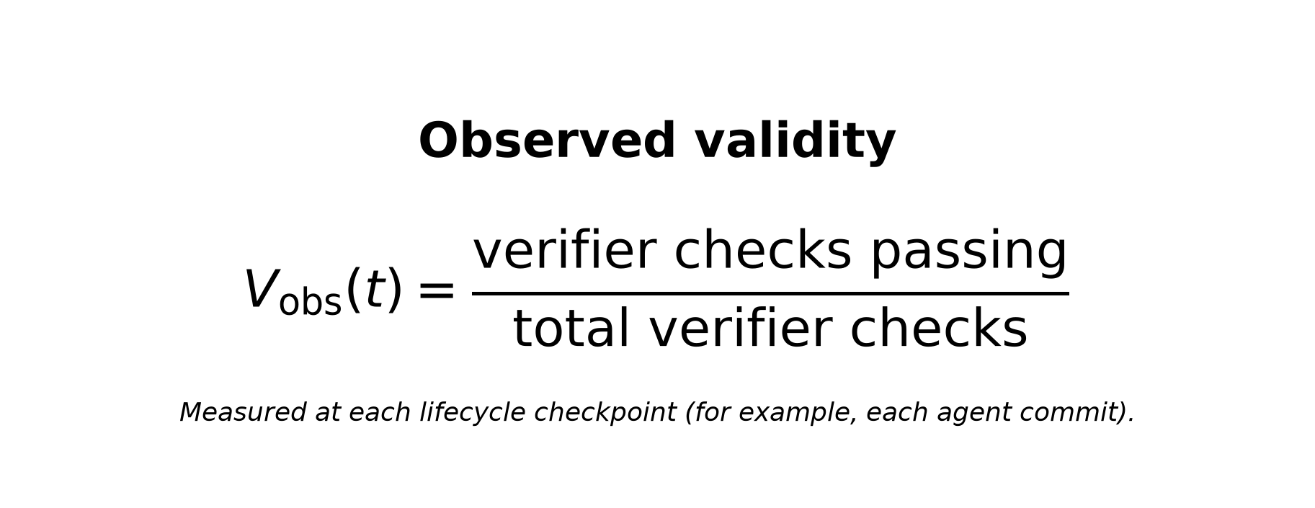
So V(t) is a time series of verified workflow evidence, not a subjective opinion about the model. The framework rates the delivery setup from that series.

3. From compounding error to a decay rate
Model the agent as a sequence of steps. With a roughly constant per-step error rate, the probability of an entirely correct trajectory falls exponentially with the number of steps. Taking the continuous-time limit turns that into a decay hazard D(t):
Without safeguards: validity only falls — dV/dt = −D(t)·V. That is the mathematical form of “long runs drift incorrect unless something catches and repairs mistakes.”
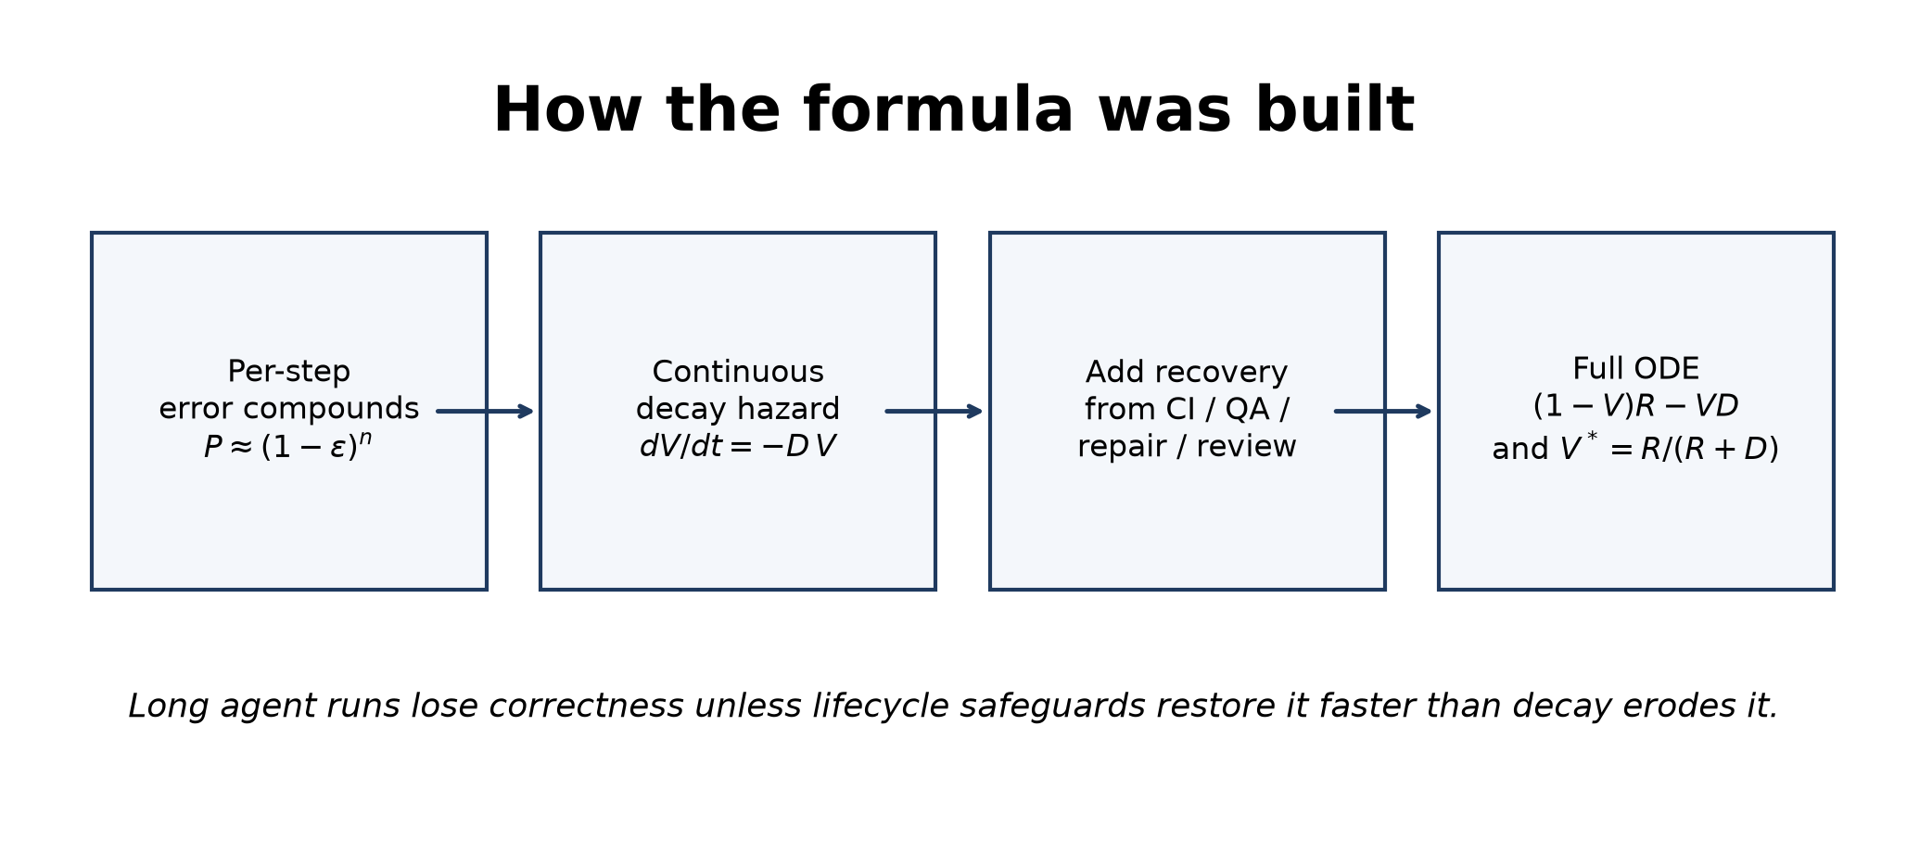

4. Adding recovery: the full ODE
Real setups push back. CI catches regressions, QA rejects broken work, repair loops fix failures, review gates stop unsafe merges. We model that push-back as a recovery rate R(t) that acts on invalid work (capacity 1 − V), while decay acts on valid work (mass V):
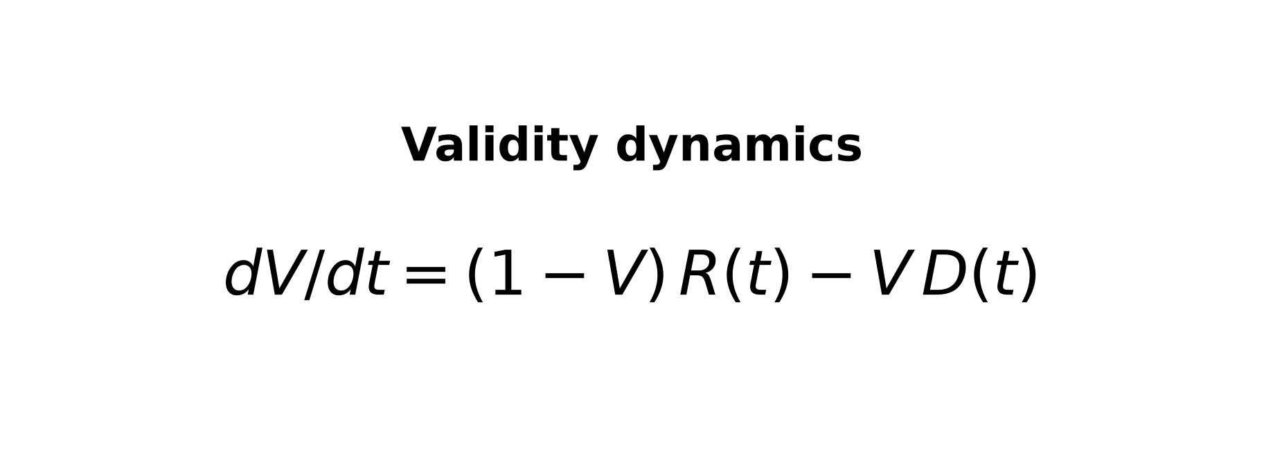
When work is mostly wrong (V low), there is more room for recovery to help. When work is mostly right (V high), there is more mass that can still decay. Raising R (better CI, QA, repair, review) pulls trust up. Raising D (lost context, vague acceptance criteria, hard-to-review diffs, wide blast radius) pulls trust down.

5. Building the decay rate D(t)
Many measurable stresses collapse into one decay rate. The v1.1 default form is hybrid: main effects plus one interaction (broad change under a vague specification):
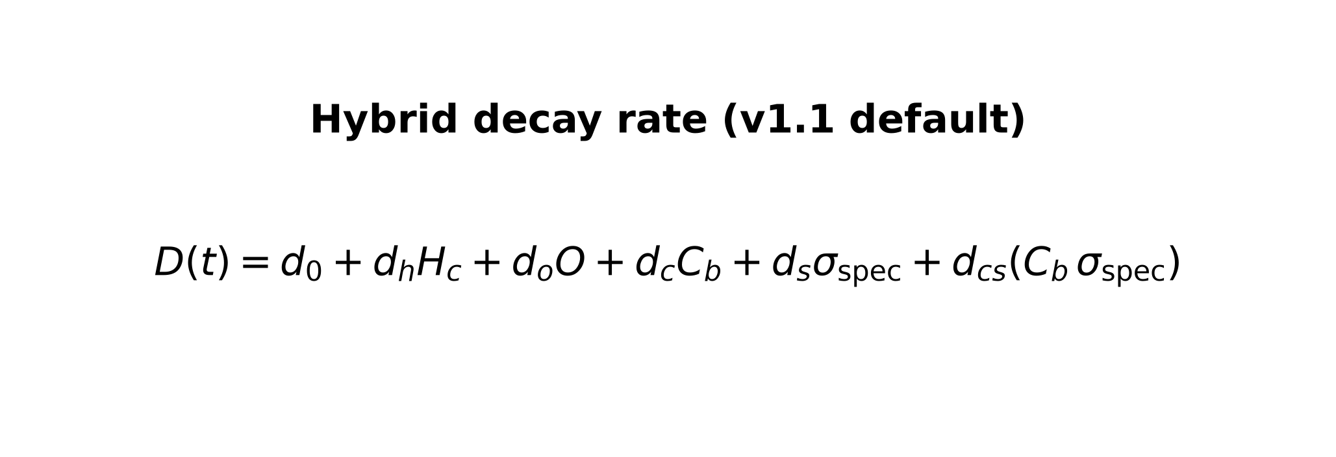
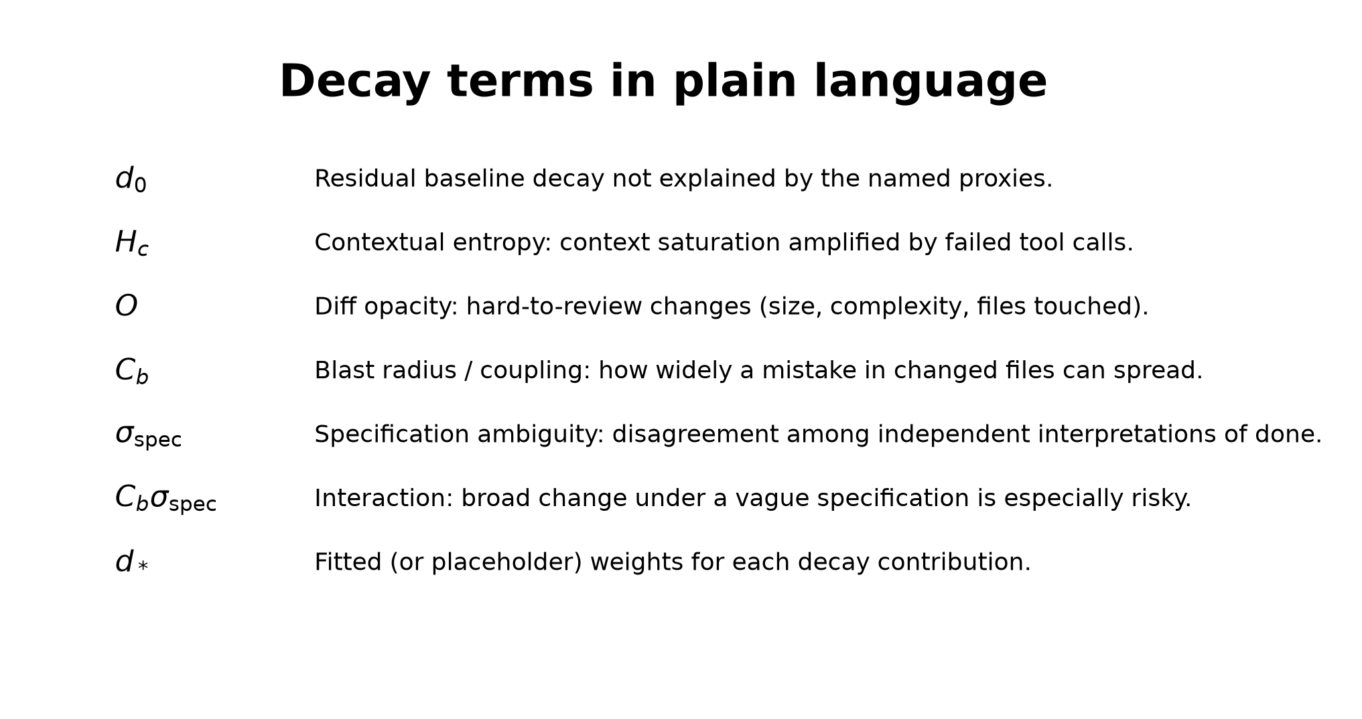
Alternative forms (purely multiplicative or purely additive) exist for model comparison. Simulation and fitting chose hybrid as the default pending repository-fitted campaign data.

6. Building the recovery rate R(t)
Recovery is not a hardcoded three-term expression. It is a registry sum over enabled setup factors. Each factor has activity f_f(t) in [0, 1] and a weight w_f:
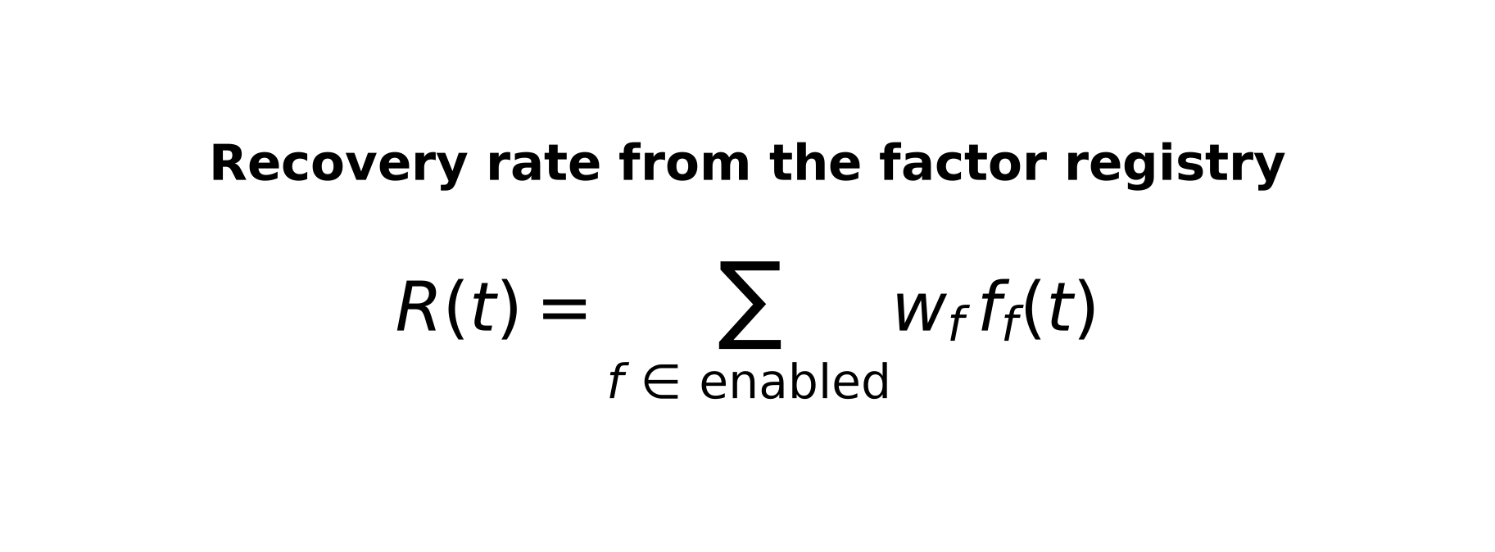
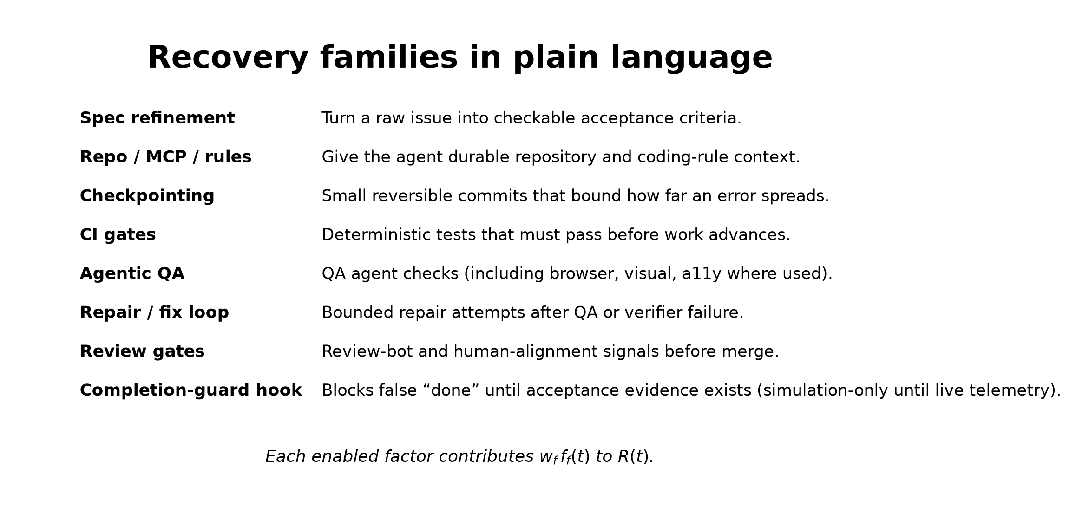
That registry design is why the framework can diagnose a missing control (for example, a completion-guard hook) instead of only saying “the model failed.”

7. Equilibrium trust V*
When R and D are roughly steady, validity settles at:
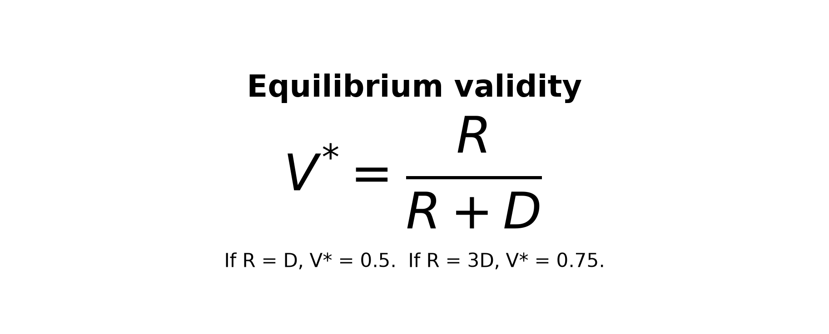
If recovery equals decay (R = D), then V* = 0.5. If recovery is three times decay (R = 3D), then V* = 0.75.
Simulations set a provisional high trust threshold near V* = 0.65 (placeholder; updated later from live campaign results). Scores below that threshold mean the setup is not yet earning the trust level we require before loosening review depth.

8. How we use the formula in practice
1. Score a run so we get provisional R, D, and V*.
2. Diagnose the weak layer or factor (environment, implement–QA–repair loop, or handoff).
3. Change one control.
4. Remeasure.
On Modus Web Components, applying the framework to a Cursor Cloud Automations run showed a skipped acceptance criterion and named the weak recovery sub-factor as the completion-guard hook. Provisional V* moved from below the 0.65 threshold to above it after adding that hook and re-running. That case is a directional pilot with placeholder weights, not a fitted factory calibration.

