Powershell command to get process id
Get-process notepad | Select-Object Id, ProcessName

The part
#include <windows.h>
#include <tlhelp32.h>

And the functions
CreateToolhelp32Snapshot
Module32FirstW
Module32NextW
OpenProcess
ReadProcessMemory
CloseHandle
GetLastError
FormatMessageW
LocalFree

The point of the code is to select the target process as standard input then pass it to windows API functions
Ask windows for loaded DLLs, find the requested DLL and calculate the memory address , read and print that memory

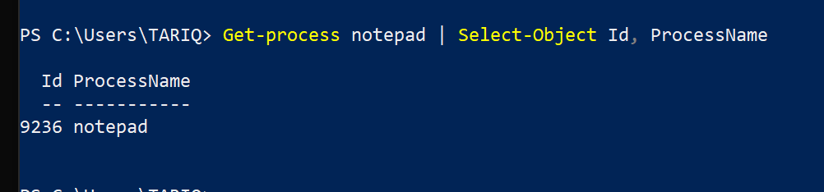
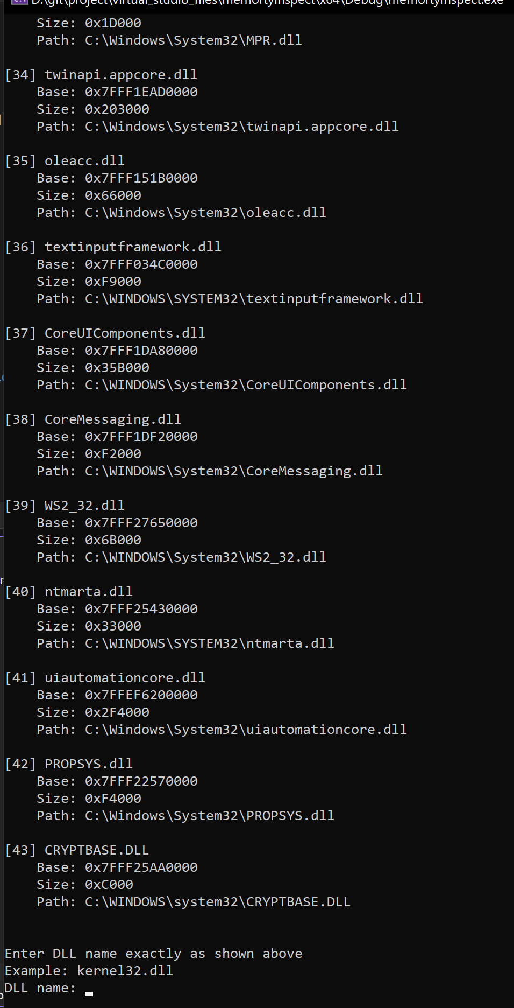
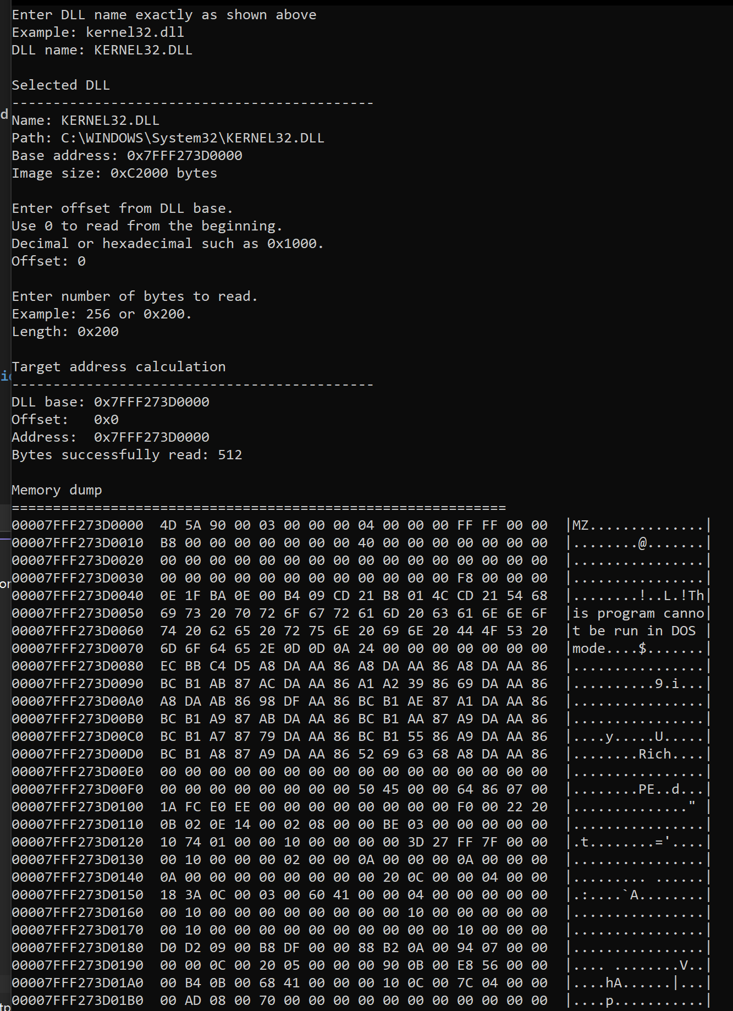
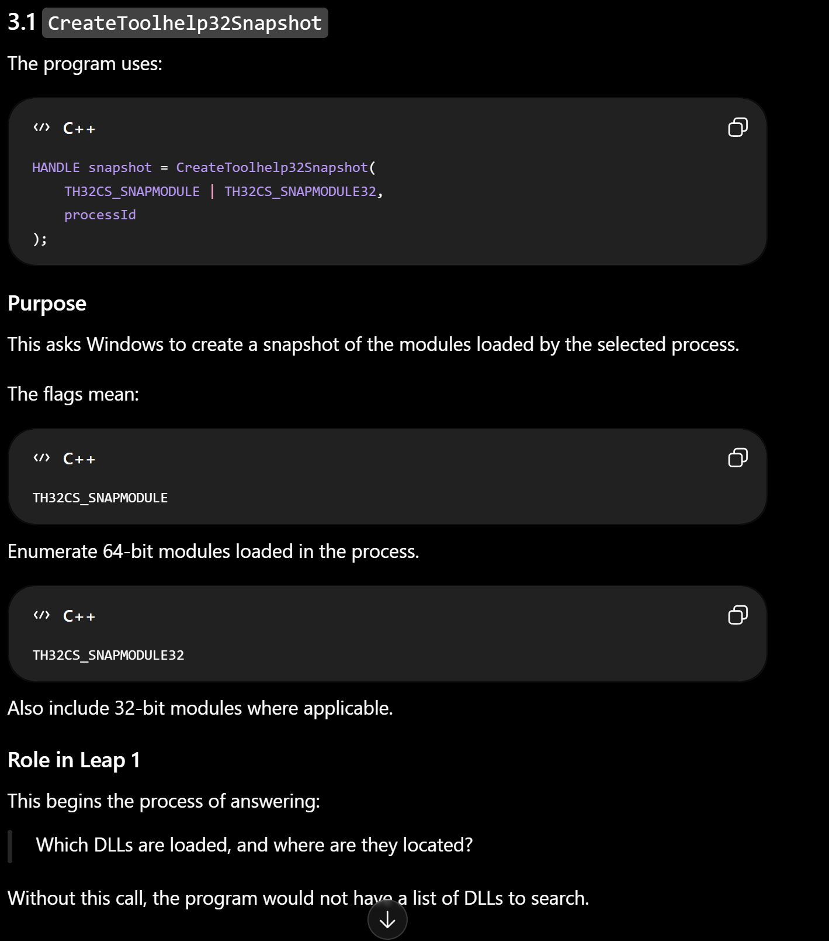
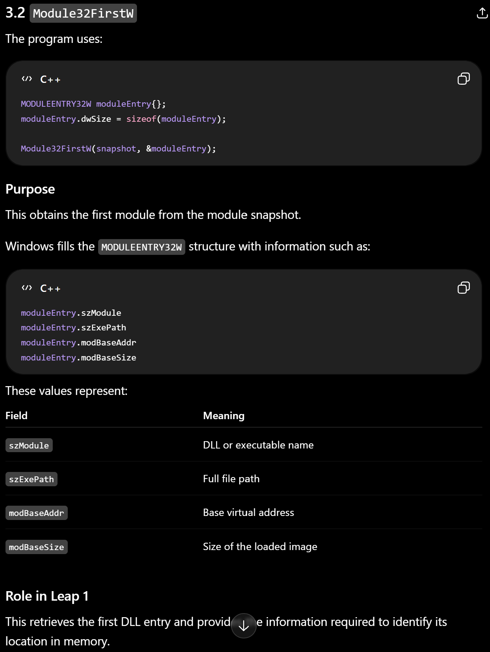

Csgo offsets taken by a dumper file from git https://github.com/a2x/cs2-dumper
added its implementation to my project , used offset values and which is base value + fixed value

The project first locates process and module by pid and opens it using OpenProcess
it enumerates modules and records the module base address and size
finds a signature in module memory , the dumper converts a signature string with wildcard lets say, into a byte pattern and scans the module memory regions for matchs.
scan memory return the virtual address of any matching instruction sequesce inside the target module

