以论文ACE伪代码为实现标准，使用matlab语言，引入net.sf.javabdd.BDDFactory作javabdd运算，使用论文中样例网图做Reliability结果验证，吻合。二元决策图生成地址（https://graphviz.herokuapp.com/），网站需要翻墙，把我程序生成的digraph G语言描述的图复制进去自动生成决策图。

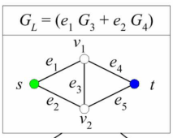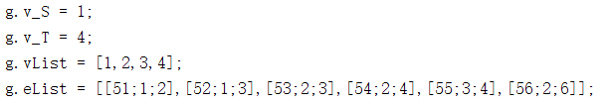

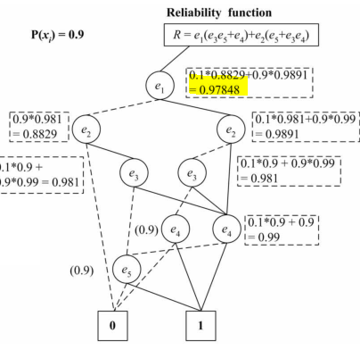

运行结果：

r =

0.9785

digraph G {

0 [shape=box, label="0", style=filled, shape=box, height=0.3, width=0.3];

1 [shape=box, label="1", style=filled, shape=box, height=0.3, width=0.3];

2 [label="51"];

2 -> 3 [style=dotted];

2 -> 4 [style=filled];

3 [label="52"];

3 -> 0 [style=dotted];

3 -> 5 [style=filled];

5 [label="53"];

5 -> 6 [style=dotted];

5 -> 7 [style=filled];

6 [label="55"];

6 -> 0 [style=dotted];

6 -> 1 [style=filled];

7 [label="54"];

7 -> 6 [style=dotted];

7 -> 1 [style=filled];

4 [label="52"];

4 -> 8 [style=dotted];

4 -> 7 [style=filled];

8 [label="53"];

8 -> 9 [style=dotted];

8 -> 7 [style=filled];

9 [label="54"];

9 -> 0 [style=dotted];

9 -> 1 [style=filled];

}

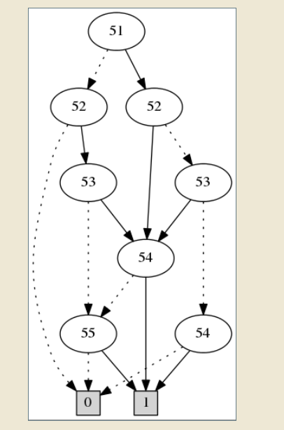

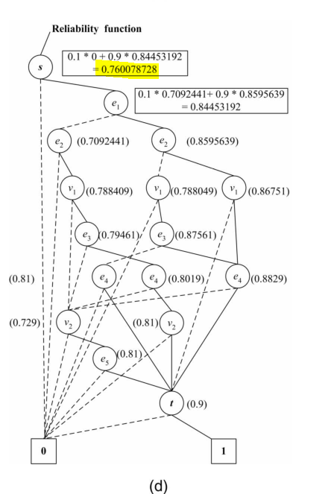

运行结果：

digraph G {

0 [shape=box, label="0", style=filled, shape=box, height=0.3, width=0.3];

1 [shape=box, label="1", style=filled, shape=box, height=0.3, width=0.3];

2 [label="1"];

2 -> 0 [style=dotted];

2 -> 3 [style=filled];

3 [label="2"];

3 -> 4 [style=dotted];

3 -> 5 [style=filled];

4 [label="3"];

4 -> 0 [style=dotted];

4 -> 6 [style=filled];

6 [label="4"];

6 -> 0 [style=dotted];

6 -> 7 [style=filled];

7 [label="52"];

7 -> 0 [style=dotted];

7 -> 8 [style=filled];

8 [label="55"];

8 -> 0 [style=dotted];

8 -> 1 [style=filled];

5 [label="3"];

5 -> 9 [style=dotted];

5 -> 10 [style=filled];

9 [label="4"];

9 -> 0 [style=dotted];

9 -> 11 [style=filled];

11 [label="51"];

11 -> 0 [style=dotted];

11 -> 12 [style=filled];

12 [label="54"];

12 -> 0 [style=dotted];

12 -> 1 [style=filled];

10 [label="4"];

10 -> 0 [style=dotted];

10 -> 13 [style=filled];

13 [label="51"];

13 -> 14 [style=dotted];

13 -> 15 [style=filled];

14 [label="52"];

14 -> 0 [style=dotted];

14 -> 16 [style=filled];

16 [label="53"];

16 -> 8 [style=dotted];

16 -> 17 [style=filled];

17 [label="54"];

17 -> 8 [style=dotted];

17 -> 1 [style=filled];

15 [label="52"];

15 -> 18 [style=dotted];

15 -> 17 [style=filled];

18 [label="53"];

18 -> 12 [style=dotted];

18 -> 17 [style=filled];

}

r =

0.7601

