根据论文中样例图实现伪代码InsetVAll(B,x),由于论文中未给出图的Reliability，且kuo的样例是双端可靠性不适合用来检测这个算法K端可靠性，所以只检查生成的图是否与论文一致，结果完全一致，故认为算法吻合。

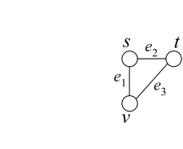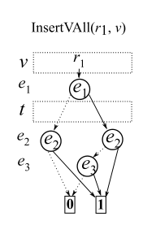

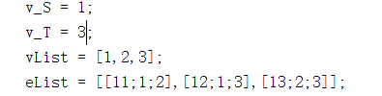

算法运行结果;

digraph G {

0 [shape=box, label="0", style=filled, shape=box, height=0.3, width=0.3];

1 [shape=box, label="1", style=filled, shape=box, height=0.3, width=0.3];

2 [label="11"];

2 -> 3 [style=dotted];

2 -> 4 [style=filled];

3 [label="12"];

3 -> 0 [style=dotted];

3 -> 1 [style=filled];

4 [label="12"];

4 -> 5 [style=dotted];

4 -> 1 [style=filled];

5 [label="13"];

5 -> 0 [style=dotted];

5 -> 1 [style=filled];

}

digraph G {

0 [shape=box, label="0", style=filled, shape=box, height=0.3, width=0.3];

1 [shape=box, label="1", style=filled, shape=box, height=0.3, width=0.3];

2 [label="11"];

2 -> 3 [style=dotted];

2 -> 4 [style=filled];

3 [label="12"];

3 -> 0 [style=dotted];

3 -> 1 [style=filled];

4 [label="12"];

4 -> 5 [style=dotted];

4 -> 1 [style=filled];

5 [label="13"];

5 -> 0 [style=dotted];

5 -> 1 [style=filled];

}

ans =

0.9810

