DESIGN DOCUMENT FOR PS5 – Company Subsidiaries – Group-117

- Choice of Data Structure

General Tree as a Linked List

Reasons:

- There is a hierarchical nature in any company structure.

- Representing a company as a node and holding pointers to children (acquired companies) in the form of a list is an intuitive way to hold our data. We have decided to design our problem as follows (Kindly note that the node representations here are for understanding sake only and could contain any generic company name).
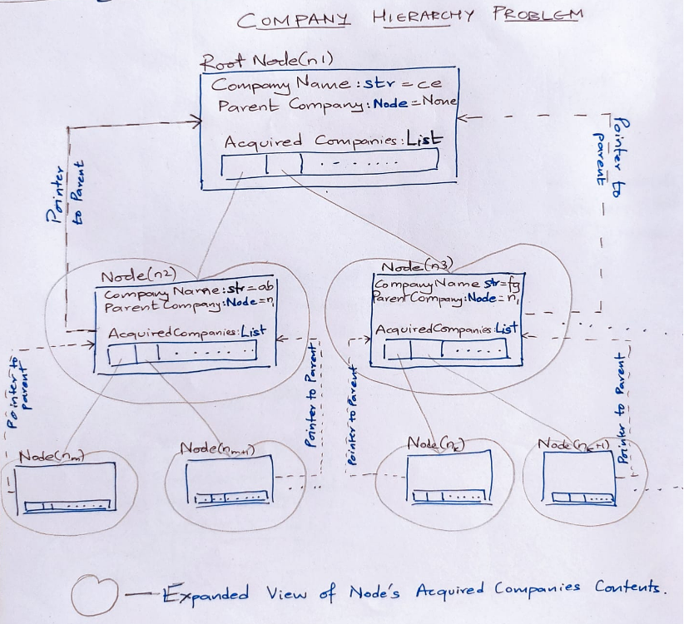
- Unlike a binary tree where we’re sure that each parent has two children only, the number of acquired companies could be anything in this case. Hence, we have chosen to implement this hierarchical representation as a general tree where any node can have any number of children.

In the above diagram, each node contains
- The name of current company
- A reference to its parent node
- A list of child nodes (which correspond to the acquired subsidiary companies)

- Time Complexity Analysis
Primarily we have to implement three algorithms which we have implemented in a tree class, and we present the time complexity analysis as follows with respect to each function.
We have a function called search which is used by all three primary methods acquire, detail and release. So, we will first present the complexity of search and then proceed to the other three methods.

  - Time complexity of search
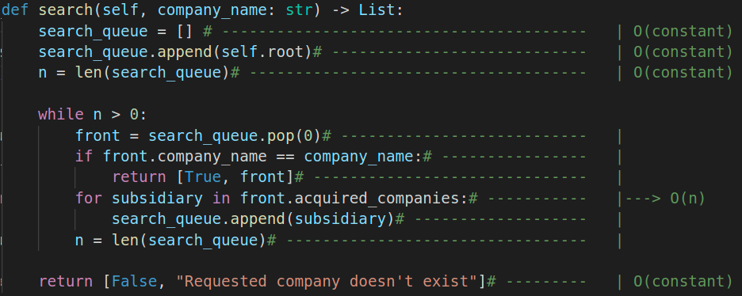
This method implements breadth first search (BFS) to have a look at each and every element in the tree.
We start with the root and then keep adding children at every level continuously to a queue and whenever we reach our node, we end and return that node.
In the above function, there are several operations which take constant time for eg. appending to array, finding, logical comparisons etc.
There is also a while loop which looks at the queue and runs for as many times. Now, this while loop can at most run n times where n is the number of nodes/companies in the organizational hierarchy structure.
→ In worst case, we can say that the time complexity is O(n) where n → no of companies

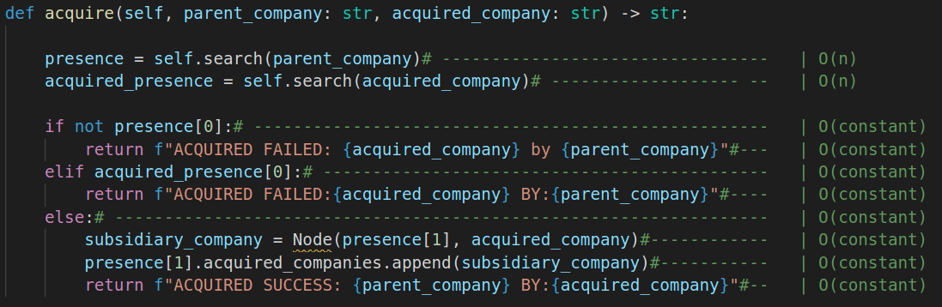
  - Time complexity of acquisition
In acquire, we are first checking if the parent company exists and if the acquired company exists. This warrants two calls to the search method which both cost O(n).

Other operations are inexpensive as they happen in constant time (like logical checks and print statements)

O(ACQUIRE) = O(n) + O(n) + constant * O(constant) ~ O(n)
Since constant operations do not depend on the size of input, because asymptotically, the cost of constant operations is very small, hence we can approximate the time complexity in each to O(n) in worst case scenario.

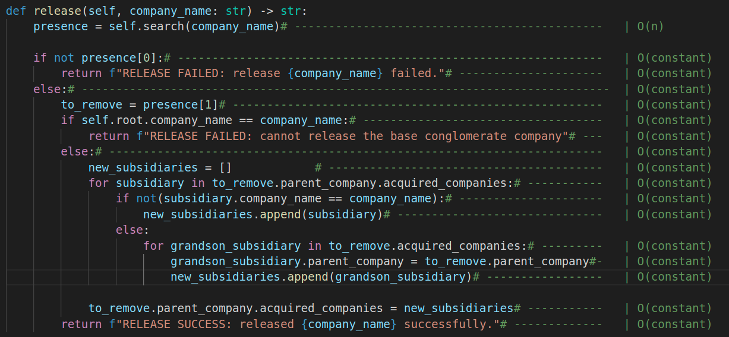
  - Time complexity of release
In release, we are first checking if the given company to be released exists. This needs a call to the search method which costs O(n) where n is total number of companies in the organizational hierarchy.

There are a few other operations like removing this company from the child array of its parent, I/O for informing the status of these operations etc. So, we can say that

O(RELEASE) = O(n) + constant * O(constant) ~ O(n)
Since constant operations do not depend on the size of input, because asymptotically, the cost of constant operations is very small, hence we can approximate the time complexity in each to O(n) in worst case scenario.

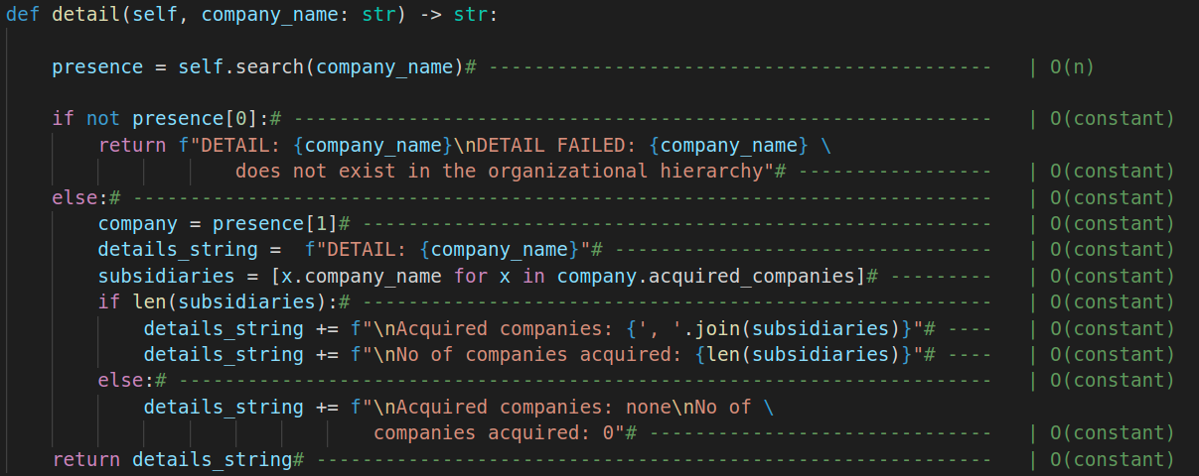
  - Time complexity of detail
In detail, we are first checking if the given company to be released exists. Again, for this we must call the search procedure which costs O(n) where n is total number of companies in the organizational hierarchy.

All other operations are either logical comparisons or I/O based which means they happen in a constant time. Therefore, we can say that

  - O(DETAIL) = O(n) + constant * O(constant) ~ O(n)
Since constant operations do not depend on the size of input, because asymptotically, the cost of constant operations is very small, hence we can approximate the time complexity in each to O(n) in worst case scenario.

- Fundamental Assumptions
- First line always contains the base conglomerate which is denoted by keyword Company:
- Only three operations are considered valid i.e., the ones which precede with the keywords ACQUIRED, DETAIL and RELEASE respectively.
- Names of operations are case insensitive i.e., acquired = Acquired = ACQuiRED we are only considering acquire operation in each case, same way for both release and detail. Also, we will handle leading and trailing whitespaces for every instruction by removing them.
- No two companies will have the same name.
- No two companies will have the same parent.
- Releasing a company will lead to acquisition of its children by the parent of the company to be released. The schematic is shown below.
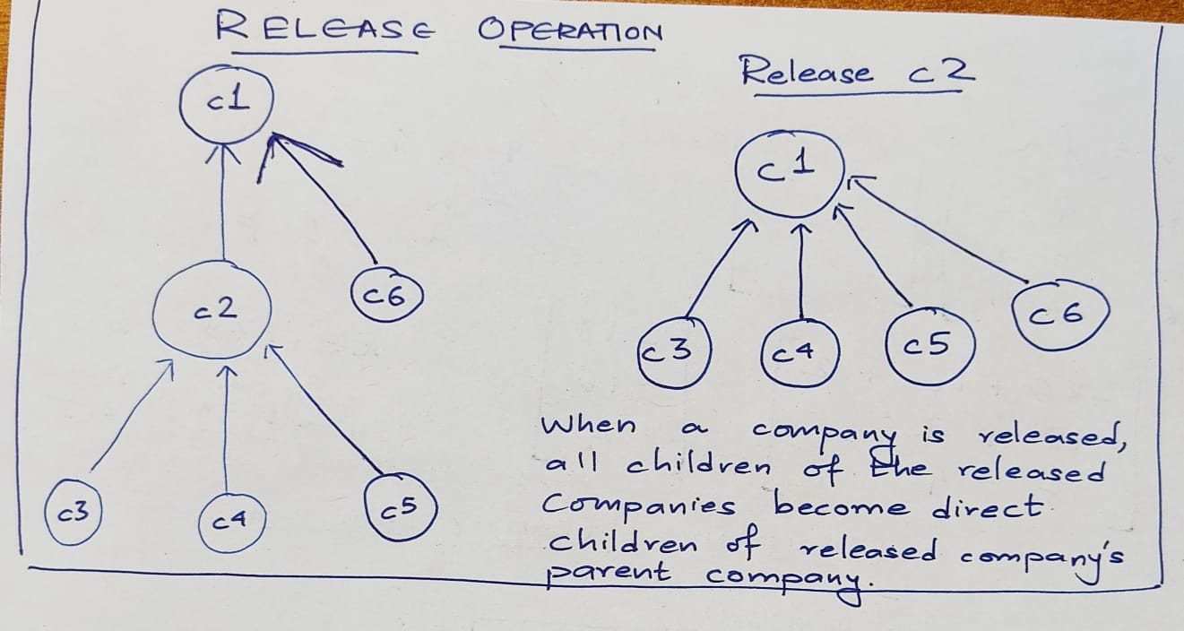
- Releasing the parent (topmost conglomerate) will cause all the companies to be dissolved and no subsequent operations will be performed since there is no hierarchy to start with.

- Consideration of edge cases:

For release:
  - Check if company exists. If not, then release will fail.
  - Check if the company asked to release is the base company (the biggest conglomerate); if so, release the company but every subsequent operation will lead to nowhere i.e., since we have dissolved the root company, we cannot perform any operation.

For acquire:
- Check if the company which has to acquire already exists, if not then raise an error.
- Check if the company which has to be acquired already exists, if yes, then raise an error. Since it is already acquired by a company, it must first be released before another company can acquire it.

- Integrating our other solution for your reference with similar time complexity

Solution_2: 