1.Check whether sale of ice-creams and sunglasses are related

2.Suppose 2 stocks A&B have following values in one week

(2,5),(3,8),(5,10),(4,11),(6,14) check if stocks are affected by same industry trends. Will their prices rise or fall together?

3. Researchers have conducted a survey of 1600 coffee drinkers asking how much coffee they drink in order to confirm previous studies. Previous studies have indicated that 72% of Americans drink coffee. The results of previous studies (left) and the survey (right) are below. At α = 0.05, is there enough evidence to conclude that the distributions are the same?

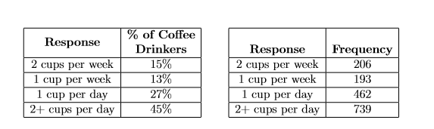

4. Smooth the given data set based on **Equal width partitioning and equal depth partitioning**

[0,2, 8,10,20,21,29,29,30]

5. A department store, A, has four competitors: B,C,D, and E. Store A hires a consultant to determine if the percentage of shoppers who prefer each of the ﬁve stores is the same. A survey of 1100 randomly selected shoppers is conducted, and the results about which one of the stores shoppers prefer are below. Is there enough evidence using a signiﬁcance level α = 0.05 to conclude that the proportions are really the same?

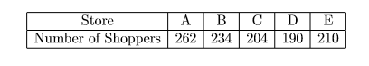

6.The table below describes the rate of economic growth (xi) and the rate of return on the S&P 500 (yi). Using the covariance formula, determine whether economic growth and S&P 500 returns have a positive or inverse relationship. Before you compute the covariance, calculate the mean of x and y.

