**Birla Institute of Technology & Science, Pilani**

**Work Integrated Learning Programmes Division**

**Second Semester 2021-2022**

**Mid-Semester Test**

**(EC-2 Regular)**

Course No. : DSECLZG522

Course Title : Big Data Systems

Nature of Exam : Open Book

Weightage : 30%

No. of Pages = 2

# No. of Questions = 7

Duration : 2 Hours

Date of Exam : 03/07/2022 (FN)

Note to Students:

1. Please follow all the *Instructions to Candidates* given on the cover page of the answer book.
2. All parts of a question should be answered consecutively. Each answer should start from a fresh page.
3. Assumptions made if any, should be stated clearly at the beginning of your answer.
4. In each of the following scenarios, point out and give a brief reason what type of multi-processor computer one would use as per Flynn’s taxonomy, i.e. the choices are SIMD, SISD, MIMD or MISD. [4 marks]
   1. A scientific computing application does a f1(x) + f2(x) transformation for every data item x given f1 and f2 are specialized operations built into the hardware.
   2. A video is processed to extract each frame which can be either an anchor frame (full image) or a compressed frame (difference image wrt anchor). A compressed frame (C) is transformed using a function f, where each pixel is compared with the last anchor (A) to recreate the uncompressed image (B), i.e.  B(i, j) = f(C(i, j), A(i,j)) for all pixels (i,j) in the input frames.
   3. A multi-machine Apache Hadoop system for data analysis.
   4. A development system with multiple containers running JVMs and CouchDB nodes running on a single multi-core laptop.
5. You have a 928 MB file stored on HDFS as part of a Hadoop 2.x distribution. A data analytics program uses this file and runs in parallel across the cluster nodes. [6 marks]
   1. The default block size and replication factor is used in the configuration. How many total blocks including replicas will be stored in the cluster ? What are the unique HDFS block sizes you will find for the specific file?
   2. The cluster has 64 cores to speed up the processing. If the program can at best achieve 60% parallelism in the code to exploit the multiple cores and the rest of it is sequential, what is the theoretical limit on speed-up you can expect with 64 cores compared to a sequential version of the same program running on one core with the same file ? How will this limit change if you doubled the compute power to 128 cores ? You can simplify the system to assume cluster nodes and cores mean the same and we can ignore the overheads of communication etc. depending on the specific cluster configuration, scheduling etc.
   3. Suppose you could use a more scalable algorithm with 80% parallelism and a larger file as you move to a 128 core system. What would be the theoretical speed-up limit for 128 cores ?
6. Consider the following use cases carefully to suggest what is going to be your choice of a distributed database as per the design principles of CAP theorem, i.e. is it of type CA, CP or CA? Justify your  design choice in each case.  [4 marks]
   1. metaltrade.com is a real-time commodities trading platform with users from across the globe. Their database is deployed across multiple regional data centers but trades are limited between users within a region. Users need to view the prices in real-time and trades are requested based on this real-time view. Users would never want their committed  trades to be reversed. The database clusters are large and failures cannot be ruled out.
   2. buymore.com is an online e-retailer. Everyday early morning, the prices of various products (especially fresh produce) are updated in the database. However, the customers can still continue their shopping 24x7. Customer browsing uses the same database and customer churn is very sensitive to page access latency.
7. Figures (a) and (b) show two independent sequences of reads and writes for data items in a distributed DB across various nodes P1, P2, P3, P4 on a timeline. “R: X=V” at Pi means read operation on data item X returns value V at node Pi and “W: Y=V” at Pj means data item Y is written with value V by node Pj. In each case, evaluate if the sequence satisfies or violates causal consistency ? Give reasons for your answer. [4 Marks]

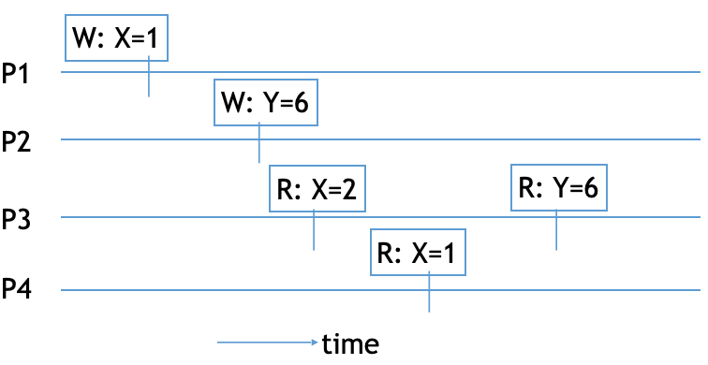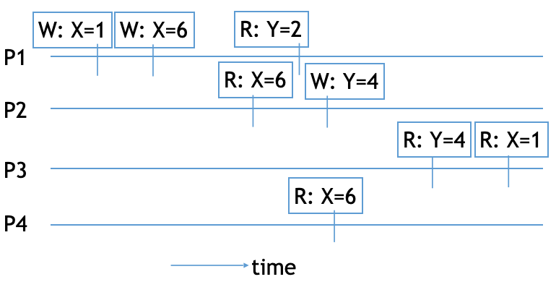

(a) (b)

1. Hadoop is basically designed for infrequent write and frequent read scenarios. The way an ML model works is an iterative process where it tries to write the model parameter for every epoch. Explain the challenges related to training ML models on Hadoop environments. Propose the basic elements of a modified architecture in an attempt to solve the issues.  [4 marks]
2. Consider the checkout counter at a large supermarket chain. For each item sold, it generates a record of the form [ProductId, Supplier, Price]. Here, ProductId is the unique identifier of a product, Supplier is the supplier name of the product and Price is the sale price for the item. Assume that the supermarket chain has accumulated many terabytes of data over a period of several months. The CEO wants a list of suppliers, listing for each supplier the average sale price of items provided by the supplier. How would you organize the computation using the Map-Reduce computation model? Write the pseudocode for the map and reduce stages. [4 marks]
3. A 2-tier  application uses a 3 node application cluster and a 2 node DB cluster. The application works only when all tiers are available. The application tier is in an active-active load-balanced configuration with the given nodes. But the database tier is in a cold standby mode where it takes 12 hours to switch bring a passive node online. If an application node fails every 10 days and a DB node fails every 100 days, find the following: [4 marks]
   1. MTTF of the application tier
   2. MTTF of the database tier
   3. Availability of the database tier
   4. Overall availability of the 2-tier system, assuming MTTR of the application tier is negligible

***********