**Statistics Day-2 Activities – Probability theory**

1. Tickets numbered 1 to 20 are mixed up and then a ticket is drawn at random. What is the probability that the ticket drawn has a number which is a multiple of 3 or 5?

**ANSWER:-**

Multiple of 3 = { 3,6,9,12,15,18 } & Multiple of 5 = {5,10,15,20}, overall there are 6 + 4 =10 possible options, However 15 is in both the side so it will be considered only once . So, the probability that the ticket drawn has a number which is a multiple of 3 or 5 is **9/20**

//////////////////////////////////////////////////////////////////////////////////////////////////////////////////////////

2. What is the probability of a randomly selected leap year will contain 53 Sundays?

**ANSWER:-**

A leap year has 366 days or 52 weeks and 2 odd days. The two odd days can be {Sunday,Monday},{Monday,Tuesday},{Tuesday,Wednesday},{Wednesday,Thursday},{Thursday,Friday},{Friday,Saturday},{Saturday,Sunday}. So, there are 7 possibilities out of which 2 have a Sunday. So, the probability of 53 Sundays is **2/7.**

//////////////////////////////////////////////////////////////////////////////////////////////////////////////////////////

3. The probability that a Ramesh passes a Math test is 2/3 and the probability that he passes both Math and English test is 14/45. The probability that he passes at least one test is 4/5. What is the probability that he passes the English test?

**ANSWER:-**

P(M) = 2/3

P(E) = ?

P(M&E) = 14/45

P(MorE) = 4/5

P(M&E) = P(M)+ P(E) – P(MorE)

4/5 = 2/3+E-14/45

E= 4/5-2/3+14/45

**E= 4/9**

//////////////////////////////////////////////////////////////////////////////////////////////////////////////////////////

4. The joint probability distribution of two random variables X and Y is given by:

P(X=0,Y=1)=1/3 , P(X=1,Y=−1)=1/3 , P(X=1,Y=1)=1/3 .

Find the below probabilities:

(i) Marginal distribution of X and Y.

(ii) Conditional probability distribution of X given Y=1.

|  |  |  |  |  |
| --- | --- | --- | --- | --- |
| **ANSWER:-** | X |  |  |  |
| Y |  | 0 | 1 |  |
|  | -1 | 0 | 1/3 | 1/3 |
|  | 1 | 1/3 | 1/3 | 2/3 |
|  |  | 1/3 | 2/3 |  |

(ii) Conditional probability distribution of X given Y=1.

Total Events occurring is 1/3 and total possible outcome is 2/3, So the Conditional probability distribution of X given Y=1.is (1/3)/(2/3) = **1/2**

//////////////////////////////////////////////////////////////////////////////////////////////////////////////////////////

5. In a region during a 1-year period, there were 1000 deaths. It was observed that 321 people died of a renal failure and 460 people had at least one parent with renal failure. Of these 460 people, 115 died of renal failure.

(i) Calculate the Probability that a person dies of Renal Failure in the population if you pick him at random

**ANSWER:-**

Total Population (total possible outcome) = 1000

Total # died of renal failure (Event) = 321

Probability of person dies of RF = **321/1000 = 0.321**

(ii) If you pick a person at random from the population, calculate the Probability that a person dies of Renal Failure and at least one of his parents died due to a Renal Failure

Ans : -

Total Population (total possible outcome) = 1000

Total # died of renal failure & at least one of his parents died due to a Renal Failure (Event) = 115

Probability of person dies of RF = **115/1000 = 0.115**

(iii) Calculate the probability that a patient dies of renal failure if neither of his parents had a renal failure

|  |  |  |  |
| --- | --- | --- | --- |
|  | PRF | NPRF | Total |
| RF | 115 | 206 | 321 |
| NRF | 345 | 334 | 679 |
| Total | 460 | 540 | 1000 |

RF= Renal Failure

NRF = No Renal Failure

PRF = Parent with Renal Failure

NPRF = Parent with No Renal Failure

Total Population (total possible outcome) = 1000

Total # died of renal failure & at least one of his parents died due to a Renal Failure (Event) = 206

Probability of person dies of RF = **206/540 = 0.381**

//////////////////////////////////////////////////////////////////////////////////////////////////////////////////////////

6. The probability that you park in a no-parking zone and get a parking ticket is 0.06. The probability that you must park in a no-parking zone (as you cannot find a legal parking space) is 0.20. Today, you arrive at INSOFE and must park in a no-parking zone. What is the probability that you will get a parking ticket?

**ANSWER:-**

P(Park in No Parking Zone) = 0.20 (Possible Outcome)

P(getting Parking ticket in No Parking Zone = 0.06 (Event)

Probability of getting parking ticket = **0.06/0.20 = 0.3**

//////////////////////////////////////////////////////////////////////////////////////////////////////////////////////////

7. Half a percent of the population of an area are affected by a particular disease. A test is developed for identification of it. This test gives a false positive 3% of the time and false negative 2% of the time.

(i) Draw the tree diagram for this problem.

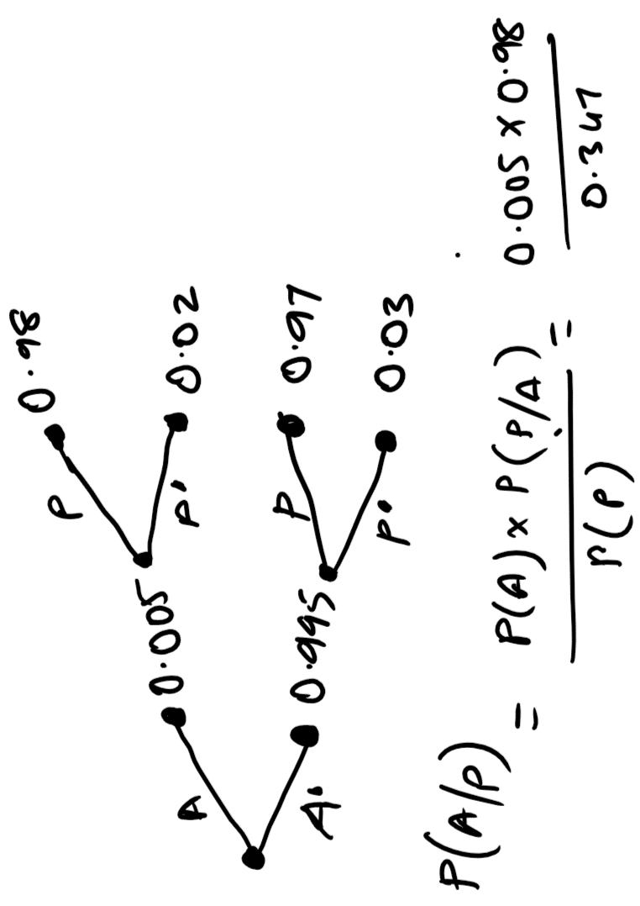

(ii) What is the probability that Joe (a random person) tests positive?

**ANSWER:-**

P(P) = 0.98*0.005 + 0.03*0.995 = 0.347

(iii) If Joe's test turns out to be positive, what is the probability that Joe actually have the disease?

Ans :- P(A/P)= P(A) * P(P/A) / P(A) = 0.005 * 0.98 / 0.347 = 0.0049 / 0.347 = **0.141 (14%)**

//////////////////////////////////////////////////////////////////////////////////////////////////////////////////////////

8. Consider all families with two children and assume that each child is equally likely to be a girl or a boy. If such a family is picked at random and found to have a boy, then what is the probability that it has another boy?

**ANSWER:-**

Possible outcomes { BB, BG, GB, GG }, out of all outcomes. Total possible outcome will boys will be only 3 and only 1 possible outcome will have both boy out of all 3. So, **the probability is 1/3**

//////////////////////////////////////////////////////////////////////////////////////////////////////////////////////////

9. Below is a table of graduates and post graduates

|  |  |  |  |
| --- | --- | --- | --- |
| Graduate | Post Graduate | | Total |
| Male | 19 | 41 | 60 |
| Female | 12 | 28 | 40 |
| Total | 31 | 69 | **100** |

**ANSWER:-**

a) What is the probability that a randomly selected individual is a male and a graduate? What kind of probability is it (Marginal/ Joint/Conditional)

Ans :- 0.19 and its Joint

b) What is the probability that a randomly selected individual is a male

Ans :- 0.60 and its Marginal

c) What is the probability of a randomly selected individual being a graduate? What kind of probability is this?

Ans :- 0.31 and its Marginal

d) What is the probability that a randomly selected person is a female given that the selected person is a post graduate? What kind of probability is this?

Ans :- 0.405 and its Conditional.

///////////////////////////////////////////////////////////***///////////////////////////////////////////////////////////////

/////////////////////////////////////////////////////////////***/////////////////////////////////////////////////////////////