**PREPPAL**

An Android Mobile Application Project presented to the

**Faculty of Information Technology**

School of Arts, Science, and Technology

The National Teachers College

629 J. Nepomuceno St., Quiapo Manila

By

CRUZ, ELISSA MAE C.

FAJARDO, ANTHONETTE MAE R.

GALERA, AARON GABRIELLE A.

LEOCADIO, MICAH MAE J.

LLONA, RHENE F.

MORENTE, MC JAYSTER A.

UMPAR, AINA A.

In Partial Fulfillment of the

Requirements for the subject

Mobile Development focusing on Android Development

**APPROVAL SHEET**

This Android mobile application entitled “PREPPAL” were prepared and submitted by:

CRUZ, ELISSA MAE C.

FAJARDO, ANTHONETTE MAE R.

GALERA, AARON GABRIELLE A.

LEOCADIO, MICAH MAE J.

LLONA, RHENE F.

MORENTE, MC JAYSTER A.

UMPAR, AINA A.

has been approved by the subject adviser as partial fulfillment of the requirements for the

subject **MOBILE DEVELOPMENT FOCUSING ON ANDROID DEVELOPMENT.**

**PROF. JOHN PAULO I. PERMINOLA**Subject Adviser

**TABLE OF CONTENTS**

**Chapter I. PLANNING STAGE**

1.0 Introduction……………………………………………………………….

1.1 Objective of the Study…………………………………………………….

1.2 Scope and Limitation of the Study………………………………......……

1.3 Significance of the Study………………………………………………….

1.4 Requirements Gathering……………………………………………..……

1.5 Visual Table of Contents Diagram………………………………….…….

1.6 Definition of Terms……………………………………………………….

**Chapter II. UI / UX DESIGN**

2.0 Information Architecture……………………………………………..……

2.1 Wireframes…………………………………………………………………

2.2 Prototyping…………………………………………………………………

2.3 Mockups……………………………………………………………………

**Chapter III. DEVELOPMENT**

3.1 Mobile Architecture………………………………………………………..

3.2 Project Development……………………………………………………….

**Appendices**

Appendix A: References………………………………………………………………..

Appendix E: Gantt Chart………………………………………………………………..

Appendix F: Roadmap…………………………………………………………………..

Appendix G: Curriculum Vitae………………………………………………………….

**CHAPTER I**

**THE PROBLEM AND ITS BACKGROUND**

**1.0 Introduction**

People can prepare food more quickly these days. People's eating habits have changed significantly, and they depend on processed foods. Nevertheless, it is debatable whether or not this adjustment has made a difference in people's lives. Technology has made food preparation considerably more accessible than it has ever been. There is more technology, such as refrigerators, microwaves, and stoves, that makes cooking meals faster. Although busy people's lives are convenient, lives have yet to be improved by this development. Food consumption patterns have changed significantly in the modern period, with the convenience-driven society frequently at odds with the quest for more sustainable, better eating habits. It has several interrelated issues that change people's perspectives on nutrition, meal selection, and the effects on the environment and personal health. Even if technology has improved to the point where an application is utilized to make meal preparation more accessible, there are still several issues.

While meal prep apps have attempted to tackle several ongoing problems, they still face several common ones. Even though these applications are organized and convenient, some users still want assistance incorporating these platforms into their daily lives. (1) One notable health issue brought on by this convenience is the recent rise in overweight individuals. People have consumed a lot of precooked foods with high sugar and fat content, such as fast food. The prevalence of takeout and convenience food diets may be linked to a need for more time for meal planning and preparation at home. (2) A lack of culinary expertise and knowledge may hinder cooking at home when preparing intricately or nourishing foods. Therefore, such people spend their money on food. (3) People may struggle to make selections at the last minute or turn to repetitious, less nourishing meals if they do not need a set strategy. (4) Meal preparation may need considerable thought and planning due to dietary restrictions, allergies, or other health concerns. (5) Frequent time is one of the biggest obstacles to making meals from scratch. Making time for dinner preparation can be difficult while having obligations to family, career, and personal life. All of these issues point to the necessity for meal prep applications to improve their services even more by catering to the needs of individual users, improving accessibility, and incorporating tools for effective planning and waste minimization.

Meal prep application is a powerful remedy to the pervasive issues in today's health and preparation problems, ranging from excessive waste and nutritional imbalances to sustainability problems.

* **Meal Planning:** Assisting consumers in organizing their weekly meals while considering dietary restrictions and nutritional objectives.
* **Grocery Lists:** This feature allows users to create shopping lists based on selected recipes to make grocery shopping more accessible and help users save time.
* **Nutrition and Health:** Encouraging a healthy diet by disseminating dietary recommendations and nutritional information.
* **Cooking Methods:** To improve a user's culinary talents, teach them cooking skills and techniques. ·
* **Convenience:** facilitating mobile device access to recipes and cooking instructions for quick meal preparation.

The meal prep app is proactive to the complex issues in the current food environment and lifestyle. This application immediately addresses several critical difficulties by smoothly making meal planning, purchasing, and cooking easier, providing accurate shopping lists that align with meal plans, and reducing unnecessary purchases. The app’s nutritional insights guarantee well-balanced meal planning, encouraging better eating practices and reducing the risk of diet-related health problems. Additionally, by suggesting meals that use seasonal, locally available products, the app promotes sustainability and lessens the environmental impact and food production and consumption. Its easy-to-use interface and design improve convenience and encourage a better comprehension of how dietary decisions affect the environment and one’s health. Ultimately, this application promotes thoughtful consumption and provides workable solutions that benefit the general food ecology and the well-being of individual users.

**1.1 Objective of the Mobile Application**

The mobile app's goal is to provide a valuable experience for users who are passionate about cooking and discovering new recipes through the following means:

* **User-friendly Interface**: Constructing a mobile application that is user-friendly and easy to navigate.
* **Profile Personalization:** Providing users the ability to customize their profile in order to showcase their preferences and track shared recipes.
* **Recipe Sharing:** Enable users to share their recipes and view recipes from other users, enabling collaboration and culinary engagement between users.
* **List Ingredients:** Allowing users to share ingredients list for each recipe that helps inspiration seekers explore avant-garde techniques.
* **Search Feature:** Allows users to find specific recipes or ingredients quickly and conveniently.
* **Media Embedding:** Allowing users to share images and videos of recipes and ingredients.
* **Save Recipe:** Enables users to easily access curated collections to easily access preferred recipes without searching. This also allows users to personalize recipe collection based on their preferences, such as cooking style and dietary restrictions.
* **Offline Accessibility:** Providing users the ability to download saved recipes and ingredients to enable accessibility in various places.
* **Recipe Scheduling:** Meal planner which allows users to organize and schedule their meals in advance.

**1.2 Scope and Limitation of the Mobile Application**

* To ensure optimal performance and seamless functionality, it is imperative that the device selected for testing is compatible with Android versions 12.0 through 14.0. This requirement underscores the necessity for the device's operating system to fall within this specific range. In keeping with the range of compatibility, it is possible to ensure that our testing process takes place under conditions which are precise in view of the intended environment for the application so as to minimize any concerns and provide an appropriate assessment of its performance.
* Three distinct yet interrelated target audiences have been identified for the development of our cuisine application: Home cooks, food enthusiasts and individuals seeking a wide range of culinary inspiration. The trio illustrates a diversity of culinary engagement, from everyday cooking to the passionate study of diverse flavors and innovative recipes.
* The primary user base is home cooks, who are the foundation of family kitchens. We need to make a seamless experience for food planning, grocery shopping and execution of tasks in the kitchen so that we can tailor our service according to their needs. This pragmatic and working population will be impressed by features such as enhancing efficiency, the ability to configure your interface in any way that is user friendly.
* Food fanatics are the other side of this spectrum, and they have an intense interest in cooking. Our application shall become a platform of creativity to this audience. Their adventurous spirit will be complemented by a selection of recipes, which include cultural delicacies and those that employ avantgarde techniques. It can offer the depth and variety that food lovers are craving by means of advanced search features and curated collections.
* Lastly, our application's reach has broadened beyond those looking for food inspiration. This segment seeks motivation and fresh ideas, whether a regular cook or an amateur chef looking to enhance his kitchen skills. Our application turns into a goto source for the trendmakers who seek to spice up their meals with creativity and diversity when it provides a well curated menu of recipes, cooking tips or personalized recommendations.
* To put it simply, our application seeks to bring these various audiences together within the framework of food enjoyment. We aim to build a flexible space that enhances the cooking experience for all and foster a community where cuisine exploration knows no limits, because we understand and take into account the specific needs of home cooks, food lovers or inspiration seekers.

**1.3 Significance of the Study**

The study of the project was undertaken to make a digital alternative in processing and creating a meal plan. This aims to give reliable data, safe storage, and quick access to authorize users and the information gathered. These benefits are intended to assist individuals and even societal groups, particularly foodie people, meal planner, and cuisine enthusiasts.

Thus, the findings of this study will be beneficial to the following entities:

**Meal planner**. The findings of this study will let them be familiarized with the use of digital Meal plan systems that would somehow impact their health lifestyle. Through this study, they will become aware of the food contents or ingredients and may have an active interest in their health. This will help meal planners have a clear preparation and do things on their own.

**Food service/preparation workers.** The direction given by this project will help them to give proper guidance to food workers pertaining to this kind of digital setting. The findings in this study may serve as a premise in guiding and teaching food workers with the appropriate usage of this system.

**Education**. This project will contribute in the field of food related education in a way that this study will increase the awareness of students, residents, educators, food service workers, and the curriculum itself. As a result of this project, people will be able to get new knowledge and a better understanding of the subject.

**Future Researchers**. The results of this project may serve as their basis information and findings to those future researchers who want to conduct a study related to this project.

**1.4 Requirements Gathering**

The development of the mobile application involves the strategic utilization of a comprehensive set of tools to ensure efficiency, functionality, and adherence to industry standards throughout the following tools:

* **ANDROID.** The IDE to be used for the development of this project.
* **JAVA.** The programming language designated for the development of this project.
* **MySQL.** The database management system assigned for the development of this project.
* **FIGMA.** The design tool assigned for the development of this project.

**1.5 Visual Table of Contents Diagram**

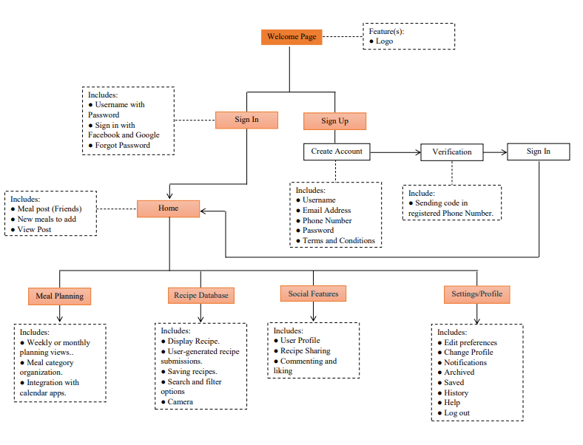

**1.6 Definition of terms**

* **Curated Collections-** Carefully chosen and thoughtfully organized or presented collection of recipes.
* **Culinary Engagement-** Involvement of individuals regarding culinary activities such as cooking, experimenting with recipes and exploring diverse flavors.
* **Meal Planner -** Meal planning is the simple act of planning meals ahead of time. The action of deciding meals in advance using your schedule, preferences, foods on hand, seasonal produce, sale items, etc.
* **Inspiration Seekers-** The act of looking for someone or something that inspires or promotes action, thought and/or feeling
* **Avant-garde-** The act of new and unusual or experimental ideas, especially in the arts, or the people introducing them.

**CHAPTER II**

**UI/ UX DESIGN**

This chapter indicates the interaction between users and digital products that focuses on the overall experience, usability, and accessibility of a user interface. To ensure that users can easily access and accomplish their goals by navigating and interacting with the user interface.

**2.0 Information Architecture**

* Diagram on how the information is processed from the database to the application and vice versa.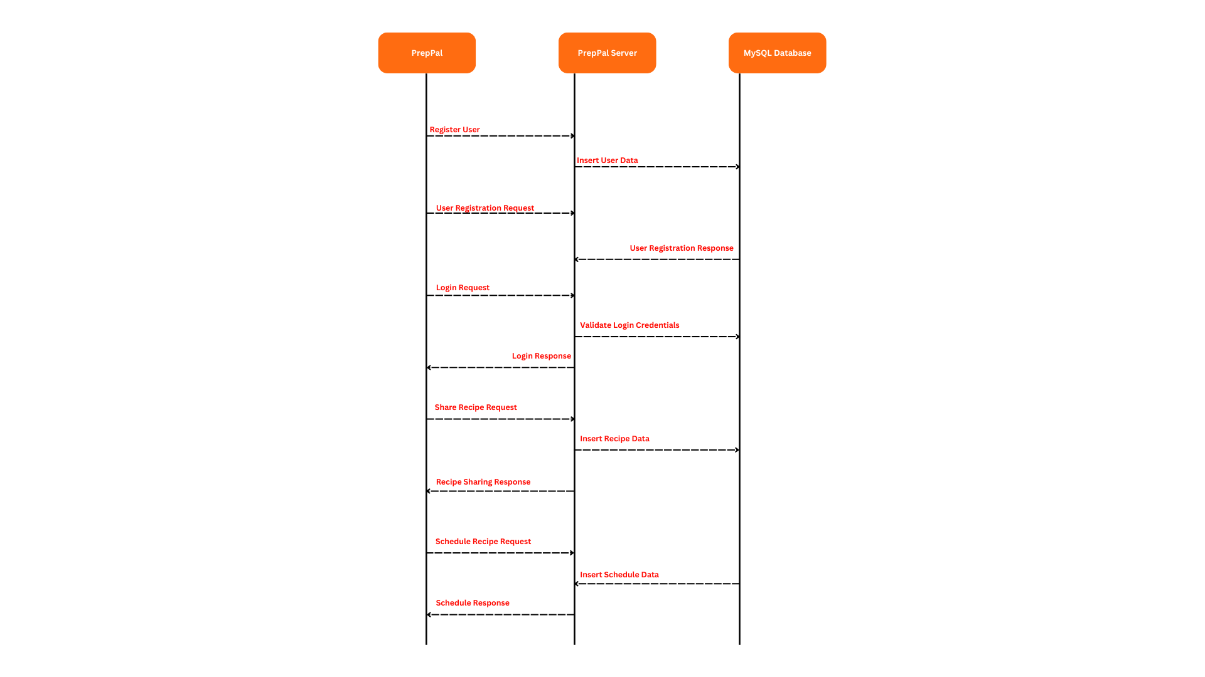

**2.1 Wireframes**

* Wireframes ( Figure # and name each frame) and its process and flow.

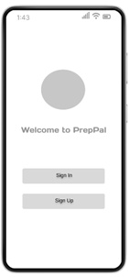

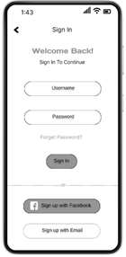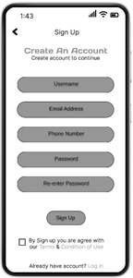







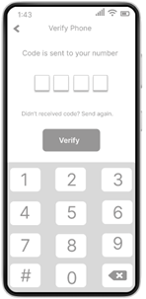



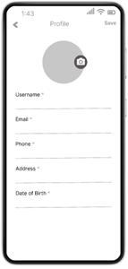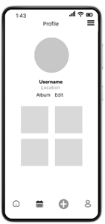





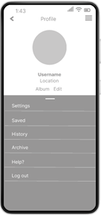





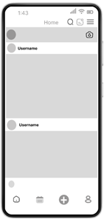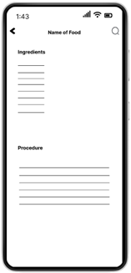















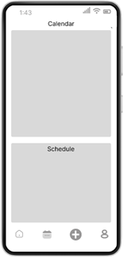



**2.2 Prototyping**

* Prototyping ( Figure # and name each frame) and its process and flow.

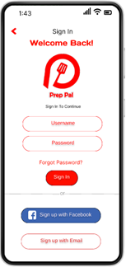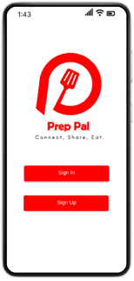





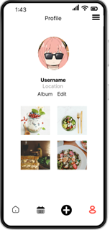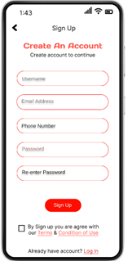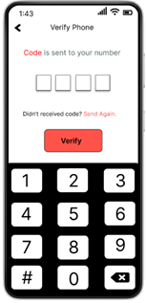





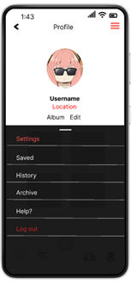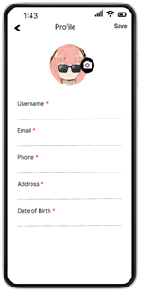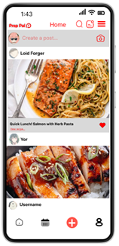





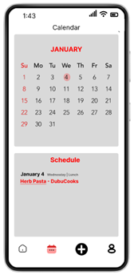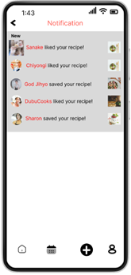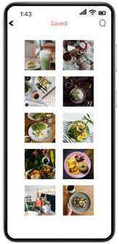





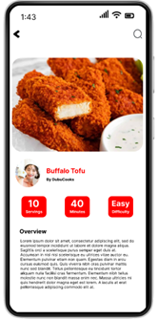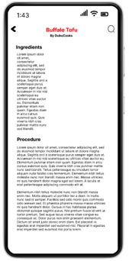





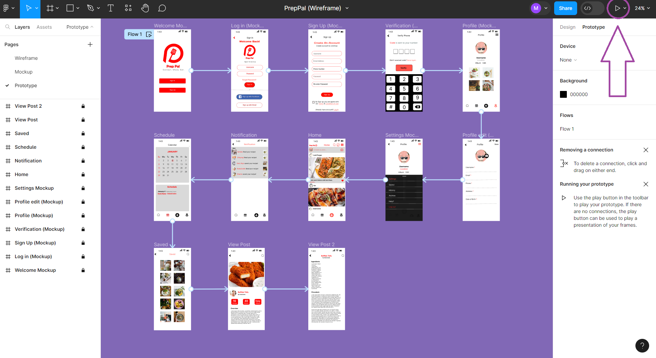



**2.3 Mockups**



























































**CHAPTER III**

**DEVELOPMENT**

In this chapter, the development of the application is being tracked. The mobile architecture is elaborated, and further diagrams along with discussions on important source codes are presented.

**3.1 Mobile Architecture**

- Pano naimplement yung UI nyo then , Workflow ng bawat structure at data.

**3.2 Project Development**

- Coding Process

**APPENDIX A**

**REFERENCES**

* B. Garcia, M. (2019). Plan-Cook-Eat: A Meal Planner App with Optimal Macronutrient Distribution of Calories Based on Personal Total Daily Energy Expenditure. *Conference Paper*. <https://doi.org/10.1109/HNICEM48295.2019.9073490>
* Mills, S., Brown, H., Wrieden, W. L., White, M., & Adams, J. (2017b). Frequency of eating home cooked meals and potential benefits for diet and health: cross-sectional analysis of a population-based cohort study. *International Journal of Behavioral Nutrition and Physical Activity*, *14*(1). <https://doi.org/10.1186/s12966-017-0567-y>
* Reicks, M., [PhD, RD], C. Trofholz, A., [MPH, RD], S. Stang, J., [PhD, MPH, RD], & N. Laska, M., [PhD, RD]. (2014). Impact of Cooking and Home Food Preparation Interventions Among Adults: Outcomes and Implications for Future Programs. *Nutrition Education*, *Volume 46*(ISSUE 4), 259–276. <https://www.jneb.org/article/S1499-4046(14)00058-X/fulltext>

**APPENDIX E**

**GANTT CHART**

**APPENDIX F**

**ROADMAP**

**APPENDIX G**

**CURRICULUM VITAE**