C# Hello world

using System;

namespace example1

{

class Program

{

static void Main(string[] args)

{

Console.Write("Hello World");

Console.ReadKey();

}

}

}

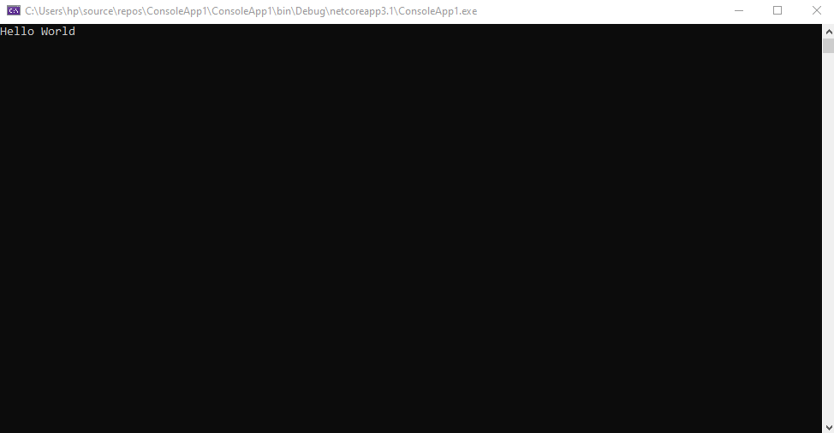

-----------------------------------------------------------------------------------------

C# Data Types

using System;

namespace example2

{

class Program

{

static void Main(string[] args)

{

Int32 num = 30;

Console.Write(num);

Console.ReadKey();

}

}

}

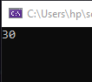

-----------------------------------------------------------------------------------------

C# Data Types

using System;

namespace example3

{

class Program

{

static void Main(string[] args)

{

double num = 30.33;

Console.Write(num);

Console.ReadKey();

}

}

}

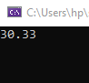

-----------------------------------------------------------------------------------------

C# Enum

using System;

namespace example4

{

class Program

{

enum Days { Monday, Tuesday, Wednesday, Thursday, Friday, Saturnday, Sunday };

static void Main(string[] args)

{

Console.Write(Days.Sunday);

Console.ReadKey();

}

}

}

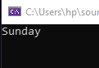

-----------------------------------------------------------------------------------------

C# Variables operator

using System;

namespace example5

{

class Program

{

static void Main(string[] args)

{

String message = "The value is ";

Int32 val = 30;

Console.Write(message + val);

Console.ReadKey();

}

}

}

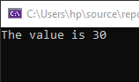

-----------------------------------------------------------------------------------------

C# Variables operator

using System;

namespace example6

{

class Program

{

static void Main(string[] args)

{

Int32 val1 = 10, val2 = 20;

bool status = true;

Console.WriteLine(val1 + val2);

Console.WriteLine(val1 < val2);

Console.WriteLine(!(status));

Console.ReadKey();

}

}

}

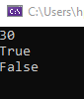

-----------------------------------------------------------------------------------------

C# Conditional Statements

using System;

namespace example7

{

class Program

{

static void Main(string[] args)

{

Int32 value = 11;

if (value < 10)

{

Console.WriteLine("Value is less than 10");

}

else

{

Console.WriteLine("Value is greater than 10");

}

Console.ReadKey();

}

}

}

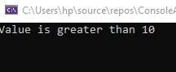

-----------------------------------------------------------------------------------------

C# Conditional Statements

using System;

namespace example8

{

class Program

{

static void Main(string[] args)

{

Int32 value = 11;

switch (value)

{

case 1:

Console.WriteLine("Value is 1");

break;

case 2:

Console.WriteLine("Value is 2");

break;

default:

Console.WriteLine("value is different");

break;

}

}

}

}



-----------------------------------------------------------------------------------------

C# Conditional Statements

using System;

namespace example9

{

class Program

{

static void Main(string[] args)

{

Int32 value = 5, i = 0;

while (i < value)

{

Console.WriteLine(i);

i = i + 1;

}

Console.ReadKey();

}

}

}



-----------------------------------------------------------------------------------------

C# Conditional Statements

using System;

namespace example10

{

class Program

{

static void Main(string[] args)

{

for (Int32 i = 0; i < 10; i++)

{

Console.WriteLine(i);

}

Console.ReadKey();

}

}

}



-----------------------------------------------------------------------------------------

C# Arrays

using System;

namespace example11

{

class Program

{

static void Main(string[] args)

{

Int32[] vlera;

vlera = new Int32[3];

vlera[0] = 1;

vlera[1] = 2;

vlera[2] = 3;

Console.WriteLine(vlera[0]);

Console.WriteLine(vlera[1]);

Console.WriteLine(vlera[2]);

Console.ReadKey();

}

}

}



----------------------------------------------------------------------------------------

C# Class and Object

using System;

namespace example12

{

class Tutorial

{

int TutorialID;

string TutorialName;

public void SetTutorial(int pID, string pName)

{

TutorialID = pID;

TutorialName = pName;

}

public String GetTutorial()

{

return TutorialName;

}

}

}

using System;

namespace example14

{

class Program

{

static void Main(string[] args)

{

Tutorial pTutor = new Tutorial();

pTutor.SetTutorial(1, ".NET");

Console.WriteLine(pTutor.GetTutorial());

Console.ReadKey();

}

}

}

-----------------------------------------------------------------------------------------

C# Access Modifiers and Constructor

using System;

namespace example15

{

class Tutorial

{

public int TutorialID;

public string TutorialName;

public Tutorial()

{

TutorialID = 0;

TutorialName = "Default";

}

public void SetTutorial(int pID, string pName)

{

TutorialID = pID;

TutorialName = pName;

}

public String GetTutorial()

{

return TutorialName;

}

static void Main(string[] args)

{

Tutorial pTutor = new Tutorial();

Console.WriteLine(pTutor.GetTutorial());

Console.ReadKey();

}

}

}



-----------------------------------------------------------------------------------------

C# Inheritance and Polymorphism

using System;

namespace example16

{

class Tutorial

{

protected int TutorialID;

protected string TutorialName;

public void SetTutorial(int pID, string pName)

{

TutorialID = pID;

TutorialName = pName;

}

public String GetTutorial()

{

return TutorialName;

}

}

public class ExampleTutorial : Tutorial

{

public void RenameTutorial(String pNewName)

{

TutorialName = pNewName;

}

static void Main(string[] args)

{

ExampleTutorial pTutor = new ExampleTutorial();

pTutor.RenameTutorial(".Net by Example");

Console.WriteLine(pTutor.GetTutorial());

Console.ReadKey();

}

}

}

-----------------------------------------------------------------------------------------

C# Inheritance and Polymorphism

using System;

namespace example17

{

class Tutorial

{

public int TutorialID;

public string TutorialName;

public void SetTutorial(int pID, string pName)

{

TutorialID = pID;

TutorialName = pName;

}

public void SetTutorial(string pName)

{

TutorialName = pName;

}

public String GetTutorial()

{

return TutorialName;

}

static void Main(string[] args)

{

Tutorial pTutor = new Tutorial();

pTutor.SetTutorial(1, "First Tutorial");

Console.WriteLine(pTutor.GetTutorial());

pTutor.SetTutorial("Second Tutorial");

Console.WriteLine(pTutor.GetTutorial());

Console.ReadKey();

}

}

}

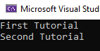

-----------------------------------------------------------------------------------------

C# Abstract classes

using System;

namespace example18

{

abstract class Tutorial

{

public virtual void Set()

{

}

}

class ExampleTutorial : Tutorial

{

protected int TutorialID;

protected string TutorialName;

public void SetTutorial(int pID, string pName)

{

TutorialID = pID;

TutorialName = pName;

}

public String GetTutorial()

{

return TutorialName;

}

static void Main(string[] args)

{

ExampleTutorial pTutor = new ExampleTutorial();

pTutor.SetTutorial(1, ".Net");

Console.WriteLine(pTutor.GetTutorial());

Console.ReadKey();

}

}

}



-----------------------------------------------------------------------------------------

C# Interface

using System;

namespace example19

{

interface ExampleInterface

{

void SetTutorial(int pID, string pName);

String GetTutorial();

}

class ExampleTutorial : ExampleInterface

{

protected int TutorialID;

protected string TutorialName;

public void SetTutorial(int pID, string pName)

{

TutorialID = pID;

TutorialName = pName;

}

public String GetTutorial()

{

return TutorialName;

}

static void Main(string[] args)

{

ExampleTutorial pTutor = new ExampleTutorial();

pTutor.SetTutorial(1, ".Net by Example");

Console.WriteLine(pTutor.GetTutorial());

Console.ReadKey();

}

}

}



-----------------------------------------------------------------------------------------

C# ArrayList

using System;

using System.Collections;

namespace example20

{

class Program

{

static void Main(string[] args)

{

ArrayList a1 = new ArrayList();

a1.Add(1);

a1.Add("Example");

a1.Add(true);

Console.WriteLine(a1[0]);

Console.WriteLine(a1[1]);

Console.WriteLine(a1[2]);

Console.ReadKey();

}

}

}

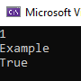

-----------------------------------------------------------------------------------------

C# ArrayList

using System;

using System.Collections;

namespace example21

{

class Program

{

static void Main(string[] args)

{

ArrayList a1 = new ArrayList();

a1.Add(1);

a1.Add("Example");

a1.Add(true);

Console.WriteLine(a1.Count);

Console.WriteLine(a1.Contains(2));

Console.WriteLine(a1[1]);

a1.RemoveAt(1);

Console.WriteLine(a1[1]);

Console.ReadKey();

}

}

}

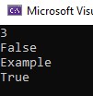

-----------------------------------------------------------------------------------------

C# Stack

using System;

using System.Collections;

namespace example22

{

class Program

{

static void Main(string[] args)

{

Stack st = new Stack();

st.Push(1);

st.Push(2);

st.Push(3);

foreach (Object obj in st)

{

Console.WriteLine(obj);

}

Console.WriteLine(); Console.WriteLine();

Console.WriteLine("The number of elements in the stack " + st.Count);

Console.WriteLine("Does the stack contain the elements 3 " + st.Contains(3));

Console.ReadKey();

}

}

}

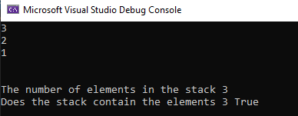

-----------------------------------------------------------------------------------------

C# Stack

using System;

using System.Collections;

namespace example23

{

class Program

{

static void Main(string[] args)

{

Stack st = new Stack();

st.Push(1);

st.Push(2);

st.Push(3);

st.Pop();

foreach (Object obj in st)

{

Console.WriteLine(obj);

}

Console.ReadKey();

}

}

}

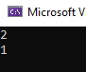

-----------------------------------------------------------------------------------------

C# Queue

using System;

using System.Collections;

namespace example24

{

class Program

{

static void Main(string[] args)

{

Queue qt = new Queue();

qt.Enqueue(1);

qt.Enqueue(2);

qt.Enqueue(3);

foreach (Object obj in qt)

{

Console.WriteLine(obj);

}

Console.WriteLine(); Console.WriteLine();

Console.WriteLine("The number of elements in the Queue " + qt.Count);

Console.WriteLine("Does the Queue contain " + qt.Contains(3));

Console.ReadKey();

}

}

}

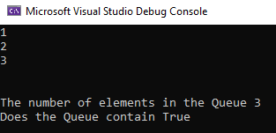

-----------------------------------------------------------------------------------------

C# Queue

using System;

using System.Collections;

namespace example25

{

class Program

{

static void Main(string[] args)

{

Queue qt = new Queue();

qt.Enqueue(1);

qt.Enqueue(2);

qt.Enqueue(3);

qt.Dequeue();

foreach (Object obj in qt)

{

Console.WriteLine(obj);

}

Console.ReadKey();

}

}

}



-----------------------------------------------------------------------------------------

C# Hashtable

using System;

using System.Collections;

namespace example26

{

class Program

{

static void Main(string[] args)

{

Hashtable ht = new Hashtable();

ht.Add("001", ".Net");

ht.Add("002", "C#");

ht.Add("003", "ASP.Net");

ICollection keys = ht.Keys;

foreach (String k in keys)

{

Console.WriteLine(ht[k]);

}

Console.ReadKey();

}

}

}

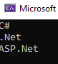

-----------------------------------------------------------------------------------------

C# Hashtable

using System;

using System.Collections;

namespace example27

{

class Program

{

static void Main(string[] args)

{

Hashtable ht = new Hashtable();

ht.Add("001", ".Net");

ht.Add("002", "C#");

ht.Add("003", "ASP.Net");

Console.WriteLine(ht.ContainsKey("001"));

Console.WriteLine(ht.ContainsValue("C#"));

Console.ReadKey();

}

}

}



-----------------------------------------------------------------------------------------

C# File Operations

using System;

namespace example28

{

class Tutorial

{

static void Main(string[] args)

{

String path = @"D:\Example.txt";

if (File.Exists(path))

{

Console.WriteLine("File Exists");

}

Console.ReadKey();

}

}

}

-----------------------------------------------------------------------------------------

C# File Operations

using System;

namespace example29

{

class Tutorial

{

static void Main(string[] args)

{

String path = @"D:\Example.txt";

String[] lines;

lines = File.ReadAllLines(path);

Console.WriteLine(lines[0]);

Console.WriteLine(lines[1]);

Console.ReadKey();

}

}

}

-----------------------------------------------------------------------------------------

C# File Operations

using System;

namespace example30

{

class Tutorial

{

static void Main(string[] args)

{

String path = @"D:\Example.txt";

String lines;

lines = File.ReadAllText(path);

Console.WriteLine(lines);

Console.ReadKey();

}

}

}

-----------------------------------------------------------------------------------------

C# File Operations

using System;

namespace example31

{

class Tutorial

{

static void Main(string[] args)

{

String path = @"D:\Example.txt";

File.Delete(path);

Console.ReadKey();

}

}

}

-----------------------------------------------------------------------------------------  
C# Serialization

using System;

using System.IO;

namespace example32

{

class Tutorial

{

static void Main(string[] args)

{

String path = @"D:\Example.txt";

using (StreamReader sr = File.OpenText(path))

{

String s = "";

while ((s = sr.ReadLine()) != null)

{

Console.WriteLine(s);

}

}

Console.ReadKey();

}

}

}

-----------------------------------------------------------------------------------------

C# Serialization

using System;

using System.IO;

namespace example33

{

class Tutorial

{

static void Main(string[] args)

{

String path = @"D:\Example.txt";

using (StreamWriter sr = File.AppendText(path))

{

sr.WriteLine("Example - ASP.Net");

sr.Close();

Console.WriteLine(File.ReadAllText(path));

}

Console.ReadKey();

}

}

}