Thanaphon Naksri 6634421523
Intro to Computational Linguistics: PA1
Question 1: precision, recall, F1-score for each label + overall accuracy
Using the “classification_report” function from scikit-learn, these are the evaluations:
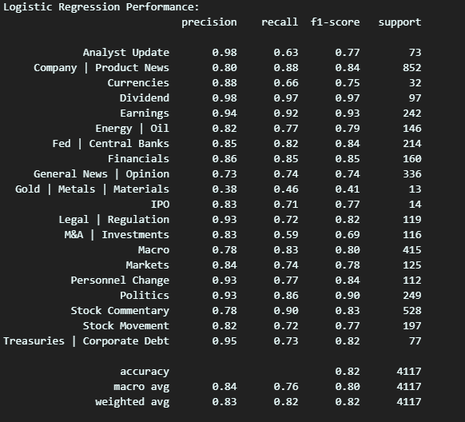

The next questions (Q2 & Q3) are identified using these codes
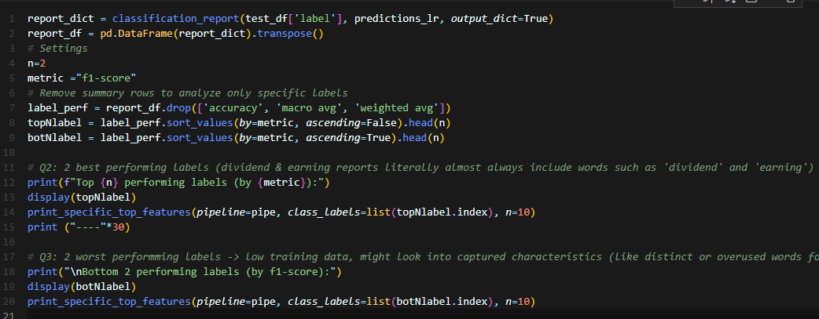
Main code for making a report on these questions
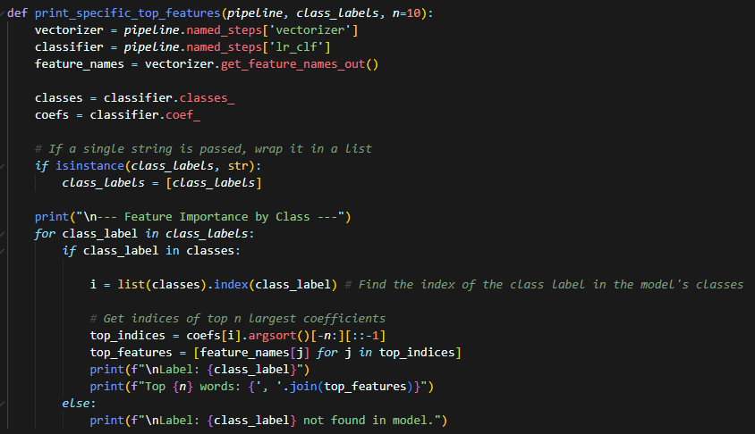
Function for looking into the trained model’s weight for a specific class
Question 2: Two best-performing labels & top 10 highest-weighted features
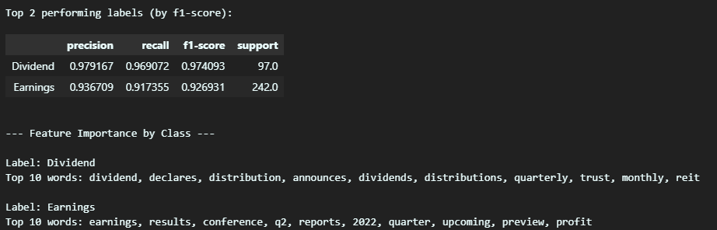
They include words that are specific to them, like dividend, earnings, results, quarterly terms etc.
Also, “Earnings” has a relatively high support, meaning they are trained on a lot
Question 3: Two worst-performing labels & top 10 highest-weighted features
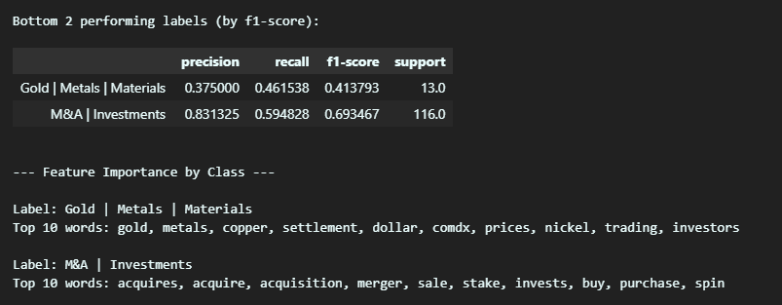
Gold etc. has a significantly low amount of data so the model doesn’t have enough information to learn
M&A | Investment included common word in finance also found in other classes such as sale, buy, purchase
Question 4: Prompt I’ve ended up using (for both predicting news by news & batch)
First, Define the classes we want the prediction to be (using unique() on the label column)
Also, make a detailed description of each class for the LLM to “understand”
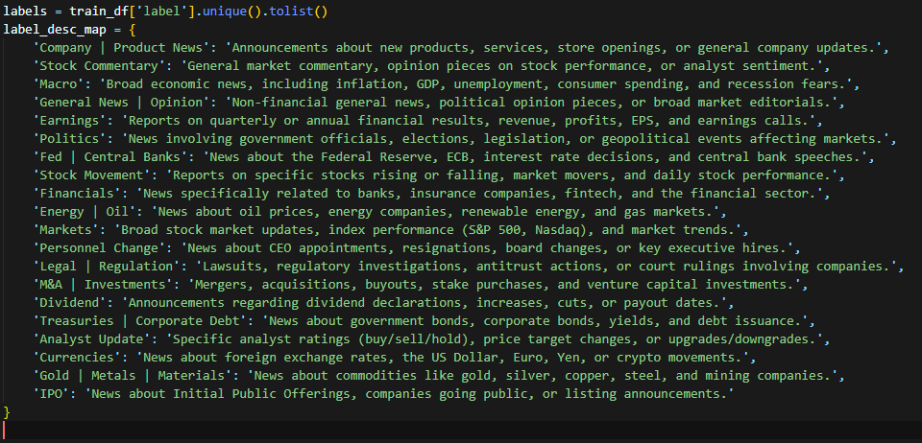

Prompt Structure (“input_text_block” is the concatenation of input data according to batch size)
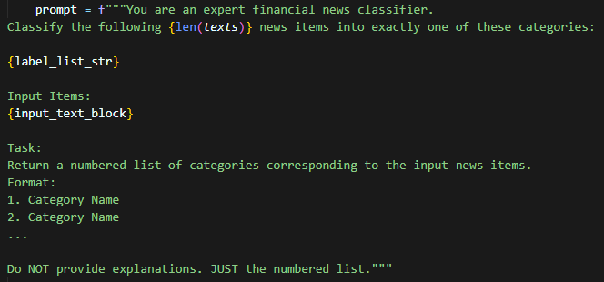

Full Code (Including helper functions for batch processing)
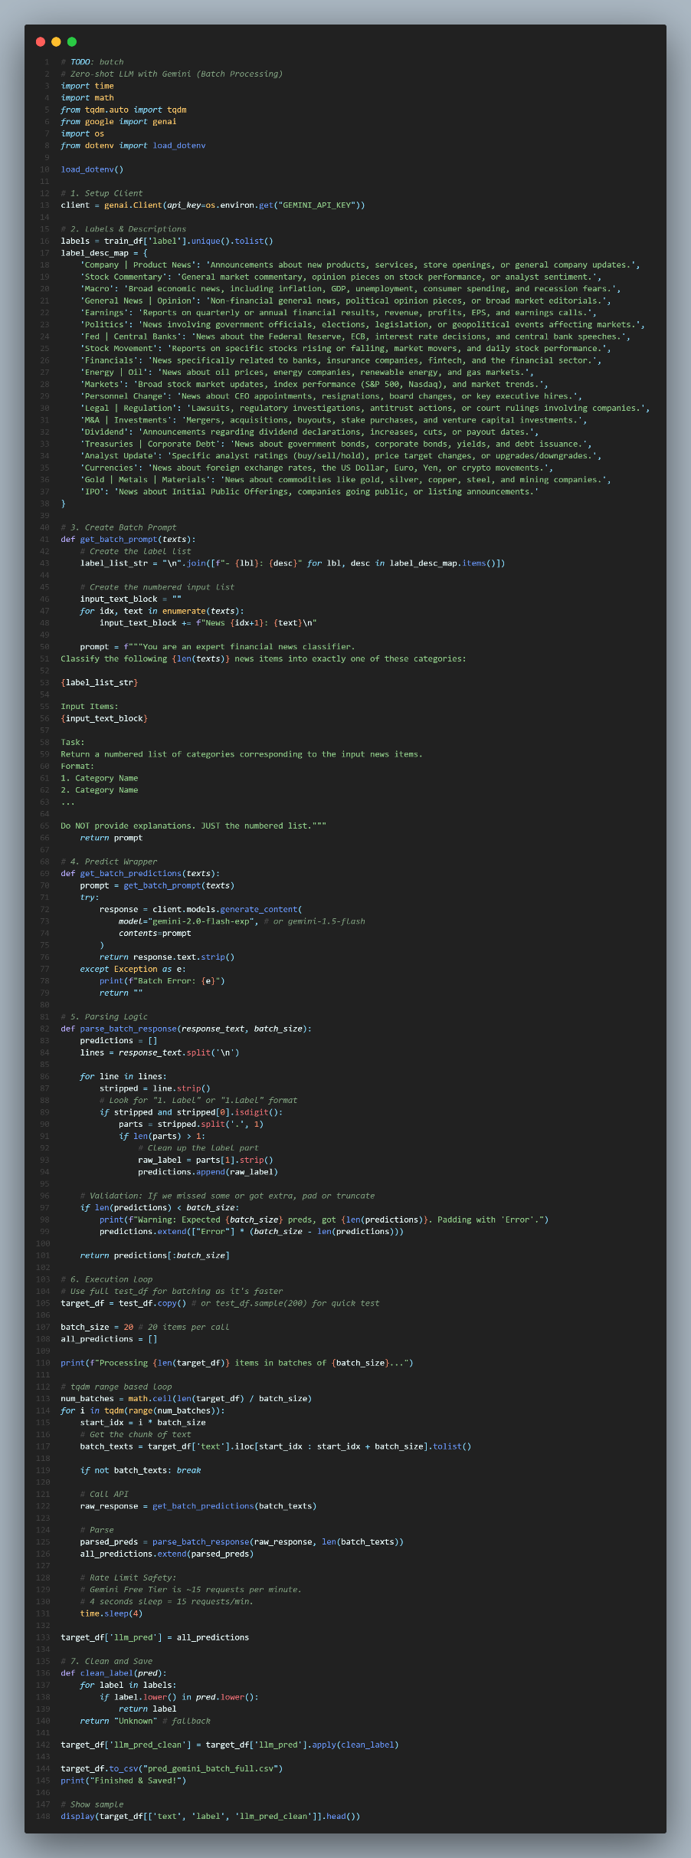
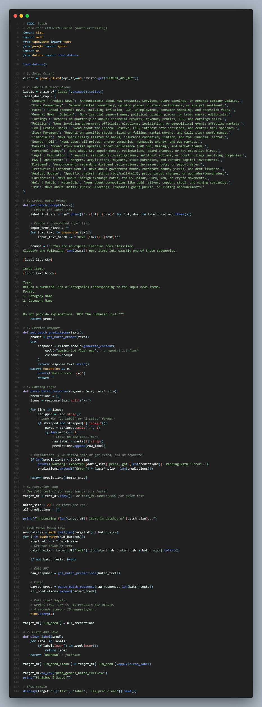
Question 5: Zero-shot LLM better or worse?
These are the same classifications report for predictions made on test.csv using Typhoon
(typhoon-v2.5-30b-a3b-instruct)
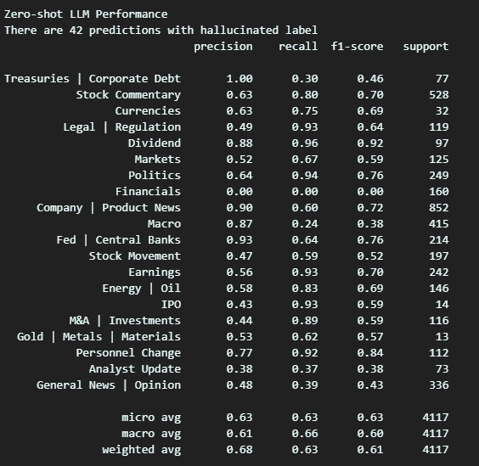
As seen in the 2 reports, Typhoon v2.5 performs approximately 25% worse in weighted f1-score on test.csv
This might be due to the LLM not being specifically tuned for this domain & dataset.
Also, some labels might be ambiguous & confusing to LLM like:
- "Gold | Metals | Materials" vs "Commodities"
- "M&A | Investments" vs "Company | Product News"
In terms of computational resources used for inference, typhoon takes around 15- 30 minutes to make predictions on 4117 news found in test.csv while logistic regression only takes seconds to train the model & predict
For cost, LR is free to use while LLM cost money per token spent in most cases or require expensive gear to host powerful model locally

