BUIDL CTC 2026 Fall

TrustFutures Technical Whitepaper
Cross Chain Performance Bonds for ERC 8004 AI Agents
TrustFutures Team | 14 September 2026 | Testnet prototype

Abstract
TrustFutures is a cross-chain market for performance bonds on AI-agent work. A client creates a funded, objective mandate on Ethereum Sepolia and identifies the executing agent through ERC-8004. Independently keyed underwriters price failure risk and commit a 20 percent junior first-loss tranche. A senior liquidity vault on Creditcoin CC3 reserves the remaining 80 percent. Attestcoin proves the resulting Sepolia transaction before Creditcoin can release capital or pay the client. The prototype therefore replaces a subjective claim about agent behavior with a cryptographically verified event and a pre-funded settlement rule.
The public testnet implementation has completed the full failure path: ERC-8004 agent registration, Sepolia mandate execution, competitive EIP-712 quotes, Creditcoin policy acceptance, a real Attestcoin inclusion and continuity proof, junior-first slashing, a 500 mUSDC payout, and repricing after the verified failure. The balanced premium increased from 9.25 to 42.35 mUSDC. Model training uses a disclosed fixed-seed synthetic dataset; confirmed testnet outcomes are added only as runtime evidence. The code is suitable for hackathon evaluation and testnet experimentation, not production insurance or mainnet custody.

Verified result
Evidence | Confirmed value | Why it matters
Agent and job | ERC-8004 agent 10130, Sepolia job 0 | Portable identity is bound to an objective mandate
Policy | 500 mUSDC coverage on CC3 | 20% junior and 80% senior capital were reserved
Attestcoin | Proof transaction 0x148b2e97...145fc | Creditcoin received verified Sepolia transaction evidence
Settlement | 500 mUSDC payout | The client was paid through the junior-first waterfall
Learning loop | Premium 9.25 to 42.35 mUSDC | Verified failure changed the next risk price

Reader guide
Pages 2 through 5 explain the market design, contracts, and proof boundary. Pages 6 through 8 cover risk governance, implementation, verification, commercial feasibility, limitations, and public references.

Problem and protocol design

The economic gap in agent trust
ERC-8004 gives an AI agent a portable on-chain identity and standardized trust surfaces, but identity alone does not compensate a client when an agent fails. Reputation can help select an agent, yet it remains backward-looking and does not guarantee capital for the next job. Escrow also solves a different problem: it can withhold payment to the agent, but it does not necessarily reimburse the client for execution loss. TrustFutures adds a job-specific, capital-backed promise whose price is set before execution and whose payout is determined from an objective source-chain outcome.
The initial use case is a treasury rebalance. The client defines the input amount, minimum acceptable output, execution deadline, agent identity, and requested coverage. These conditions turn performance into a finite state machine with three outcomes: Success, Violation, or Expired. The market does not attempt to judge open-ended quality, intent, or model reasoning. This narrow scope makes automated proof and settlement credible.

Protocol objectives
Objective | Mechanism | Observable property
Portable identity | Official ERC-8004 identity registry | Mandates refer to a stable agentId
Objective execution | Funded Sepolia job with minimum output and deadline | Outcome is emitted by the approved manager
Competitive risk price | Three signed underwriting strategies | Client can compare premium and model evidence
Pre-funded protection | 20% junior stake and 80% senior reserve | Full coverage is locked before execution
Cross-chain truth | Attestcoin proof verified on CC3 | Settlement does not trust an API or operator assertion
Deterministic settlement | Single-use policy and proof state | Success releases; failure or expiry pays

Novelty
TrustFutures is not a generic agent reputation score and is not an uncollateralized promise of insurance. Its distinctive unit is a competitively priced performance bond for one identified agent and one verifiable mandate. The quote binds risk price, coverage, underwriter, expiry, model commitment, nonce, job key, chain, and verifying contract. The capital structure makes the party pricing risk absorb the first loss, while pooled senior liquidity supports scale. Attestcoin supplies the missing cross-chain trust boundary: the settlement chain verifies the source event rather than accepting a relayer's claim.
This composition creates a credible market signal. A poor outcome does more than lower a reputation score: it consumes underwriter capital, pays a client, and becomes evidence for future pricing. The testnet loop demonstrates all three consequences in one traceable sequence.

Scope boundary
The prototype caps coverage at 1,000 mUSDC, uses mock tokens and a deterministic mock exchange, and makes no legal insurance claim. It deliberately excludes subjective disputes, a protocol token, DAO governance, mainnet deployment, and opaque LLM-controlled pricing. These exclusions reduce demonstration risk and keep the proof, collateral, and settlement path auditable.

Cross chain architecture
The architecture separates identity and execution, proof transport, and economic settlement. Each chain performs the work for which it is best suited, while a canonical job key prevents the same mandate from being interpreted differently across components.
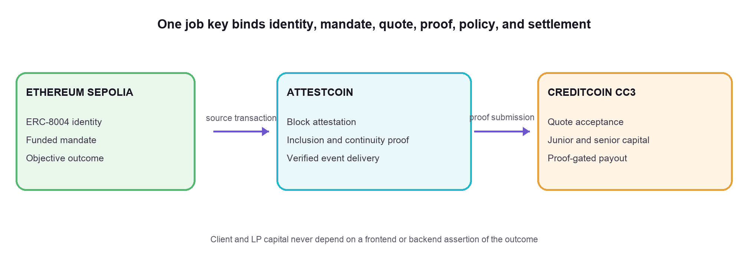
Figure 1 TrustFutures system boundary and cross-chain direction

Canonical identity and job binding
The Sepolia manager accepts an ERC-8004 agentId and validates it against the deployed identity registry. When a job is created, every downstream component derives the same identifier:
jobKey = keccak256 abi.encode sourceChainId sourceJobManager jobId
The Attestcoin adapter derives this value again from the proven event. The API does not trust a browser-supplied job key for live quotes; it reads the Sepolia receipt, verifies the manager emitter and stored job, then returns the canonical key. PolicyManager permits only one active policy per key.

End to end lifecycle
Phase | Authoritative action | Result
Mandate | Client funds TreasuryJobManager on Sepolia | Objective terms and ERC-8004 agent are recorded
Auction | Underwriters sign EIP-712 quotes | Three capital prices compete for the same job
Policy | Client accepts one quote on CC3 | Junior stake and senior liquidity become reserved
Execution | Approved executor performs the constrained swap | Manager emits Success, Violation, or Expired
Proof | Worker obtains and submits Attestcoin proof | CC3 adapter stores a verified, single-use outcome
Settlement | Anyone calls PolicyManager.settle | Capital releases or full coverage is paid
Feedback | Confirmed outcome enters the evidence ledger | Next risk request reflects observed history

Failure handling
The browser orchestrates the user journey but never decides the economic state. XState rejects out-of-order transitions; transaction receipts hydrate the state after refresh. If quote generation fails after createJob is mined, the frontend stores the confirmed mandate and retries only quote hydration. It never submits a duplicate createJob transaction. Proof jobs are idempotent by job key and can be persisted in PostgreSQL for restart-safe retries.

Contracts and economic mechanism

Sepolia mandate contracts
TreasuryJobManager holds the funded input and delegates execution only to administrator-approved adapters. The manager grants an exact allowance for the current call, clears it afterward, and compares the executor's reported output with the client's actual output-token balance increase. Both values must satisfy minOut. A reverted venue call rolls back nested transfers, returns retained input, and records a violation. If the agent does not execute before the deadline, any account may finalize expiry, preventing a no-show deadlock.

Creditcoin market contracts
Contract | Responsibility | Key invariant
CoverageVault | Senior LP shares, free assets, and policy reserves | Withdrawals cannot consume reserved assets
UnderwriterRegistry | Junior deposits, locks, nonce use, release, and slash | Locked first-loss capital cannot be withdrawn
PolicyManager | Quote validation, premium receipt, capital lock, and settlement | One job, one policy, one settlement
AttestcoinOutcomeAdapter | Proof verification and source-event decoding | Only the configured chain and manager can establish outcome

Quote integrity
Each quote uses EIP-712 typed structured data. The signed fields are jobKey, underwriter, coverageAmount, premiumAmount, juniorAmount, validUntil, modelHash, and nonce. Domain separation binds the signature to TrustFutures version 1, Creditcoin chain ID 102031, and the deployed PolicyManager. The contract rejects an expired quote, incorrect signer, reused nonce, altered field, invalid 20 percent junior amount, excessive coverage, or a second policy for the same job. Analytics such as SHAP values and natural-language explanations accompany the quote but do not alter the signed economics; modelHash is the compact provenance commitment.

Figure 2 Capital reserved for a 100 percent coverage promise

Capital and premium rules
Event | Junior underwriter | Senior LP vault | Client
Policy accepted | Locks 0.20C | Reserves 0.80C | Pays premium P
Success | Stake released; receives 0.30P | Reserve released; receives 0.70P | No payout
Violation or expiry | 0.20C slashed first | 0.80C paid second | Receives full C

For the completed 500 mUSDC failure test, junior capital supplied 100 mUSDC and senior liquidity supplied 400 mUSDC. This first-loss structure aligns underwriting incentives: the party setting the quote loses its own capital before pooled liquidity is used.

Attestcoin verification boundary
Attestcoin is a core protocol dependency, not a decorative bridge. Creditcoin settlement cannot rely on the application server because that would let an operator invent success or failure. The proof worker follows the official USC pattern: it waits until Creditcoin has attested the Sepolia source height, requests an inclusion and continuity proof for the transaction, and calls the deployed outcome adapter on CC3.
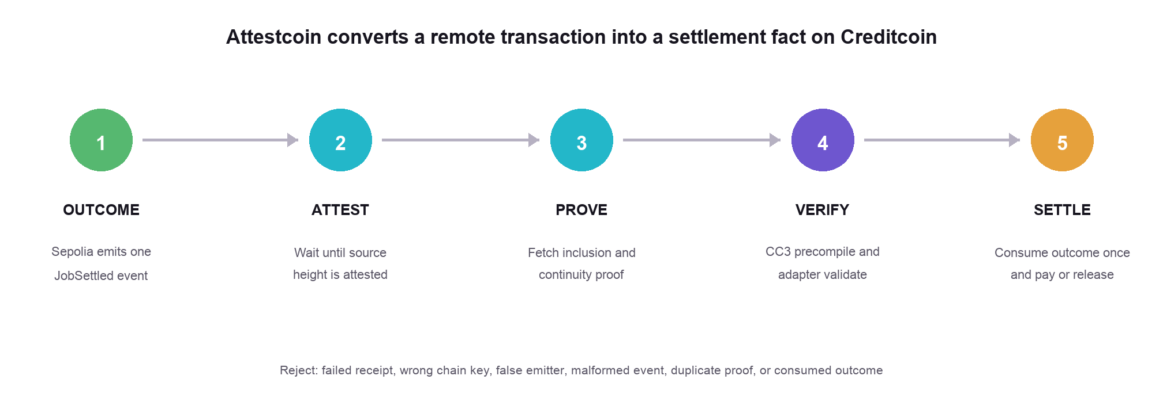
Figure 3 Proof-gated delivery of a Sepolia outcome to Creditcoin

On chain verification
The adapter extends the USC verification base and decodes the proven receipt with Gluwa's EvmV1Decoder. It requires a successful source transaction receipt, exactly one JobSettled event, the configured Sepolia chain key, and the deployed TreasuryJobManager as emitter. It decodes the indexed jobId and outcome, reconstructs jobKey from immutable source parameters, rejects an already proven job, and records only Success, Violation, or Expired. PolicyManager then consumes that outcome once. Query uniqueness, proven-job state, consumed-outcome state, policy state, and quote nonce create independent replay barriers.

Public proof and payout evidence
Stage | Network | Transaction | Confirmed result
Source violation | Sepolia | 0x45649de2...42140d | JobSettled emitted at block 11654361
Attestcoin submission | Creditcoin CC3 | 0x148b2e97...145fc | Proof accepted at block 5446466
Policy settlement | Creditcoin CC3 | 0x46631b26...95cdb | 500 mUSDC payout at block 5446468

The proof transaction emitted both the Creditcoin verifier-precompile event and OutcomeProven from the deployed adapter. Settlement later emitted OutcomeConsumed and PolicySettled. The recorded proof contains chain key 1, source header 11654361, transaction bytes, Merkle siblings, and continuity roots. These values are retained in the public deployment journal for reproducibility.

Operational path
The TypeScript worker uses @gluwa/usc-sdk 0.18.0 and an ethers signer. Production-shaped operation uses a PostgreSQL queue with atomic claim, bounded retry scheduling, sanitized errors, and idempotency by job key. The proof may take longer than a three-minute presentation because source finality and attestation are external. The demo therefore shows the interactive local flow and then the already confirmed explorer transactions without representing cached evidence as a new proof.

Risk pricing and application implementation

Model and data lineage
The risk service trains a GradientBoostingClassifier on a committed fixed-seed synthetic mandate dataset. Agent-disjoint train, validation, and test splits reduce direct identity leakage. Isotonic calibration is applied when both classes exist in validation data, and predicted probabilities are clipped to 1 through 95 percent. The service publishes model version, model hash, dataset hash, calibration method, probability bounds, confidence, feature drift, out-of-distribution status, abstention reasons, warnings, and held-out metrics. SHAP attributions explain the direction and relative influence of each feature.
Feature | Interpretation | Risk relevance
Failure rate | Violations and expiries divided by observed jobs | Direct evidence of unsuccessful completion
Mean slippage | Average execution loss in basis points | Measures output quality
Mean lateness | Observed deficit relative to expected output timing | Captures deadline reliability
Job size versus P95 | Coverage relative to historical task size | Detects extrapolation beyond experience
Deadline tightness | Time constraint transformed to basis points | Prices execution difficulty
Volatility | Simulated market volatility for the mandate | Represents external execution conditions

For feature vector x, the service computes a calibrated probability p = clamp(calibrate(GBM(x)), 0.01, 0.95). The underwriting layer applies strategy sensitivity but never permits a signed probability below its deterministic history floor. Premium basis points are bounded between 75 and 3,000, and premium equals coverage multiplied by premium basis points divided by 10,000. Low-confidence, drifted, unseen-category, or invalid attested inputs trigger abstention instead of a quote.

AI authority boundary
The economic output is deterministic. OpenAI receives the fixed probability, premium, ranked factors, and capital terms only after pricing. It returns a strict JSON explanation containing summary, top risks, and protective terms. It cannot change probability, premium, coverage, signature, or policy state. If the API is unavailable or returns invalid output, a deterministic explanation derived from the same factors is used. This preserves usability without assigning monetary authority to an LLM.

Frontend and services
The Next.js 14 application supports embedded demonstration and MetaMask wallet modes. wagmi and viem manage EIP-1193 transactions and chain switching; RainbowKit is optional for external wallet discovery. An XState machine tracks the ordered Sepolia, auction, Creditcoin, Attestcoin, and settlement lifecycle. React Three Fiber renders the cross-chain topology, and Recharts displays signed-quote analytics and SHAP evidence. Human mUSDC inputs are parsed as decimal strings into six-decimal bigint base units, preventing floating-point and display errors.
Service surface | Role
POST /v1/live/quotes | Verify a mined Sepolia receipt and return three signed CC3 quotes
POST /v1/proofs | Idempotently enqueue Attestcoin proof generation
GET /v1/proofs/jobKey | Expose proof state and transaction references
GET /v1/agents/agentId/risk | Return attested features, score, lineage, confidence, and diagnostics
GET /v1/live/market | Read public Creditcoin policy history for the connected wallet

Security and verification

Threat controls
Threat | Implemented control | Residual boundary
Fabricated source outcome | Native proof, chain key, successful receipt, manager emitter, exact event | Depends on USC and configured source addresses
Quote mutation or replay | EIP-712 domain, expiry, nonce, signer recovery, jobBound | Underwriter keys remain operational trust
Proof, payout, or no-show | Single-use proof and outcome state; permissionless expiry | Network liveness still matters
Reserved liquidity withdrawal | Vault exposes only free assets while coverage is reserved | Mock asset behavior is trusted
Malicious executor | Allowlist, exact allowance, output-balance verification | Administrator and approved bytecode are trusted
LLM changes economics | Model prices first; schema-limited explanation and deterministic fallback | Model governance remains off-chain
Duplicate wallet mandate | Confirmed receipt persistence and quote-only retry | Browser storage can be cleared manually

Verification results
A fresh verification run on 14 September 2026 passed deployment checks, TypeScript typecheck, the optimized Next.js build, 76 root tests, 64 web tests, and 12 Python risk tests. These 152 tests cover local EVM execution, ERC-8004 outcomes, EIP-712 integrity, junior-first settlement, API validation, proof retries, risk lineage, wallet recovery, unit conversion, analytics, and state order. Optional wallet-library warnings did not prevent compilation or route generation.
Suite | Passed | Representative assurance
Root Node and EVM | 76 | Contracts, API, local success and violation sagas, queues, deployment
Next.js application | 64 | Wallet plans, recovery, parsers, topology, analytics, bigint conversion
Python risk service | 12 | Dataset, calibration, metrics, drift, abstention, model output
Production checks | Pass | Typecheck, seven generated routes, deployment manifests

Public deployment
Network | Core address | Purpose
Sepolia | 0x85F34Ddd...715baF9 | TreasuryJobManager
Creditcoin CC3 | 0x76a75FC7...02E4EE89 | AttestcoinOutcomeAdapter
Creditcoin CC3 | 0x5cCd9246...c139495a | PolicyManager
Creditcoin CC3 | 0xDa571807...F0Fb4D7E | CoverageVault; registry listed in manifest

The manifest also records the official Sepolia ERC-8004 registry at 0x8004A818...A494BD9e, constructor arguments, receipts, code hashes, explorer links, and the completed proof loop. Live RPC checks confirmed the principal contracts and all three proof-loop receipts.

Feasibility market and roadmap

Technical feasibility
The prototype proves the hardest dependency: a Sepolia outcome becomes a Creditcoin settlement fact through a real Attestcoin proof. EVM contracts, typed signatures, deterministic outcomes, and capped collateral keep computation modest. New mandate categories need objective source semantics but can reuse the underwriting and settlement layer.

Marketability
Initial customers are teams delegating bounded treasury operations, payments, or scheduled execution to external agents. Buyers pay a premium for job-specific coverage. Underwriters earn for first-loss exposure, LPs earn for senior capacity, and credible agent history can lower future premiums. A practical launch begins with testnet agent tooling and later reaches protocol treasuries after audit and legal review. Revenue can come from a premium-flow fee and specialized underwriting services; no protocol token is required.

Scalability
Dimension | Current design | Scale path
Agents and quotes | ERC-8004 identities and three keyed strategies | Index by mandate class; permissionless underwriting and batch discovery
Capital | Single senior vault with 1,000 mUSDC cap | Risk buckets, utilization limits, reinsurance, and multiple vaults
Chains and proofs | Sepolia source, CC3 settlement, durable worker | More Attestcoin-supported sources, parallel workers, and relayer redundancy
Models | One disclosed GBM | Versioned models, monitoring, challenger models, and governance approvals

Roadmap and production gates
Next, collect proof-confirmed outcomes and publish calibration reports by mandate category. Production requires an independent Solidity review, fuzzing and invariants, multisig administration, incident procedures, secrets management, monitoring, backups, relayer redundancy, audited venue adapters, token testing, and jurisdiction-specific legal analysis.

Limitations
TrustFutures is a testnet performance-bond prototype. Training data is synthetic; testnet outcomes are runtime evidence. The deployment uses mock assets and MockDexExecutor, has no independent audit, and lacks production-grade key management and monitoring. Coverage is capped at 1,000 mUSDC. The system does not adjudicate subjective work or eliminate model, operator, and protocol risk.

References
Standards and code | Public testnet evidence
[1] TrustFutures public repository  [2] ERC 8004 Trustless Agents  [3] EIP 712 Typed Structured Data Hashing and Signing  [4] Gluwa USC end to end proof example | [5] Creditcoin Testnet explorer proof transaction  [6] Creditcoin Testnet explorer settlement transaction  [7] Sepolia source outcome transaction  [8] Creditcoin endpoints

