A digital printout/screenshot of the “Resource Utilization by Entity” page. Include the computed size of your design, which can be calculated using the instructions above. If you do not write/type this somewhere, we will not be able to award any (potential) bonus points.

DE1_SoC Module:
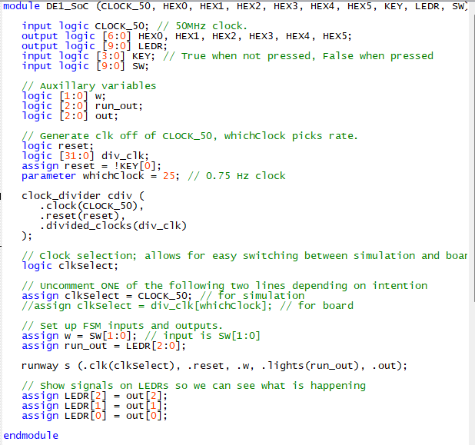

Runway Module
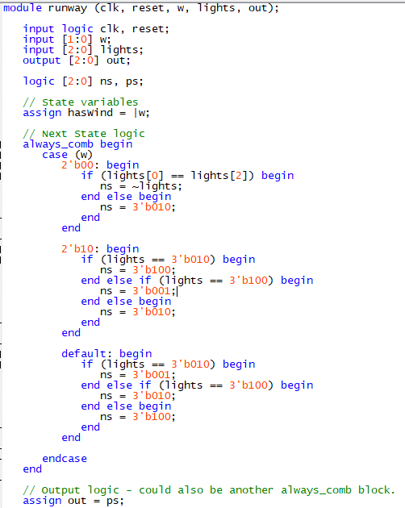
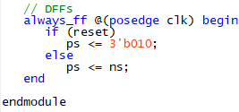

Clock Module
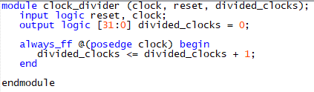

Resource Utilization
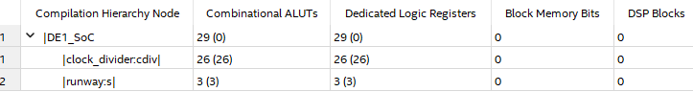
Calculation: (29 + 29) – (26+26) = 6

