AI SEARCH METHODS · CASE STUDY
Multi-Agent F1 Race Strategy
Final plan: what we build, how the app works, every command, and how we prepare and defend each choice
Course component | Case study (20 marks): Presentation 1, Problem Definition (10) + Presentation 2, Implementation & Demo (10). Maximum 6 slides.
What we build | A 20-lap simulated race at Silverstone with 12 agents. Strategy agents plan and change pit stops; the examiner can trigger a Safety Car or rain during the race.
Teams and agents | McLaren (NOR, PIA) · Ferrari (LEC, HAM) · Red Bull (HAD, VER) · Mercedes (RUS, ANT). Each team has 1 strategist agent and 2 driver agents. Race Control is part of the environment.
Algorithms | From Russell & Norvig, AI: A Modern Approach (AIMA): A* search (Ch. 3), belief-state update (Ch. 4), minimax with alpha-beta (Ch. 5), condition-action rules (Ch. 2), replanning after events
Data | The real 2026 British Grand Prix (5 July 2026, dry), prepared once and stored inside the project
App | Python backend with a terminal for commands and the full conversation log; a Next.js page with one panel: the track map
Project folder | Desktop/F1-Strategy-MAS, independent of every other project; data already prepared

Contents
1. The project on one page 4
1.1 What the examiner sees 4
1.2 What we must prove, and where 4
1.3 Rubric traceability 4
2. F1 in 60 seconds (for the audience) 6
3. Problem statement 6
4. PEAS formulation 7
4.1 System-level PEAS 7
4.2 PEAS per agent type 7
4.3 Performance measure 7
4.4 Global impact matrix: how one agent's action changes the environment for others 7
5. Environment and agent analysis 8
5.1 Environment classification (AIMA Ch. 2) 8
5.2 Multi-agent dynamics 8
5.3 State-space size (why the problem must be decomposed) 8
5.4 Communication bottlenecks and friction points 9
6. Algorithms and how we defend them 9
6.1 A* for the pit-stop plan 10
6.2 Belief states for hidden rival tyres 11
6.3 Minimax with alpha-beta for pit duels (undercut and overcut) 11
6.4 Drivers: condition-action rules 12
6.5 Sudden events: replanning 12
6.6 One-sentence defences 13
7. Agent interactions 13
7.1 Messages 13
7.2 Request → reply, and the strategist has the final say 13
7.3 The 'Decision changed' record: proof that interaction happened 14
7.4 Interaction 1: a driver changes the strategist's decision 14
7.5 Interaction 2: a rival team's move (undercut and overcut) 15
7.6 Interaction 3: Safety Car 15
7.7 Interaction 4: rain 16
8. Race data: the 2026 British Grand Prix 17
8.1 Why this race 17
8.2 How the data was prepared (done once) 17
8.3 Files in data/ 17
8.4 The race model and where each number comes from 18
9. How the app works 19
9.1 Starting it 19
9.2 What happens during the race 19
9.3 The page: one panel, the track map 20
9.4 The terminal 21
10. Commands 21
11. Demo script (about 7 minutes) 22
12. Tools and project structure 22
12.1 Tools 22
12.2 Folder structure 23
13. Build plan 23
14. Tests 24
15. Preparing and defending 24
15.1 Slides (6) 24
15.2 Preparation checklist 24
15.3 Q&A 25
16. Later: merging into the F1 app 25

1. The project on one page
We simulate a Formula 1 race in which each team is run by agents. A strategist agent decides when its cars stop for new tyres, and two driver agents drive and report how their tyres feel. Teams cooperate internally and compete with each other. Strategists never see rival teams' tyre condition; they only see a public timing screen. During the race the examiner can type safety_car or rain into a terminal, and every team has to rethink its plan.

1.1 What the examiner sees
- A full-screen map of Silverstone with 8 cars moving, in 2026 team colours.
- Short notifications on the map whenever an agent sends a message: driver reports, strategist instructions, pit-lane entries.
- A red 'Decision changed' card whenever a strategist changes a plan, saying before → after → because of which agent or event.
- A terminal that prints every message in colour and answers commands such as plan NOR (shows the A* search) and why ANT (explains the last change).
- A Safety Car or rain arriving at a moment the examiner chooses, with all four teams reacting.

1.2 What we must prove, and where
We must show that we understand… | Proved by
The problem as an AI problem (PEAS, environment type, multi-agent nature) | §3–5 and slides 1–2
Which search algorithms fit which decision, and why the others do not | §6 with a worked A* example, a minimax tree and comparison tables; plan and why commands live
Real interaction: agents changing each other's decisions | §7 and the 'Decision changed' cards; the end-of-race summary counts changes by cause
A working, well-organised implementation on real data | §8–13: real 2026 race data, one-command start, clean folder structure, tests

One rule for the whole demo
Every moment on screen should answer two questions: who told what to whom, and whose decision changed because of it.

1.3 Rubric traceability
Rubric criterion (weight) | Covered in | Seen in the demo at
P1 · PEAS (3) | §4 PEAS tables, performance measure, global impact matrix | Scene 1: plans made from driver reports and the timing screen
P1 · Environment & agents (3) | §5 classification, cooperation vs competition, state-space size, bottlenecks | Scene 3: rival tyres are hidden and only guessed
P1 · Algorithms & search (3) | §6 A*, belief states, minimax, with rejected alternatives | Scene 1: plan NOR; scene 3: why ANT
P1 · Q&A (1) | §15.3 prepared answers | n/a
P2 · Tools (3) | §12 tools and reasons; §9 how the app runs | Scene 0: backend and page start with one command each
P2 · Interaction (3) | §7 messages, request → reply, decision-change record, 4 interactions | Scenes 2–5: decision cards naming their cause
P2 · Demo & testing (3) | §11 script; §14 tests | Scenes 4–5: examiner chooses when the Safety Car and rain happen
P2 · Code structure (1) | §12.2 folder tree; §14 tests | Slide 4

PART A — THE AI PROBLEM

2. F1 in 60 seconds (for the audience)
Most of the audience will not follow F1. Put this table on slide 1 and use the same plain words everywhere in the app.
Term | Plain meaning | Why it matters to our agents
Race | 20 laps; the car with the least total time wins | The goal every team plans for
Tyres | Soft: fastest but wears out quickly · Medium: in between · Hard: slowest but lasts longest · Wet: only useful in rain | The main choice the strategist makes
Tyre wear | The older the tyre, the slower each lap | Sooner or later the car must stop
Pit stop | Drive through the pit lane to get new tyres; costs about 21 seconds (measured from the real race) | The main action; the key question is when
Tyre rule | Each car must use two different dry tyre types, unless it has used Wet tyres | Every car stops at least once
Undercut | Stop before your rival. Your new tyres are faster, so you can come out ahead | One team's move forces the other to react
Overcut | Stay out while your rival stops, if they would come out behind slower cars | The opposite answer to the same situation
Safety Car | After a crash everyone drives slowly behind a safety car. A stop now costs only about 10 seconds | Sudden change: every team replans at once
Rain | Dry tyres become very slow on a wet track; Wet tyres are needed | Sudden change: when should each car switch?
Strategist / Driver | Strategist: the team's planner at the pit wall. Driver: in the car, feels the tyres | Our two agent types, with different information

3. Problem statement
An F1 race is a sequence of decisions made with incomplete information. Each team must decide when to stop and which tyres to fit while rival teams make the same decisions, hide their tyre condition, and the race can change suddenly (Safety Car, rain). Drivers feel things the strategist cannot see, and the strategist sees things the drivers cannot.
We model this as a hierarchical multi-agent system. In each team, a strategist agent plans with search and two driver agents drive and report. Teams cooperate internally and compete with each other. Agents affect each other through messages (team radio, the public timing screen) and through the shared track (blocking, where a car rejoins after a stop).
Goal
Show, in a way anyone can follow, that 12 agents with partial information plan using search, communicate, and change their decisions because of other agents and events, with every change traceable on screen.

4. PEAS formulation

4.1 System-level PEAS
 | Description
Performance (P) | Team points from both cars (8-car scale: 25, 18, 15, 12, 10, 8, 6, 4). Secondary: total race time; decision changes that gained or kept a position.
Environment (E) | Static: Silverstone (5.8 km, 18 corners, 3 long straights where overtaking is possible), pit lane with one box per team, tyre types {Soft, Medium, Hard, Wet}, 20 laps, two-dry-tyre rule.  Dynamic: car positions and gaps, tyre age and wear, weather (dry/rain), Safety Car on/off, other teams' plans.
Actuators (A) | Strategist: INSTRUCTION 'pit now for tyre X' or 'stay out'; pace 'push / normal / save tyres'.  Driver: pace mode, overtaking attempt on a straight, entering the pit lane; messages INFO (report), REQUEST ('box now?'), REPLY ('OK' / 'tyres are fine').
Sensors (S) | Driver: own tyre wear, lap time, gap to the car ahead and behind, grip (rain).  Strategist: team radio from its own drivers; public timing screen (positions, gaps, lap times, tyre type, laps since last stop); Race Control announcements.  Hidden: rivals' tyre wear and rivals' plans.

4.2 PEAS per agent type
 | Strategist agent (×4) | Driver agent (×8)
Performance | Least predicted race time for each car; win position duels against close rivals | Follow the plan, keep the tyres alive, gain places on the straights
Environment | Whole race, seen only through reports and the timing screen | Own car and the cars just ahead and behind
Actuators | Instructions to its own two drivers | Pace mode, overtaking attempt, pit entry, messages to its strategist
Sensors | Team radio + timing screen + Race Control | Own car sensors + what it can see around it
AIMA agent type (Ch. 2) | Goal- and utility-based agent that plans with search | Model-based reflex agent (condition-action rules)

4.3 Performance measure
Plan cost (A* path cost, lower is better):
T(plan) = sum of predicted lap times + sum of pit-stop losses
lap time = base + tyre offset + tyre wear x tyre age + fuel effect x lap (+ rain, traffic)

Duel value (minimax, higher is better for us):
V = our predicted gap to the rival after both cars have stopped (seconds)

Team result (reported at the end):
U_team = points(car 1) + points(car 2)

4.4 Global impact matrix: how one agent's action changes the environment for others
Action (by whom) | Effect on own car | Effect on everyone else | Who has to react
Pit stop (strategist → driver) | Loses ~21 s, gets new faster tyres | Car rejoins in a new place; can drop in front of a rival or behind traffic | Nearby rivals' strategists (undercut / overcut)
Push (driver) | Faster now, tyres wear sooner | Closes the gap to the car ahead | Car ahead, own strategist (earlier stop)
Save tyres (driver) | Slower now, tyres last longer | Car behind catches up | Car behind
Blocking (automatic on track) | Holds position | Car behind loses 0.3 s per lap until a straight | Following driver reports 'stuck'; strategist may change plan
Safety Car (Race Control) | Everyone slows down | Stops become cheap for all teams at once | All 4 strategists at the same moment
Rain (Race Control) | Dry tyres become slow | Order changes depending on who switches first | All drivers report; all strategists decide

5. Environment and agent analysis

5.1 Environment classification (AIMA Ch. 2)
Property | Our environment | Why
Observable? | Partially observable | Strategists see rivals only through the timing screen. Other teams' tyre wear and plans are hidden.
Agents | Multi-agent: cooperative and competitive | Teammates share points (cooperative); teams fight for positions (competitive).
Deterministic? | Stochastic | Lap times vary slightly, overtakes can fail, Safety Car and rain arrive unexpectedly.
Episodic? | Sequential | Stopping now changes every later lap.
Static? | Dynamic | The race keeps moving while agents decide.
Discrete? | Continuous, discretised by lap | Cars move continuously; planning happens once per lap.
Known? | Known rules, unknown rival details | Lap-time rules are known; rival tyre condition and event timing are not.

5.2 Multi-agent dynamics
- Cooperative (inside a team): drivers report to their strategist; teammates share one pit box, so their stops must be coordinated.
- Competitive (between teams): a position gained by one team is lost by another. Undercut and overcut are moves in this competition.
- Hierarchy: the strategist decides; a driver can answer once ('tyres are fine'), then the strategist has the final say. No two agents ever give opposite orders.
- Indirect interaction: rival agents never message each other. They react to what they see on the public timing screen and on track.

5.3 State-space size (why the problem must be decomposed)
Formulation | Size | What it means
One car, each lap choose {stay, pit Soft, pit Medium, pit Hard}, 20 laps | 4^20 ≈ 1.1 × 10^12 action sequences | Listing every plan is impossible
Same problem as a state graph: lap × tyre × tyre age × tyres used × stops | ≤ 21 × 3 × 21 × 7 × 4 = 37,044 states | Small enough for A*
All 8 cars planned together | (4^20)^8 = 4^160 ≈ 2 × 10^96 | Joint planning is hopeless, so each strategist plans its own cars
Minimax over the whole race (4 teams, 16 choices each per lap) | 16^4 = 65,536 branches per lap, 20 laps deep | Minimax only fits small two-player duels

5.4 Communication bottlenecks and friction points
- One decision maker per team: simple and consistent, but every decision waits for the strategist.
- Delayed, partial information: the timing screen shows gaps and tyre type, not wear. A rival's stop is only known once the car enters the pit lane.
- Shared pit box: two teammates cannot stop at the same moment without the second one waiting.
- Undercut window: if the gap between two cars is smaller than what new tyres gain, whoever stops first wins. Both teams know this, which makes it a game.
- Outside our scope (discussion only): real teams also deal with radio loss, sensor failure and team orders. We leave them out to keep the demo clear.

6. Algorithms and how we defend them
Each decision in the race is a different type of problem, so it uses the AIMA algorithm designed for that type. This section is the main talking point for 'why this algorithm and not another'.
Decision | Problem type | AIMA chapter | Algorithm we use
When to stop and which tyres (own car) | Single-agent path finding with different step costs | Ch. 3 Solving problems by searching | A* search with an admissible heuristic
How worn are the rival's tyres? | Partially observable state | Ch. 4 Search in complex environments (belief states) | Belief-state update (predict, then filter by observation)
Stop now or stay out against a close rival? | Two-player, zero-sum game | Ch. 5 Adversarial search | Minimax with alpha-beta pruning, depth 2, evaluation function at the cutoff
How to drive right now | Fast local reaction | Ch. 2 Intelligent agents | Condition-action rules (model-based reflex agent)
Safety Car or rain arrives | The world changed after planning | Ch. 4 online search idea: act, observe, replan | Replan with A* from the new state

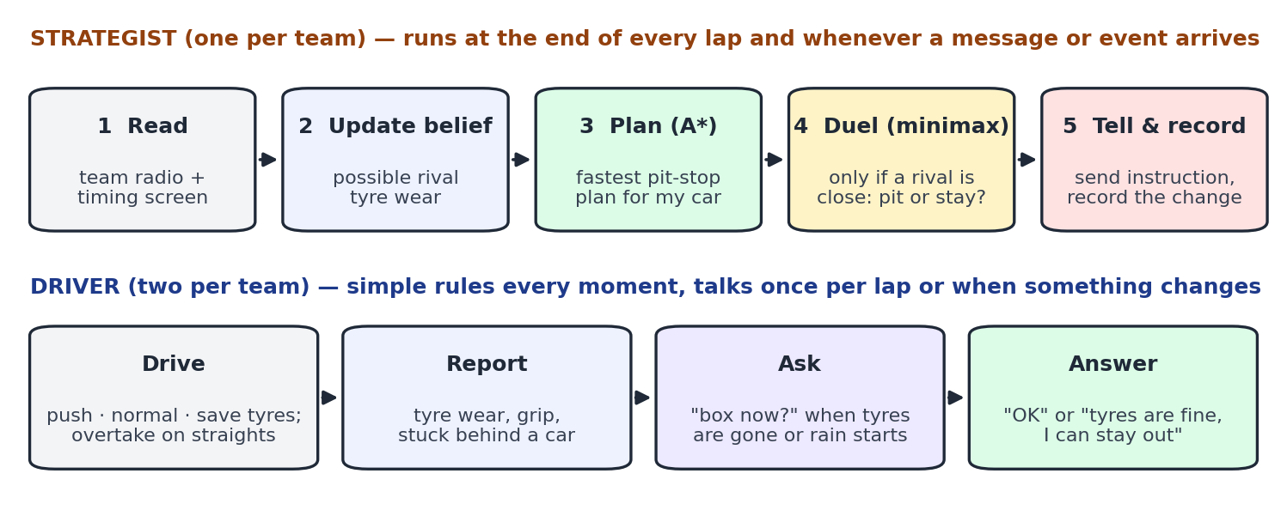
Figure 1. What each agent does, and where each algorithm is used

6.1 A* for the pit-stop plan
Element | Definition
State | (lap, current tyre, tyre age, tyre types used so far, stops made)
Start state | The car's state now (for a rival's car, the believed state)
Actions | STAY OUT, or PIT for Soft / Medium / Hard (plus Wet once it is raining); at most 3 stops
Step cost | Predicted lap time; a PIT action adds the pit loss (21.0 s, or 10 s under the Safety Car)
Goal test | Lap 20 reached and at least two dry tyre types used (or a Wet tyre used)
Heuristic h(n) | (laps left) × (fastest possible lap time) + (one pit loss if a second tyre type is still required)

Why the heuristic is admissible (AIMA: heuristics from relaxed problems)
h is the exact cost of an easier (relaxed) problem: tyres never wear out, the fastest tyre is always fitted, and only one more stop is needed. A relaxed problem can never cost more than the real one, so h never overestimates. A* with an admissible heuristic returns the cheapest plan.
It is also consistent: one more lap lowers h by exactly the fastest lap time, and no real lap is faster than that. A* therefore never needs to re-open a state.

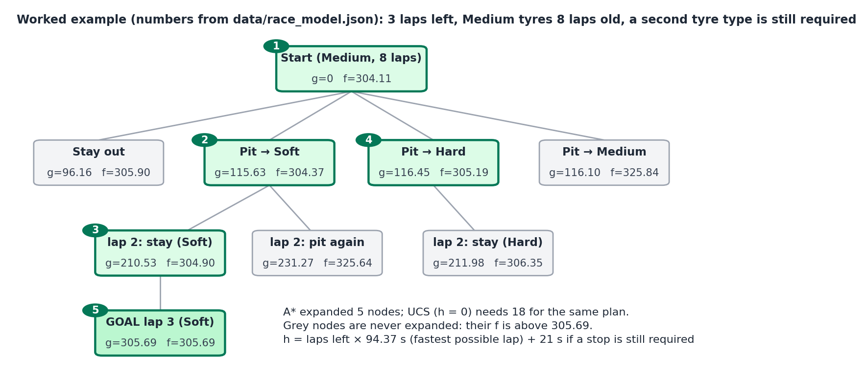
Figure 2. A* on a small case using the real model numbers (checked in code: A* expands 5 nodes, UCS 18, same plan)

Why not the other search algorithms?
Algorithm (AIMA) | Why not for the pit plan | Verdict
Breadth-first search | Finds the plan with the fewest steps, not the least time. A stop (~21 s) and a lap (~95 s) cost different amounts, so it would pick wrong plans | Rejected
Depth-first, depth-limited, iterative deepening | Not cost-optimal when step costs differ; DFS can commit to a bad early choice | Rejected
Uniform-cost search (Dijkstra) | Always finds the cheapest plan, but explores blindly in every direction | Kept as the comparison in the plan command
Greedy best-first | Fast, but only follows h, so it can miss the cheapest plan | Rejected (not optimal)
A* | Cheapest plan, like UCS, but guided by h, so far fewer nodes are expanded | Chosen
IDA*, RBFS, SMA* | Memory-saving versions of A*; our 37,044 states fit in memory easily | Not needed
Bidirectional search | There are many goal states (any tyre, any age at lap 20), so searching backwards is awkward | Rejected
Hill climbing, simulated annealing, genetic algorithms | Improve a full plan step by step, but can get stuck and give no guarantee of the best plan. They suit huge spaces; ours is small | Rejected
CSP backtracking (Ch. 6) | Finds a plan that satisfies the rules, not the fastest one; the rules are already our goal test | Rejected
AND-OR search (plans for every possible event) | A Safety Car or rain could come on any lap, so a conditional plan explodes (2^20 branches). Replanning when the event happens is simpler | Rejected; we replan instead

6.2 Belief states for hidden rival tyres
A strategist cannot see a rival's tyre wear. Following AIMA Ch. 4 (search in partially observable environments), it keeps a belief state: the set of wear levels the rival could still have.
Belief for each rival car: { LOW wear (x0.8), NORMAL wear (x1.0), HIGH wear (x1.25) }

Every lap:
1. Predict: for each level still in the belief, predict the rival's lap time
2. Update: keep only the levels whose prediction is within 0.4 s of the real lap time
(skip the update on laps behind the Safety Car or stuck in traffic)
3. Use: 'rival may stop soon' if ANY remaining level says its tyres are past 70% worn
Alternative | Why not
Assume every rival is average | The strategist would be surprised by every undercut from a rival with high wear
Full probability model (Bayes, hidden Markov model) | More precise, but needs probability distributions and is outside the search portion. A set of possible levels is enough to decide 'could they stop soon?'
Let strategists read rivals' true wear | Breaks partial observability, which is the point of the environment analysis

6.3 Minimax with alpha-beta for pit duels (undercut and overcut)
When a rival car is within about 3 seconds and neither car has stopped yet, the decision is no longer just 'what is fastest for me'. It depends on what the rival does. For those two cars the position is zero-sum (one gains exactly what the other loses), which is the setting minimax is designed for.
Element | Definition
Players | Our strategist (MAX) and the rival strategist (MIN)
Moves | PIT now or STAY out, for each player
Turn order | We move first and the rival replies. It sees our stop on the timing screen, so this is the cautious assumption
Depth | 2 plies (our move, their reply), repeated every lap
Evaluation at cutoff | Predicted gap after both cars have stopped, using the same lap-time model as A* (AIMA: heuristic minimax with an evaluation function)
Result | PIT wins → undercut. STAY wins (for example the rival would rejoin behind slower cars) → overcut
After the rival has already stopped | Its move is known, so its branch is fixed and we only compare our two options with the same evaluation

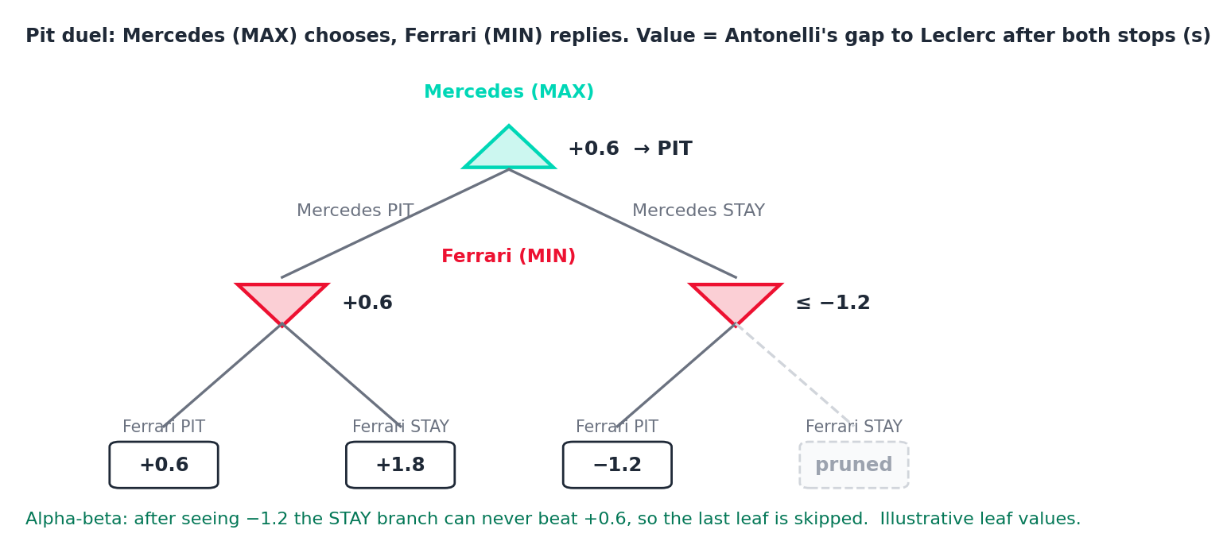
Figure 3. Minimax with alpha-beta: Mercedes should stop Antonelli now; the last leaf never needs to be evaluated

Why not the other game-search algorithms?
Algorithm (AIMA) | Why not | Verdict
Minimax over the whole race | 4 teams, not 2; teammates are not enemies; 65,536 joint moves per lap for 20 laps | Rejected (used only for 2-car duels)
Minimax + alpha-beta, depth-limited | Exactly two players, one position at stake, 4 leaves; alpha-beta skips leaves that cannot matter | Chosen
Expectiminimax (chance nodes) | Would add a chance node for a Safety Car on every lap. We replan when a Safety Car actually happens, which keeps the tree tiny | Not needed (good Q&A point)
Monte Carlo tree search | Built for huge game trees (Go); ours has 4 leaves | Not needed

6.4 Drivers: condition-action rules
Drivers react many times a second, so they do not search. They are model-based reflex agents (AIMA Ch. 2): they keep a small internal state (tyre wear, weather, gap ahead) and apply rules in priority order.
If… | then the driver…
An instruction arrives | follows it and REPLIES 'OK'; if told to stop early while its tyres are under 50% worn, it REPLIES 'tyres are fine, I can stay out' once
Tyre wear passes 70% | sends INFO 'tyres worn' and a REQUEST 'box now?'
It is raining and the car is on dry tyres | sends INFO 'track slippery' and a REQUEST 'box for wets?'
It has been stuck within 1 s of a slower car for 2 laps | sends INFO 'stuck behind [car]'
It is on one of the 3 long straights, within 1 s of the car ahead and at least 0.5 s per lap faster | attempts to overtake: succeeds with probability 0.5 (seeded random); otherwise stays behind
Otherwise | drives at the pace mode the strategist set

6.5 Sudden events: replanning
A Safety Car or rain does not break the plan; it changes the costs. Under a Safety Car a stop costs about 10 s instead of 21 s. In rain a dry tyre is about 6 s slower per lap and Wet tyres become an action. The strategist runs A* again from the current state with the new costs. This 'act, observe, replan' loop is the online-search idea from AIMA Ch. 4, and it is why we do not need AND-OR search or Expectiminimax.
Trigger | Who replans | Algorithm run
End of each lap | Own strategist | Belief update, A*
Driver report or reply (worn tyres, 'tyres are fine', slippery track, stuck) | Own strategist | A* with the reported condition
Rival within 3 s and neither has stopped / rival has just stopped | Both strategists | Minimax
Safety Car or rain announced | All 4 strategists at once | A* with the new costs

6.6 One-sentence defences
Choice | Say this
A* | Different actions cost different times, so we need a cost-optimal search, and A* with a relaxed-problem heuristic finds the same best plan as UCS while expanding far fewer nodes.
Belief states | Rival tyres are hidden, so we keep the set of wear levels that still match the lap times we observe, which is how AIMA handles partial observability without probabilities.
Minimax + alpha-beta | A pit duel between two cars is a small two-player zero-sum game, so minimax picks the move that is best even if the rival answers perfectly, and alpha-beta skips branches that cannot change the answer.
Reflex drivers | Drivers must react instantly and locally, so rules are enough; the planning happens at the strategist.
Replanning | Safety Car and rain only change costs, so re-running A* from the new state is simpler than planning for every possible event in advance.

7. Agent interactions

7.1 Messages
Agents communicate with five plain message types. They correspond to FIPA-ACL speech acts (INFORM, REQUEST, AGREE), which is worth one sentence in the presentation.
Type | Meaning | Example
INFO | Report a fact | Hamilton → Ferrari strategist: 'Tyres 70% worn, losing half a second a lap'
REQUEST | Ask for a decision | Norris → McLaren strategist: 'Box this lap?'
INSTRUCTION | A decision, sent down | Mercedes strategist → Antonelli: 'Stop now to cover Leclerc'
REPLY | Answer to an instruction | Antonelli → Mercedes strategist: 'OK, boxing' / 'Tyres are fine, I can stay out'
EVENT | Public news from Race Control or the timing screen | 'Safety Car deployed' · 'Leclerc entered the pit lane'

Who can read what: team radio (INFO, REQUEST, INSTRUCTION, REPLY) is delivered only inside the team. EVENTs are public. The screen and terminal show everything so the audience can follow, but each agent only receives what it is allowed to see.

7.2 Request → reply, and the strategist has the final say
Strategist ──INSTRUCTION──▶ Driver 'stop on lap 9'
Driver ──REPLY────────▶ Strategist 'OK' → done
or 'tyres are fine, I can stay out' (allowed once)
Strategist re-runs A* with the driver's information and sends a final INSTRUCTION → no further replies

Driver ──REQUEST──────▶ Strategist 'box now?'
Strategist re-runs A* and answers with an INSTRUCTION (box now / stay out)
Because the strategist always ends the exchange, there is no endless back-and-forth and no deadlock. Teammates sharing the pit box follow a simple rule: the car ahead on track stops first and the second car stops right behind it, unless A* says waiting a lap is cheaper.

7.3 The 'Decision changed' record: proof that interaction happened
Whenever a strategist's new plan for a car differs from the old one, it writes a record. The page shows it as a red card, the terminal prints it, and why <driver> explains it.
DecisionChange(
lap = 9,
team = 'Mercedes', car = 'ANT',
before = 'stop on lap 11 (Hard)',
after = 'stop now, lap 9 (Hard)',
cause = message #41 'Leclerc entered the pit lane' (from Ferrari, via timing screen),
reason = 'Minimax: stay out -> 1.2 s behind; stop now -> 0.6 s ahead',
)
A change is only recorded when there is a cause: a message, an event, or a rival's move. At the end, a summary counts decision changes by cause (driver reports, rivals, Safety Car, rain), which gives a one-line answer to 'did the agents really interact?'.

7.4 Interaction 1: a driver changes the strategist's decision
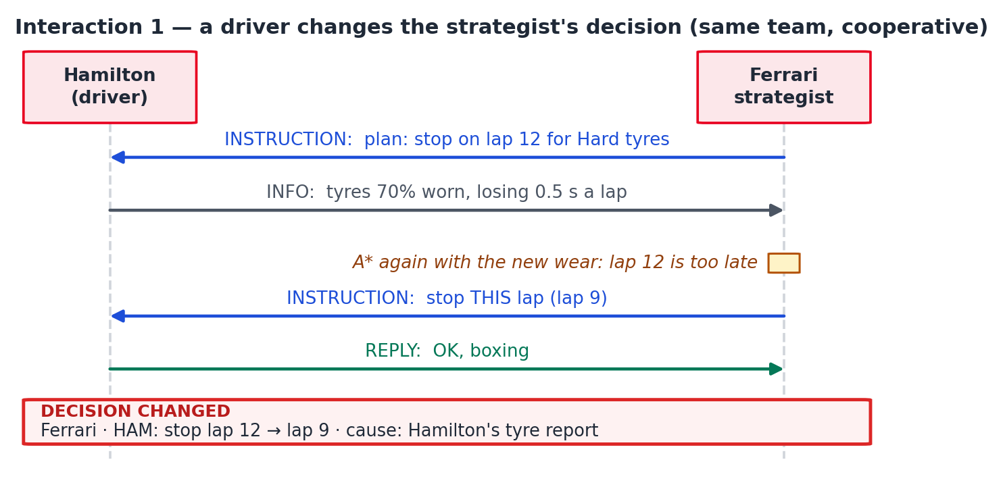
Figure 4. Cooperative interaction inside a team
Seen on screen: Hamilton's message appears as a notification, then a red card: 'Ferrari · HAM: stop lap 12 → lap 9 · because: Hamilton's tyre report'. The reverse also happens: a driver replies 'tyres are fine' and the strategist moves the stop later.

7.5 Interaction 2: a rival team's move (undercut and overcut)
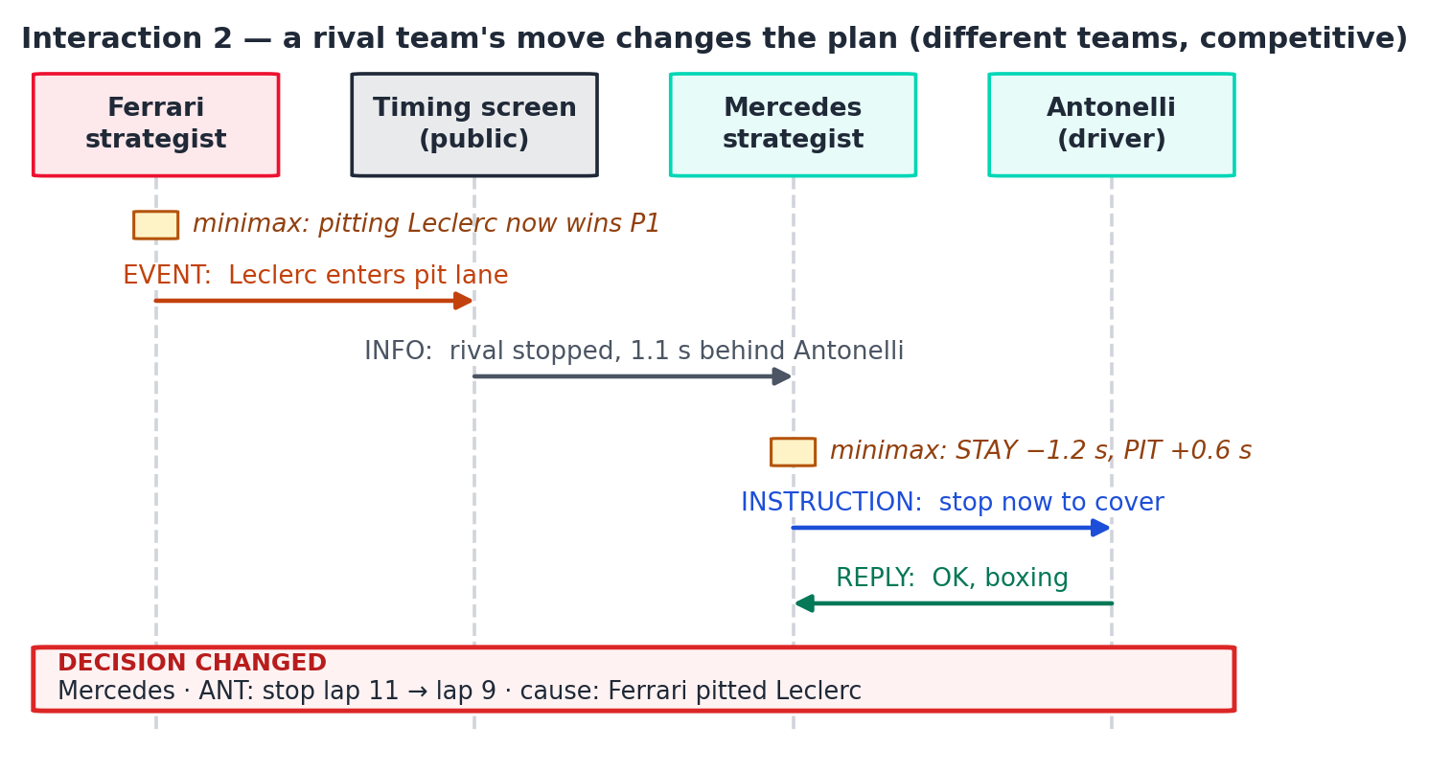
Figure 5. Competitive interaction between teams through the public timing screen
Seen on screen: Leclerc's car gets an 'IN PIT' ring on the map, a ring pulses on Antonelli, and the card says 'because: Ferrari stopped Leclerc'. Typing why ANT prints the two minimax values. In another situation the same check returns STAY (overcut), and the card reads 'stay out: Leclerc will rejoin behind Norris'.

7.6 Interaction 3: Safety Car
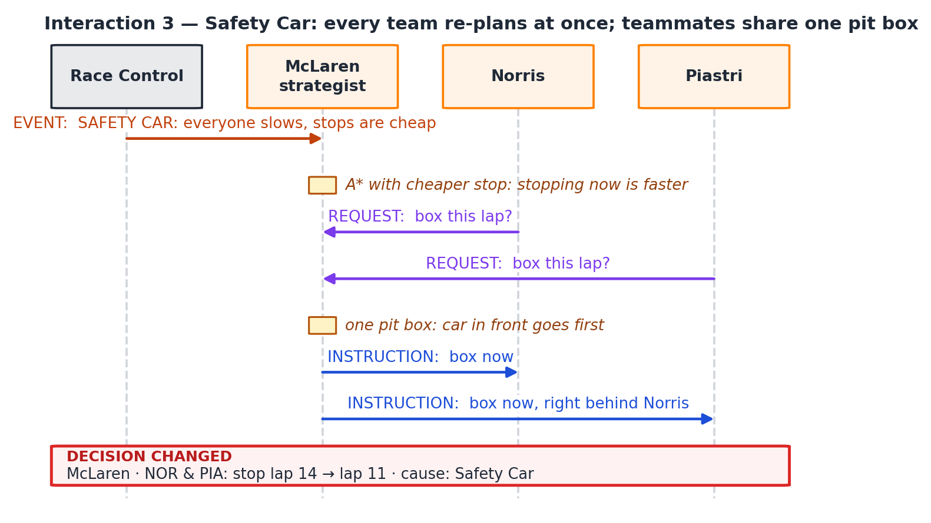
Figure 6. One event, four teams replanning at the same time, teammates sharing a pit box

7.7 Interaction 4: rain
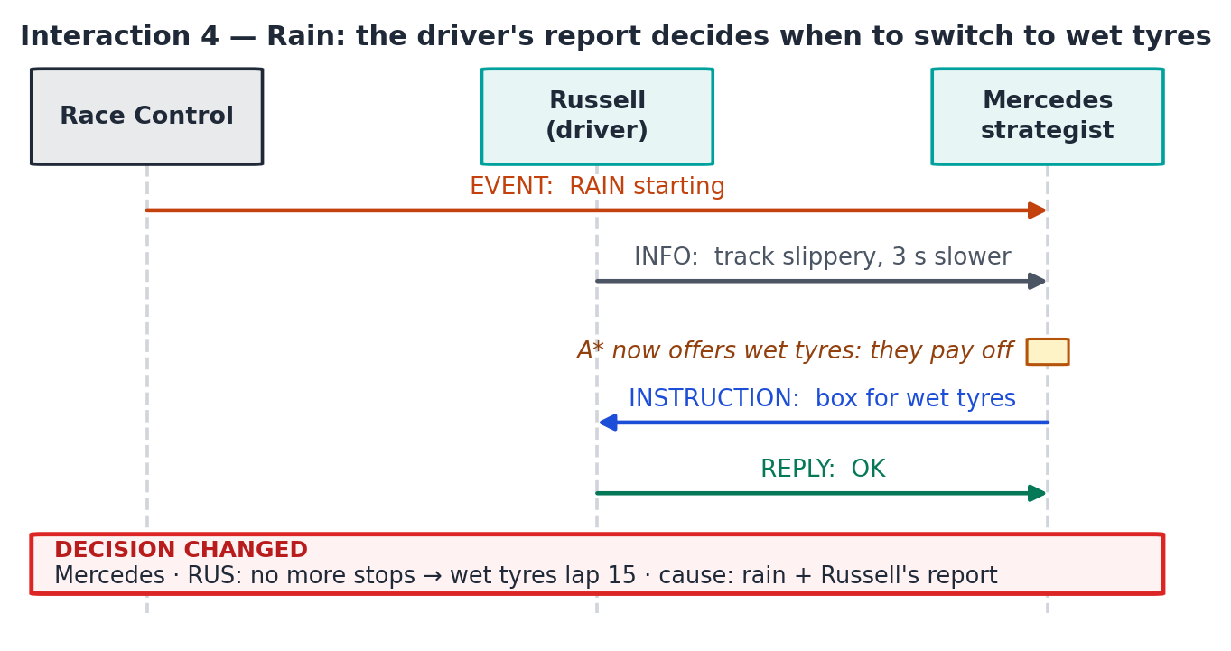
Figure 7. The driver's report plus the event lead to the tyre switch
Seen on screen: the map turns blue-tinted, drivers report slippery conditions, and teams switch to Wet tyres on different laps. The order changes, and each card explains why that team switched when it did.

PART B — DATA AND THE APP

8. Race data: the 2026 British Grand Prix

8.1 Why this race
Fact (from the data) | Why it helps
Held 5 July 2026 at Silverstone, 52 laps, 5,817 m per lap | The most recent race at our track
Dry: no rainfall readings, air 24.8 °C, track 40.0 °C; only Soft, Medium and Hard tyres used | A clean dry race to start from; rain only happens when we type rain
Our 8 drivers started from grid slots 1–8: ANT, LEC, HAM, RUS, HAD, NOR, VER, PIA | We use the real starting order
Real result among our 8: LEC 1st, RUS 2nd, HAM 3rd, NOR 4th, HAD 5th, PIA 11th, ANT 15th, VER retired | Good closing slide: compare with our simulated result
Safety Car on the last laps; 5 of our 8 cars stopped on laps 47–48, right as it came out | Real-world proof that a Safety Car makes every team rethink at once
First stops were spread out: VER lap 17, HAD 19, HAM and RUS 23, LEC 25, NOR 28, ANT 35 (PIA stopped on lap 2) | Real teams chose very different stop timing, which is exactly the decision our strategists make

8.2 How the data was prepared (done once)
- FastF1 3.8.3 downloaded the race (laps, telemetry, weather, flags), reusing the cache folder of the F1-Telemetry-Analysis project so nothing was downloaded twice.
- tools/extract_race_data.py wrote the small CSV and JSON files below into data/. The racing line comes from the fastest race lap, drawn the same way as the existing track map.
- Corner positions normally come from the MultiViewer circuit service, which was unreachable from our network. The script instead lined up the 2026 lap with a saved Silverstone layout (rotation 92°, average distance between the two lines 3.0 m, well inside the track width) and placed the 18 corners on the 2026 lap.
- tools/fit_model.py measured tyre wear, fuel effect and pit-stop loss from the laps and wrote race_model.json.
The app never touches FastF1, the internet or the other project
Everything the app needs is in data/ (about 120 KB). A teammate only needs this folder. The tools are kept so the data can be regenerated or another race used later.

8.3 Files in data/
File | Contents | Size
silverstone_2026_track.csv | Racing line: x, y, distance | 37.9 KB
silverstone_2026_corners.csv | 18 corners with label positions; the 3 long straights (T5–T6 732 m, T14–T15 865 m, T18–T1 592 m) are computed from their gaps | 1.8 KB
silverstone_2026_laps.csv | Every lap of all 22 drivers: lap time, tyre, tyre age, stint, pit in/out, flag status, position, 'clean lap' flag | 74.6 KB
silverstone_2026_summary.json | Race facts used above | 0.9 KB
teams.json | The 4 teams, 2026 colours, drivers, real grid and finish, hidden wear level per driver | 1.7 KB
race_model.json | Every number the simulator uses, each tagged 'data' or 'hand' (next section) | 2 KB

8.4 The race model and where each number comes from
The demo race is 20 laps instead of 52. To keep strategy meaningful, tyre wear and fuel effect are multiplied by 52/20 = 2.6, so a 20-lap race wears tyres like the full race.
Quantity | Value used | Source | Reason
Base lap time | 94.97 s | Data | Median driver pace on 818 clean laps
Fuel effect | −0.167 s per lap (real −0.064, ×2.6) | Data | Cars get lighter and faster
Medium tyre | offset 0, wear 0.132 s per lap of age (real 0.051, ×2.6), life 12 laps | Data | 440 clean Medium laps
Soft tyre | −0.6 s, wear 0.264, life 7 laps | Hand | Only 14 clean Soft laps: faster than Medium, wears about 2×
Hard tyre | +0.4 s, wear 0.079, life 18 laps | Hand | Medium and Hard pace cannot be separated in this race: slower, wears about 0.6×
Pit stop loss | 21.0 s | Data | Median of 24 green-flag stops (15 of them took 18–23 s)
Safety Car | 3 laps, lap times ×1.4, stop costs 10 s, no overtaking | Hand | Standard behaviour
Rain | Dry tyres +6 s per lap; Wet tyres +2.5 s; Wet tyres on a dry track +3 s | Hand | The real race was dry
Traffic | Within 1 s of the car ahead: +0.3 s per lap; overtaking only on the 3 straights | Hand | Simple and visible
Randomness | Lap-time noise 0.15 s; overtaking chance; fixed by a seed | Hand | Repeatable demo

How to defend the numbers
We use the real race where it gives reliable numbers (base pace, fuel, Medium wear, pit loss) and label every hand-set value with its reason. The project is about how agents decide and interact, not about perfect tyre physics, and every agent uses the same model, so the comparison between their decisions is fair.

9. How the app works
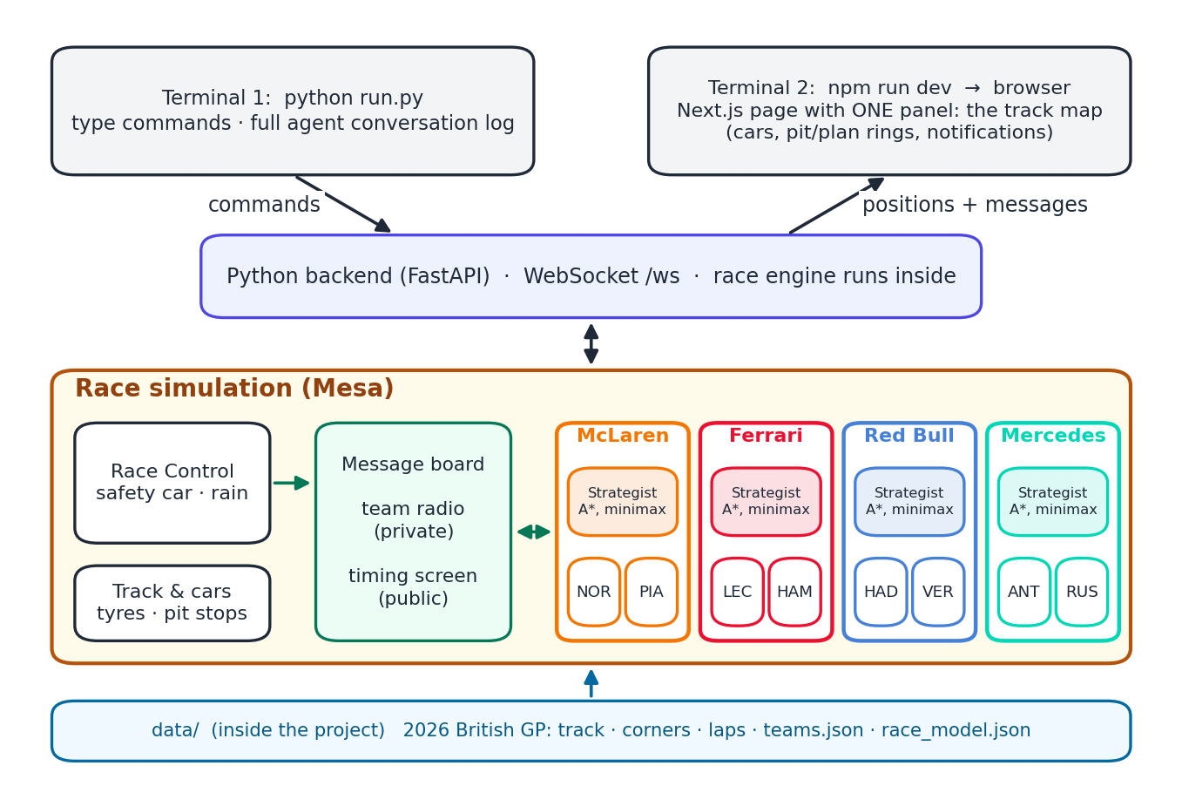
Figure 8. The whole system: Python backend with the race inside, a terminal, and one Next.js page

9.1 Starting it
Terminal 1 (backend + commands):
pip install -r requirements.txt
python run.py # backend on http://localhost:8000, then a '>' prompt

Terminal 2 (the page):
cd web
npm install # first time only
npm run dev # open http://localhost:3000

9.2 What happens during the race
The race engine updates 10 times per simulated second and speeds up with the speed command. At the start all cars line up in the real 2026 grid order on Medium tyres, as in the real race, and each strategist runs A* to make its first plan. After that, the loop below repeats:
Step | What happens
1. Race Control | Applies any Safety Car or rain the examiner has triggered and announces it as a public EVENT
2. Cars move | Lap times come from the race model; traffic slows cars; overtakes happen on the 3 straights; pit stops take the pit loss
3. Drivers act | Each driver applies its rules and sends INFO, REQUEST or REPLY messages
4. Messages delivered | Team radio only to the team; timing screen and Race Control to everyone
5. Strategists decide | At each lap end or when a message arrives: belief update → A* → minimax if a rival is within 3 s → compare with the current plan → send INSTRUCTION and record any DecisionChange
6. Screen updated | The backend streams car positions (10 per second), messages and decision changes to the page; the terminal prints each message in colour

9.3 The page: one panel, the track map
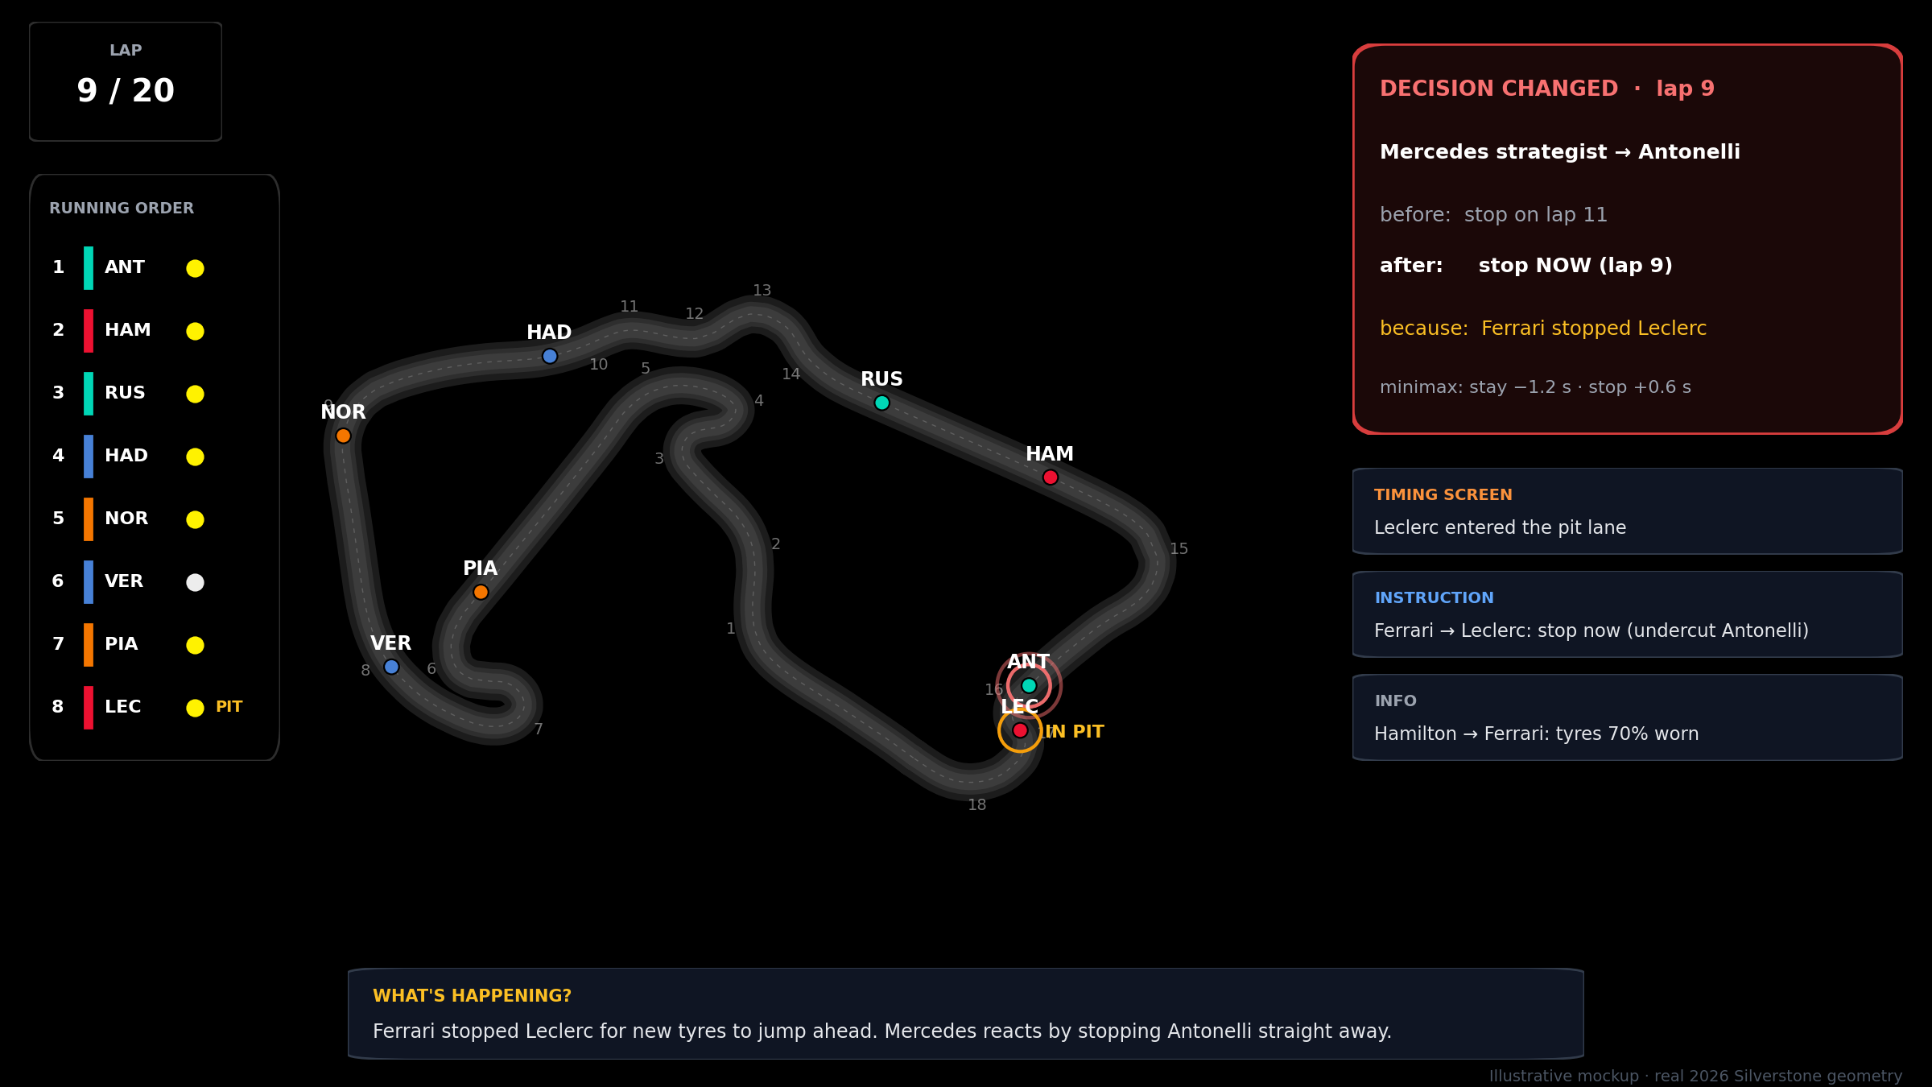
Figure 9. The track map panel (illustrative values) on the real 2026 Silverstone geometry

Element on the map panel | What it shows
Track and cars | Silverstone with corner numbers; each car a coloured dot with its code. The drawing code is copied from the F1-Telemetry-Analysis TrackMap component (copied, not linked)
Lap counter (top left) | Current lap / 20
Running order (left) | Position, team colour, driver code, tyre colour, 'PIT' while in the pit lane
Rings on cars | Amber ring: in the pit lane. Pulsing red ring: this car's plan just changed
Banner (top centre) | SAFETY CAR in yellow or RAIN in blue while active; blue tint on the map during rain
Decision changed card (top right) | Team → driver, before, after, because, and the search result behind it; stays about 10 seconds, newer cards push older ones down
Message notifications (right) | The latest messages in plain English with their type; fade after about 6 seconds (the terminal keeps the full log)
What's happening? (bottom) | One plain sentence explaining the latest event for the audience

9.4 The terminal
[lap 9] #40 Ferrari strategist -> Leclerc INSTRUCTION Stop now (undercut Antonelli)
[lap 9] #41 Timing screen -> everyone EVENT Leclerc entered the pit lane
[lap 9] #42 Mercedes strategist -> Antonelli INSTRUCTION Stop now to cover Leclerc
[lap 9] #43 Antonelli -> Mercedes strategist REPLY OK, boxing
[lap 9] DECISION CHANGED Mercedes / ANT: stop lap 11 -> lap 9 (because #41)
>

10. Commands
Commands are typed at the > prompt in terminal 1. Driver names can be given as a code or a surname in any case (ant, ANT, antonelli). A wrong command or name prints a hint and never stops the race.
Command | What it does
start | Start the race from the grid
pause / resume | Freeze and continue the race (useful while explaining a card)
speed <1–20> | Race speed multiplier; default 10 (one lap ≈ 10 seconds)
safety_car | Deploy the Safety Car now, for 3 laps
rain | Start rain now; it stays wet until the end
status | Print the running order with tyre, tyre age, stops and each car's next planned stop
plan <driver> | Print the car's current A* plan and how many nodes A* and UCS expanded to find it
why <driver> | Explain the car's latest decision change: before, after, cause, and the A* or minimax numbers
restart [seed] | New race from the grid; the same seed repeats a race exactly, another seed gives a different race
help | List the commands
quit | Stop the backend

Example output (format; numbers come from the live race)
> plan NOR
Norris (McLaren) - lap 6 - Medium, 6 laps old
Best plan (A*): stay out to lap 11 -> pit for Hard -> finish predicted race time 31:26.4
Search: A* expanded 214 nodes in 3 ms | UCS expanded 1,902 nodes in 24 ms (same cost)

> why ANT
Lap 9 - Mercedes strategist changed Antonelli's plan
before: pit on lap 11 for Hard
after: pit now (lap 9) for Hard
because: #41 Timing screen: 'Leclerc entered the pit lane'
minimax: STAY -> 1.2 s behind Leclerc PIT -> 0.6 s ahead (1 leaf pruned)

> status
Lap 9/20 - green flag - dry
P Driver Team Tyre Age Stops Next stop
1 ANT Mercedes Medium 9 0 lap 9 (Hard)
2 HAM Ferrari Medium 9 0 lap 10 (Hard)

11. Demo script (about 7 minutes)
# | Laps | Type / do | Audience sees | Point out
0 | – | python run.py, npm run dev, open the page | Silverstone, 8 cars on the real 2026 grid | 12 agents: 4 strategists, 8 drivers; how to read the map
1 | 1–4 | start · plan NOR | Plan notifications; terminal prints NOR's plan and A* vs UCS node counts | PEAS in action; why A*
2 | 4–8 | (watch) | Hamilton reports worn tyres, then a red card 'lap 12 → lap 9 · because: Hamilton's report' | A driver changed the strategist's decision
3 | 8–11 | (watch) · why ANT | Ferrari stops Leclerc, Mercedes reacts; card 'because: Ferrari stopped Leclerc'; terminal prints minimax values | A rival changed the decision; undercut; hidden tyres
4 | ~12 | safety_car | Yellow banner, several cards at once, teammates stopping one behind the other | Sudden event: all teams replan; shared pit box. The real race had the same thing on laps 47–48
5 | ~15 | rain | Blue tint, drivers report, teams switch to Wet tyres on different laps, order changes | Driver reports + event decide the timing
6 | 20 | speed 20 | Final order and a summary: decision changes by cause | Evidence of interaction; compare with the real result

- Let the examiner choose when to type safety_car and rain. The agents react whenever it happens, which covers the 'environmental shock' criterion.
- Scenes 2 and 3 happen on their own with seed 42: Hamilton has HIGH hidden wear in teams.json, and Antonelli and Leclerc start 1st and 2nd, which naturally creates the duel.
- Backup: restart 42 repeats the rehearsed race exactly; keep a screen recording of a full run on the laptop.

12. Tools and project structure

12.1 Tools
Tool | What it does in the project | Why
Python 3.12 | Race engine, agents, backend | One language for all logic
Mesa 3 | Agent-based modelling framework: agent classes, step order, seeded random numbers | Industry-standard framework named in the rubric; light to use
heapq (built into Python) | Priority queue for A* and UCS | Search code stays short and readable
pandas, NumPy | Read data/ and do the lap-time maths | Simple, well known
FastAPI + uvicorn | Serves the track data and streams the race over a WebSocket | Same backend framework as the existing F1 app
rich + prompt_toolkit | Coloured terminal log and a command prompt that is not broken by printed messages | Clean terminal during the demo
Next.js 16, React 19, Tailwind 4, framer-motion | The track map page, its overlays and notification animations | Same stack and versions as the existing F1 app, so the map code and look carry over
pytest | Tests | Shows the code is checked
FastF1, SciPy (tools/ only) | One-off data preparation | Not needed to run the demo

Not used: LLM agent frameworks such as CrewAI (slow, unpredictable, not search); ROS (robot middleware, heavy for an in-process simulation); game engines such as Pygame (would replace the existing track map instead of reusing it).

12.2 Folder structure
F1-Strategy-MAS/
├── README.md
├── requirements.txt mesa, fastapi, uvicorn, pandas, numpy, rich, prompt_toolkit, pytest
├── run.py starts the backend and the command prompt
├── data/ READY: track, corners, laps, summary, teams.json, race_model.json
├── tools/ READY: extract_race_data.py, fit_model.py, requirements.txt
├── sim/
│ ├── model.py reads race_model.json; lap-time and tyre-wear rules
│ ├── track.py track and corners; car position on the map; the 3 straights
│ ├── race.py RaceModel (Mesa): step order, pit stops, overtakes, Safety Car, rain
│ ├── messages.py Message, MessageBoard (who can read what), DecisionChange
│ ├── driver.py DriverAgent: condition-action rules
│ ├── strategist.py StrategistAgent: belief update, A*, minimax, instructions
│ └── search.py A*, UCS, minimax with alpha-beta, belief-state update
├── server/
│ ├── api.py FastAPI: GET /track, WebSocket /ws
│ └── console.py the terminal commands
├── web/ Next.js app with one page
│ └── src/
│ ├── app/page.tsx full-screen track map panel
│ ├── components/RaceMap.tsx canvas drawing (from TrackMap.tsx) + overlays
│ ├── components/Notifications.tsx decision cards and message toasts
│ └── lib/raceSocket.ts WebSocket hook and types
├── tests/ test_search.py, test_race.py
└── docs/ this plan

13. Build plan
Phase | Work | Time | Done when | Status
0 · Data | Download the 2026 race, extract files, fit the race model | – | data/ complete; app needs nothing else | Done
1 · Race engine | model.py, track.py, race.py: cars move, laps, traffic, overtakes, pit stops, Safety Car, rain | 1.5 days | A 20-lap race runs headless with fixed stops and prints lap-by-lap order | To do
2 · Agents and algorithms | messages.py, search.py, driver.py, strategist.py | 2 days | Plans change because of driver reports, rival stops, Safety Car and rain, each with a cause | To do
3 · Backend and terminal | server/api.py, server/console.py, run.py | 1 day | Every command in §10 works; a WebSocket client receives the race | To do
4 · Track map page | Next.js app: RaceMap, Notifications, raceSocket | 1.5 days | Cars move smoothly; cards and notifications appear; Safety Car and rain banners show | To do
5 · Tune, test, rehearse | Seed 42 scenes, tests, backup video, slides | 1 day | The §11 script runs three times in a row without problems | To do

Splitting the work for three people: person A does phase 1, person B does phase 2 (after agreeing the interfaces in messages.py with A), person C does phases 3 and 4. Everyone does phase 5 together.

14. Tests
Test | Checks
A* is optimal | On 20 random starting states, A* and UCS return the same plan cost, and A* expands no more nodes
Heuristic is admissible | On short races (3–4 laps), h never exceeds the true cheapest cost found by UCS
Worked example | The Figure 2 case gives 305.69 s, pit for Soft, with 5 A* expansions
Minimax | The Figure 3 case returns PIT with value +0.6 and prunes the last leaf
Belief update | A rival with HIGH wear is narrowed down to {HIGH} within a few clean laps
Privacy | A strategist never receives another team's radio messages
Race runs | 20 different seeds with Safety Car and rain at random laps all finish without errors

15. Preparing and defending

15.1 Slides (6)
# | Slide | Content | Rubric
1 | Problem & PEAS | F1 in 60 seconds (6 terms); problem in one sentence; PEAS table; 3 rows of the impact matrix | P1 PEAS
2 | Environment & agents | Classification table; cooperative vs competitive; agent types; state-space numbers | P1 Environment
3 | Algorithms & why | Decision → algorithm table; A* example (Fig. 2); minimax tree (Fig. 3); 'why not' in 4 short lines | P1 Algorithms
4 | Data, tools & structure | Real 2026 race facts; data vs hand-set numbers; architecture (Fig. 8); folder tree | P2 Tools, Code
5 | Interactions | The 4 interaction diagrams (Figs. 4–7) as thumbnails; request → reply rule; decision-change record | P2 Interaction
6 | Demo | Scene list and commands; 'you choose when the Safety Car and rain happen'; then the live demo | P2 Demo

15.2 Preparation checklist
- Every member can explain the PEAS table and the environment classification without notes.
- Every member can work through the A* example (Fig. 2) and the minimax tree (Fig. 3) on a whiteboard, including why h is admissible and which leaf alpha-beta skips.
- Know the data facts: 2026 British GP, dry, 52 laps, real grid, 21 s pit loss from 24 stops, which numbers are hand-set and why.
- Rehearse the §11 script three times; decide who talks and who types.
- Presentation laptop: pip install and npm install already done, ports 8000 and 3000 free, page readable on the projector, backup video on the desktop.

15.3 Q&A
Question | Answer
Why A* and not BFS? | BFS finds the plan with the fewest steps. Our steps cost different times (a stop ~21 s, a lap ~95 s), so we need a cost-optimal search.
Why A* and not UCS? Both are optimal. | Same answer, less work. In our example A* expands 5 nodes and UCS 18, because h points the search at promising plans. plan shows this live.
Prove the heuristic is admissible. | It is the cost of a relaxed problem (no tyre wear, fastest tyre, one stop). A relaxed problem is never more expensive than the real one.
Why not greedy best-first? It is faster. | It follows only h and ignores the time already spent, so it can return a slower plan.
Why minimax only for duels? | Minimax needs two players with opposite goals. Two cars fighting over one position fit that; four teams over 20 laps do not, and the tree would be astronomically large.
Why not Expectiminimax for the Safety Car chance? | It would add a chance node on every lap. We replan the moment a Safety Car happens, which gives the right decision for what actually occurred with a tiny tree.
What does alpha-beta save here? | Branches that cannot change the result, like the last leaf in Figure 3. The answer is always the same as plain minimax, with less work.
How do you handle not knowing rival tyres? | Belief states: we keep the set of wear levels that are still consistent with the lap times we observe (AIMA Ch. 4).
Is it really multi-agent? | Each agent has its own information and rules and acts only through messages or the track. The end summary counts how many decisions were changed by another agent.
Is this real data? | Yes: the 2026 British Grand Prix, a dry race. Base pace, fuel effect, Medium tyre wear and the 21 s pit loss are measured from it; values the race cannot give us are set by hand and labelled.
Why 20 laps, not 52? | To fit a live demo. Tyre wear and fuel are scaled by 52/20 so the strategy problem stays the same.
Does it need the internet or your other app? | No. All data is inside the project; the page and backend run locally.

16. Later: merging into the F1 app
- sim/ has no web code, so it can move into the F1-Telemetry-Analysis backend and be exposed with a few FastAPI routes.
- RaceMap.tsx uses the same drawing code as TrackMap.tsx and the same Next.js version, so it can become a new tab in that app.
- With any race the app loads, tools/fit_model.py and the same A* planner and belief update can predict pit windows and undercut threats during replays.

