**Workshop: Selenium Testing**

You are given the same web application as the one from the previous workshop. You are given the same rough specification regarding the requirements. Your task is to automate as much of your manual tests as you can using Selenium IDE. Use the tests you have written during the previous workshop.

## Resources

The project is located at: <https://www.animal.co.uk/>

## Software Requirements

1. **Introduction**
   1. **Purpose**

The purpose of this document is to present a partial description of the Online Web Store application. It will explain some of its key features.

* 1. **Scope**

The document will cover the basic functionality of the Online Store. The user-management system, navigating through available products, categories, and respective details. The administrative part – what the special user (Administrator) **is not** in the scope.

1. **Overall description**
   1. **System environment**

The Store has two active actors and one cooperating system. All of them are accessing their parts from the internet. Also, both of them can access some of the basic operations over the orders. Both can create order. Only the registered one can edit its own orders, add and remove details from it, rate products and details regarding payments, address of delivery, and add products as favorites.

* 1. **Vocabulary**
     1. **Product page**

A product page is the main information block regarding a product. It consists of the Product picture on the left and product name and the "ADD TO BAG" button on the right. Should contain Product price in GBP, also if a discount is available right below the name. Additional information about the product can also be seen on the right. After that, there are size options and available colors. In order to improve our sales, we display what products of this sub-category are most bought from other users in a "Why not try…" section. Here users will get quick image links to other products.

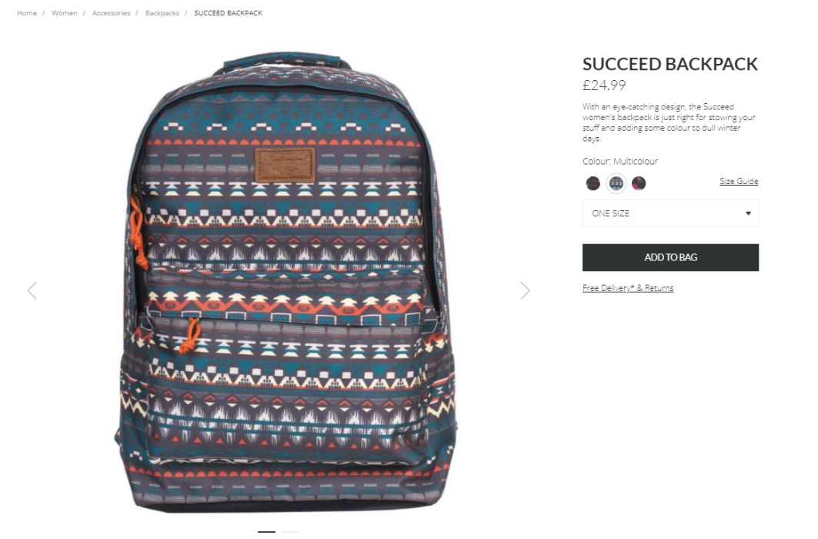

* + 1. **Catalog categories**

A simple list of product, containing 4 products per line. Each product has its name, size and price.

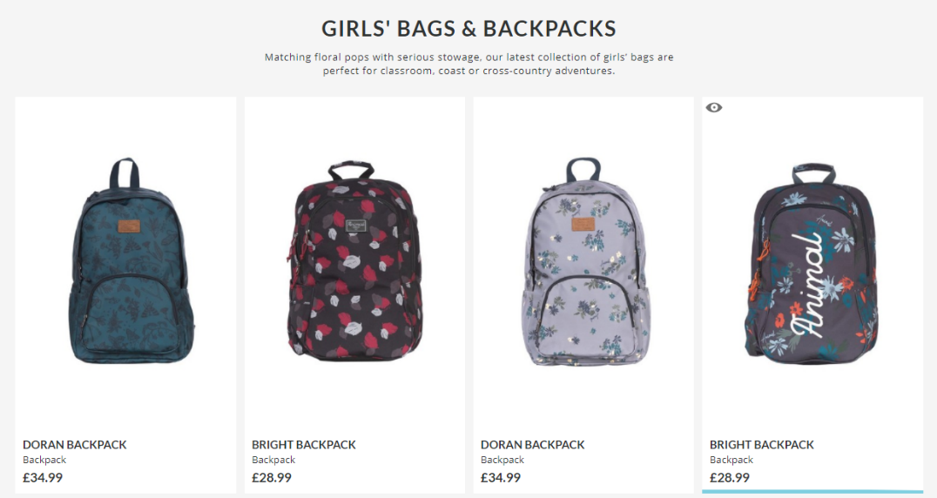

* 1. **Functional requirement specification**
     1. **Use Case 1 (Accessing the system)**

The system is accessed through the internet from its initial URL. It loads header, navigation bar and a home page.

* + 1. **Use Case 2 (Navigation bar)**

The navigation bar has navigational hyperlinks to the Home, Product categories (Men, Women, Boys, etc.), Store finder, Login and Registration option. It should also have navigation to the Checkout and Search.

* + 1. **Use Case 3 (Home page)**

The home page shows the links to products' collections in the following order from the left to the right (there are two collection links on each row): Shop Men's Collection, Shop Women's Collection, Shop Boys' Collection, Shop Girls' Collection. Clicking on the banners leads to the relevant category with products. Featured products section should be available below.

* + 1. **Use Case 4 (Products Category Page)**

Information regarding the sub-categories is shown as links (e.g. Jeans, T-Shirts) in the navigation pane, where user can choose where to go next. Below the banner, there are filter and sort options. Filtering can be done by:

* Size
* Color
* Price

Sorting can be done by:

* Price (ascending and descending)
* Name (ascending and descending)
* Best Sellers

When a filter is applied (sub-category) the page should display the respective products found. When a specific sorting option is requested, the respective sorting should be displayed.

* + 1. **Use Case 5 (My account)**

Clicking on the My Account hyperlink from the header navigates to the My account page. Page lists the available sections:

* Personal Details
* Address Book
* Order History
* Saved Items
  + 1. **Use Case 6 (Search)**

Clicking on Search from in the header allows for product finds by given keywords. If we have such products, we should show a list with the results. If no product is found, we should display error message stating that ***"We searched high and low. Sorry, no matches found for {search input}"***.

## Tasks

* Use the manual tests you have written during the previous workshop or create enough new test cases to test the functionalities described in the SRS.
* Automate as much of your manual test as you can using Selenium IDE.
* Save your tests in a file.
* Upload the file as a single zip file in the SoftUni website.

<https://www.animal.co.uk/>

[gkgfkyiotvieslwdby@tmmwj.net](mailto:gkgfkyiotvieslwdby@tmmwj.net)

12345678