Capstone Project: Customer Behaviour and Retention Analytics
Eliud Mule
2026-03-24

Set Working Directory
# setwd("C:/Users/ADMIN/OneDrive/Desktop/Eliud/R")

Phase1:Data Understanding and Cleaning
# Load necessary libraries
library(dplyr)
library(tidyverse)
library(rio)
library(psych)
# Load the dataset
data <- read.csv("customerData.csv")
head(data)
customer_id age gender education employment_status annual_income
1 1 43 Male High School Employed 36939.42
2 2 36 Male Diploma Self-Employed 40943.14
3 3 45 Male PhD Employed 81559.11
4 4 56 Male Bachelor Employed 53075.37
5 5 35 Female Diploma Employed 46630.28
6 6 35 Male Bachelor Employed 45729.72
marital_status number_of_children region annual_spending credit_score
1 Married 3 Suburban 9034.57 439
2 Married 0 Suburban 7949.83 446
3 Married 2 Urban 34276.90 527
4 Single 0 Urban 19219.62 498
5 Married 1 Rural 10544.99 488
6 Single 0 Rural 13366.91 442
loyalty_years payment_type online_shopper churn
1 19 Debit Card No No
2 9 Mobile Money No No
3 18 Credit Card Yes No
4 35 Credit Card No No
5 15 Debit Card No No
6 16 Debit Card Yes No

Data Structure and Summary Statistics
str(data)
'data.frame': 10000 obs. of 15 variables:
$ customer_id : int 1 2 3 4 5 6 7 8 9 10 ...
$ age : int 43 36 45 56 35 35 56 47 32 44 ...
$ gender : chr "Male" "Male" "Male" "Male" ...
$ education : chr "High School" "Diploma" "PhD" "Bachelor" ...
$ employment_status : chr "Employed" "Self-Employed" "Employed" "Employed" ...
$ annual_income : num 36939 40943 81559 53075 46630 ...
$ marital_status : chr "Married" "Married" "Married" "Single" ...
$ number_of_children: int 3 0 2 0 1 0 5 1 1 2 ...
$ region : chr "Suburban" "Suburban" "Urban" "Urban" ...
$ annual_spending : num 9035 7950 34277 19220 10545 ...
$ credit_score : int 439 446 527 498 488 442 515 383 432 379 ...
$ loyalty_years : int 19 9 18 35 15 16 36 22 7 18 ...
$ payment_type : chr "Debit Card" "Mobile Money" "Credit Card" "Credit Card" ...
$ online_shopper : chr "No" "No" "Yes" "No" ...
$ churn : chr "No" "No" "No" "No" ...
describe(data)
vars n mean sd median trimmed mad min
customer_id 1 10000 5000.50 2886.90 5000.50 5000.50 3706.50 1
age 2 10000 37.73 11.45 37.00 37.48 11.86 18
gender* 3 10000 1.48 0.50 1.00 1.47 0.00 1
education* 4 10000 2.39 1.20 2.00 2.30 1.48 1
employment_status* 5 10000 1.70 1.00 1.00 1.50 0.00 1
annual_income 6 10000 43632.35 23346.70 42386.12 42858.75 24540.74 5000
marital_status* 7 10000 1.38 0.48 1.00 1.34 0.00 1
number_of_children 8 10000 1.03 1.42 0.00 0.76 0.00 0
region* 9 10000 2.30 0.78 3.00 2.37 0.00 1
annual_spending 10 10000 15281.57 9541.26 14169.99 14585.07 9582.87 1000
credit_score 11 10000 461.78 59.55 460.00 460.84 60.79 300
loyalty_years 12 10000 15.64 11.17 15.00 14.97 11.86 0
payment_type* 13 10000 2.44 0.92 2.00 2.43 1.48 1
online_shopper* 14 10000 1.53 0.50 2.00 1.54 0.00 1
churn* 15 10000 1.10 0.30 1.00 1.00 0.00 1
max range skew kurtosis se
customer_id 10000.00 9999.00 0.00 -1.20 28.87
age 70.00 52.00 0.22 -0.43 0.11
gender* 2.00 1.00 0.09 -1.99 0.00
education* 5.00 4.00 0.43 -0.82 0.01
employment_status* 4.00 3.00 1.22 0.18 0.01
annual_income 123314.91 118314.91 0.31 -0.36 233.47
marital_status* 2.00 1.00 0.51 -1.74 0.00
number_of_children 5.00 5.00 1.32 0.78 0.01
region* 3.00 2.00 -0.58 -1.15 0.01
annual_spending 59228.89 58228.89 0.69 0.28 95.41
credit_score 693.00 393.00 0.15 -0.16 0.60
loyalty_years 52.00 52.00 0.42 -0.47 0.11
payment_type* 4.00 3.00 0.16 -0.80 0.01
online_shopper* 2.00 1.00 -0.14 -1.98 0.00
churn* 2.00 1.00 2.68 5.17 0.00
Conclusion: The dataset contains 10000 observations and 15 variables, i.e eight numerical variables and nine categorical variables.

Checking for Missing Values, Duplicates, and Data Inconsistencies
# Check for missing values
missing_values <- colSums(is.na(data))
print(missing_values)
customer_id age gender education
0 0 0 0
employment_status annual_income marital_status number_of_children
0 0 0 0
region annual_spending credit_score loyalty_years
0 0 0 0
payment_type online_shopper churn
0 0 0
There are no missing values in the dataset, which indicates that the data is complete and ready for analysis.
# Check for duplicates
duplicates <- data[duplicated(data), ]
print(duplicates)
[1] customer_id age gender education
[5] employment_status annual_income marital_status number_of_children
[9] region annual_spending credit_score loyalty_years
[13] payment_type online_shopper churn
<0 rows> (or 0-length row.names)
There are no duplicate records in the dataset, which ensures that each observation is unique and contributes to the analysis without redundancy.
# Check for Data Inconsistencies
inconsistent_data <- data %>%
filter(age < 18 | age > 100 | annual_spending < 0 |loyalty_years < 0 |gender =="male" |gender == "female" )
print(inconsistent_data)
[1] customer_id age gender education
[5] employment_status annual_income marital_status number_of_children
[9] region annual_spending credit_score loyalty_years
[13] payment_type online_shopper churn
<0 rows> (or 0-length row.names)
There are no data inconsistencies in the dataset, which indicates that the data is clean and adheres to expected ranges and categories for the variables.

Detecting Outliers using Boxplot
# Boxplot for annual_spending
boxplot(data$annual_spending, main = "Boxplot of Annual Spending", ylab = "Annual Spending")
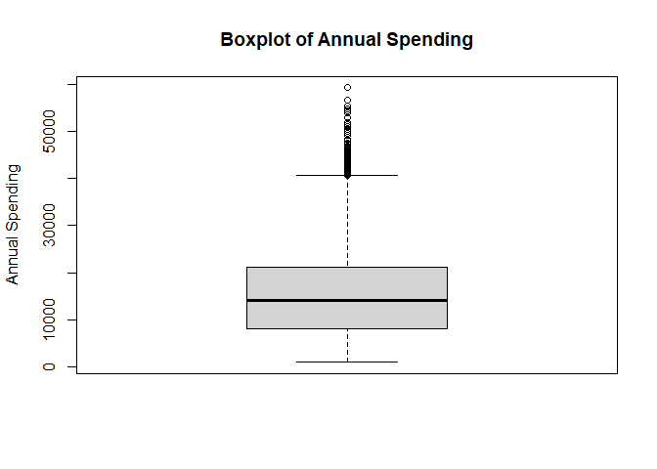 > The boxplot for annual spending reveals the presence of outliers, as indicated by the points that fall outside the whiskers of the boxplot.
# Boxplot for Credit Score
boxplot(data$credit_score, main = "Boxplot of Credit Score", ylab = "Credit Score")
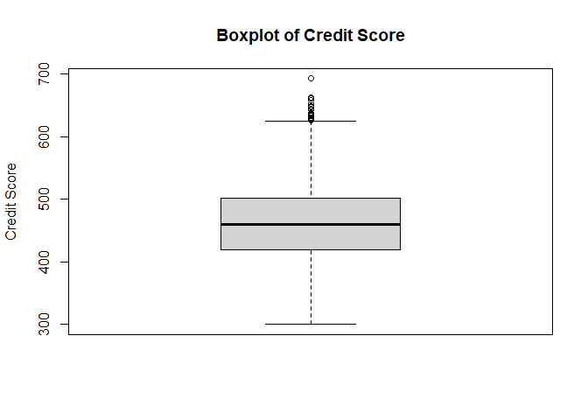 > The boxplot for credit score also indicates the presence of outliers, as there are points that lie outside the whiskers of the boxplot.

Handling Outliers
# Applying IQR method to remove outliers from annual_spending
Q1 <- quantile(data$annual_spending, 0.25)
Q3 <- quantile(data$annual_spending, 0.75)
IQR <- Q3 - Q1
lower_bound <- Q1 - 1.5 * IQR
upper_bound <- Q3 + 1.5 * IQR
data_cleaned <- data %>%
filter(annual_spending >= lower_bound & annual_spending <= upper_bound)
# Applying IQR method to remove outliers from credit_score
Q1_cs <- quantile(data$credit_score, 0.25)
Q3_cs <- quantile(data$credit_score, 0.75)
IQR_cs <- Q3_cs - Q1_cs
lower_bound_cs <- Q1_cs - 1.5 * IQR_cs
upper_bound_cs <- Q3_cs + 1.5 * IQR_cs
data_cleaned <- data_cleaned %>%
filter(credit_score >= lower_bound_cs & credit_score <= upper_bound_cs)

Visualize after removing outliers
boxplot(data_cleaned$credit_score, main = "Boxplot of Credit Score (Cleaned Data)", ylab = "Credit Score")
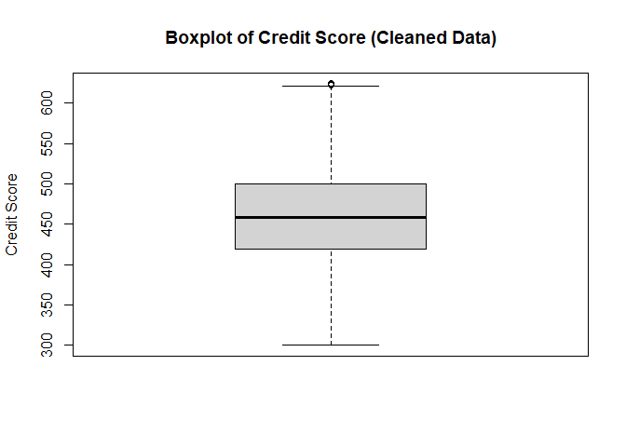
# Boxplot of cleaned data
boxplot(data_cleaned$annual_spending, main = "Boxplot of Annual Spending (Cleaned Data)", ylab = "Annual Spending")
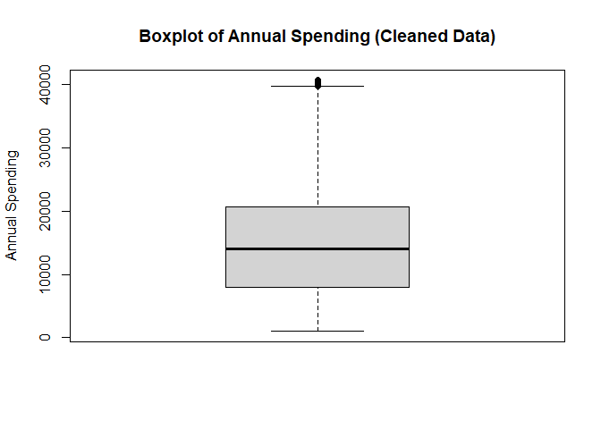

Phase 2: Preprocessing and Feature Engineering

Feature Engineering
# Create new features: Spending _to_income ratio,Customer Tenure,Financial_stability_score
data_cleaned <-data_cleaned %>% mutate( spending_to_income_ratio = annual_spending / annual_income, customer_tenure = loyalty_years*12, financial_stability_score = credit_score / annual_income)
head(data_cleaned)
customer_id age gender education employment_status annual_income
1 1 43 Male High School Employed 36939.42
2 2 36 Male Diploma Self-Employed 40943.14
3 3 45 Male PhD Employed 81559.11
4 4 56 Male Bachelor Employed 53075.37
5 5 35 Female Diploma Employed 46630.28
6 6 35 Male Bachelor Employed 45729.72
marital_status number_of_children region annual_spending credit_score
1 Married 3 Suburban 9034.57 439
2 Married 0 Suburban 7949.83 446
3 Married 2 Urban 34276.90 527
4 Single 0 Urban 19219.62 498
5 Married 1 Rural 10544.99 488
6 Single 0 Rural 13366.91 442
loyalty_years payment_type online_shopper churn spending_to_income_ratio
1 19 Debit Card No No 0.2445780
2 9 Mobile Money No No 0.1941676
3 18 Credit Card Yes No 0.4202706
4 35 Credit Card No No 0.3621194
5 15 Debit Card No No 0.2261404
6 16 Debit Card Yes No 0.2923025
customer_tenure financial_stability_score
1 228 0.011884323
2 108 0.010893156
3 216 0.006461571
4 420 0.009382883
5 180 0.010465303
6 192 0.009665487

Encoding Categorical Variables
# One-hot encoding for categorical variables
encoded_data <- model.matrix(~ . - 1, data = data_cleaned)
# Convert the encoded data to a data frame
encoded_data <- as.data.frame(encoded_data)
head(encoded_data)
customer_id age genderFemale genderMale educationDiploma educationHigh School
1 1 43 0 1 0 1
2 2 36 0 1 1 0
3 3 45 0 1 0 0
4 4 56 0 1 0 0
5 5 35 1 0 1 0
6 6 35 0 1 0 0
educationMaster educationPhD employment_statusSelf-Employed
1 0 0 0
2 0 0 1
3 0 1 0
4 0 0 0
5 0 0 0
6 0 0 0
employment_statusStudent employment_statusUnemployed annual_income
1 0 0 36939.42
2 0 0 40943.14
3 0 0 81559.11
4 0 0 53075.37
5 0 0 46630.28
6 0 0 45729.72
marital_statusSingle number_of_children regionSuburban regionUrban
1 0 3 1 0
2 0 0 1 0
3 0 2 0 1
4 1 0 0 1
5 0 1 0 0
6 1 0 0 0
annual_spending credit_score loyalty_years payment_typeCredit Card
1 9034.57 439 19 0
2 7949.83 446 9 0
3 34276.90 527 18 1
4 19219.62 498 35 1
5 10544.99 488 15 0
6 13366.91 442 16 0
payment_typeDebit Card payment_typeMobile Money online_shopperYes churnYes
1 1 0 0 0
2 0 1 0 0
3 0 0 1 0
4 0 0 0 0
5 1 0 0 0
6 1 0 1 0
spending_to_income_ratio customer_tenure financial_stability_score
1 0.2445780 228 0.011884323
2 0.1941676 108 0.010893156
3 0.4202706 216 0.006461571
4 0.3621194 420 0.009382883
5 0.2261404 180 0.010465303
6 0.2923025 192 0.009665487

Phase 3: Exploratory Data Analysis (EDA)

Univariate Analysis
# Histogram for annual_spending
ggplot(encoded_data, aes(x = annual_spending)) +
geom_histogram(binwidth = 500, fill = "steelblue", color = "black") +
labs(title = "Distribution of Annual Spending", x = "Annual Spending", y = "Frequency") +
theme_minimal()
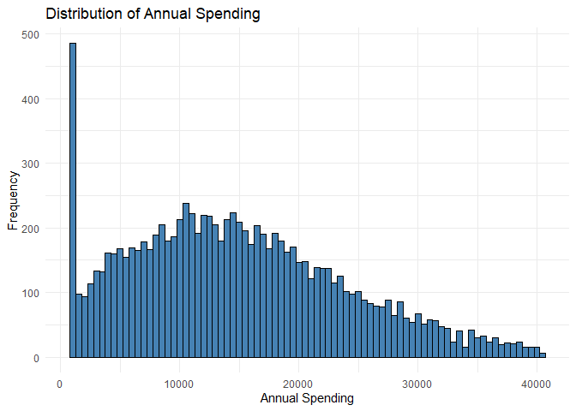 Interpretation: The histogram of annual spending shows a right-skewed distribution, indicating that most customers have lower annual spending, while a smaller number of customers have higher annual spending.
# Density plot for credit_score
ggplot(encoded_data, aes(x = credit_score)) +
geom_density(fill = "lightblue", color = "black") +
labs(title = "Density Plot of Credit Score", x = "Credit Score", y = "Density") +
theme_bw()
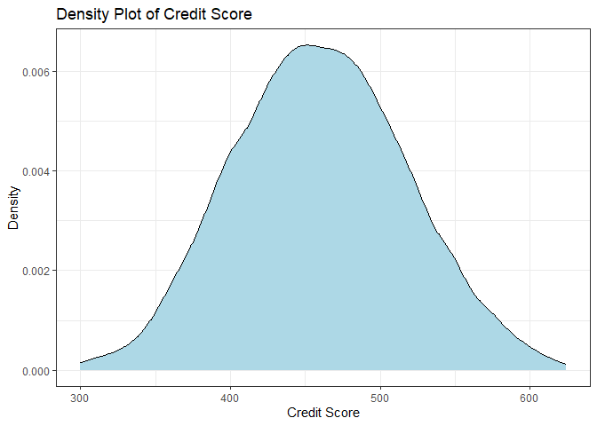
Interpretation: The density plot of credit score shows a unimodal distribution, with most customers having credit scores around the mean, and fewer customers having very low or very high credit scores.
# Frequency table for annual_income
#table(encoded_data$annual_income)
#prop.table(table(encoded_data$annual_income))
Interpretation: The frequency table for annual income shows that the majority of customers fall within the lower income brackets, with a smaller proportion of customers in the higher income brackets. This suggests that the customer base is predominantly composed of individuals with lower to moderate annual incomes.

Multivariate Analysis
# Boxplot of Spending by Region
ggplot(data_cleaned, aes(x = region, y = annual_spending)) +
geom_boxplot(fill = "lightgreen", color = "black") +
labs(title = "Boxplot of Annual Spending by Region", x = "Region", y = "Annual Spending") +
theme_classic()
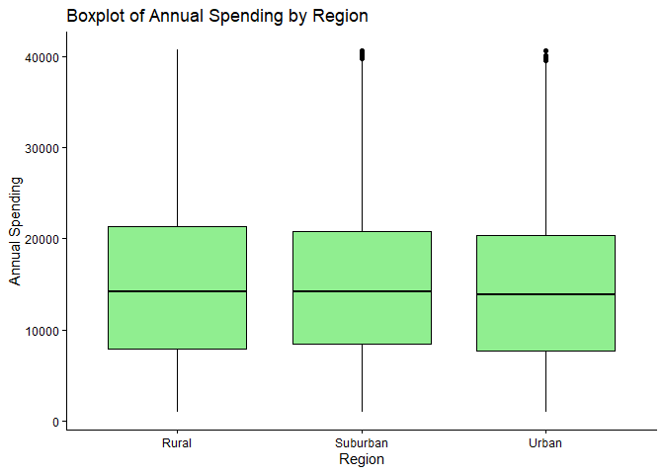 Interpretation:From the boxplot of annual spending by region above, we observe that there are no significant differences in annual spending across the different regions. The median annual spending and interquartile ranges appears to be relatively similar across all regions.However, there are some outliers in suburban and urban regions, indicating that there are a few customers with significantly higher or lower annual spending compared to the majority of customers in each region.
# Boxplot of Spending by employment_status
ggplot(data_cleaned, aes(x = employment_status, y = annual_spending)) +
geom_boxplot(fill = "lightcoral", color = "black") +
labs(title = "Boxplot of Annual Spending by Employment Status", x = "Employment Status", y = "Annual Spending") +
theme_classic()
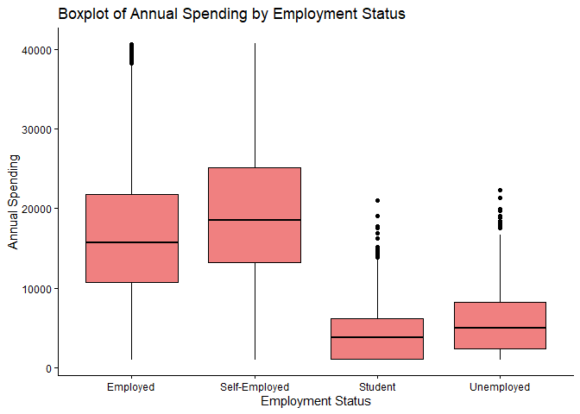 Interpretation: The boxplot of annual spending by employment status shows that there are significant differences in annual spending across different employment statuses.Self_Employed customers tend to have higher median annual spending compared to employed,student,unemployed and retired customers. Additionally, the interquartile range for employed customers is wider, indicating greater variability in annual spending among this group. Unemployed and student customers have lower median annual spending and narrower interquartile ranges, suggesting that they generally spend less annually compared to employed customers.Also, there are some outliers in the student, employed and unemployed categories, indicating that there are a few customers with significantly higher or lower annual spending compared to the majority of customers in each employment status.
#Scatterplot of income vs credit score by churn
ggplot(data_cleaned, aes(x = annual_income, y = credit_score, color = churn)) +
geom_point(size = 2) +
labs(title = "Scatterplot of Annual Income vs Credit Score by Churn", x = "Annual Income", y = "Credit Score") +
theme_minimal()
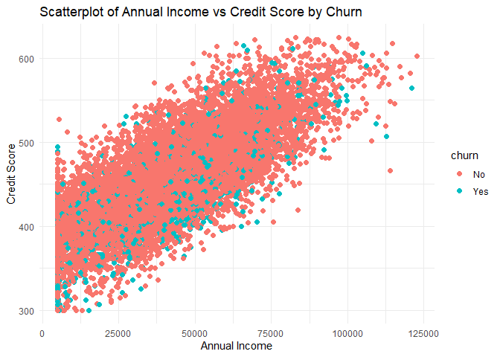 Interpretation: There is a moderate positive correlation between annual income and credit score, as customers with higher annual incomes tend to have higher credit scores. Additionally, non-churned customers generally have higher credit scores compared to churned customers, regardless of their annual income. This suggests that credit score may be a more important factor in customer retention than annual income.However,there is an overlap in the scatterplot, indicating that there are some churned customers with high credit scores and some non-churned customers with low credit scores, suggesting that income and credit score alone may not fully explain customer churn, and other factors may also play a role in customer retention.
#Scatterplot of income vs credit score by churn
ggplot(data_cleaned, aes(x = annual_income, y = credit_score, )) +
geom_point(size = 2,color ="yellow") +
facet_wrap(~churn) +
labs(title = "Scatterplot of Annual Income vs Credit Score by Churn", x = "Annual Income", y = "Credit Score") +
theme_minimal()
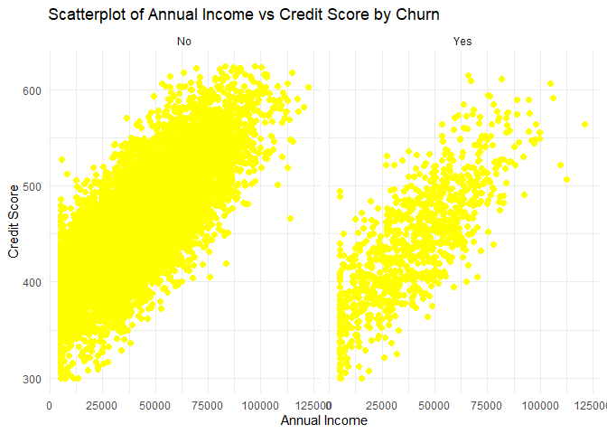 Interpretation: The scatterplot shows a positive correlation between annual income and credit score for both churned and non-churned customers. However, non-churned customers generally have higher credit scores compared to churned customers across all income levels. This suggests that credit score may be a more important factor in customer retention than annual income. Additionally, there is an overlap in the scatterplot, indicating that there are some churned customers with high credit scores and some non-churned customers with low credit scores, suggesting that income and credit score alone are not strong predictors of customer churn, and other factors may also play a role in customer retention.
# Correlation matrix for numerical variables
numeric_data <- data_cleaned %>%
select_if(is.numeric)
cor_matrix <- cor(numeric_data, use = "complete.obs")
print(cor_matrix)
customer_id age annual_income
customer_id 1.000000000 -0.009704517 -0.0038425507
age -0.009704517 1.000000000 -0.0110538281
annual_income -0.003842551 -0.011053828 1.0000000000
number_of_children -0.002927762 0.557208505 -0.0001300045
annual_spending -0.004386163 -0.003118750 0.8262650612
credit_score -0.020742182 0.377664676 0.7674681382
loyalty_years -0.002680103 0.966786523 -0.0101777735
spending_to_income_ratio -0.002176860 0.011493977 -0.1462322654
customer_tenure -0.002680103 0.966786523 -0.0101777735
financial_stability_score 0.001316877 0.057221604 -0.7121258574
number_of_children annual_spending credit_score
customer_id -0.0029277623 -0.004386163 -0.02074218
age 0.5572085054 -0.003118750 0.37766468
annual_income -0.0001300045 0.826265061 0.76746814
number_of_children 1.0000000000 -0.003968832 0.21194571
annual_spending -0.0039688317 1.000000000 0.63398094
credit_score 0.2119457147 0.633980935 1.00000000
loyalty_years 0.5479081079 -0.002820720 0.36427631
spending_to_income_ratio -0.0095231382 0.279847002 -0.11116109
customer_tenure 0.5479081079 -0.002820720 0.36427631
financial_stability_score 0.0213009278 -0.590141385 -0.49412265
loyalty_years spending_to_income_ratio
customer_id -0.002680103 -0.002176860
age 0.966786523 0.011493977
annual_income -0.010177773 -0.146232265
number_of_children 0.547908108 -0.009523138
annual_spending -0.002820720 0.279847002
credit_score 0.364276312 -0.111161092
loyalty_years 1.000000000 0.011790271
spending_to_income_ratio 0.011790271 1.000000000
customer_tenure 1.000000000 0.011790271
financial_stability_score 0.052120571 0.238181454
customer_tenure financial_stability_score
customer_id -0.002680103 0.001316877
age 0.966786523 0.057221604
annual_income -0.010177773 -0.712125857
number_of_children 0.547908108 0.021300928
annual_spending -0.002820720 -0.590141385
credit_score 0.364276312 -0.494122654
loyalty_years 1.000000000 0.052120571
spending_to_income_ratio 0.011790271 0.238181454
customer_tenure 1.000000000 0.052120571
financial_stability_score 0.052120571 1.000000000
# Heatmap of correlation matrix
library(corrplot)
corrplot(cor_matrix,
#title = "Pairwise Correlation Plot",
method = "color",
# type = "upper",
addCoef.col = "white",
tl.col = "black",
tl.srt = 45)
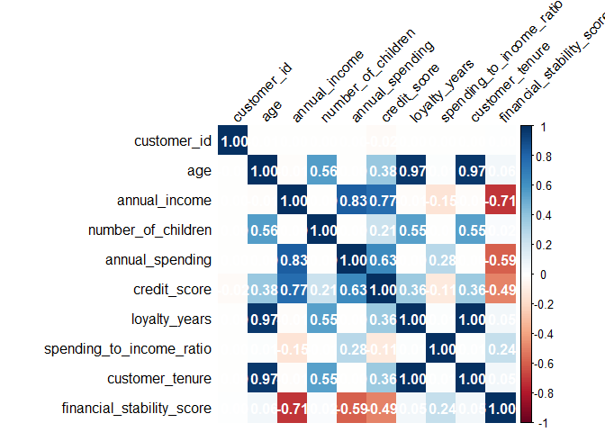 Interpretation: The correlation matrix and heatmap reveal several significant correlations among the numerical variables. Annual spending has a strong positive correlation with annual income (r = 0.83), indicating that customers with higher incomes tend to spend more annually. Additionally, there is a moderate positive correlation between credit score and annual spending (r = 0.63), suggesting that customers with higher spendings also tend to have better credit scores. However, there is a weak negative correlation between loyalty years and annual spending (r = -0.0028), indicating that customers who have been loyal for longer periods may spend slightly less annually. Overall, these correlations suggest that income and credit score are important factors influencing annual spending, while loyalty years have a less significant impact on spending behavior.

Phase 4: Descrriptive Statistics and Inference

Summary Statistics for spending across groups
# Summary statistics for annual_spending by region
data_cleaned %>%
group_by(region) %>%
summarise(mean_spending = mean(annual_spending),
median_spending = median(annual_spending),
sd_spending = sd(annual_spending),
IQR_spending = IQR(annual_spending))
# A tibble: 3 × 5
region mean_spending median_spending sd_spending IQR_spending
<chr> <dbl> <dbl> <dbl> <dbl>
1 Rural 15047. 14210. 9120. 13465.
2 Suburban 15142. 14180. 8949. 12448.
3 Urban 14658. 13847. 8930. 12677.
# Summary statistics for annual_spending by employment_status
data_cleaned %>%
group_by(employment_status) %>%
summarise(mean_spending = mean(annual_spending),
median_spending = median(annual_spending),
sd_spending = sd(annual_spending),
IQR_spending = IQR(annual_spending))
# A tibble: 4 × 5
employment_status mean_spending median_spending sd_spending IQR_spending
<chr> <dbl> <dbl> <dbl> <dbl>
1 Employed 16733. 15708. 7997. 10980.
2 Self-Employed 19442. 18512. 8277. 11904.
3 Student 4388. 3749. 3454. 5097.
4 Unemployed 5694. 4975. 4051. 5836.
# Summary statistics for annual_spending by education_level
data_cleaned %>%
group_by(education) %>%
summarise(mean_spending = mean(annual_spending),
median_spending = median(annual_spending),
sd_spending = sd(annual_spending),
IQR_spending = IQR(annual_spending))
# A tibble: 5 × 5
education mean_spending median_spending sd_spending IQR_spending
<chr> <dbl> <dbl> <dbl> <dbl>
1 Bachelor 17319. 17636. 8716. 12383.
2 Diploma 12334. 12243. 6635. 9343.
3 High School 9724. 9475. 5465. 7760.
4 Master 21101. 21852. 10104. 14333.
5 PhD 23284. 24431. 11448. 17848.

Confidence Intervals
conf_int <- t.test(data_cleaned$annual_spending)
print(conf_int)
One Sample t-test
data: data_cleaned$annual_spending
t = 164.54, df = 9850, p-value < 2.2e-16
alternative hypothesis: true mean is not equal to 0
95 percent confidence interval:
14703.63 15058.19
sample estimates:
mean of x
14880.91
- The mean annual spending is estimated to be approximately 14880.91 with a 95% confidence interval ranging from 14703.63 to 15058.19. The interval does not include zero,indicating statistical significance at the 5% level. In addition, the confidence interval is relatively narrow, suggesting a precise estimate of the mean annual spending for the customer base. This information can be valuable for business decision-making and strategic planning related to customer spending behavior.

Phase 5: Hypothesis Testing

Parametric Tests

Two-sample t-test
State the null and alternative hypotheses: - Null Hypothesis (H0): There is no significant difference in mean annual spending between churned and non-churned customers. - Alternative Hypothesis (H1): There is a significant difference in mean annual spending between churned and non-churned customers.
Assumptions for the two-sample t-test and A: 1. Independence: The observations in each group (churned and non-churned) are independent of each other. 2. Normality: The annual spending variable is approximately normally distributed within each group. 3. Homogeneity of Variances: The variances of annual spending are equal across the two groups.
# Two-sample t-test for annual_spending by churn
t_test_result <- t.test(annual_spending ~ churn, data = data_cleaned)
print(t_test_result)
Welch Two Sample t-test
data: annual_spending by churn
t = 4.3965, df = 1213.2, p-value = 1.196e-05
alternative hypothesis: true difference in means between group No and group Yes is not equal to 0
95 percent confidence interval:
734.7357 1918.8948
sample estimates:
mean in group No mean in group Yes
15013.71 13686.90
The two-sample t-test results indicate that there is a statistically significant difference in mean annual spending between churned and non-churned customers (p-value < 0.001). The mean annual spending for non-churned customers is higher than that of churned customers, suggesting that customers who do not churn tend to spend more annually compared to those who do churn. This finding can provide valuable insights for customer retention strategies, as it highlights the importance of targeting non-churned customers who have higher spending potential.

ANOVA with post-hoc Analysis
Assumptions for ANOVA: 1. Independence: The observations in each group (regions) are independent of each other. 2. Normality: The annual spending variable is approximately normally distributed within each group. 3. Homogeneity of Variances: The variances of annual spending are equal across the different regions.
State the null and alternative hypotheses: - Null Hypothesis (H0): There mean annual spendingis the same across different regions. - Alternative Hypothesis (H1): At least one region has a different mean annual spending compared to the others.
model_aov <- aov(annual_spending ~ region, data = data_cleaned)
summary(model_aov)
Df Sum Sq Mean Sq F value Pr(>F)
region 2 5.001e+08 250050644 3.105 0.0449 *
Residuals 9848 7.932e+11 80542332
---
Signif. codes: 0 '***' 0.001 '**' 0.01 '*' 0.05 '.' 0.1 ' ' 1
The reults above with an F-value of 3.105 and a p-value of 0.045 indicate that there is a statistically significant difference in mean annual spending across different regions although small. Therefore, we reject the null hypothesis, suggesting that regional location does have a small significant impact on customers’ annual spending behavior in this dataset.
# Effect size calculation (Eta Squared)
library(effectsize)
eta_squared_result <- eta_squared(model_aov)
print(eta_squared_result)
# Effect Size for ANOVA
Parameter | Eta2 | 95% CI
-----------------------------------
region | 6.30e-04 | [0.00, 1.00]
- One-sided CIs: upper bound fixed at [1.00].
The effectsize(Eta2) of 0.00063 indicates that only 0.063% of the variance in annual spending can be explained by the region variable, suggesting a very small effect size. This implies that while there is a statistically significant difference in mean annual spending across regions, the practical significance of this difference is minimal, and other factors may play a more substantial role in influencing customers’ annual spending behavior.
# Post-hoc analysis using Tukey's HSD test
tukey_result <- TukeyHSD(model_aov)
print(tukey_result)
Tukey multiple comparisons of means
95% family-wise confidence level
Fit: aov(formula = annual_spending ~ region, data = data_cleaned)
$region
diff lwr upr p adj
Suburban-Rural 94.51283 -515.2416 704.267238 0.9298237
Urban-Rural -389.76071 -946.9582 167.436817 0.2290295
Urban-Suburban -484.27354 -975.4612 6.914155 0.0543216
From the Tukey’s HSD test results, we can see that there is no statistically significant difference in mean annual spending between any pair of regions, as all p-values are greater than 0.05. This suggests that while the ANOVA indicated a significant difference across regions, the post-hoc analysis does not identify any specific pairs of regions that differ significantly from each other in terms of annual spending. Therefore, we can conclude that regional location does not have a significant impact on customers’ annual spending behavior in this dataset when comparing specific regions to each other.

Plot the post-hoc results
plot(tukey_result, las = 1, col = "blue", )
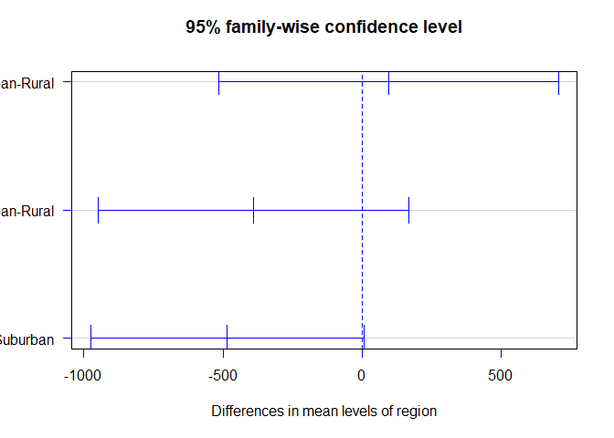

Non-Parametric Tests

Mann-Whitney U Test
Assumptions for Mann-Whitney U Test: 1. Independence: The observations in each group (marital statuses) are independent of each other. 2. Ordinal or Continuous Data: The dependent variable (annual spending) should be measured at an ordinal or continuous level. 3. Non-Normal Distribution: The Mann-Whitney U test does not assume normality of the data, making it suitable for non-normally distributed data or when the sample size is small.
State the null and alternative hypotheses: - Null Hypothesis (H0): There is no significant difference in the median annual spending between different marital statuses since the distibution of the two groups is identical. - Alternative Hypothesis (H1): There is a significant difference in the median annual spending between different marital statuses since the distribution of the two groups is not identical.
# Mann-Whitney U test for annual_spending by churn
mann_whitney_result <- wilcox.test(annual_spending ~ marital_status, data = data_cleaned)
print(mann_whitney_result)
Wilcoxon rank sum test with continuity correction
data: annual_spending by marital_status
W = 11265850, p-value = 0.3673
alternative hypothesis: true location shift is not equal to 0
The results with a p-value of 0.3673 indicate that there is no statistically significant difference in median annual spending between different marital statuses. Therefore, we fail to reject the null hypothesis, suggesting that marital status does not have a significant impact on customers’ annual spending behavior in this dataset.

Kruskal-Wallis Test
Assumptions for Kruskal-Wallis Test: 1. Independence: The observations in each group (regions) are independent of each other. 2. Ordinal or Continuous Data: The dependent variable (annual spending) should be measured at an ordinal or continuous level. 3. Non-Normal Distribution: The Kruskal-Wallis test does not assume normality of the data, making it suitable for non-normally distributed data or when the sample size is small.
State the null and alternative hypotheses: - Null Hypothesis (H0): There is no significant difference in the median annual spending across different regions since the distribution of annual spending is identical across all regions. - Alternative Hypothesis (H1): There is a significant difference in the median annual spending across different regions since the distribution of annual spending is not identical across all regions.
# Kruskal-Wallis test for annual_spending by region
kruskal_result <- kruskal.test(annual_spending ~ region, data = data_cleaned)
print(kruskal_result)
Kruskal-Wallis rank sum test
data: annual_spending by region
Kruskal-Wallis chi-squared = 5.7116, df = 2, p-value = 0.05751
The results with a p-value of 0.0575 indicate that there is no statistically significant difference in median annual spending across different regions at the 5% significance level. Therefore, we fail to reject the null hypothesis, suggesting that regional location does not have a significant impact on customers’ annual spending behavior in this dataset.

Chi-Square Test for Categorical Variables
Assumptions for Chi-Square Test: 1. Independence: The observations in the contingency table are independent of each other. 2. Expected Frequency: The expected frequency for each cell in the contingency table should be at least 5 to ensure the validity of the test. 3. Categorical Variables: Both variables being analyzed should be categorical in nature. 4.Sufficient Sample Size: The sample size should be sufficiently large to provide reliable results, typically with at least 20 observations per cell in the contingency table.
State the null and alternative hypotheses: - Null Hypothesis (H0): There is no association between customer churn and region, meaning that the distribution of churn is the same across all regions. - Alternative Hypothesis (H1): There is an association between customer churn and region, meaning that the distribution of churn differs across regions.
# Create contingency table for churn and region
contingency_table <- table(data_cleaned$churn, data_cleaned$region)
contingency_table
Rural Suburban Urban
No 1818 2632 4415
Yes 189 293 504
# Perform Chi-Square test
chi_square_result <- chisq.test(contingency_table)
print(chi_square_result)
Pearson's Chi-squared test
data: contingency_table
X-squared = 1.0877, df = 2, p-value = 0.5805
The results above with a p-value of 0.5805 indicate that there is no statistically significant association between customer churn and region. Therefore, we fail to reject the null hypothesis, suggesting that the distribution of churn is similar across all regions in this dataset. This implies that regional location does not have a significant impact on customer churn behavior.

Phase 6 :Regression Modelling

Simple Linear Regression
-State the null and alternative hypotheses: - Null Hypothesis (H0): There is no statistically significant effect of annual income on annual spending, meaning that the slope of the regression line is equal to zero. - Alternative Hypothesis (H1): There is a statistically significant effect of annual income on annual spending, meaning that the slope of the regression line is not equal to zero.
# Simple linear regression for annual_spending by annual_income
model1 <- lm(annual_spending ~ annual_income, data = encoded_data)
summary(model1)
Call:
lm(formula = annual_spending ~ annual_income, data = encoded_data)
Residuals:
Min 1Q Median 3Q Max
-19027.4 -3262.3 -152.7 3291.5 18042.4
Coefficients:
Estimate Std. Error t value Pr(>|t|)
(Intercept) 8.054e+02 1.093e+02 7.369 1.86e-13 ***
annual_income 3.285e-01 2.257e-03 145.576 < 2e-16 ***
---
Signif. codes: 0 '***' 0.001 '**' 0.01 '*' 0.05 '.' 0.1 ' ' 1
Residual standard error: 5057 on 9849 degrees of freedom
Multiple R-squared: 0.6827, Adjusted R-squared: 0.6827
F-statistic: 2.119e+04 on 1 and 9849 DF, p-value: < 2.2e-16

The Equation of the SLR Model
$$\hat{AnnualSpending}=805.4+0.3285×AnnualIncome$$
Interpretation: The simple linear regression model indicates that for every one unit increase in annual income, the annual spending is expected to increase by approximately 0.3285 units, holding all else constant. The intercept of 805.4 represents the estimated annual spending when annual income is zero, although this may not be a meaningful value in practice. The model is statistically significant (p-value < 0.001), suggesting that annual income is a significant predictor of annual spending in this dataset. However, the R-squared value of 0.6827 indicates that approximately 68.27% of the variance in annual spending can be explained by annual income while the adjusted R-squared value of 0.6827 suggests that the model has a good fit to the data, accounting for the number of predictors included in the model. Overall, this simple linear regression model provides valuable insights into the relationship between annual income and annual spending among customers in this dataset.

Residual Diagnostics
# Generate diagnostic plots
par(mfrow =c(2 ,2))
plot(model1)
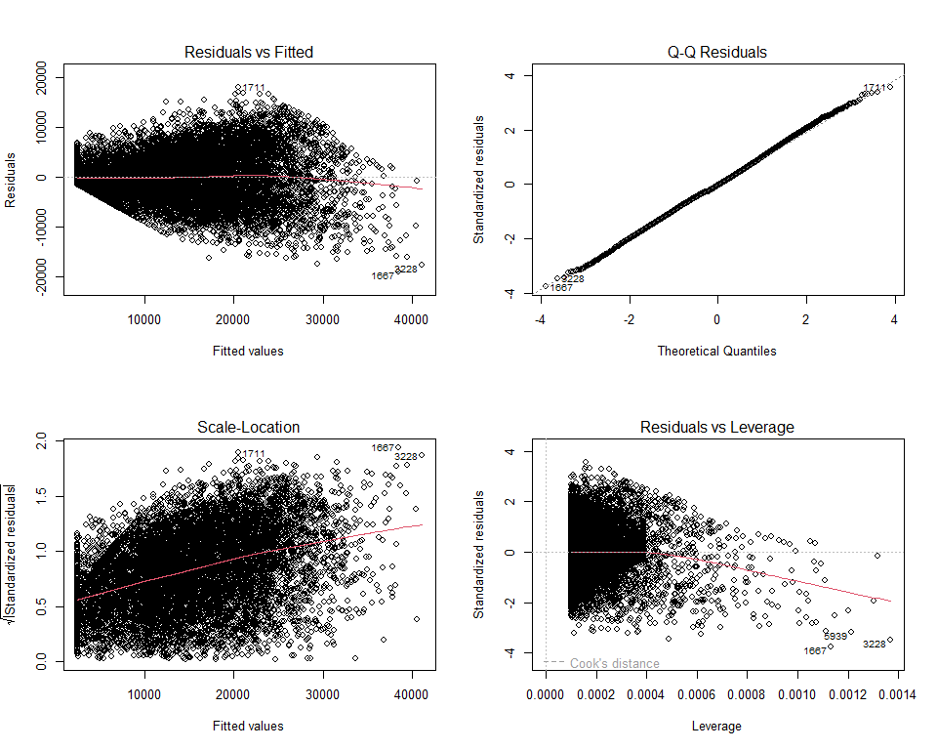
par(mfrow =c(1 ,1))
State the null and alternative hypotheses for linearity - Null Hypothesis (H0): The relationship between the independent variable (annual income) and the dependent variable (annual spending) is linear. - Alternative Hypothesis (H1): The relationship between the independent variable (annual income) and the dependent variable (annual spending) is not linear.
# Linearity Test
library(car)
linear_test <- linearHypothesis(model1, "annual_income = 0")
print(linear_test)
Linear hypothesis test:
annual_income = 0
Model 1: restricted model
Model 2: annual_spending ~ annual_income
Res.Df RSS Df Sum of Sq F Pr(>F)
1 9850 7.9368e+11
2 9849 2.5182e+11 1 5.4186e+11 21192 < 2.2e-16 ***
---
Signif. codes: 0 '***' 0.001 '**' 0.01 '*' 0.05 '.' 0.1 ' ' 1
The results with a p-value of < 0.05 indicate that we reject the null hypothesis, suggesting that there is non linearity in the relationship between annual income and annual spending.
State the null and alternative hypotheses for normality of residuals: - Null Hypothesis (H0): The residuals from the regression model are normally distributed. - Alternative Hypothesis (H1): The residuals from the regression model are not normally distributed.
#Anderson-Darling test for normality of residuals
library(nortest)
ad_test_result <- ad.test(model1$residuals)
print(ad_test_result)
Anderson-Darling normality test
data: model1$residuals
A = 4.7097, p-value = 1.156e-11
The results with a p-value of < 0.0001 indicate that we reject the null hypothesis, suggesting that the residuals from the regression model are not normally distributed.
# Normality of Residuals
qqnorm(model1$residuals, main = "Q-Q Plot of Residuals")
qqline(model1$residuals, col = "red")
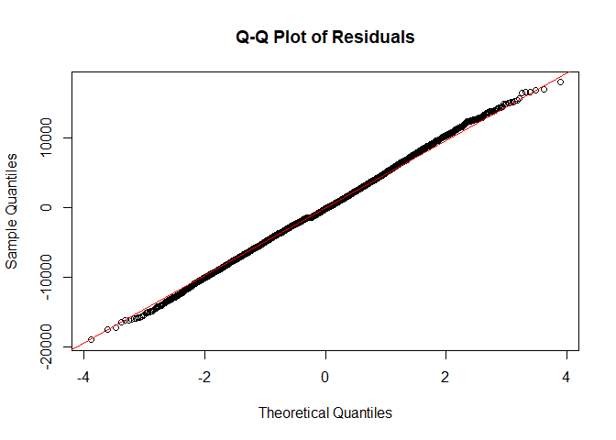
State the null and alternative hypotheses for homoscedasticity: - Null Hypothesis (H0): The residuals from the regression model have constant variance - Alternative Hypothesis (H1): The residuals from the regression model do not have constant variance, meaning that there is heteroscedasticity in the residuals.
# Breusch-Pagan test for homoscedasticity
library(lmtest)
bp_test_result <- bptest(model1)
print(bp_test_result)
studentized Breusch-Pagan test
data: model1
BP = 1516.2, df = 1, p-value < 2.2e-16
The results with a p-value of < 0.05 indicate that we reject the null hypothesis, suggesting that there is heteroscedasticity in the residuals of the regression model, meaning that the variance of the residuals is not constant across all levels of the independent variable (annual income).
# Homoscedasticity
plot(model1,which=3 )
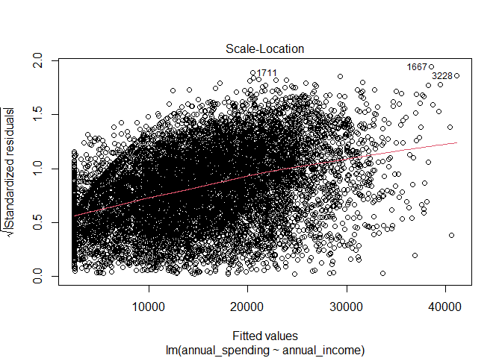
# Outliers and Influential Points
plot(model1, which = 4)
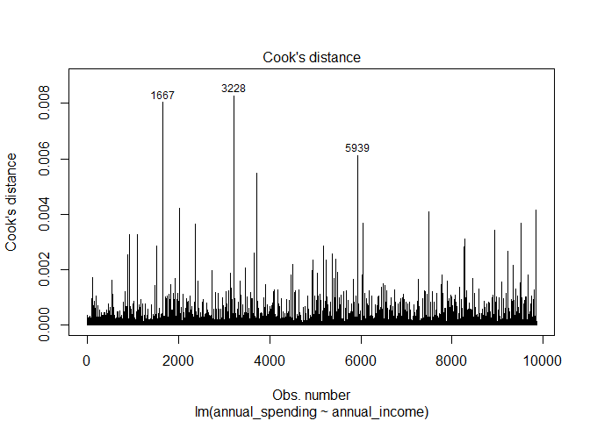 From the plot of residuals vs leverage, we can identify potential outliers and influential points in the regression model. Points that fall outside the dashed lines (Cook’s distance) may be considered influential, as they have a significant impact on the regression coefficients.
State the null and alternative hypotheses for the Durbin-Watson test:** - Null Hypothesis (H0): The residuals from the regression model are independent, meaning that there is no autocorrelation in the residuals. - Alternative Hypothesis (H1): The residuals from the regression model are not independent, meaning that there is autocorrelation in the residuals
# Independence of Residuals
library(lmtest)
dwtest(model1)
Durbin-Watson test
data: model1
DW = 2.0181, p-value = 0.8161
alternative hypothesis: true autocorrelation is greater than 0
- The Durbin-Watson test results with a p-value of 0.8161 indicate that we fail to reject the null hypothesis, suggesting that there is no significant autocorrelation in the residuals of the simple linear regression model. This implies that the assumption of independence of residuals is satisfied, and the model’s estimates are not biased due to autocorrelation.

Multiple Linear Regression
- State the null and alternative hypotheses:
- Null Hypothesis (H0): There is no statistically significant effect of the independent variables (annual income, credit score, loyalty years, age, region, employment status, and online shopper status) on annual spending, meaning that the coefficients of all independent variables are equal to zero.
- Alternative Hypothesis (H1): There is a statistically significant effect of at least one of the independent variables (annual income, credit score, loyalty years, age, region, employment status, and online shopper status) on annual spending, meaning that the coefficient of at least one independent variable is not equal to
model2 <- lm(annual_spending ~ annual_income + credit_score + loyalty_years + age + region + employment_status + online_shopper, data = data_cleaned)
summary(model2)
Call:
lm(formula = annual_spending ~ annual_income + credit_score +
loyalty_years + age + region + employment_status + online_shopper,
data = data_cleaned)
Residuals:
Min 1Q Median 3Q Max
-18824.5 -3273.9 -154.2 3292.0 18030.1
Coefficients:
Estimate Std. Error t value Pr(>|t|)
(Intercept) 1.065e+03 6.783e+02 1.571 0.116
annual_income 3.289e-01 4.594e-03 71.583 <2e-16 ***
credit_score -1.484e+00 1.723e+00 -0.862 0.389
loyalty_years -2.566e+00 1.792e+01 -0.143 0.886
age 1.053e+01 1.782e+01 0.591 0.555
regionSuburban 9.496e+01 1.467e+02 0.647 0.517
regionUrban 5.281e+01 1.349e+02 0.392 0.695
employment_statusSelf-Employed -6.278e+01 1.358e+02 -0.462 0.644
employment_statusStudent -2.618e+02 2.062e+02 -1.270 0.204
employment_statusUnemployed -2.290e+02 2.018e+02 -1.135 0.257
online_shopperYes 1.070e+02 1.043e+02 1.026 0.305
---
Signif. codes: 0 '***' 0.001 '**' 0.01 '*' 0.05 '.' 0.1 ' ' 1
Residual standard error: 5057 on 9840 degrees of freedom
Multiple R-squared: 0.6829, Adjusted R-squared: 0.6826
F-statistic: 2119 on 10 and 9840 DF, p-value: < 2.2e-16
Interpretation: The multiple linear regression model indicates that only annual income is a statistically significant predictor of annual spending (p-value < 0.001), while credit score, loyalty years, age, region, employment status, and online shopper status do not have a statistically significant effect on annual spending (p-values > 0.05). The coefficient for annual income suggests that for every one unit increase in annual income, the annual spending is expected to increase,es constant. The R-squared value of 0.6829 indicates that approximately 68.29% of the variance in annual spending can be explained by the independent variables included in the model, while the adjusted R-squared value of 0.6826 suggests that 68.26% of the variance in annual spending can be explained by annual income,credit score, loyalty years, age, region, employment status, and online shopper status, after adjusting for the number of predictors in the model. Overall, this multiple linear regression model provides insights into the factors influencing annual spending among customers in this dataset, with annual income being the most significant predictor.

Checking for Multicollinearity
library(car)
vif(model2)
GVIF Df GVIF^(1/(2*Df))
annual_income 4.143930 1 2.035664
credit_score 3.819963 1 1.954472
loyalty_years 15.335849 1 3.916101
age 15.945673 1 3.993203
region 1.029513 2 1.007298
employment_status 1.859912 3 1.108959
online_shopper 1.042344 1 1.020953
Interpretation: The VIF values for all predictors in the multiple linear regression model are below the commonly used threshold of 5, indicating that there is no significant multicollinearity among the independent variables. This suggests that the predictors are not highly correlated with each other, and the model can provide reliable estimates of the coefficients without concerns of inflated standard errors due to multicollinearity

