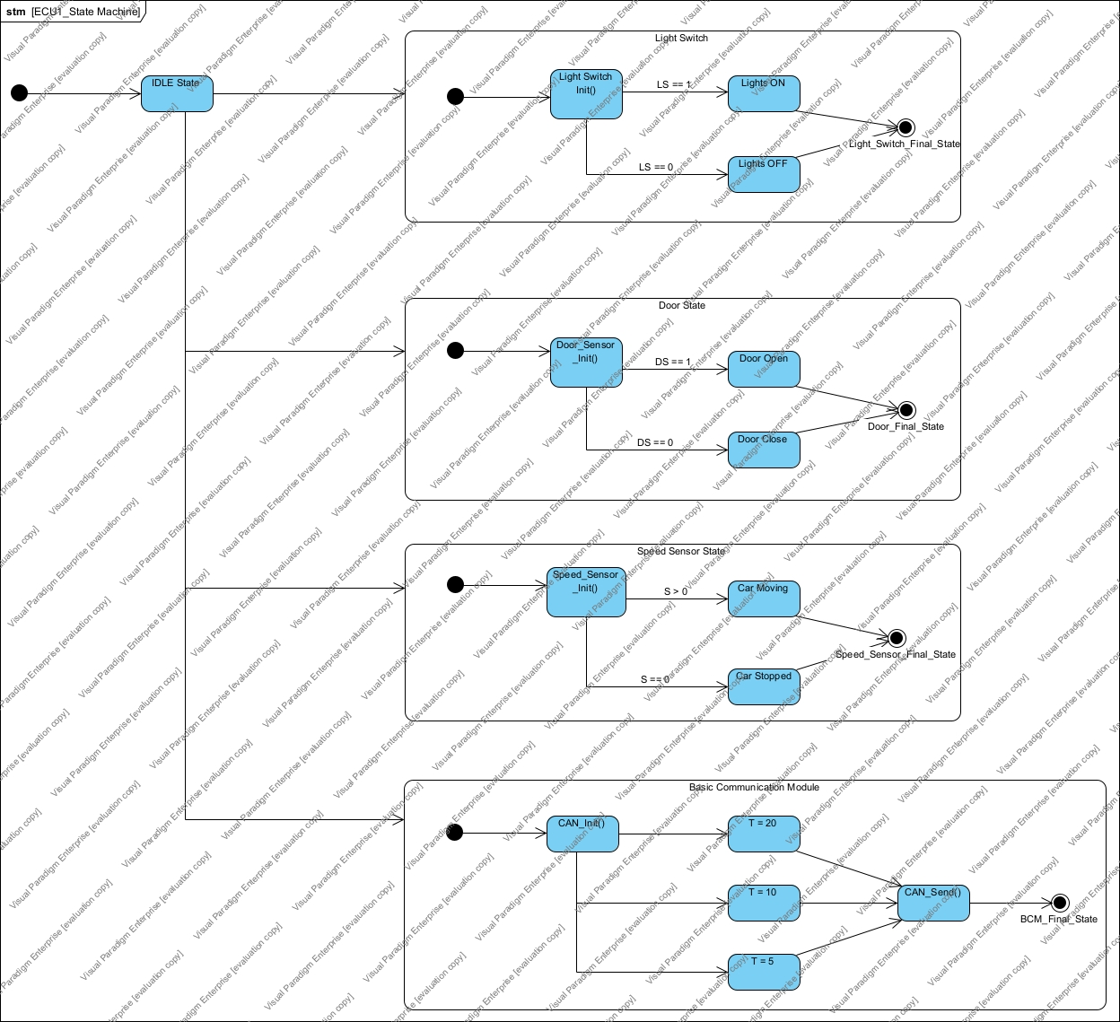**ECU1 State Machine Diagram**

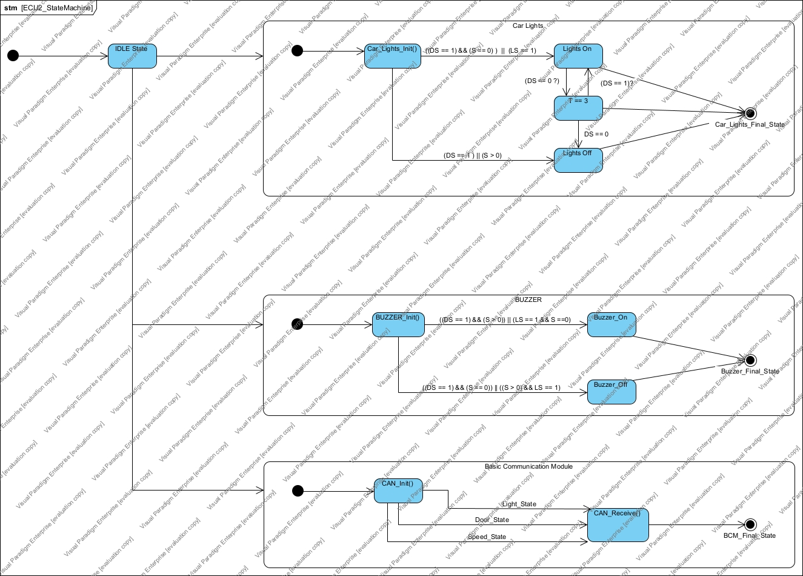**ECU2 State Machine Diagram**

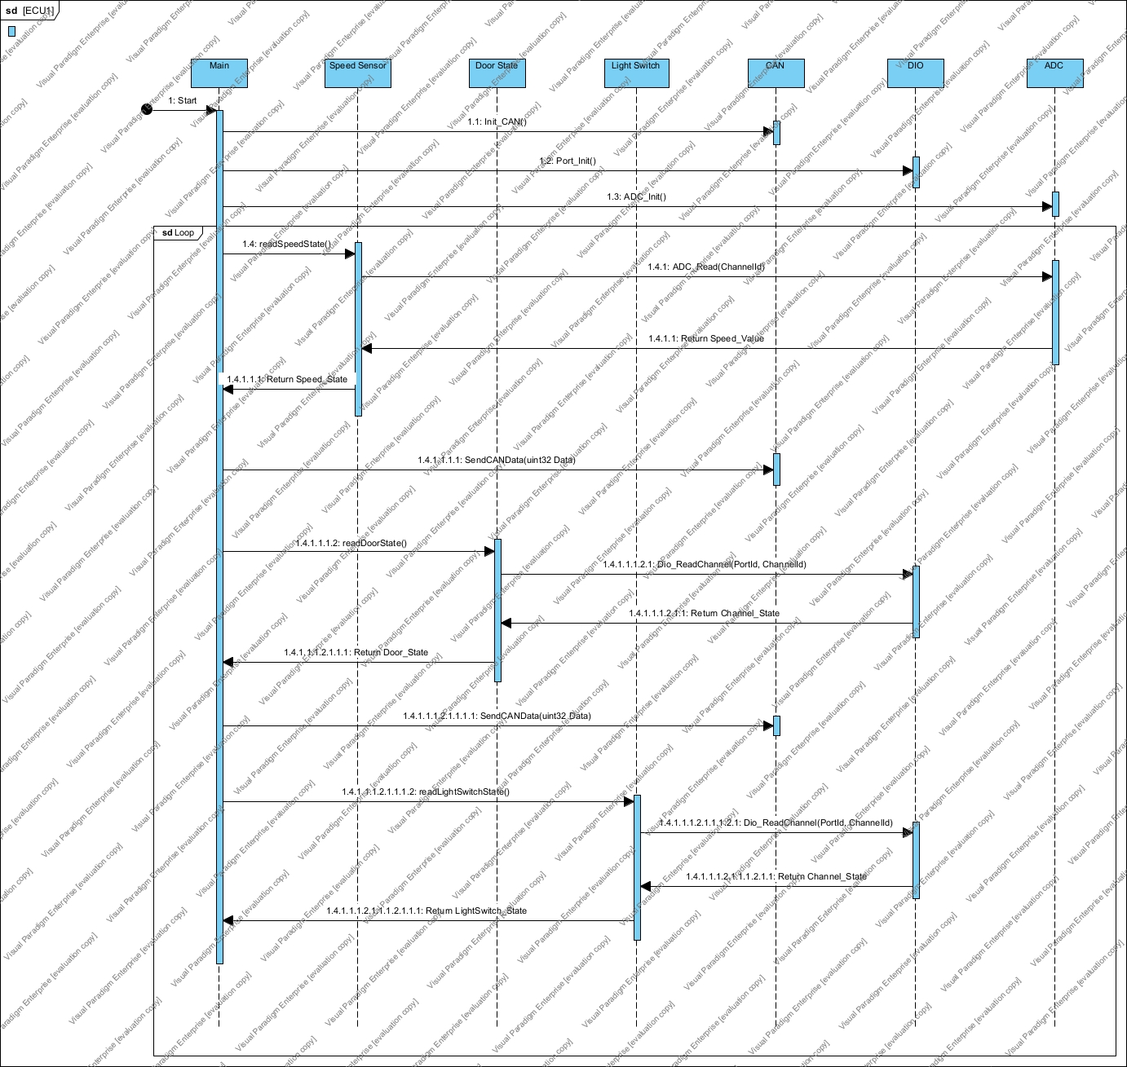**ECU1 Sequence Diagram**

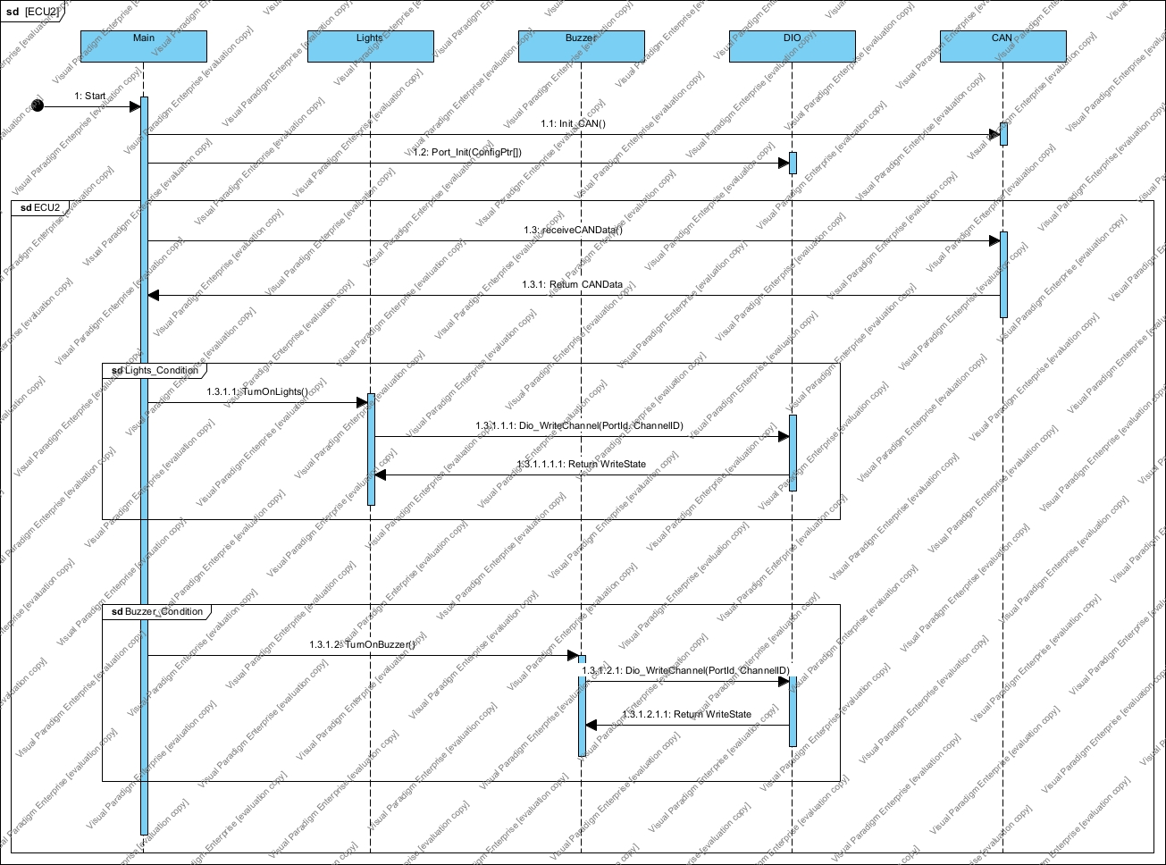**ECU2 Sequence Diagram**

**ECUs Calculations**

**ECU1 – CPU LOAD**

**Task1 (Speed State)**

Period = 5ms

Deadline = 5ms

Execution Time = 2ms Assumed

**Task1 (Door State)**

Period = 10ms

Deadline = 10ms

Execution Time = 1ms Assumed

**Task3 (Light Switch State)**

Period = 20ms

Deadline = 20ms

Execution Time = 1ms Assumed

Hyper Period is 20ms

So CPU load for ECU1 is = ((2 x 4) + (1 x 2) + (1 x 1)) / 20 = 0.55 x 100 = 55%

**ECU2 – CPU LOAD**

**Task1 (Buzzer State)**

Period = 5ms

Deadline = 5ms

Execution Time = 1ms Assumed

**Task3 (Lights State)**

Period = 10ms

Deadline = 10ms

Execution Time = 1ms Assumed

Hyper Period is 10ms

So CPU load for ECU2 is = ((1 x 2) + (1 x 1)) / 10 = 0.4 x 100 = 40%

**BUS LOAD**

**Door State Message**

1. Door state message will be sent every 10ms to ECU 2 The door state message contains one byte of data and a 11-bit identifier. Therefore, the total number of bits in each frame is 47 bits (1 start bit + 11-bit identifier + 1 RTR bit + 1 DLC byte + 8 data bits + 4 CRC bits + 1 ACK bit + 1 EOF bit).

The number of messages transmitted per second is 100 (since the message is sent every 10ms). Therefore, the total number of bits transmitted per second for the door state message is 4,700 bits (47 bits per message x 100 messages per second).

**Light Switch State Message**

1. Light switch state message will be sent every 20ms to ECU 2 The light switch state message also contains one byte of data and a 11-bit identifier. Therefore, the total number of bits in each frame is 47 bits.

The number of messages transmitted per second is 50 (since the message is sent every 20ms). Therefore, the total number of bits transmitted per second for the light switch state message is 2,350 bits (47 bits per message x 50 messages per second).

**Speed Sensor State Message**

1. Speed state message will be sent every 5ms to ECU 2 The speed state message contains two bytes of data and a 11-bit identifier. Therefore, the total number of bits in each frame is 59 bits (1 start bit + 11-bit identifier + 1 RTR bit + 1 DLC byte + 16 data bits + 4 CRC bits + 1 ACK bit + 1 EOF bit).

The number of messages transmitted per second is 200 (since the message is sent every 5ms). Therefore, the total number of bits transmitted per second for the speed state message is 11,800 bits (59 bits per message x 200 messages per second).

Total Bits per Second is = 4700 + 2350 + 9400 = 16450 bits

Finally, we can calculate the bus load as a percentage by dividing the total number of bits per second by the maximum number of bits per second (based on the bus baud rate) and multiplying by 100. Assuming a bus baud rate of 500 kbps:

Bus load = (16450 / 500000) x 100 = 3.29%

Therefore, the bus load in this scenario is 3.29%.