**HDFS High Availability — Enable/Disable**

Login to Cloudera Manager

On the homepage, click on HDFS

On HDFS’ page, click on Actions -> Enable High Availability

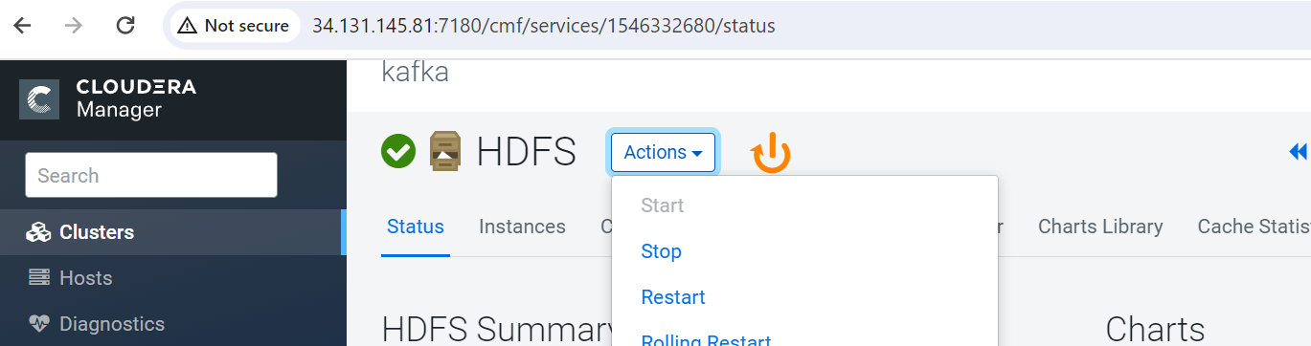

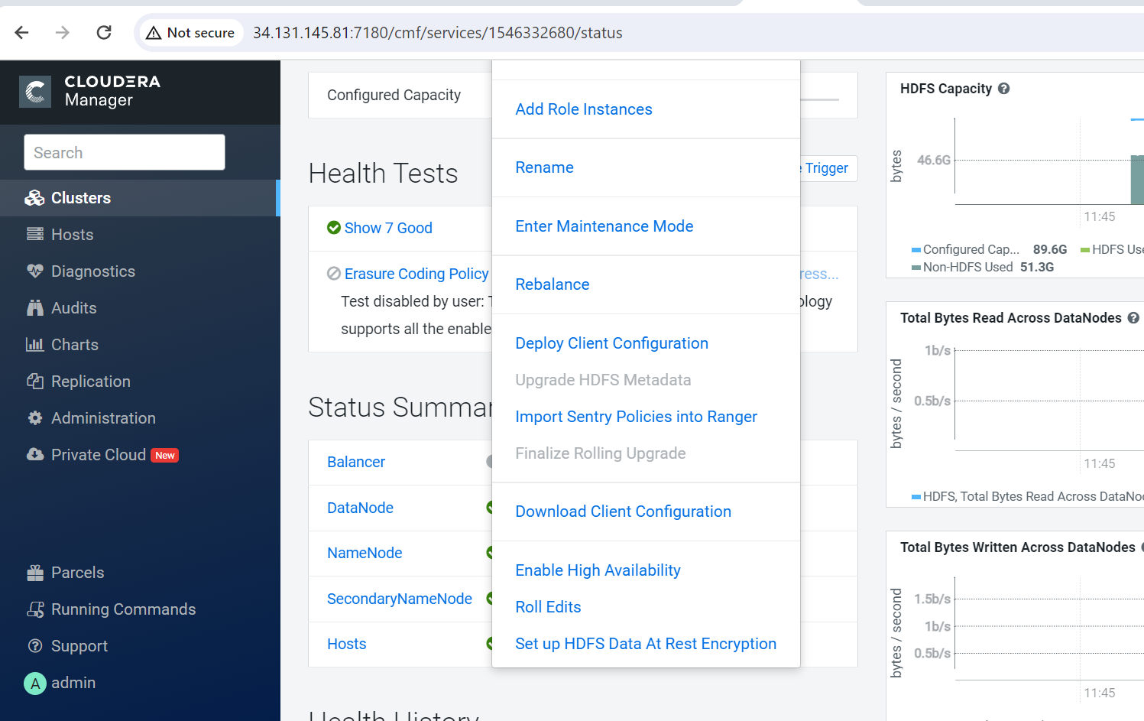

Add a generic name or leave as default

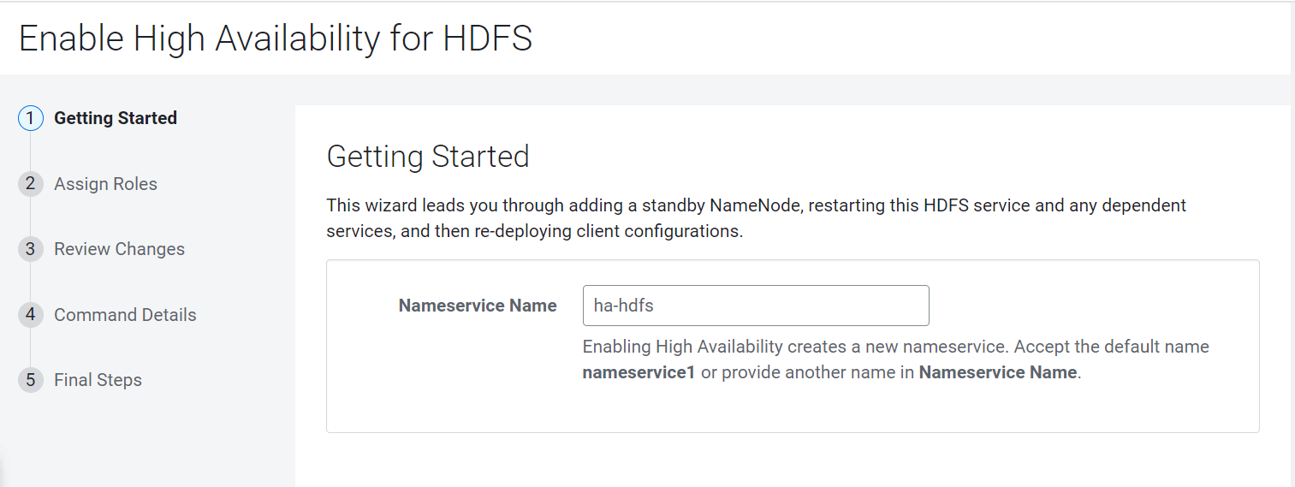

Select a new name node host and journal node host

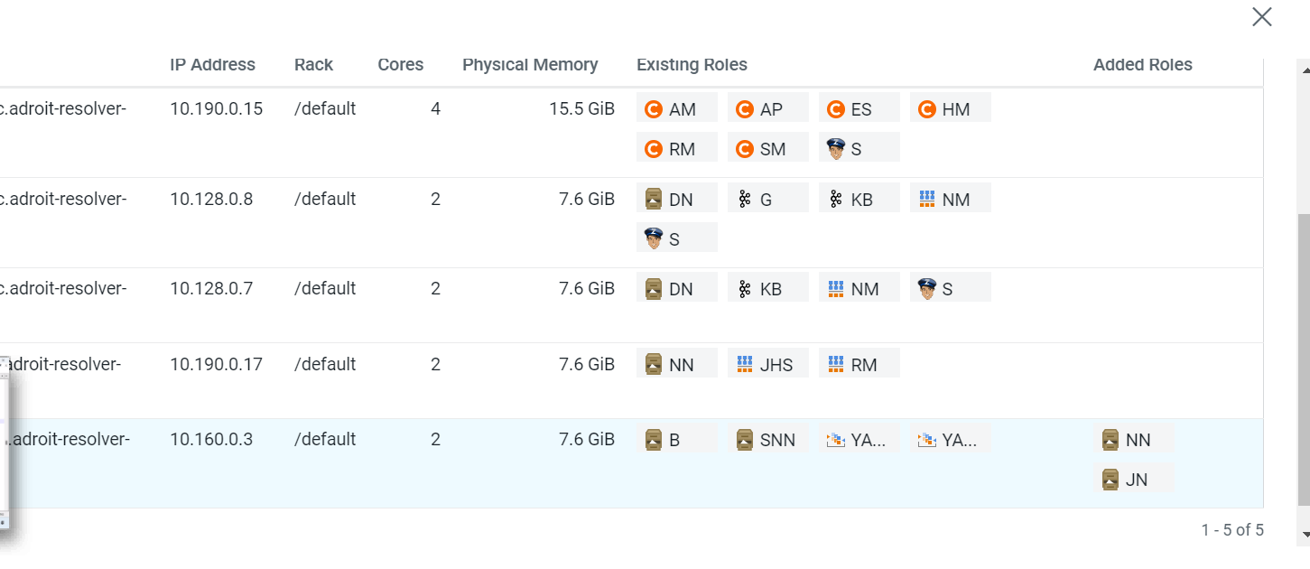

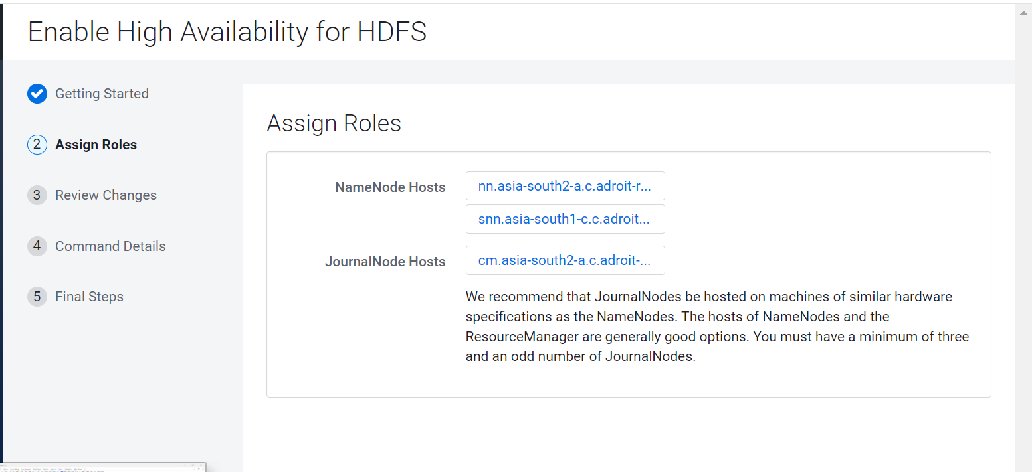

Add new locations for “journalnode” edits directory

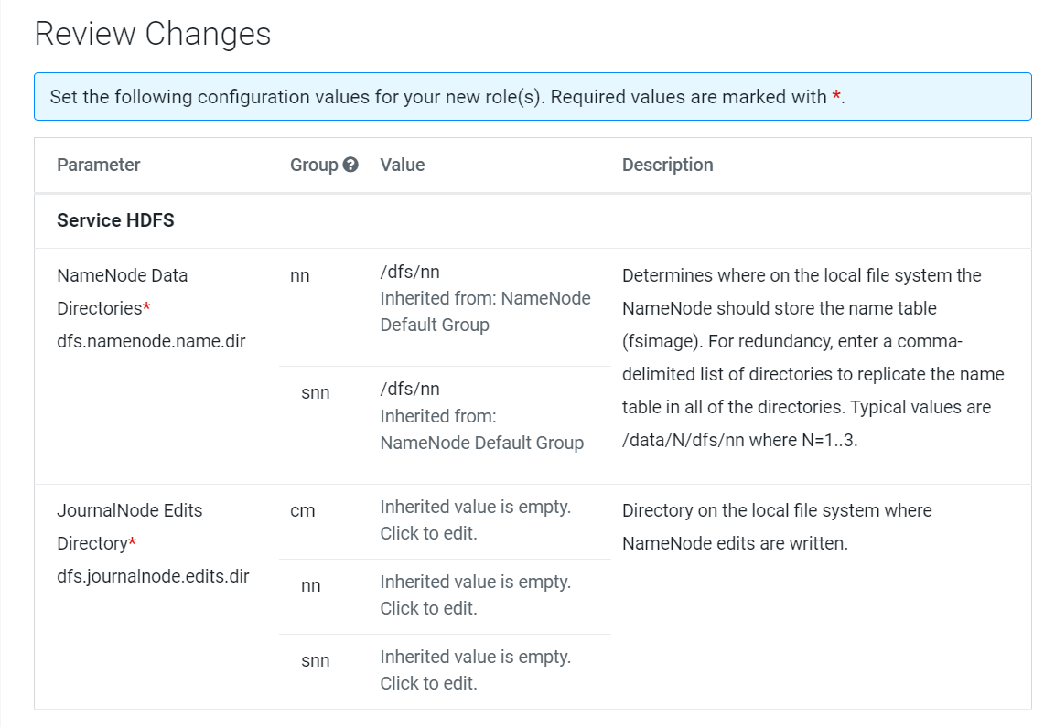

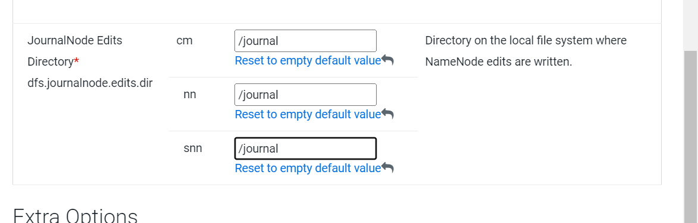

Commands are running to enable the HA

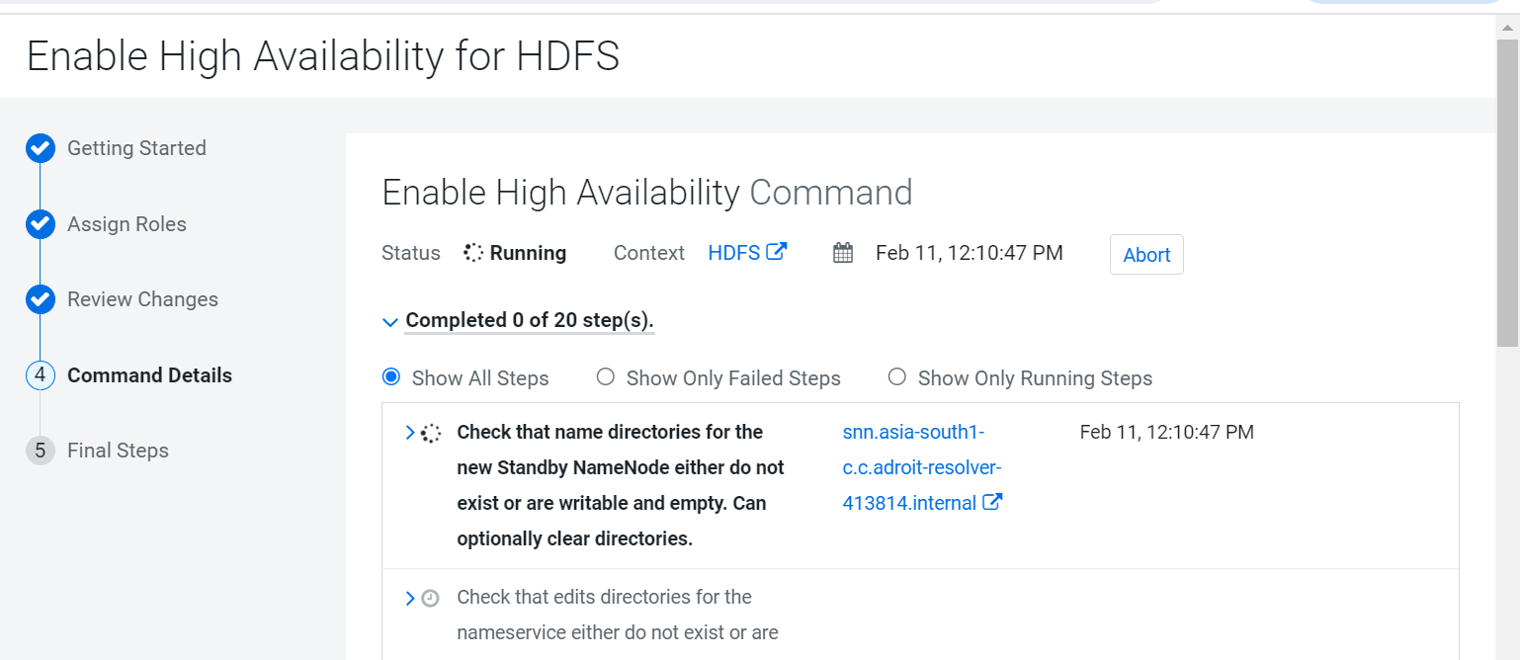

*Once the commands execute, navigate to HDFS’ page to find the Active and Stand by Name Node commissioned*

High Availability is enabled