|  |  |
| --- | --- |
| User Action | System Response |
| 1. User types in PIN into main screen | 1. System checks validity of PIN and presents options to user on another screen |
| 2.User selects withdraw money option | 2.System shows the options of selecting various amount on another screen |
| 3.User selects the amount to withdraw | 3. System checks the user account and shows processing message on another screen |
| 4.User takes the cash from machine | 3.Systems shows successfully withdrawn message on screen |

1.WITHDRAW_MONEY Use Case Description: Main Flow

2. Use Case Diagram for the ATM system

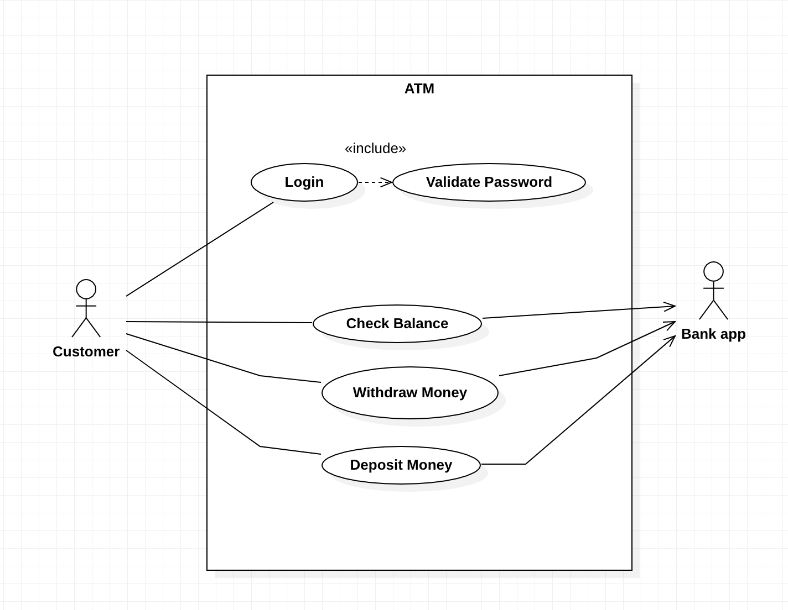

3.The Project Management Tracking System

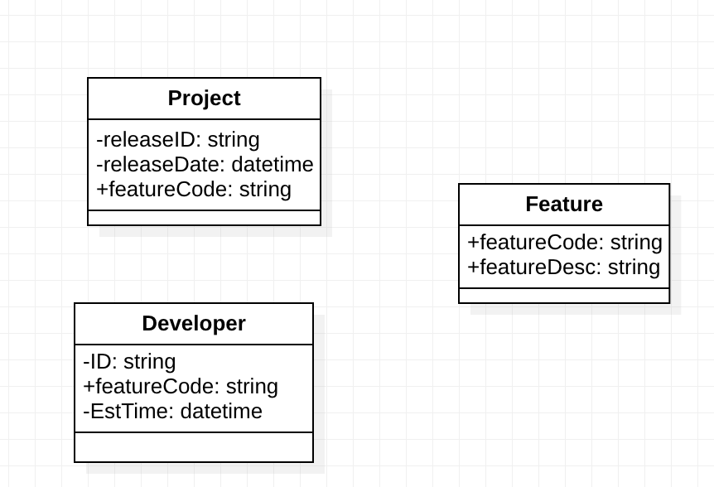

4. Properties Management System

