# Module 3 - Assignment 3

## Angelo, Elizabeth

### More Practice with Plots

library(tidyverse)

## ── Attaching packages ─────────────────────────────────────── tidyverse 1.3.1 ──

## ✔ ggplot2 3.3.5 ✔ purrr 0.3.4  
## ✔ tibble 3.1.6 ✔ dplyr 1.0.7  
## ✔ tidyr 1.1.4 ✔ stringr 1.4.0  
## ✔ readr 2.1.1 ✔ forcats 0.5.1

## ── Conflicts ────────────────────────────────────────── tidyverse_conflicts() ──  
## ✖ dplyr::filter() masks stats::filter()  
## ✖ dplyr::lag() masks stats::lag()

GOOG <- read_csv("~/Desktop/MIS 503/Module 3/GOOG.csv")

## Rows: 253 Columns: 7

## ── Column specification ────────────────────────────────────────────────────────  
## Delimiter: ","  
## dbl (6): Open, High, Low, Close, Adj Close, Volume  
## date (1): Date  
##   
## ℹ Use `spec()` to retrieve the full column specification for this data.  
## ℹ Specify the column types or set `show_col_types = FALSE` to quiet this message.

#### Google Stock Price Plots

The following is an analysis of Google’s stock price from October of 2019 to October of 2020. This will include a scatter, line, bar, histogram and boxplot. All the plots represent the closing price on the dates listed on the x-axis.

library(ggplot2)  
ggplot(GOOG, aes(x = Date, y = Close)) +  
 geom_point() +  
 labs(title = "Scatterplot of Google's Close Prices (Oct 2019 - Oct 2020)",  
 x = "Date",  
 y = "Close")

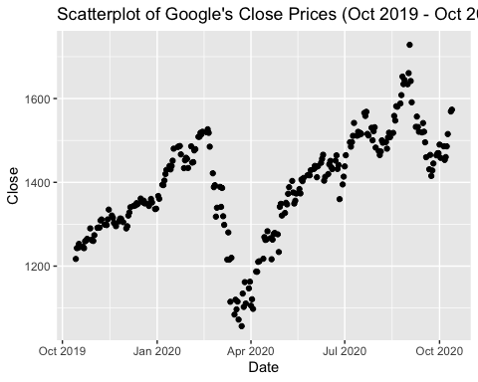

ggplot(GOOG, aes(x = Date, y = Close)) +  
 geom_line() +  
 labs(title = "Line Graph of Google's Close Prices (Oct 2019 - Oct 2020)",  
 x = "Date",  
 y = "Close")

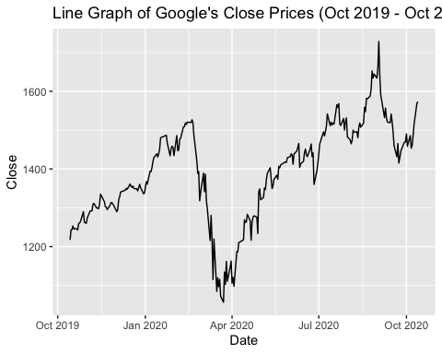

ggplot(GOOG, aes(x = Date, y = Close)) +  
 geom_col() +  
 labs(title = "Bar Graph of Google's Close Prices (Oct 2019 - Oct 2020)",  
 x = "Date",  
 y = "Close")

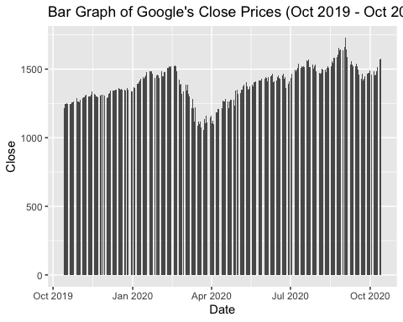

ggplot(GOOG, aes(x = Close)) +  
 geom_histogram(binwidth = 10, fill = "darkblue", color = "black", alpha = 0.7) +  
 labs(title = "Histogram of Google's Close Prices (Oct 2019 - Oct 2020)",  
 x = "Close",  
 y = "Frequency")

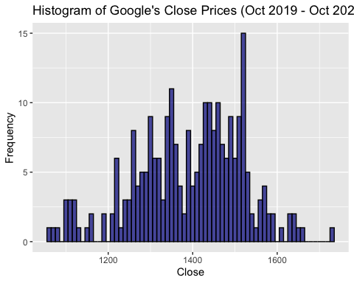

ggplot(GOOG, aes(x = Close)) +  
 geom_boxplot(fill = "red", color = "black", alpha = 0.7) +  
 labs(title = "Box Plot of Google's Close Prices (Oct 2019 - Oct 2020)",  
 x = "Close",  
 y = "Value")

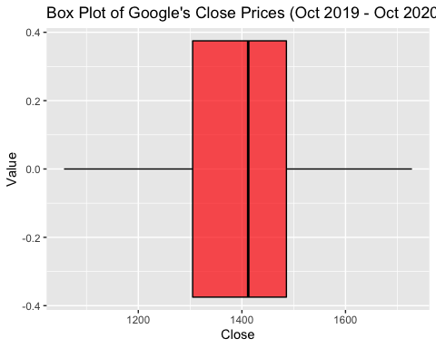

ggplot(GOOG, aes(x = Date, y = Close)) +  
 geom_line(color = "orange") +  
 geom_point(color = "brown", size = 0.5) +  
 labs(title = "Line Graph with Points of Google's Close Prices (Oct 2019 - Oct 2020)",  
 x = "Date",  
 y = "Close")

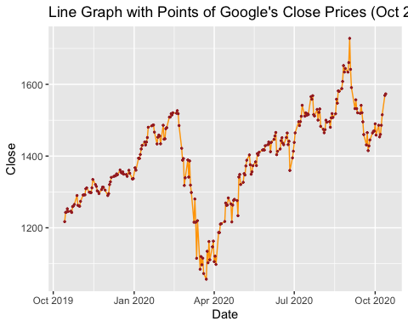

Based on the plots you created, which one do you find most useful and why?  
I found the line graph, and line graph with points to be the most useful. These two graphs give a clean, easy to analyze visual of the data set over the span of October 2019 to October 2020. The original line graph itself if very clean and easy on the eyes, allowing for a quick analysis. Whereas the line graph with plot points help to pinpoint specific areas of focus within the data, while also staying easy to read and analyze. I also am personally fond of having both variables “Date” and “Close” in the plot.

#### Google Stock Daily Price Comparisons

ggplot(GOOG) +  
 geom_line(aes(x = Date, y = High, color = "High")) +  
 geom_line(aes(x = Date, y = Low, color = "Low")) +  
 labs(title = "Line Graph of Google's High and Low Prices (Oct 2019 - Oct 2020)",  
 x = "Date",  
 y = "Price")

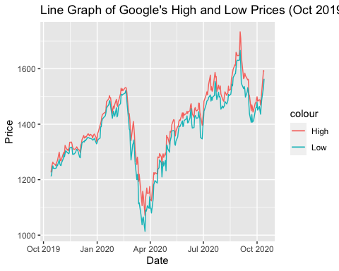

ggplot(GOOG, aes(x = Date, y = Close)) +  
 geom_area(color = "black", fill = "blue", alpha = 0.20)

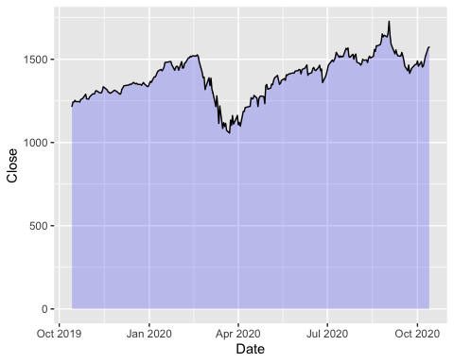

ggplot(GOOG, aes(x = Date, y = Open)) +  
 geom_area(color = "blue", fill = "green", alpha = 0.10)

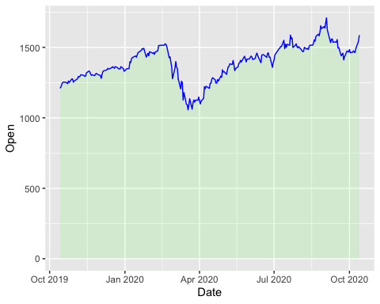

MayPrice <- subset(GOOG, Date > "2020-04-30" & Date < "2020-06-01")  
  
ggplot(MayPrice, aes(x = Date, y = Close)) +  
 geom_point() +  
 geom_text(aes(label = round(Close)), size = 3, vjust = -1)

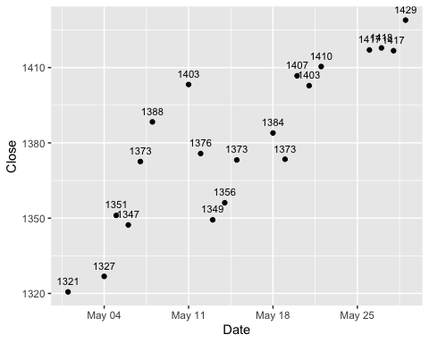

AprilPrice <- subset(GOOG, Date > "2020-04-01" & Date < "2020-04-30")  
ggplot(AprilPrice, aes(x = Date, y = Open)) +  
 geom_point() +  
 geom_text(aes(label = round(Open)), size = 2, vjust = 1.5)

