

Modelo de datos

Pregnancy Care

|  |  |  |  |
| --- | --- | --- | --- |
| Nombre del proyecto: |  | | |
| Alias del proyecto: | *Pregnancy Care* | | |
| Versión: | *2.0* | Fecha última  modificación: | *22/06/2017* |

**Diagrama Relacional**

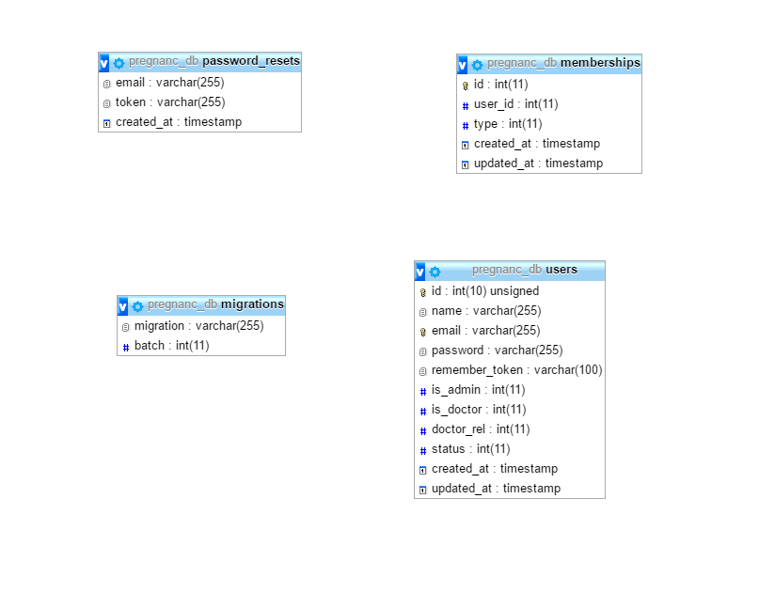

**Script de la base de datos**

--

-- Base de datos: `pregnanc_db`

--

-- --------------------------------------------------------

--

-- Estructura de tabla para la tabla `memberships`

--

CREATE TABLE `memberships` (

`id` int(11) NOT NULL,

`user_id` int(11) NOT NULL,

`type` int(11) NOT NULL,

`created_at` timestamp NULL DEFAULT NULL,

`updated_at` timestamp NULL DEFAULT NULL

) ENGINE=MyISAM DEFAULT CHARSET=latin1;

--

-- Estructura de tabla para la tabla `migrations`

--

CREATE TABLE `migrations` (

`migration` varchar(255) COLLATE utf8_unicode_ci NOT NULL,

`batch` int(11) NOT NULL

) ENGINE=MyISAM DEFAULT CHARSET=utf8 COLLATE=utf8_unicode_ci;

--

-- Estructura de tabla para la tabla `password_resets`

--

CREATE TABLE `password_resets` (

`email` varchar(255) COLLATE utf8_unicode_ci NOT NULL,

`token` varchar(255) COLLATE utf8_unicode_ci NOT NULL,

`created_at` timestamp NOT NULL DEFAULT CURRENT_TIMESTAMP ON UPDATE CURRENT_TIMESTAMP

) ENGINE=MyISAM DEFAULT CHARSET=utf8 COLLATE=utf8_unicode_ci;

-- --------------------------------------------------------

--

-- Estructura de tabla para la tabla `users`

--

CREATE TABLE `users` (

`id` int(10) UNSIGNED NOT NULL,

`name` varchar(255) COLLATE utf8_unicode_ci NOT NULL,

`email` varchar(255) COLLATE utf8_unicode_ci NOT NULL,

`password` varchar(255) COLLATE utf8_unicode_ci NOT NULL,

`remember_token` varchar(100) COLLATE utf8_unicode_ci DEFAULT NULL,

`is_admin` int(11) NOT NULL DEFAULT '0',

`is_doctor` int(11) NOT NULL DEFAULT '0',

`doctor_rel` int(11) DEFAULT NULL,

`status` int(11) NOT NULL DEFAULT '1',

`created_at` timestamp NULL DEFAULT NULL,

`updated_at` timestamp NULL DEFAULT NULL

) ENGINE=MyISAM DEFAULT CHARSET=utf8 COLLATE=utf8_unicode_ci;

ALTER TABLE `memberships`

ADD PRIMARY KEY (`id`);

--

-- Indices de la tabla `password_resets`

--

ALTER TABLE `password_resets`

ADD KEY `password_resets_email_index` (`email`),

ADD KEY `password_resets_token_index` (`token`);

--

-- Indices de la tabla `users`

--

ALTER TABLE `users`

ADD PRIMARY KEY (`id`),

ADD UNIQUE KEY `users_email_unique` (`email`);

--

-- AUTO_INCREMENT de las tablas volcadas

--

--

-- AUTO_INCREMENT de la tabla `memberships`

--

ALTER TABLE `memberships`

MODIFY `id` int(11) NOT NULL AUTO_INCREMENT, AUTO_INCREMENT=5;

--

-- AUTO_INCREMENT de la tabla `users`

--

ALTER TABLE `users`

MODIFY `id` int(10) UNSIGNED NOT NULL AUTO_INCREMENT, AUTO_INCREMENT=20;