CS 229 Machine Learning, spring 2020

Homework 2:

Bayesian Regression

Due Saturday February 29, 11:59pm

Submit by the **blackboard system**

The goal of this homework is to become familiar with the Bayesian Linear Regression. **Bishop’s text book about this part is attached in the end of this file.**

**Task 1 (2 points):**

Please show the derivation of the parameter **m**N and **S**N of theposterior distribution (p(**w**|**t**)=*N*(w| **m**N, **S**N)). See Eq (3.50) and (3.51) in the attached file.

**Code:**

Write your code by any programming languages and submit your results together with the programs.

**Task2 (8 points):**

Figure 1 gives an illustration of ***sequential Bayesian learning*** of a simple linear model of the form y(x,w)=w0+w1*x. Implement ***sequential Bayesian learning*;** show the results of **likelihood, prior/posterior, and examples in data space** in the same way as Figure 1.

Please read the attached description of this illustration from Bishop’s text book for more information.

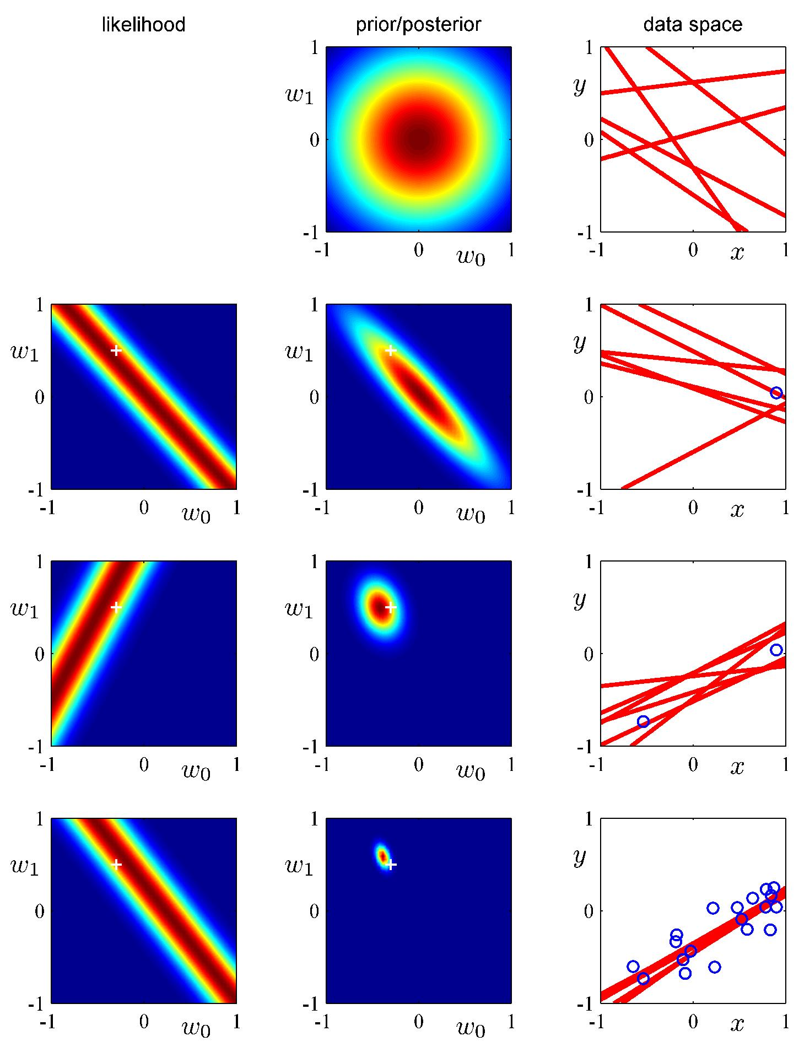

Figure 1 Illustration of sequential Bayesian learning of a simple linear model of the form y(x,w)=w0+w1*x