Elizabeth Yeo

May 19, 2021

ITFnd130

Assignment 6

**SQL View, Function, And Stored Procedure**

**Introduction**

Some issues we face as database engineers or builders is how overwhelming the data in a database can be. The rules of Normalization help to keep data organized in smaller tables that are related to each other. And as developers or engineers or builders, queries are written to retrieve that data. Even though it is possible to write to multiple queries, and joins, and various other statements, ultimately the data has to be retrieved at some point. A few ways of doing this is through views, functions, and stored procedures.

**When to Use a View**

To begin, “A VIEW in SQL Server is like a virtual table that contains data from one or multiple tables. It does not hold any data and does not exist physically in the database.” (SQLShack, [SQL View - A complete introduction and walk-through (sqlshack.com)](https://www.sqlshack.com/sql-view-a-complete-introduction-and-walk-through/) 2021). Since a view does not hold any data and does not exist in the database, when would it be used? “Views are used for security purposes in databases. Views restrict the user from viewing certain columns and rows.” (C#Corner, [Learning Views In SQL Server (c-sharpcorner.com)](https://www.c-sharpcorner.com/UploadFile/f0b2ed/views-in-sql-server/) 2021). Views are used to restrict specific users or people from having access to specific rows and columns of data that they do not need to see.

**Similarities and Differences Between View, Function, and Stored Procedure**

A Function in SQL “…is a subroutine or a small program that can be used again and again throughout the database…The return value can be a single value or a result set.” (JanBaskTraining, [Different Types of SQL Server & SQL Database Functions (janbasktraining.com)](https://www.janbasktraining.com/blog/different-types-sql-server-sql-database-functions/) 2021). The great thing about using Functions is, as stated above, they can be used again and again. Later in the code, they can be recalled however many times as needed (**Figure 1**).

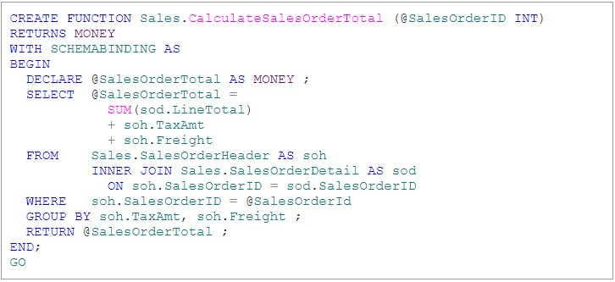

***Figure 1: Example of a Function***

A Stored Procedure in SQL “…is a prepared SQL code that you can save, so the code can be reused over and over again.” (w3schools, [SQL Stored Procedures (w3schools.com)](https://www.w3schools.com/sql/sql_stored_procedures.asp) 2021). The nice thing about Stored Procedures is, as stated above, we can save them and reuse them. It saves time on writing things out over and over again or perhaps a piece of code that has been written is flawlessly beautiful in how it executes and so we may want to use it repeatedly.

The primary difference between the View, Function, and Stored Procedure is in how they are used and what they are used for. The view allows us to restrict access to what is seen and it’s not a table that exists. A Function returns values in within a set of parameters. The Stored Procedure helps with unnecessary repetition and redundancy of code in a database. The main similarity between the three is that the data can be seen once we write and execute the code.

**Summary**

To refresh, views allow builders, engineers, and developers to restrict what type of data is seen by someone else. This is in a way a type of security measure when someone else has to work on the same code in the same database and prevents data from going missing. Both stored procedures and functions can be used again and again as needed. A function can be recalled but it is not saved to the database. The stored procedure can be saved to the databse.