CREATE TABLE CUSTOMER(CNAME VARCHAR(15)PRIMARY KEY,CITY VARCHAR(20)NOT NULL);

INSERT INTO CUSTOMER VALUES('ANIL','CALCUTTA');

INSERT INTO CUSTOMER VALUES('SUNIL','DELHI');

INSERT INTO CUSTOMER VALUES('MEHUL','BARODA');

INSERT INTO CUSTOMER VALUES('MANDAR','PATNA');

INSERT INTO CUSTOMER VALUES('MADHURI','NAGPUR');

INSERT INTO CUSTOMER VALUES('PRAMOD','NAGPUR');

INSERT INTO CUSTOMER VALUES('SANDIP','SURAT');

INSERT INTO CUSTOMER VALUES('SHIVANI','BOMBAY');

INSERT INTO CUSTOMER VALUES('KRANTI','BOMBAY');

INSERT INTO CUSTOMER VALUES('NAREN','BOMBAY');

SELECT \* FROM CUSTOMER;

OUTPUT

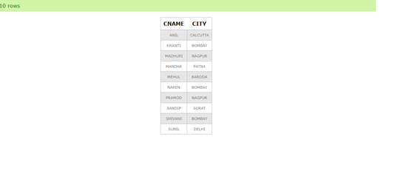

CREATE TABLE BRANCH(BNAME VARCHAR(20)PRIMARY KEY,CITY VARCHAR(30)CHECK(CITY IN('NAGPUR','DELHI','BANGALORE','BOMBAY'))NOT NULL);

INSERT INTO BRANCH VALUES('VRCE','NAGPUR');

INSERT INTO BRANCH VALUES('AJNI','NAGPUR');

INSERT INTO BRANCH VALUES('KAROLBAG','DELHI');

INSERT INTO BRANCH VALUES('CHANDI','DELHI');

INSERT INTO BRANCH VALUES('DHARAMPETH','NAGPUR');

INSERT INTO BRANCH VALUES('MG ROAD','BANGALORE');

INSERT INTO BRANCH VALUES('ANDHERI','BOMBAY');

INSERT INTO BRANCH VALUES('NEHRU PALACE','DELHI');

INSERT INTO BRANCH VALUES('POWAI','BOMBAY');

SELECT \* FROM BRANCH;

OUTPUT

