Experiment No:-1

create table branch (bname varchar(20) primary key, city varchar(30) not null check (city in('nagpur', 'delhi', 'bangalore', 'bombay')));

insert into branch (bname, city) values ('vrce', 'nagpur');

insert into branch (bname, city) values ('ajni', 'nagpur');

insert into branch (bname, city) values ('karolbagh', 'delhi');

insert into branch (bname, city) values ('chandni', 'delhi');

insert into branch (bname, city) values ('dharampeth', 'nagpur');

insert into branch (bname, city) values ('andheri', 'bombay');

insert into branch (bname, city) values ('mgroad', 'bangalore');

insert into branch (bname, city) values ('nehrupalace', 'delhi');

insert into branch (bname, city) values ('powai', 'bombay');

select \* from branch;

create table customer(cname varchar(15) primary key, city varchar(20) not null);

insert into customer (cname, city) values ('anil', 'calcutta');

insert into customer (cname, city) values ('sunil', 'delhi');

insert into customer (cname, city) values ('mehul', 'baroda');

insert into customer (cname, city) values ('mandar', 'patna');

insert into customer (cname, city) values ('madhuri', 'nagpur');

insert into customer (cname, city) values ('pramod', 'nagpur');

insert into customer (cname, city) values ('sandip', 'surat');

insert into customer (cname, city) values ('shivani', 'bombay');

insert into customer (cname, city) values ('kranti', 'bombay');

insert into customer (cname, city) values ('naren', 'bombay');

select \* from customer;

create table deposit (actno varchar(5) check(actno like 'd%') primary key, cname varchar(15), bname varchar(20), amount number(8,2) check(amount>0) not null, foreign key (cname) references customer(cname), foreign key (bname) references branch(bname), adate date);

insert into deposit (actno, cname, bname, amount, adate) values (D100, 'anil', 'vrce', '1000.00', '1995-03-01');

insert into deposit (actno, cname, bname, amount, adate) values (D101, 'sunil', 'ajni', '500.00', '1996-01-04');

insert into deposit (actno, cname, bname, amount, adate) values (D102, 'mehul', 'karolbagh', '3500.00', '1995-10-17');

insert into deposit (actno, cname, bname, amount, adate) values (D104, 'madhuri', 'chandni', '1200.00', '1995-12-17');

insert into deposit (actno, cname, bname, amount, adate) values (D105, 'pramod', 'mg road', '3000.00', '1996-04-27');

insert into deposit (actno, cname, bname, amount, adate) values (D106, 'sandip', 'andheri', '2000.00', '1996-04-31');

insert into deposit (actno, cname, bname, amount, adate) values (D107, 'shivani', 'virar', '1000.00', '1995-09-05');

insert into deposit (actno, cname, bname, amount, adate) values (D108, 'kranti', 'nehru palace', '5000.00', '1995-07-02');

insert into deposit (actno, cname, bname, amount, adate) values (D109, 'minu', 'powai', '7000.00', '1995-08-01');

select \* from deposit;

create table borrow (loanno varchar(8) primary key check(loanno like'L%'), cname varchar(15), bname varchar(20), amount float(8,2) not null check(amount>0), foreign key(cname) references customer(cname), foreign key(bname) references branch(bname));

insert into borrow (loanno, cname, bname, amount) values ('L201', 'anil', 'vrce', '1000.00');

insert into borrow (loanno, cname, bname, amount) values ('L206', 'mehul', 'ajni', '5000.00');

insert into borrow (loanno, cname, bname, amount) values ('L311', 'sunil', 'dharampeth', '3000.00');

insert into borrow (loanno, cname, bname, amount) values ('L321', 'madhuri', 'andheri', '2000.00');

insert into borrow (loanno, cname, bname, amount) values ('L371', 'pramod', 'virar', '8000.00');

insert into borrow (loanno, cname, bname, amount) values ('L481', 'kranti', 'nehru palace', '3000.00');

select \* from borrow;

Experiment No:-2

1.select \* from deposit;

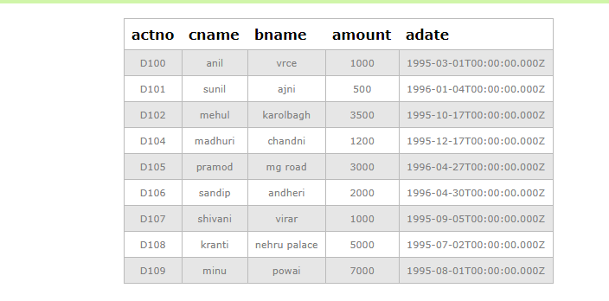

2. select \* from borrow;

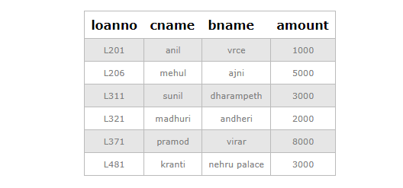

3. select \* from customer;

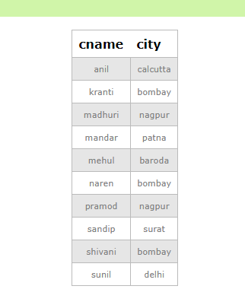

4. select \* from branch;

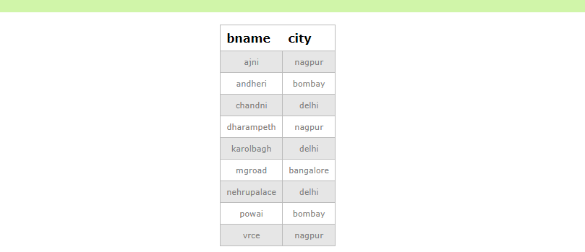

5. select actno,amount from deposit;

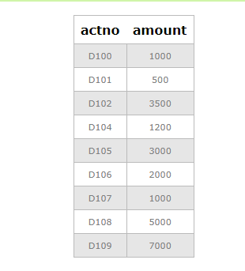

6. select cname,actno from deposit;

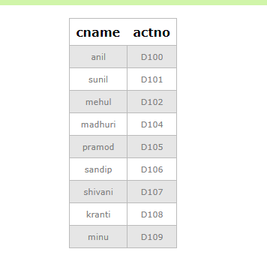

7. select cname from customer;

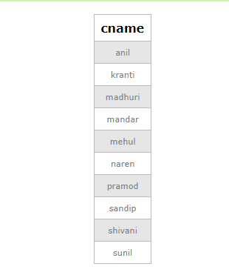

8. select bname from branch;

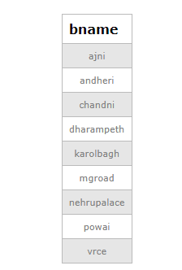

9. select cname from borrow;

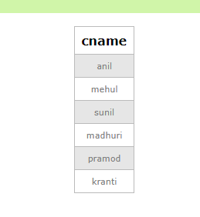

10. select cname from customer where city="nagpur";

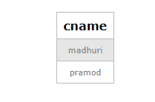

11. select cname from deposit where amount>4000;

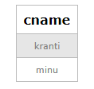

12. select adate from deposit where cname="anil";

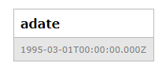

13. select bname from branch where city="bombay";

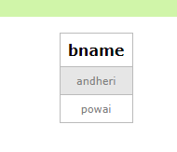

14. select cname from borrow where loanno="L206";

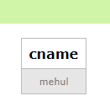

15. select cname from deposit where bname="vrce";

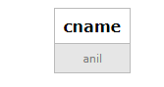

16. select bname from branch where city="delhi";

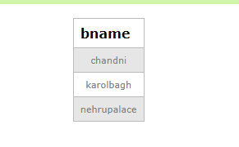

17. select cname from deposit where adate='1996-12-01';

18. select actno,amount from deposit where adate>='1995-12-01' and adate<='1996-05-01';

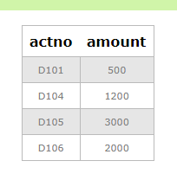

19. select city from branch where bname="karolbagh";

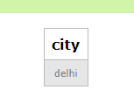

20. select \* from customer join bororw on customer.cname=borrow.cname join deposit on deposit.cname=borrow.cname where customer.cname='anil';

