* create table regions(region_id numeric(4) not null primary key,region_name varchar(25));
* create table country(country_id char(2) primary key, country_name varchar(40), region_id numeric(4) ,FOREIGN KEY (region_id) REFERENCES regions(region_id));
* create table locations(location_id numeric(4) not null primary key,street_address varchar(40),postal_code varchar(12),city varchar(30) not null,state_province varchar(25),country_id char(2),FOREIGN KEY (country_id) REFERENCES country(country_id));
* create table departments(department_id int(20) not null primary key, department_name varchar(40), manager_id int(20),location_id numeric(4), FOREIGN KEY (location_id) REFERENCES locations(location_id));
* create table employees(employee_id int(20) not null primary key,first_name varchar(40),last_name varchar(40) not null ,email varchar(25) not null, phone_number varchar(25),hire_datedate,job_id varchar(25) not null,salary numeric(8,2),commission_pct numeric(2,2),manager_id int(20),department_id int(20),FOREIGN KEY (department_id) REFERENCES departments(department_id));
* create table jobs(job_id varchar(10) not null primary key,job_title varchar(35) not null,min_salary numeric(10),max_salary numeric(20));
* create table job_grades(grade_level varchar(20) primary key ,lowest_sal numeric(10),highest_sal numeric(20));
* create table job_history(employee_id int(20) not null,start_date date not null,end_date date not null,job_id varchar(20),department_id int(20),FOREIGN KEY (department_id) REFERENCES departments(department_id),FOREIGN KEY (employee_id)

REFERENCES employees(employee_id), FOREIGN KEY (job_id) REFERENCES jobs(job_id));

INSERT INTO regions VALUES(1,'EUROPE');

INSERT INTO regions VALUES(2,'AMERICA');

INSERT INTO regions VALUES(3,'ASIA');

INSERT INTO regions VALUES(4,'MIDDLE EAST AND AFRICA');

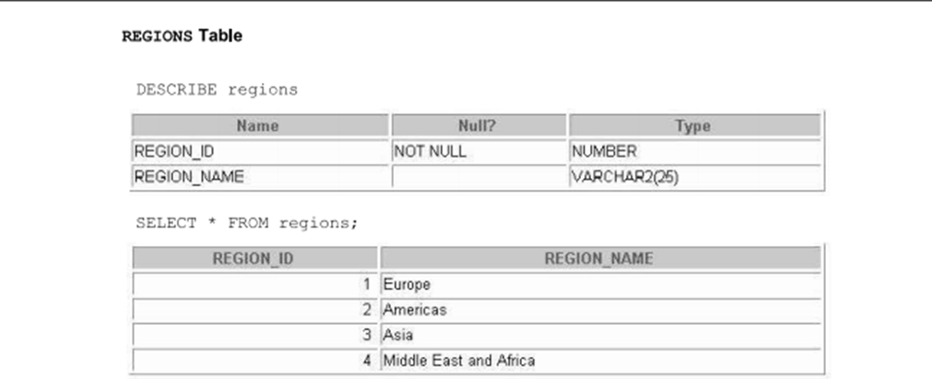

INSERT INTO country VALUES('CA','CANADA',2);

INSERT INTO country VALUES('DE','GERMANY',1);

INSERT INTO country VALUES('UK','UNITED KINGDOM',1);

INSERT INTO country VALUES('US','UNITED STATES OF AMERICA',2);

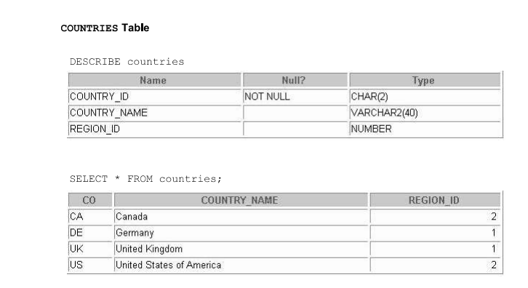

INSERT INTO locations VALUES(1400, '2014 jabberwocky rd', '296192', 'southlake ', 'texas', 'US');

INSERT INTO locations VALUES(1500, '2011 interiors blvd', '99236', 'south sanfrancisco', 'california', 'US');

INSERT INTO locations VALUES(1800, '460 bloorst', 'on m5s 1X8', 'toronto', 'ontario', 'CA');

INSERT INTO locations VALUES(1700, '2004 charade rd', '98199', 'seattle', 'washington', 'US');

INSERT INTO locations VALUES(2500, 'magdalen center,the oxford science park', 'ox99zb', 'oxford', 'oxford', 'UK');

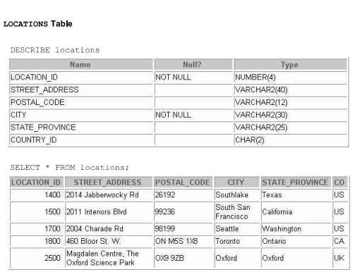

INSERT INTO departments VALUES(10, 'Administration', 200, 1700);

INSERT INTO departments VALUES(20, 'Marketing', 201, 1800);

INSERT INTO departments VALUES(50, 'Shipping', 124, 1500);

INSERT INTO departments VALUES(60, 'IT', 103, 1400);

INSERT INTO departments VALUES(80, 'Sales', 149, 2500);

INSERT INTO departments VALUES(90, 'Executive', 100, 1700);

INSERT INTO departments VALUES(110, 'Accounting', 205, 1700);

INSERT INTO departments VALUES(190, 'Contracting', NULL, 1700);

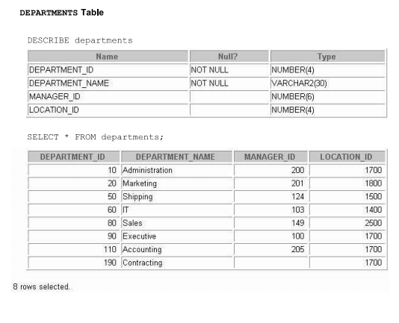

INSERT INTO jobs VALUES('ad_pres', 'president', 20000, 40000);

INSERT INTO jobs VALUES('ad_vp', 'Administrator vise president', 15000, 30000);

INSERT INTO jobs VALUES('ad_assist', 'Administrator Assistant', 3000, 6000);

INSERT INTO jobs VALUES('ac_mgr', 'Accounting manager', 8200, 16000);

INSERT INTO jobs VALUES('ac_account', 'public accountant', 4200, 9000);

INSERT INTO jobs VALUES('sa_man', 'sales manager', 10000, 20000);

INSERT INTO jobs VALUES('sa_rep', 'salesrepresentative', 6000, 12000);

INSERT INTO jobs VALUES('st_man', 'stock manager', 5500, 8500);

INSERT INTO jobs VALUES('st_cleark', 'public accountant', 2000, 5000);

INSERT INTO jobs VALUES('it_prog','programmer', 4000, 10000);

INSERT INTO jobs VALUES('mk_man', 'marketing manager', 9000, 15000);

INSERT INTO jobs VALUES('mk_rep', 'marketing representative', 4000, 9000);

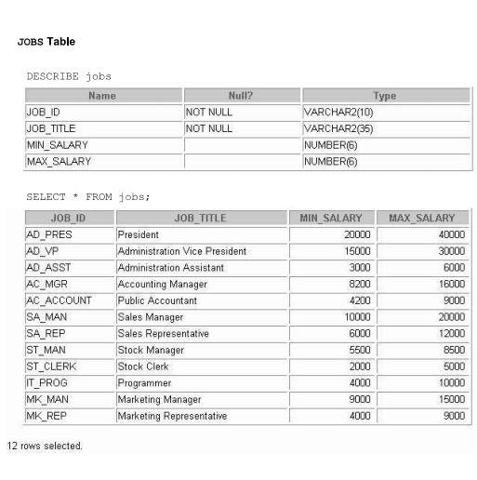

INSERT INTO job_gradesVALUES('A', 1000, 2999);

INSERT INTO job_gradesVALUES('B', 3000, 5999);

INSERT INTO job_grades VALUES('C', 6000, 9999);

INSERT INTO job_grades VALUES('D', 10000, 14999);

INSERT INTO job_grades VALUES('E', 15000, 24999);

INSERT INTO job_grades VALUES('F', 25000, 40000);

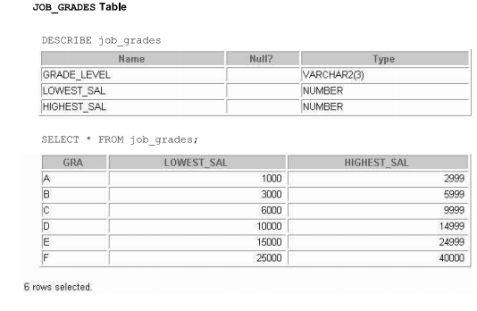

insert into employees values (100,'steven','king','sking','515.123.4567','1987-06-17','ad_pres',24000,NULL,NULL,90);

insert into employees values (101,'neena','kochhar','kochhar','515.123.4568','1989-09-21','ad_vp',24000,NULL,100,90);

insert into employees values (102,'lex','de haan','ldehaan','515.123.4569','1993-01-13','ad_vp',17000,NULL,100,90);

insert into employees values (103,'alexander','hunold','ahunold','590.423.4567','1990-01-03','it_prog',9000,NULL,102,60);

insert into employees values (104,'bruce','ernst','bernst','590.423.4568','1991-05-21','it_prog',6000,NULL,103,60);

insert into employees values (107,'diana','lorentz','dlorentz','590.423.5567','1999-02-07','it_prog',4200,NULL,103,60);

insert into employees values (124,'kevin','mourgos','kmourgos','650.123.5234','1999-11-16','st_man',5800,NULL,100,50);

insert into employees values (141,'trenaa','rajs','trajs','650.121.8009','1995-10-17','st_clerk',3500,NULL,124,50);

insert into employees values (142,'curtis','davies','cdavies','650.121.2994','1997-01-29','st_clerk',3100,NULL,124,50);

insert into employees values (143,'randall','matos','rmatos','605.121.2874','1998-03-15','st_clerk',2600,NULL,124,50);

insert into employees values (144,'peter','vargas','pvargas','605.121.2004','1998-07-09','st_clerk',2500,NULL,124,50);

insert into employees values (149,'eleni','zlotkay','ezlotkay','011.44.1344.429018','2000-01-29','sa_man',10500,.2,100,80);

insert into employees values (174,'ellen','abel','eabel','011.44.1644.429267','1996-05-11','sa_rep',11000,.3,149,80);

insert into employees values (176,'jonathon','tylor','jtylor','011.44.1644.429265','1998-03-24','sa_rep',8600,.2,149,80);

insert into employees values (178,'kimberely','grant','kgrant','011.44.1644.429263','1999-05-24','sa_rep',7000,.15,149,NULL);

insert into employees values (200,'jennifer','whalen','jwhalen','515.123.4444','1987-09-17','ad_asst',4400,NULL,101,10);

insert into employees values (201,'michael','hartstein','mhartstein','515.123.5555','1996-02-17','mk-man',13000,NULL,100,20);

insert into employees values (202,'pat','fay','pfay','603.123.6666','1997-08-17','mk_rep',6000,NULL,201,20);

insert into employees values (205,'shelley','higgins','shiggins','515.123.8080','1994-06-07','ac_mgr',12000,NULL,101,110);

insert into employees values (206,'william','gietz','wgietz','515.123.8181','1994-06-07','ac_account',8300,NULL,205,110);

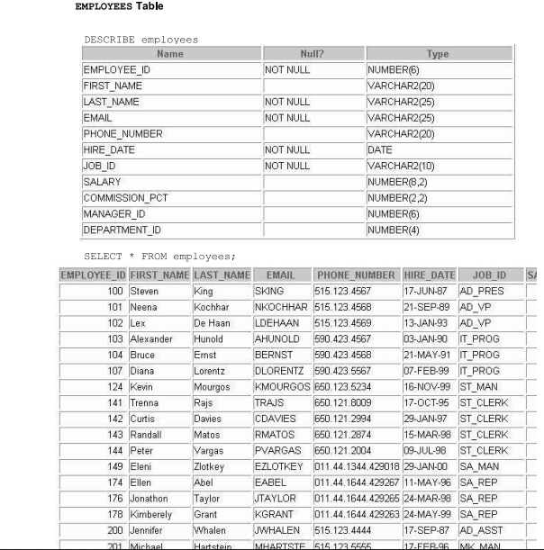

INSERT INTO job_historyVALUES(102, '1989-01-13', '1998-07-24', 'it_prog', 60);

INSERT INTO job_historyVALUES(101, '1989-09-21', '1993-10-27', 'ac_account', 110);

INSERT INTO job_historyVALUES(101, '1993-10-28', '1997-03-15', 'ac_mgr', 110);

INSERT INTO job_historyVALUES(201, '1996-02-17', '1998-12-19', 'mk_rep', 20);

INSERT INTO job_historyVALUES(114, '1998-02-24', '1999-12-19', 'st_cleark', 50);

INSERT INTO job_historyVALUES(122,'1999-01-01','1999-12-31','st_cleark',50);

INSERT INTO job_historyVALUES(200,'1993-09-17','1993-06-17','ad_assist',90);

INSERT INTO job_historyVALUES(176,'1998-03-24','1998-12-31','sa_rep',80);

INSERT INTO job_historyVALUES(176,'1999-01-01','1999-12-31','sa_man',80);

INSERT INTO job_historyVALUES(200,'1994-07-01','1998-12-31','ac_account',90);

