1.Create a Trigger for employe table it will update another table salary while updating values.To develop and execute a Trigger for After update/Delete/Insert operations on a table.

sql>

CREATE TABLE `employe` (

`emp_id` int(11) NOT NULL,

`emp_name` varchar(45) DEFAULT NULL,

`dob` date DEFAULT NULL,

`address` varchar(45) DEFAULT NULL,

`designation` varchar(45) DEFAULT NULL,

`mobile_no` int(11) DEFAULT NULL,

`dept_no` int(11) DEFAULT NULL,

`salary` int(11) DEFAULT NULL,

PRIMARY KEY (`emp_id`)

);

Sql>

CREATE TABLE `salary` (

`employee_id` int(11) NOT NULL,

`old_sal` int(11) DEFAULT NULL,

`new_sal` int(11) DEFAULT NULL,

`rev_date` date DEFAULT NULL,

PRIMARY KEY (`employee_id`)

);

sql>

CREATE DEFINER=`root`@`localhost` TRIGGER `db1`.`personal_updations_AFTER_UPDATE_1`

AFTER UPDATE ON `employe`

FOR EACH ROW

BEGIN

if(new.salary != old.salary)

then

INSERT INTO salary (employee_id,old_sal,new_sal,rev_date) values (new.emp_id,old.salary,new.salary,sysdate());

END if;

end;

sql>

update employe set salary=234569 where emp_id=1;

select * from salary;

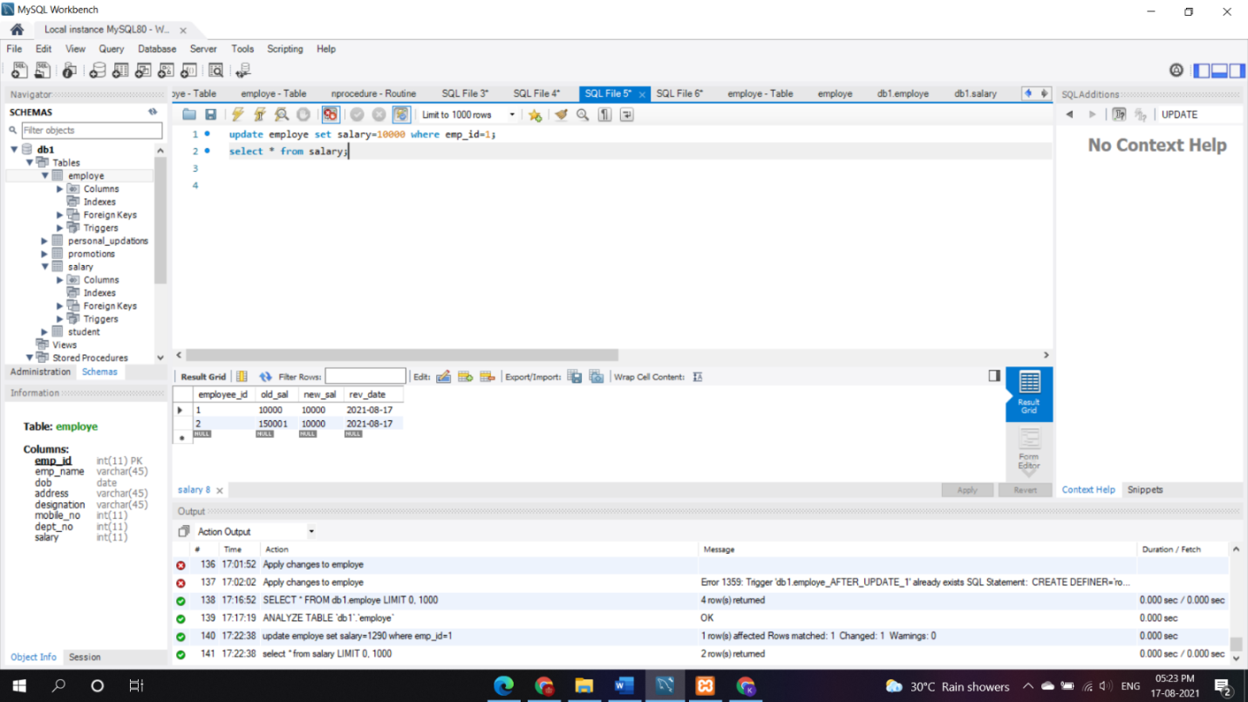

2.Create a Trigger for employe table it will update another table personal_updations while updating values. To develop and execute a Trigger for Before and After update/Delete/Insert operations on a table.

Sql>

CREATE TABLE `employe` (

`emp_id` int(11) NOT NULL,

`emp_name` varchar(45) DEFAULT NULL,

`dob` date DEFAULT NULL,

`address` varchar(45) DEFAULT NULL,

`designation` varchar(45) DEFAULT NULL,

`mobile_no` int(11) DEFAULT NULL,

`dept_no` int(11) DEFAULT NULL,

`salary` int(11) DEFAULT NULL,

PRIMARY KEY (`emp_id`)

);

Sql>

CREATE TABLE `personal_updations` (

`emp_id` int(11) NOT NULL,

`old_phoneno` int(11) DEFAULT NULL,

`new_phoneno` int(11) DEFAULT NULL,

`rev_date` date DEFAULT NULL,

PRIMARY KEY (`emp_id`)

);

sql>

CREATE DEFINER=`root`@`localhost` TRIGGER `db1`.`personal_updations_AFTER_UPDATE`

AFTER UPDATE ON `employe`

FOR EACH ROW

BEGIN

if(new.mobile_no != old.mobile_no)

then

INSERT INTO personal_updations (emp_id,old_phoneno,new_phoneno,rev_date) values (new.emp_id,new.mobile_no,old.mobile_no,sysdate());

END if;

end;

sql>

update employe set mobile_no=34566 where emp_id=4 ;

select * from personal_updations;

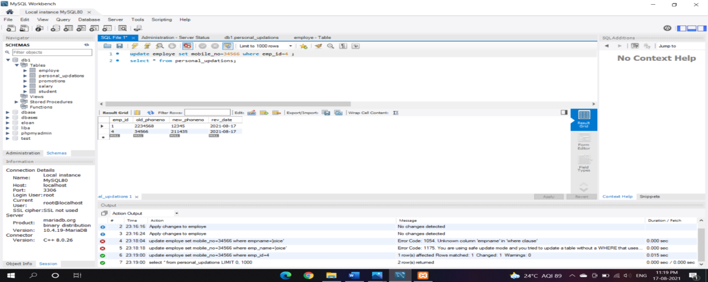

3.Create a Trigger for employe table it will update another table promotions while updating values. To develop and execute a Trigger for Before and After update/Delete/Insert operations on a table.

sql>

CREATE TABLE `employe` (

`emp_id` int(11) NOT NULL,

`emp_name` varchar(45) DEFAULT NULL,

`dob` date DEFAULT NULL,

`address` varchar(45) DEFAULT NULL,

`designation` varchar(45) DEFAULT NULL,

`mobile_no` int(11) DEFAULT NULL,

`dept_no` int(11) DEFAULT NULL,

`salary` int(11) DEFAULT NULL,

PRIMARY KEY (`emp_id`)

);

Sql>

CREATE TABLE `personal_updations` (

`emp_id` int(11) NOT NULL,

`old_phoneno` int(11) DEFAULT NULL,

`new_phoneno` int(11) DEFAULT NULL,

`rev_date` date DEFAULT NULL,

PRIMARY KEY (`emp_id`)

);

sql>

CREATE DEFINER=`root`@`localhost` TRIGGER`db1`.`employe_AFTER_UPDATE_1`

AFTER UPDATE ON `employe`

FOR EACH ROW

BEGIN

if(new.designation != old.designation)

then

INSERT INTO promotions (emp_id,old_designation,new_designation,rev_date) values (new.emp_id,new.designation,old.designation,sysdate());

END if;

end;

sql>

update employe set designation='clk' where emp_id=4 ;

select * from promotions;

