Создание БД:

create database CherEPractica

Создание таблиц:

create table Users (Id_user int NOT NULL primary key, FName nvarchar(20) NOT NULL,Surname nvarchar(20) NOT NULL, Patronymic nvarchar(20) NOT NULL,

Phone char(16) check (Phone like '8 [0-9][0-9][0-9]-[0-9][0-9][0-9]-[0-9][0-9]-[0-9][0-9]'),

Login nvarchar(15) NOT NULL, Password nvarchar(15) NOT NULL, Id_type int NOT NULL)

create table HomeTechModel (HomeTechModelID int NOT NULL primary key, HomeTechModelName nvarchar(50) NOT NULL, HomeTechTypeTypeID int NOT NULL)

create table TypeUser (Id_type int NOT NULL primary key, typeName nvarchar(15) NOT NULL)

create table Comments (CommentID int NOT NULL primary key, [Message] nvarchar(50) NOT NULL,masterID int NOT NULL, requestID int NOT NULL)

create table HomeTechType (HomeTechTypeID int NOT NULL primary key, HomeTechTypeName nvarchar(50) NOT NULL)

create table ProblemDescryption (ProblemDescryptionID int NOT NULL primary key, ProblemDescryptionName nvarchar(50) NOT NULL)

create table RequestStatus (RequestStatusID int NOT NULL primary key, RequestStatusName nvarchar(50) NOT NULL)

create table Request (ReguestID int NOT NULL primary key, StartDate date, HomeTechTypeId int NOT NULL, HomeTechModel nvarchar(50), ProblemDescryptionID int NOT NULL, RequestStatusID int NOT NULL, CompletionDate date, RepairPars nvarchar(50), MasterID int NOT NULL, ClientID int NOT NULL)

ER-модель бд:

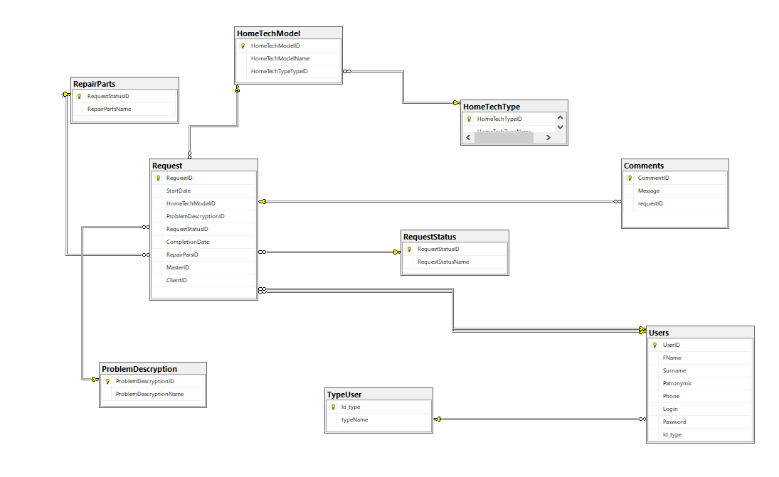

Словарь данных:

|  |  |  |  |  |
| --- | --- | --- | --- | --- |
| **KEY** | **Имя поля** | **Тип данных / Размер** | **Необходимо?** | **Примечания** |
| RequestStatus | | | | |
| PK | RequestStatusID | INTEGER | N | Auto Increment |
|  | RequestStatusName | Nvarchar(50) |  |  |
| Comments | | | | |
| PK | CommentID | INTEGER | N | Auto Increment |
|  | Message | Nvarchar(50) |  |  |
| FK | requestID | INTEGER | N | cascade |
| ProblemDescryption | | | | |
| PK | ProblemDescryptionID | INTEGER | N | Auto Increment |
|  | ProblemDescryptionName | Nvarchar(50) |  |  |
| HomeTechType | | | | |
| PK | HomeTechTypeID | INTEGER | N | Auto Increment |
|  | HomeTechTypeName | Nvarchar(50) |  |  |
| TypeUsr | | | | |
| PK | Id_type | INTEGER | N | Auto Increment |
|  | typeName | Nvarchar(15) |  |  |
| Reguest | | | | |
| PK | ReguestID | INTEGER | N | Auto Increment |
|  | StartDate | date |  |  |
| FK | HomeTechModelID | int |  | cascade |
| FK | ProblemDescryptionID | INTEGER | N | cascade |
| FK | RequestStatusID | INTEGER | N | cascade |
|  | CompletionDate | date |  |  |
| FK | RepairParsID | INTEGER | N | cascade |
| FK | MasterID | INTEGER | Y | cascade |
| FK | ClientID | INTEGER | N | cascade |
| Users | | | | |
| PK | UserID | INTEGER | N | Auto Increment |
|  | FName | Nvarchar(20) |  |  |
|  | Surname | Nvarchar(20) |  |  |
|  | Patronymic | Nvarchar(20) |  |  |
|  | Phone | Char(16) |  |  |
|  | Login | Nvarchar(15) |  |  |
|  | Password | Nvarchar(15) |  |  |
| FK | Id_type | INTEGER | N | cascade |
| HomeTechModel | | | | |
| PK | HomeTechModelID | INTEGER | N | Auto Increment |
| FK | HomeTechModelName | INTEGER | N | cascade |
| FK | HomeTechTypeTypeID | NTEGER | N | cascade |
| RepairParts | | | | |
| PK | RepairPartsID | INTEGER | N | Auto Increment |
|  | RepairPartsName | Nvarchar(50) | N |  |

Заполненные таблицы:

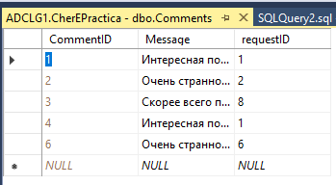

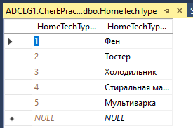

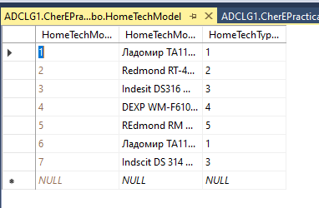

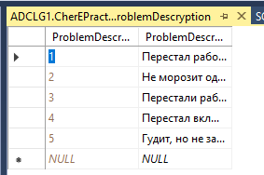

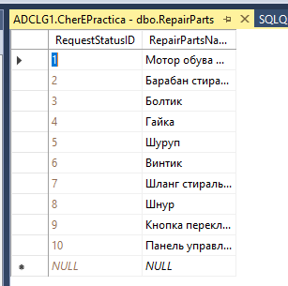

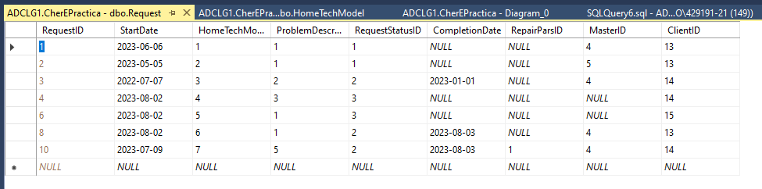

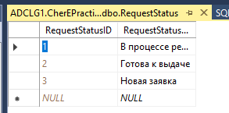

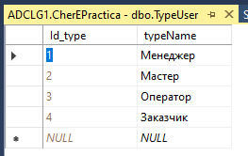

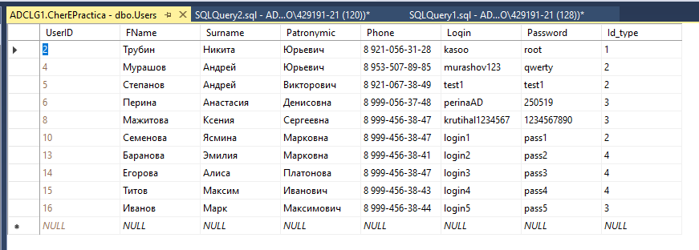

Создание скрипта:

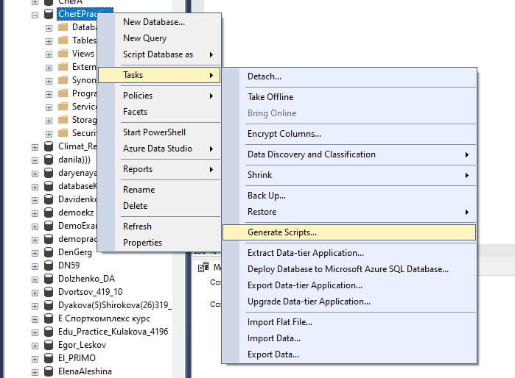

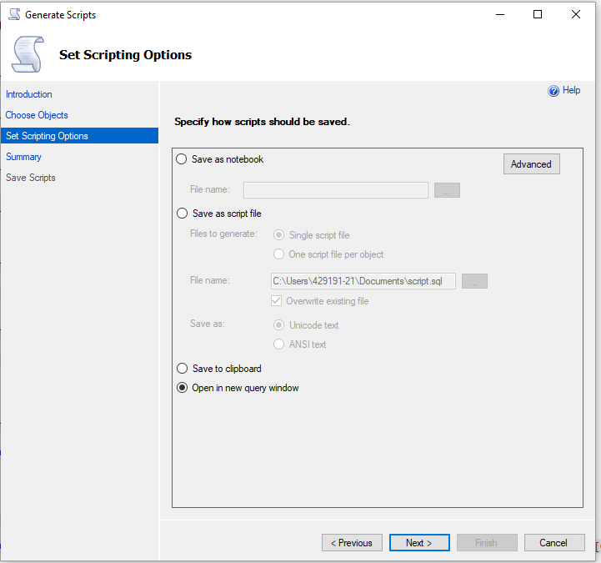

Скрипт:

USE [master]

GO

/****** Object: Database [CherEPractica] Script Date: 30.10.2024 12:51:57 ******/

CREATE DATABASE [CherEPractica]

CONTAINMENT = NONE

ON PRIMARY

( NAME = N'CherEPractica', FILENAME = N'D:\MSSQL14.SQLSERVER\MSSQL\DATA\CherEPractica.mdf' , SIZE = 8192KB , MAXSIZE = UNLIMITED, FILEGROWTH = 65536KB )

LOG ON

( NAME = N'CherEPractica_log', FILENAME = N'D:\MSSQL14.SQLSERVER\MSSQL\DATA\CherEPractica_log.ldf' , SIZE = 8192KB , MAXSIZE = 2048GB , FILEGROWTH = 65536KB )

GO

ALTER DATABASE [CherEPractica] SET COMPATIBILITY_LEVEL = 140

GO

IF (1 = FULLTEXTSERVICEPROPERTY('IsFullTextInstalled'))

begin

EXEC [CherEPractica].[dbo].[sp_fulltext_database] @action = 'enable'

end

GO

ALTER DATABASE [CherEPractica] SET ANSI_NULL_DEFAULT OFF

GO

ALTER DATABASE [CherEPractica] SET ANSI_NULLS OFF

GO

ALTER DATABASE [CherEPractica] SET ANSI_PADDING OFF

GO

ALTER DATABASE [CherEPractica] SET ANSI_WARNINGS OFF

GO

ALTER DATABASE [CherEPractica] SET ARITHABORT OFF

GO

ALTER DATABASE [CherEPractica] SET AUTO_CLOSE ON

GO

ALTER DATABASE [CherEPractica] SET AUTO_SHRINK OFF

GO

ALTER DATABASE [CherEPractica] SET AUTO_UPDATE_STATISTICS ON

GO

ALTER DATABASE [CherEPractica] SET CURSOR_CLOSE_ON_COMMIT OFF

GO

ALTER DATABASE [CherEPractica] SET CURSOR_DEFAULT GLOBAL

GO

ALTER DATABASE [CherEPractica] SET CONCAT_NULL_YIELDS_NULL OFF

GO

ALTER DATABASE [CherEPractica] SET NUMERIC_ROUNDABORT OFF

GO

ALTER DATABASE [CherEPractica] SET QUOTED_IDENTIFIER OFF

GO

ALTER DATABASE [CherEPractica] SET RECURSIVE_TRIGGERS OFF

GO

ALTER DATABASE [CherEPractica] SET ENABLE_BROKER

GO

ALTER DATABASE [CherEPractica] SET AUTO_UPDATE_STATISTICS_ASYNC OFF

GO

ALTER DATABASE [CherEPractica] SET DATE_CORRELATION_OPTIMIZATION OFF

GO

ALTER DATABASE [CherEPractica] SET TRUSTWORTHY OFF

GO

ALTER DATABASE [CherEPractica] SET ALLOW_SNAPSHOT_ISOLATION OFF

GO

ALTER DATABASE [CherEPractica] SET PARAMETERIZATION SIMPLE

GO

ALTER DATABASE [CherEPractica] SET READ_COMMITTED_SNAPSHOT OFF

GO

ALTER DATABASE [CherEPractica] SET HONOR_BROKER_PRIORITY OFF

GO

ALTER DATABASE [CherEPractica] SET RECOVERY SIMPLE

GO

ALTER DATABASE [CherEPractica] SET MULTI_USER

GO

ALTER DATABASE [CherEPractica] SET PAGE_VERIFY CHECKSUM

GO

ALTER DATABASE [CherEPractica] SET DB_CHAINING OFF

GO

ALTER DATABASE [CherEPractica] SET FILESTREAM( NON_TRANSACTED_ACCESS = OFF )

GO

ALTER DATABASE [CherEPractica] SET TARGET_RECOVERY_TIME = 60 SECONDS

GO

ALTER DATABASE [CherEPractica] SET DELAYED_DURABILITY = DISABLED

GO

ALTER DATABASE [CherEPractica] SET QUERY_STORE = OFF

GO

USE [CherEPractica]

GO

/****** Object: Table [dbo].[Comments] Script Date: 30.10.2024 12:51:58 ******/

SET ANSI_NULLS ON

GO

SET QUOTED_IDENTIFIER ON

GO

CREATE TABLE [dbo].[Comments](

[CommentID] [int] IDENTITY(1,1) NOT NULL,

[Message] [nvarchar](50) NOT NULL,

[requestID] [int] NOT NULL,

CONSTRAINT [PK__Comments__C3B4DFAA01B7ABAA] PRIMARY KEY CLUSTERED

(

[CommentID] ASC

)WITH (PAD_INDEX = OFF, STATISTICS_NORECOMPUTE = OFF, IGNORE_DUP_KEY = OFF, ALLOW_ROW_LOCKS = ON, ALLOW_PAGE_LOCKS = ON) ON [PRIMARY]

) ON [PRIMARY]

GO

/****** Object: Table [dbo].[HomeTechType] Script Date: 30.10.2024 12:51:58 ******/

SET ANSI_NULLS ON

GO

SET QUOTED_IDENTIFIER ON

GO

CREATE TABLE [dbo].[HomeTechType](

[HomeTechTypeID] [int] IDENTITY(1,1) NOT NULL,

[HomeTechTypeName] [nvarchar](50) NOT NULL,

CONSTRAINT [PK__HomeTech__AC20314F64AC8DE8] PRIMARY KEY CLUSTERED

(

[HomeTechTypeID] ASC

)WITH (PAD_INDEX = OFF, STATISTICS_NORECOMPUTE = OFF, IGNORE_DUP_KEY = OFF, ALLOW_ROW_LOCKS = ON, ALLOW_PAGE_LOCKS = ON) ON [PRIMARY]

) ON [PRIMARY]

GO

/****** Object: Table [dbo].[ProblemDescryption] Script Date: 30.10.2024 12:51:58 ******/

SET ANSI_NULLS ON

GO

SET QUOTED_IDENTIFIER ON

GO

CREATE TABLE [dbo].[ProblemDescryption](

[ProblemDescryptionID] [int] IDENTITY(1,1) NOT NULL,

[ProblemDescryptionName] [nvarchar](50) NOT NULL,

CONSTRAINT [PK__ProblemD__1C8980F33F6A7159] PRIMARY KEY CLUSTERED

(

[ProblemDescryptionID] ASC

)WITH (PAD_INDEX = OFF, STATISTICS_NORECOMPUTE = OFF, IGNORE_DUP_KEY = OFF, ALLOW_ROW_LOCKS = ON, ALLOW_PAGE_LOCKS = ON) ON [PRIMARY]

) ON [PRIMARY]

GO

/****** Object: Table [dbo].[RepairParts] Script Date: 30.10.2024 12:51:58 ******/

SET ANSI_NULLS ON

GO

SET QUOTED_IDENTIFIER ON

GO

CREATE TABLE [dbo].[RepairParts](

[RequestStatusID] [int] IDENTITY(1,1) NOT NULL,

[RepairPartsName] [nvarchar](50) NOT NULL,

CONSTRAINT [PK__RepairPa__7094B7BB4CCDCD90] PRIMARY KEY CLUSTERED

(

[RequestStatusID] ASC

)WITH (PAD_INDEX = OFF, STATISTICS_NORECOMPUTE = OFF, IGNORE_DUP_KEY = OFF, ALLOW_ROW_LOCKS = ON, ALLOW_PAGE_LOCKS = ON) ON [PRIMARY]

) ON [PRIMARY]

GO

/****** Object: Table [dbo].[Request] Script Date: 30.10.2024 12:51:58 ******/

SET ANSI_NULLS ON

GO

SET QUOTED_IDENTIFIER ON

GO

CREATE TABLE [dbo].[Request](

[ReguestID] [int] IDENTITY(1,1) NOT NULL,

[StartDate] [date] NULL,

[HomeTechTypeId] [int] NOT NULL,

[HomeTechModel] [nvarchar](50) NULL,

[ProblemDescryptionID] [int] NOT NULL,

[RequestStatusID] [int] NOT NULL,

[CompletionDate] [date] NULL,

[RepairParsID] [int] NULL,

[MasterID] [int] NULL,

[ClientID] [int] NOT NULL,

CONSTRAINT [PK__Request__BAD9EB10697C6C9C] PRIMARY KEY CLUSTERED

(

[ReguestID] ASC

)WITH (PAD_INDEX = OFF, STATISTICS_NORECOMPUTE = OFF, IGNORE_DUP_KEY = OFF, ALLOW_ROW_LOCKS = ON, ALLOW_PAGE_LOCKS = ON) ON [PRIMARY]

) ON [PRIMARY]

GO

/****** Object: Table [dbo].[RequestStatus] Script Date: 30.10.2024 12:51:58 ******/

SET ANSI_NULLS ON

GO

SET QUOTED_IDENTIFIER ON

GO

CREATE TABLE [dbo].[RequestStatus](

[RequestStatusID] [int] IDENTITY(1,1) NOT NULL,

[RequestStatusName] [nvarchar](50) NOT NULL,

CONSTRAINT [PK__RequestS__7094B7BB6F3D0D93] PRIMARY KEY CLUSTERED

(

[RequestStatusID] ASC

)WITH (PAD_INDEX = OFF, STATISTICS_NORECOMPUTE = OFF, IGNORE_DUP_KEY = OFF, ALLOW_ROW_LOCKS = ON, ALLOW_PAGE_LOCKS = ON) ON [PRIMARY]

) ON [PRIMARY]

GO

/****** Object: Table [dbo].[TypeUser] Script Date: 30.10.2024 12:51:58 ******/

SET ANSI_NULLS ON

GO

SET QUOTED_IDENTIFIER ON

GO

CREATE TABLE [dbo].[TypeUser](

[Id_type] [int] IDENTITY(1,1) NOT NULL,

[typeName] [nvarchar](15) NOT NULL,

CONSTRAINT [PK__TypeUser__74C1FDF635B2DBFD] PRIMARY KEY CLUSTERED

(

[Id_type] ASC

)WITH (PAD_INDEX = OFF, STATISTICS_NORECOMPUTE = OFF, IGNORE_DUP_KEY = OFF, ALLOW_ROW_LOCKS = ON, ALLOW_PAGE_LOCKS = ON) ON [PRIMARY]

) ON [PRIMARY]

GO

/****** Object: Table [dbo].[Users] Script Date: 30.10.2024 12:51:58 ******/

SET ANSI_NULLS ON

GO

SET QUOTED_IDENTIFIER ON

GO

CREATE TABLE [dbo].[Users](

[UserID] [int] IDENTITY(1,1) NOT NULL,

[FName] [nvarchar](20) NOT NULL,

[Surname] [nvarchar](20) NOT NULL,

[Patronymic] [nvarchar](20) NOT NULL,

[Phone] [char](16) NULL,

[Login] [nvarchar](15) NOT NULL,

[Password] [nvarchar](15) NOT NULL,

[Id_type] [int] NOT NULL,

CONSTRAINT [PK__Users__1788CCAC30CC32A8] PRIMARY KEY CLUSTERED

(

[UserID] ASC

)WITH (PAD_INDEX = OFF, STATISTICS_NORECOMPUTE = OFF, IGNORE_DUP_KEY = OFF, ALLOW_ROW_LOCKS = ON, ALLOW_PAGE_LOCKS = ON) ON [PRIMARY]

) ON [PRIMARY]

GO

ALTER TABLE [dbo].[Comments] WITH CHECK ADD CONSTRAINT [FK_Comments_Request] FOREIGN KEY([requestID])

REFERENCES [dbo].[Request] ([ReguestID])

ON UPDATE CASCADE

ON DELETE CASCADE

GO

ALTER TABLE [dbo].[Comments] CHECK CONSTRAINT [FK_Comments_Request]

GO

ALTER TABLE [dbo].[Request] WITH CHECK ADD CONSTRAINT [FK_Request_HomeTechType] FOREIGN KEY([HomeTechTypeId])

REFERENCES [dbo].[HomeTechType] ([HomeTechTypeID])

ON UPDATE CASCADE

ON DELETE CASCADE

GO

ALTER TABLE [dbo].[Request] CHECK CONSTRAINT [FK_Request_HomeTechType]

GO

ALTER TABLE [dbo].[Request] WITH CHECK ADD CONSTRAINT [FK_Request_ProblemDescryption] FOREIGN KEY([ProblemDescryptionID])

REFERENCES [dbo].[ProblemDescryption] ([ProblemDescryptionID])

ON UPDATE CASCADE

ON DELETE CASCADE

GO

ALTER TABLE [dbo].[Request] CHECK CONSTRAINT [FK_Request_ProblemDescryption]

GO

ALTER TABLE [dbo].[Request] WITH CHECK ADD CONSTRAINT [FK_Request_RepairParts] FOREIGN KEY([RepairParsID])

REFERENCES [dbo].[RepairParts] ([RequestStatusID])

ON UPDATE CASCADE

ON DELETE CASCADE

GO

ALTER TABLE [dbo].[Request] CHECK CONSTRAINT [FK_Request_RepairParts]

GO

ALTER TABLE [dbo].[Request] WITH CHECK ADD CONSTRAINT [FK_Request_RequestStatus] FOREIGN KEY([RequestStatusID])

REFERENCES [dbo].[RequestStatus] ([RequestStatusID])

ON UPDATE CASCADE

ON DELETE CASCADE

GO

ALTER TABLE [dbo].[Request] CHECK CONSTRAINT [FK_Request_RequestStatus]

GO

ALTER TABLE [dbo].[Request] WITH CHECK ADD CONSTRAINT [FK_Request_Users] FOREIGN KEY([ClientID])

REFERENCES [dbo].[Users] ([UserID])

GO

ALTER TABLE [dbo].[Request] CHECK CONSTRAINT [FK_Request_Users]

GO

ALTER TABLE [dbo].[Request] WITH CHECK ADD CONSTRAINT [FK_Request_Users1] FOREIGN KEY([MasterID])

REFERENCES [dbo].[Users] ([UserID])

ON UPDATE CASCADE

ON DELETE CASCADE

GO

ALTER TABLE [dbo].[Request] CHECK CONSTRAINT [FK_Request_Users1]

GO

ALTER TABLE [dbo].[Users] WITH CHECK ADD CONSTRAINT [FK_Users_TypeUser] FOREIGN KEY([Id_type])

REFERENCES [dbo].[TypeUser] ([Id_type])

ON UPDATE CASCADE

ON DELETE CASCADE

GO

ALTER TABLE [dbo].[Users] CHECK CONSTRAINT [FK_Users_TypeUser]

GO

ALTER TABLE [dbo].[Users] WITH CHECK ADD CONSTRAINT [CK__Users__Phone__4E88ABD4] CHECK (([Phone] like '8 [0-9][0-9][0-9]-[0-9][0-9][0-9]-[0-9][0-9]-[0-9][0-9]'))

GO

ALTER TABLE [dbo].[Users] CHECK CONSTRAINT [CK__Users__Phone__4E88ABD4]

GO

USE [master]

GO

ALTER DATABASE [CherEPractica] SET READ_WRITE

GO

Резервное копирование:

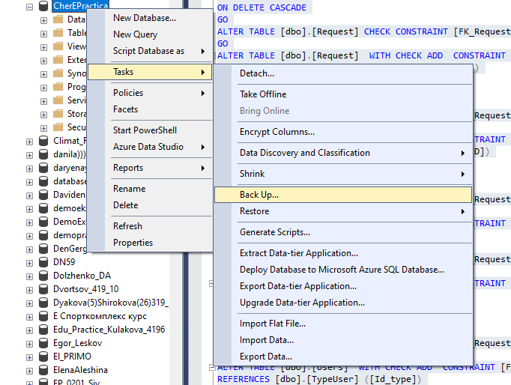

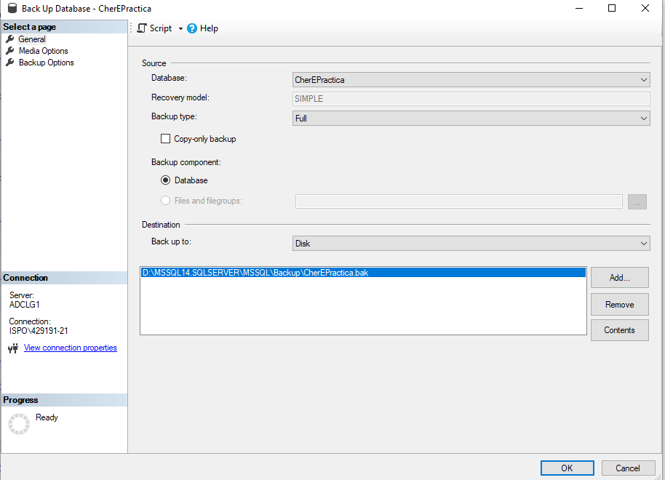

Восстановление:

