- What is your Team name and how was it decided?
London Software house was decided in a team meeting by someone.

- What roles are you and other members undertaking?

Name | Primary Role | Secondary Role
Humd | System Analyst | Deputy project manager
Ali | Deputy project manager | System Analyst
Nikki | Tester | Programmer
Elizabeth | Project manager | System Analyst
Mayan | Designer | Tester
Nizar | Programmer | Designer
Afiifa | Tester | Programmer

29/01/2026
Online meeting at 17:00 we all said hello and said each other names and everyone’s roles were omitted here.
31/01/2026
As a designer and programmer, I worked for about 2-3 hours doing the initial plans mainly showing the classes and interfaces and UML, use case diagrams that are available on the google doc on the 31st of January.
The system involves actors including Merchant, Administrator, Manager, Accounting Staff, and Operations Staff, who participate in use cases such as creating merchant accounts, updating credit limits, placing orders, generating invoices, updating payments, updating order status, generating reports, and adding or updating catalogue items. The high-level architecture includes components IPOS SA-ACC, IPOS SA-CAT, IPOS SA-ORD, and IPOS SA-RPT, each exposing and requiring interfaces to and from IPOS CA and IPOS PU, defining what data each subsystem provides and what data it consumes. The design class model includes classes such as Merchant (merchantID, contactDetails, creditLimit, discountPlan, accountState, balance), DiscountPlan (fixed or flexible with rates), Product (productID, description, unitPrice, stockLevel, minimumStockLevel), Order (orderID, merchantID, date, items, totalValue, status, dispatchDetails), OrderItem (productID, quantity, unitPrice), Invoice (invoiceID, orderID, merchantID, amount, date), Payment (paymentID, merchantID, amount, date), and UserAccount (username, password, role). The programmer role covers implementing core classes—Merchant, Product, Order, Invoice, Payment, DiscountPlan hierarchy, CatalogueManager, OrderManager, AccountManager, and ReportManager—aligned with UML, along with full database integration including SQL schema, JDBC, and CRUD operations for products, orders, stock updates, payments, and merchant balances. Business logic includes fixed and flexible discount handling, account state transitions (Normal → Reminder → Suspended → In Default → Restored), stock management with reductions and low-stock warnings, order workflow from acceptance to dispatch, and automatic invoice generation upon order acceptance with storage in the database.

https://docs.google.com/document/d/1g9RV-JQAXIlP439Pm0zqe6_sz7ex_8vlG57dOc6Ow7Y/edit?tab=t.0#heading=h.76lwi4gkzy99

02/02/2026
Went a did a team meeting with team 28 for 1 hour in the library 3E from 2-3 pm. We planned what we should do we invited each other into a GitHub repository and talked about the logo of our team and team name.

07/02/2026
Worked on the component diagram from 9pm-2am about 5 hours and sent it on GitHub it took me a while to do it as I was alone doing this I did the entirety of the subsystem for IPOS-SA as my designer partners were unavailable and that I mainly didn’t know how to do it so I researched on it.

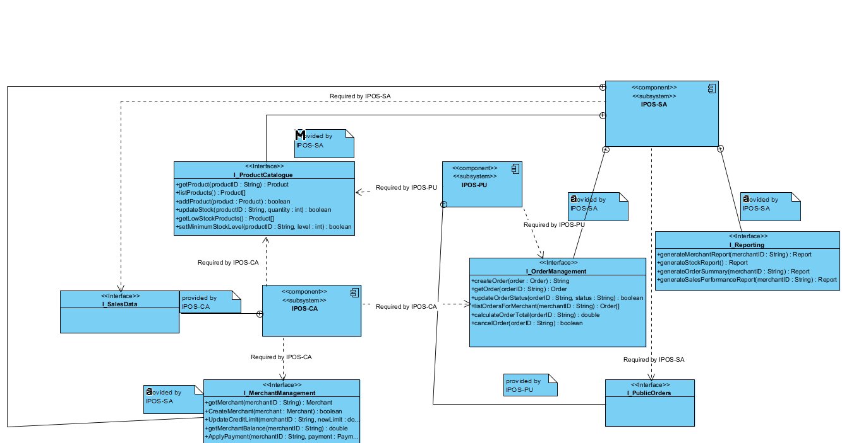

13/02/2026
Fixed the component diagram by switching the dependencies and containments to usages and realizations this fixes the design of the component diagram and makes it so that we can easily switch between the lollipop method and class method this took about 2 hrs since I had to watch the lecture capture then make the arrangements.

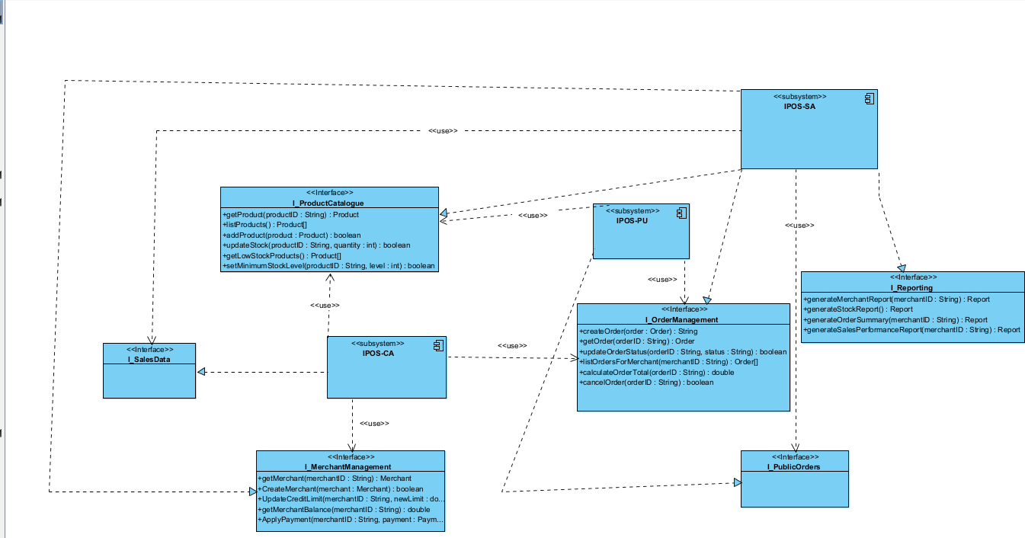
16/02/26
Meeting online 21:30-22:30 we talked about our component diagram and how the other teams haven’t completed it yet and how the use case diagram had some issues and so did the component diagram.

21/02/2026 – 22/02/2026
Worked on the class diagram turns out Nikki is pretty lazy and didn’t do much apart from the copy and paste the interfaces, so I revamped the implementation classes operations added constructors and required interfaces this took about 4 hours from 9pm-1am. I also devised a plan for our teammate Nikki to do the domain classes and do the relationships.
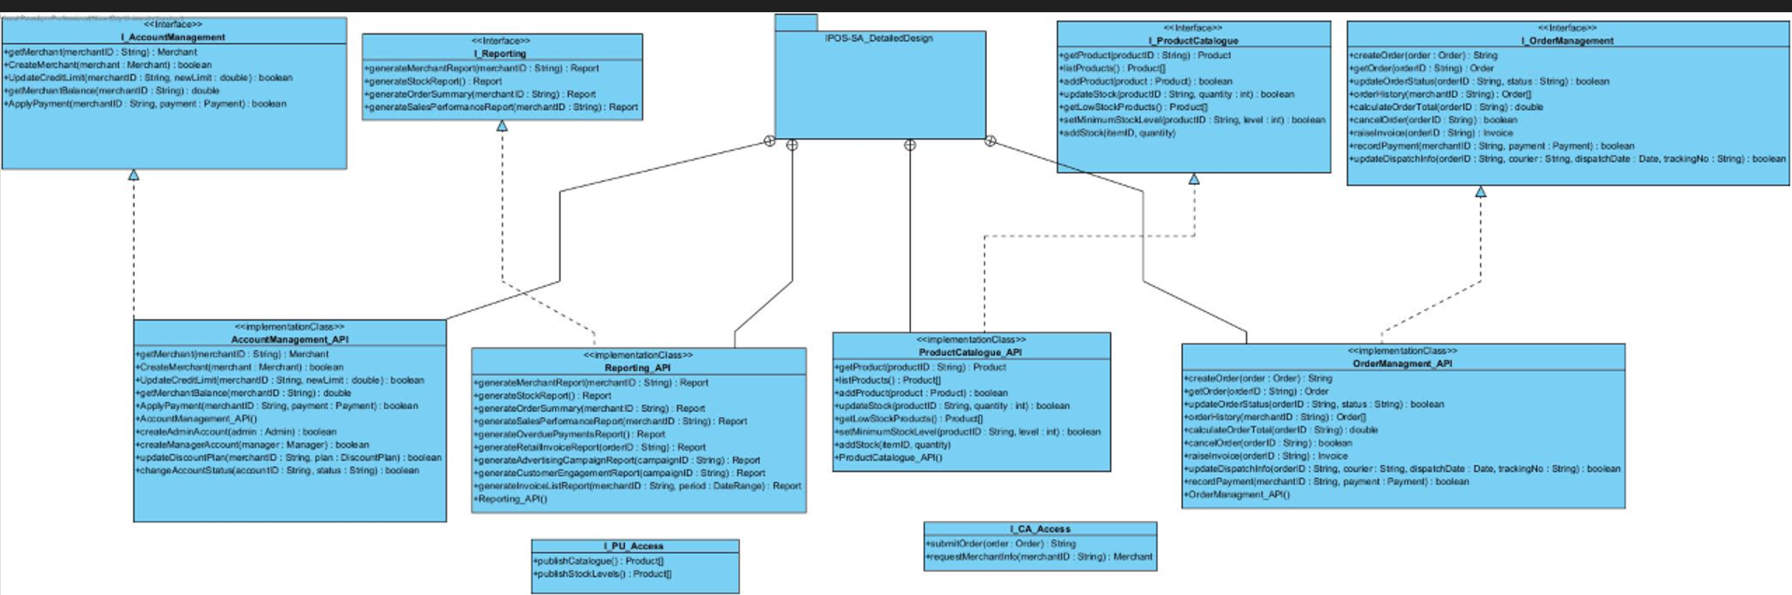

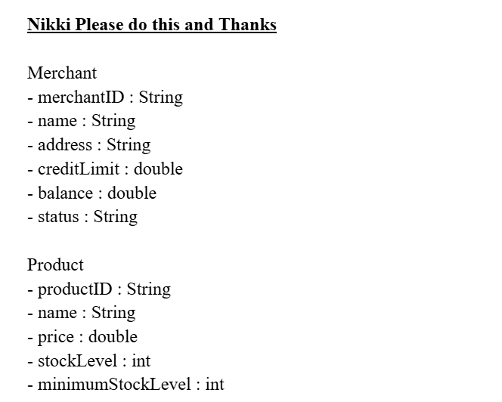 there were about 6-7 more classes after this image.

23/02/26
1 hour of meeting time from 19:30 – 20:30 about our completion and what we needed to work on more specifically about the tests class diagram and the java code generation.
About 2 hours trying to generate the java code for our project from visual paradigm I ran into an issue where the visual paradigm didn’t like the names and I was struggling to find out why and eventually worked it out.

24/02/26
5 hours of code generation coding work had to complete the “TODOS” in the implementation classes I struggled a lot doing it alone, but I finally got the job done OrderManagment_API,AccountManagment_API,Reporting_API,ProductCatalouge_API. There were some other issues in the component classes that were also finally completed as well.
1 hour of finishing touches of the component diagram and added it to the programming files as well.

