Report: Bucks Shot Chart

Elizabeth Kind

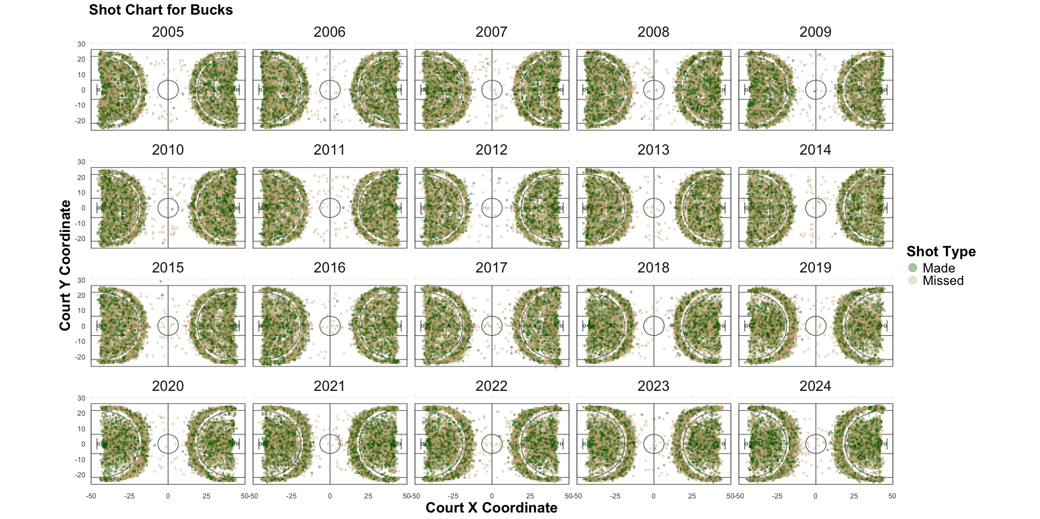

- The graphics created are of shot locations taken by the Milwaukee Bucks over 20 years (2005 to 2024).  
  
- The green dots represent shots taken and made, the tan dots represent shots taken but missed.  
  
- A trend is showing that both made shots and missed shots are being made more concentrated in the freethrow lane and right outside the 3-point line in recent years compared to older seasons.  
  
- A trend is showing where the Bucks are shooting from further outside of the 3-point line in recent years.  
  
- If 4-point line was created it would be about 30ft from the basket, and the Bucks overall score would increase by 0.59% if that was implimented.

The graphs created are of shot locations from the years 2005 to 2024 by the Milwaukee Bucks where the green data points are shots that are attempted and made whereas the tan data points are shots that are attempted but missed. When looking at the shots made, they've shown to be more evenly distributed within the 3-point line, but as time went on, it started to become more concentrated in the free throw lane and right outside the 3-point line. When looking at missed shots, it looks like more shots are being taken further outside the 3-point line in recent years compared to older seasons. How I came to these conclusions from both made shots and missed shots is by filtering made shots and missed shot separately and looking at the data points and looking at the patterns over 20 years of basketball for the Milwaukee Bucks  
   
   
 In addition to creating graphics of the Bucks shot locations, it was determined that if there was a 4-point line implimented at around 30ft from the basket, the Bucks overall score would increase by 0.59%, which is around 199.75 points increased per season. This is insignificant when it comes to the data we have since there are many games that happen during a season. However, if a 4-point shot was actually implemented, players would attempt it more often and therefore increase their score by more than 0.59. Because majority of the 3-point shots were taken just outside of the 3-point line it’s not surprising that their point increase is less than 1% if a 4-point line was implemented from previous years.