Código

clc

clear

x=[1 1 1 1];

m=[0,0,0,0];

N=4;

F=[0,2,4,6];

for k=1:N

c(k)=0;

for n=1:N

c(k)=c(k)+x(n).\*F(n);

C=c(k)/N;

end

if(abs(c(k))<1e-15)

c(k)=0;

end

Re=real(C);

Im=imag(C);

end

x1=[1,-1j,-1,1j];

for k=1:N

c(k)=0;

for n=1:N

c(k)=c(k)+x1(n).\*F(n);

C1=c(k)/N;

end

if(abs(c(k))<1e-15)

c(k)=0;

end

Re=real(C1);

Im=imag(C1);

end

x2=[1,-1,1,-1];

for k=1:N

c(k)=0;

for n=1:N

c(k)=c(k)+x2(n).\*F(n);

C2=c(k)/N;

end

if(abs(c(k))<1e-15)

c(k)=0;

end

Re=real(C2);

Im=imag(C2);

end

x3=[1,1j,-1,-1j];

for k=1:N

c(k)=0;

for n=1:N

c(k)=c(k)+x3(n).\*F(n);

C3=c(k)/N;

end

if(abs(c(k))<1e-15)

c(k)=0;

end

Re=real(C3);

Im=imag(C3);

end

a=[0 2 4 6];

m(1)=C;

m(2)=C1;

m(3)=C2;

m(4)=C3;

xlabel('alfa (a)');

ylabel('|F(a)|');

subplot 311; stem(a,abs(m));

Datos de salida

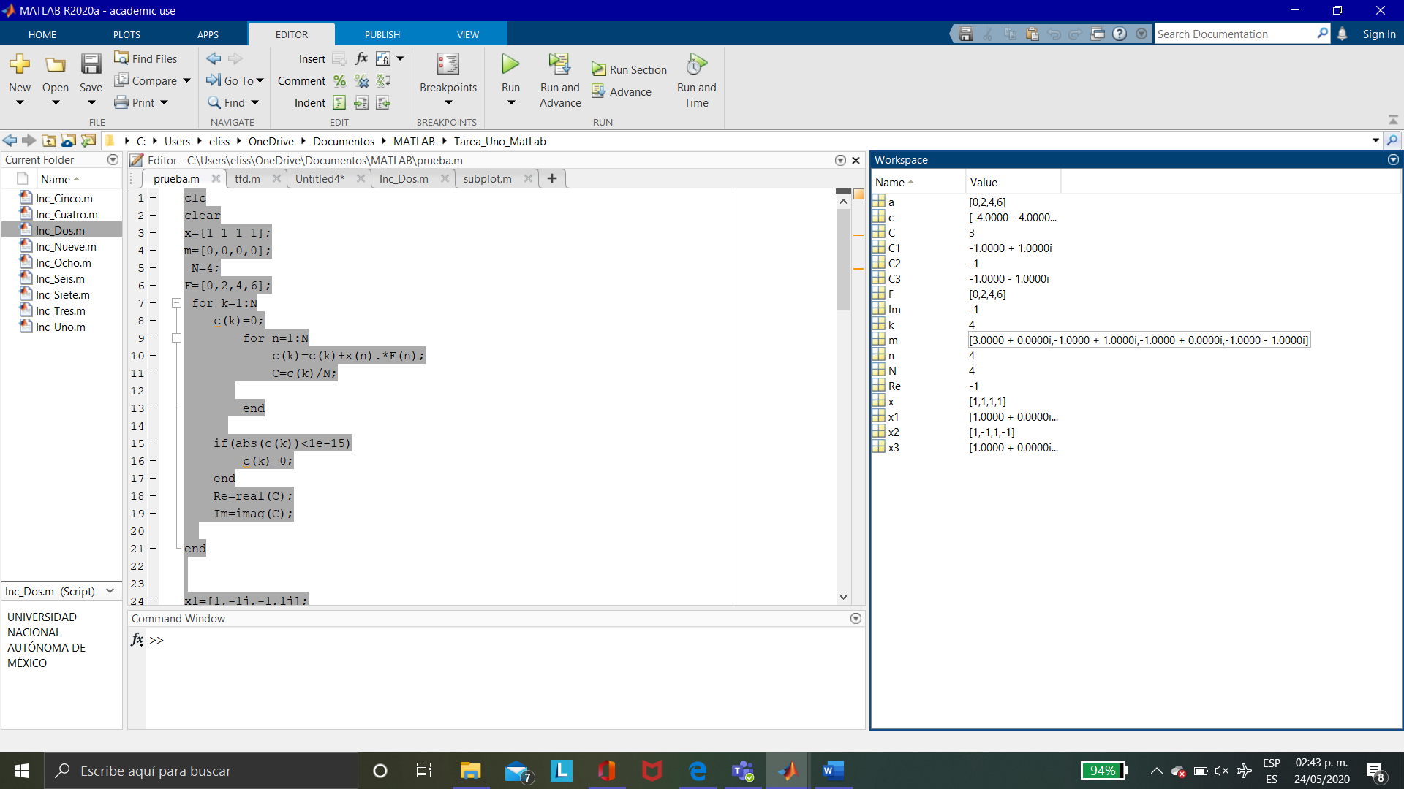

El vector m representa la matriz donde esta $\begin{matrix}c0 \\ ... \\ c3\end{matrix}$

Grafica

