Elizabeth Case

Glaciology – Spring 2018

**Modelling Firn Densification**

**Introduction**

Sea level change due to ice loss threatens coastal cities around the world; understanding the rate and magnitude of these changes depends on an accurate estimate of mass loss from ice sheets, ice caps and mountain glaciers. In addition to its role as a fundamental glaciological process, understanding firn densification is important for predictions of sea level rise, as well as for reconstructing past climate.

Satellite altimetry measures the change in height of the ice surface and assumes a density or density model to understand how much of that change is due to mass loss versus densification. Climate reconstructions from ice cores depend an accurate model of air diffusion through the firn pack; bubbles in the ice will be younger than ice crystals, affecting comparative measurements of CO2, methane, δ18O, etc.

This project looked at two models for dry firn densification, as well as data from the Korff Ice Rise taken with an autonomous phase-sensitive radar echo sounder (ApRES). This paper will describe the processes important to densification, step through both model derivations, discuss the methods used to extract downward velocity, density and densification from ApRES data, and describe the results of these methods.

**Physical processes in firn densification**

Firn begins as fresh snow around 300-350 kg m-3, and compacts primarily due to settling, packing, sintering, and other grain-deforming processes. Settling and packing involve reduction of pore space through movements of grains into lower energy positions. Sintering deforms the grains through preferential “rounding off” of edges. Three regimes of firn have been identified: 300-550 kg m-3 is a low-density regime where settling and packing dominate, and densification happens rapidly1; firn at 550-850 kg m-3 densify through grain-regime processes; and greater than 850 kg m-3, after the pore close-off depth, all densification is gained through compression of air bubbles. Other processes that affect the density profile include sublimation, which can form hoar layers and create distinct low density regions within the firn, and, in wet firn areas, meltwater percolation, storage and refreezing add latent heat to the system.

Firn densification depends primarily on temperature and overburden pressure (accumulation, in a steady-state regime); grain size also plays a role (grains grow as temperature increases, which affect settling and sintering processes). Surface winds (affects humidity, temperature), internal stress (adds heat), and the presence of meltwater (as described above) will also change the densification process’ these terms are not included in the models described here.

**Models**

*Herron and Langway*

Herron and Langway1 published a widely-used empirical model of firn densification based on 17 cores from Greenland and Antarctica. It assumes steady state (an invariant relation between rho and depth) under constant accumulation and temperature; the effects of these two variables are considered independently.

The form

$$\left(1\right) \frac{dρ}{\left(ρ_{i}-ρ\right)}= C*ρ*dh$$

was initially suggested by Robin and formulated by Schytt in 1958; this indicates a linear relationship between $\ln\left(\frac{ρ}{ρ_{i}-ρ}\right)$ and depth (see Figure 1 in results for linear fit to the Fletcher Promontory core). Rearranging, differentiating by time, setting $\frac{dh}{dt}=\frac{A}{ρ}$, and giving C a general form of C*=f(T)*f(A)* gives

$$\left(2\right) \frac{dρ}{dt}= k_{i}*A^{B_{i}}\left(ρ_{ice}-ρ\right)$$

where ki is taken to be an Arrhenius-type rate constant, $k_{i}=D*\exp\left(-\frac{E}{RT}\right)$, different for each density regime, and A is accumulation in mwe yr-1, raised to some power depending on the density regime it is in.

|  |  |  |  |
| --- | --- | --- | --- |
| k1 |  | k2 |  |
| B1 | 1 | B2 | 0.5 |

For each site, accumulation was determined from annual layers in the cores; in steady state, accumulation can be substituted for overburden pressure because it is the only source of “mass change” in the system – the only aspect that is changing the overburden pressure (which, without accumulation, would be constant).

From (2), Herron and Langway calculate depth-density to find critical transition depths and depth-age relationships. The former has no dependence, (“surprisingly”, from the authors) on accumulation, indicating perhaps that the density profile is controlled by other processes in shallow firn, or that the formulation of (2) does not adequately capture the effects of accumulation on densification.

$$\left(3\right) ρ_{h}\left(ρ<550\right)=\frac{ ρ_{ice}Z_{0}}{1+Z_{0}},where Z{}_{0}=\exp\left[ρ_{ice}k_{0}h+\ln\left(\frac{ρ_{0}}{ρ_{ice}-ρ_{0}}\right)\right]$$

$$\left(4\right) ρ_{h}\left(ρ=>550\right)=\frac{ ρ_{ice}Z_{1}}{1+Z_{1}},where Z{}_{1}=\exp\left[ρ_{ice}k_{0}(h-h_{550})/A^{0.5}+\ln\left(\frac{550}{ρ_{ice}-550}\right)\right]$$

See Figure 1 in results for this fit as compared to an ice core from the Fletcher Promontory.

*Arthern+ 2010*2

This model drew strongly from Herron and Langway, adding grain-size dependence and a partial physical theory for the form of the HL equation; it takes the same general form:

|  |  |  |
| --- | --- | --- |
| C0 | C1 | Source |
| $$\frac{\dot{b}}{ρ_{w}}11*\exp\left(-\frac{10160}{RT}\right)$$ | $${\left(\frac{\dot{b}}{ρ_{w}}\right)}^{0.5}575*\exp\left(-\frac{21400}{RT}\right)$$ | Herron and Langway |
| $$.07* \dot{b}g*\exp\left(-\frac{E_{c}}{RT}+\frac{E_{g}}{RT_{av}}\right)$$ | $$.03* \dot{b}g*\exp\left(-\frac{E_{c}}{RT}+\frac{E_{g}}{RT_{av}}\right)$$ | Arthern et. al |

Where $\dot{b}$ is accumulation rate in $\frac{kg}{m^{2} yr}$ and Ec and Eg are activation energies for creep and grain growth, respectively. Arthern extends Herron and Langway by coupling Narrbo-Herring creep and normal grain-growth, which are both (clearly) temperature-dependent processes. The general form of this coupling is

$$\left(5\right) \frac{dρ}{dt}=\frac{ σk_{c}\left(ρ_{ice}-ρ\right)\exp\left(-\frac{E_{c}}{RT}\right)}{r^{2}}$$

Arthern’s final form comes from assumptions made about grain growth (ignores initial grain size) and overburden pressure (as only dependent on accumulation) but this form can be numerically integrated where

$${ d}_{t}T=∂_{z}\left[α∂_{z}T\right]+L$$

$$d_{t}r^{2}=k_{g}e^{-\frac{E_{g}}{RT}}$$

$$d_{t}σ=\dot{b}g$$

where $α=\frac{κ}{ρ*c}, κ=2.1*{\left(\frac{ρ}{ρ_{i}}\right)}^{2}$, L = latent heat from water (ignored in this project).

Note that Arthern compared his results to firn cores / densification measurements that that reached max 700 kg / m^3; this may limit ability to assess compaction rate fits in high density regime.

*First principles derivation*3

The basic form relating the densification rate, the change in density in the firn pack, and downward velocity can be derived from first principles.

*Lagrangian view (material parcel)*

$$m=ρ*V$$

$$\frac{Dm}{Dt}=ρ*\frac{DV}{Dt}+V*\frac{Dρ}{Dt}$$

$$\frac{Dm}{Dt}=\dot{μ}, \frac{1}{V}\frac{DV}{Dt}=∇∙u$$

$$\left(6\right) \frac{Dρ}{Dt}=-ρ∇∙u+\dot{μ}$$

All analysis is done in one dimension in this paper. Thus, ignoring melt and horizontal strain, the downward velocity (w) can be derived from the compaction rate.

$$\left(7\right) w=\int_{z_{ice}}^{z}{\frac{1}{ ρ}\frac{Dρ}{Dt}dz}$$

where $\frac{Dρ}{Dt}$ is given by Herron and Langway’s or Arthern’s formulation for densification, for example, and zice is the pore-close-off depth or where firn reaches ice densities, depending on the compaction rate model limits. This velocity can then be plugged into a control-volume type mass conservation.

*Eulerian view (control volume)*

$$\left(8\right) \frac{∂ρ}{∂t}-∇∙ρu=0$$

This was the basis for the numerical solution to Arthern et al..

Ignored in this formulation is the non-linear response to stress of ice; certainly, individual crystals will respond nonlinearly to overburden pressure, but it is unclear how the firn responds as a whole. Cuffey and Patterson attempt this treatment, but the model fits observations poorly compared to Herron and Langway. This is left for future work.

**Data**

Two sets of data were used for this project: an ice core from the Fletcher Promontory, and model outputs from an inversion of ApRES profiles along the Korff Ice Rise by Kingslake et al. (2016)4.

The 34 ApRES profiles were taken at 125m intervals along the Korff Ice Rise. ApRES velocities were generated by differentiating the relative two-way travel time of individual reflectors to a bright reflector (the bed, for example) with time between measurements (here, about a year). These are corrected for density variation in a model that inverts strain rate for density.

**Results**

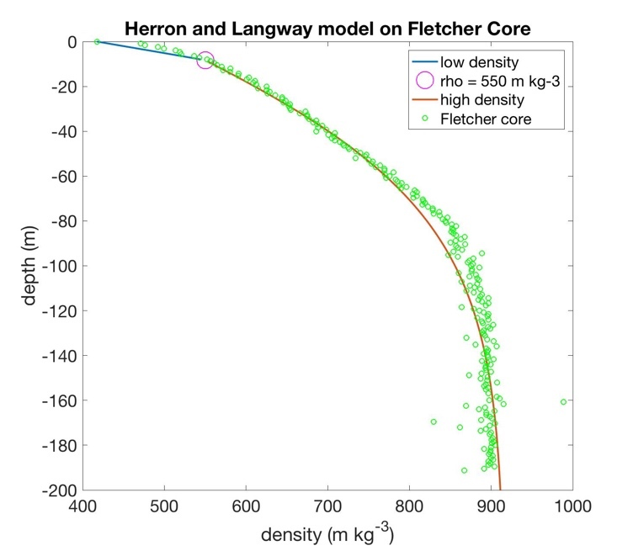

Figure 1: The Herron and Langway 2-density-regime model (eqns. 3 and 4) as compared to observed densities from the Fletcher Promontory Core. Accumulation = .38 mwe yr-1, ρ0=417.5 kg m-3, and T = 246.5 K, as stated in Mulvaney+ 20145.

Ice core densities were compared to the steady-state Herron and Langway model in Figure 1.

In the low density regime, the model underestimates the rate of densification – this could be a result of the model ignoring accumulation, or of a non-steady state regime that saw higher accumulation rates or temperatures in the past. Around 800 kg m-3, the model begins to underestimate the rate again. This is unsurprising – this is the regime right around pore-close-off depth, where bubble compression, a process ignored in Herron and Langway’s model, becomes dominant. All values for initial conditions were taken from Mulvaney et al. 2014.

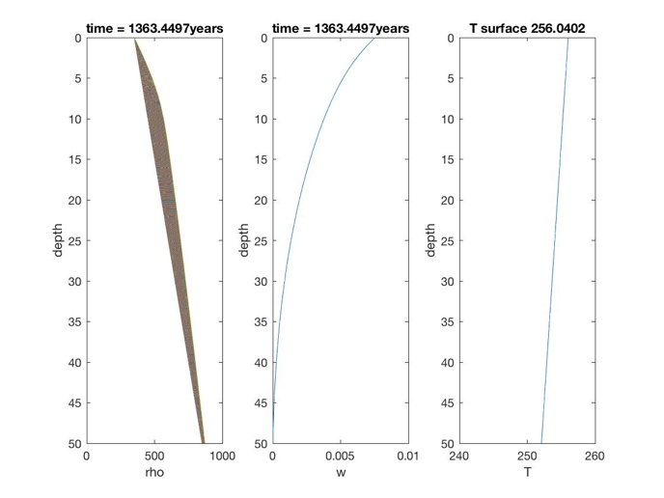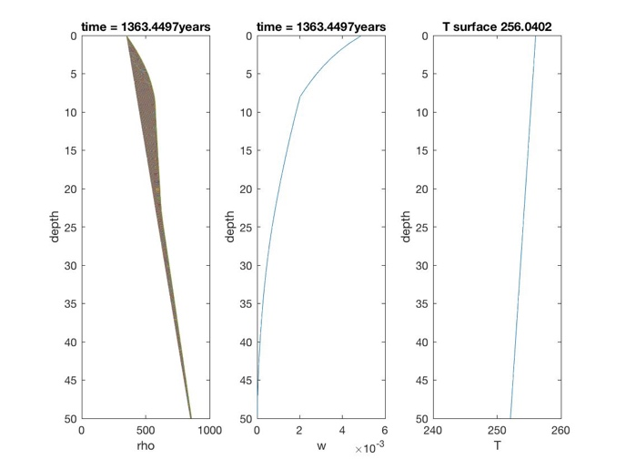

Figure 2b: 2 density regime Arthern+ model. Tav = 252, b = 950 kg/m3, r^2 = 1e-5, Ec = 60kJ. From eqn. 5

Figure 3a: 1 density regime Arthern+ model. Tav = 252, b = 950 kg/m3, r^2 = 1e-5, Ec = 60kJ. From eqn. 5

Figures 2a and 2b shows Arthern’s model in a non-steady state regime. 2a uses only c0 to update w; 2b uses c0 and c1 to update w in the two density regimes. r2 was held constant. There were a few difficulties encountered. The downward velocity is unrealistically slow, and the calculated densification rate (not shown) is likewise too small. Another problem is that this model doesn’t seem to reach steady state. This may be due to a boundary condition of w=0 at the base, so no ice is advecting out, or to the fact that the downward velocity is too small, so not enough light snow is being avected down. Then, because density is increasing with time (albeit more slowly, as the firn approaches ice density), all firn eventually compacts (this explanation, however, would indicate that there’s an issue with this model form – intuitively, there should be a point at which there is so little overburden pressure that compaction does not meaningfully occur). That said, the model produces a reasonable-looking density profile over time.

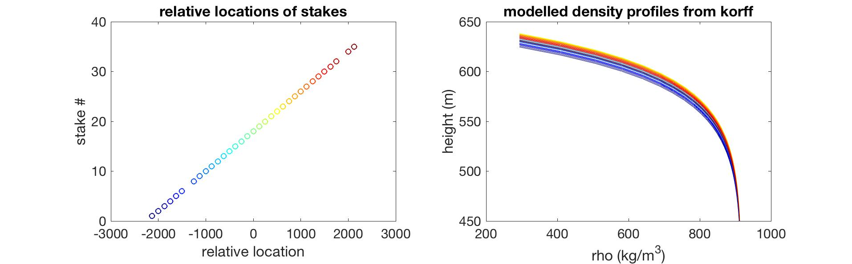

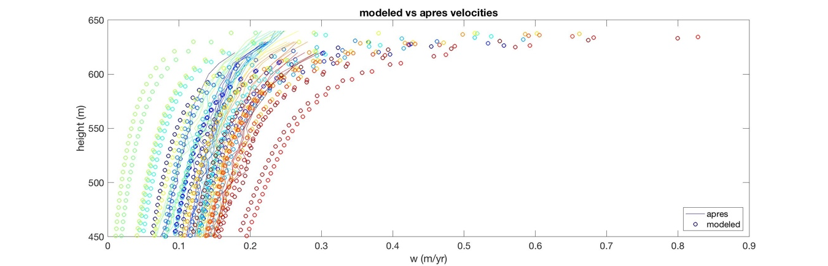

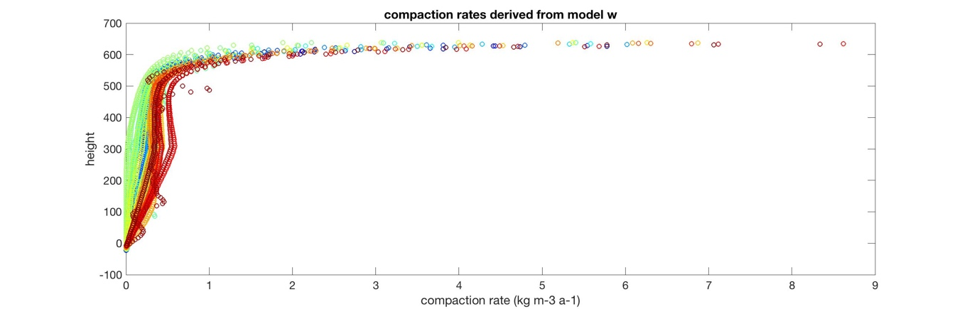

Figure 3a (relative location), 3b (density profiles), 3c (velocities), and 3d (compaction rates) look at the Korff ApRES data. Each location was color-coded so that relative densities, velocities and compaction rates could be compared. The modeled velocities have about twice the spread of raw ApRES velocities; counterintuitively, lower density profiles have the lowest compaction rates, medium compaction rates have the highest, and the densest firn has medium compaction rates. The compaction rate here was derived crudely from the modeled velocities $\frac{Dρ_{i}}{Dt}=ρ_{i}*(w_{i}-w{}_{i-1})/(z-z{}_{i-1})$ (see equation 7), but the values are sensible (increase of max of 9 kg/m3) in the firn pack; they should be ignored below the pore-off-depth, where any velocity component of the model is likely due to movement of the ice itself (or, of course, model uncertainty).

**Conclusions and future work**

This project looked at models for firn density and densification, as well as investigated some of the variation in the Korff Ice Rise ApRES data. The Herron and Langway model steady-state firn profiles, but does poorly when modelling densification rates (as per Arthern’s modelling). Arthern’s model realistically evolves the firn profile, but may do better at shorter time scales and with more accurate initial conditions (e.g. an exponential instead of a straight line).

Future work mainly involves more robust interrogation of the Korff profiles – namely, comparing densification rates to Arthern’s model and the community firn model. Moreover, the Korff data in and of itself is interesting – it belies the oft-assumed fact that density and compaction profiles over large regions are the same – compaction rates different by as much as 2x difference depending on location along the survey. Where does this variation come from? Are there wind or flow processes that could account for this? Is there stochastic variation in firn density depending on minor variations in accumulation due to blown snow or topography?

I also plan to interrogate sensitivity of a variety of models to parameters (T, b, E) to understand if different climate regimes should use different parameterizations.

Additionally, Arthern’s model has been approved upon since 2010 to try to incorporate percolation, melt and refreezing; these are key processes in wet areas. While it is clear that water presence increases densification rate, it is unclear how this might change the shape of the density profile in the firn pack, what the influence of ice lenses is within the firn pack for rerouting heat transfer, etc. None of the models presented here capture the stochastic variation in observed density profiles.

Finally, bubble compression could be added as a third density regime.

**Bibliography**

1. Herron, M. M. & Langway, C. C. Firn Densification: An Empirical Model. *J. Glaciol.* **25,** 373–385 (1980).

2. Arthern, R. J., Vaughan, D. G., Rankin, A. M., Mulvaney, R. & Thomas, E. R. In situ measurements of Antarctic snow compaction compared with predictions of models. *J. Geophys. Res. Earth Surf.* **115,** F03011 (2010).

3. Cuffey, K.M., P., W. S. B. *The Physics of Glaciers*. (Elsevier, 2010).

4. Kingslake, J., Martín, C., Arthern, R. J., Corr, H. F. J. & King, E. C. Ice-flow reorganization in West Antarctica 2.5 kyr ago dated using radar-derived englacial flow velocities. *Geophys. Res. Lett.* **43,** 2016GL070278 (2016).

5. Mulvaney, R., Triest, J. & Alemany, O. The James Ross Island and the Fletcher Promontory ice-core drilling projects. *Ann. Glaciol.* **55,** 179–188 (2014).