Product Inventory Management

Project Documentation
Team Members:
- ​Elizabeth Mary Roberts
- Nedha Thasef.H
- Rafathunissa.S
- Kowsalya.N
- 1. Introduction
The Product Inventory Management System is developed using Node.js, Express.js, and MongoDB. This system allows users to register, log in, create products, and delete products using REST APIs. API testing is performed using Thunder Client in Visual Studio Code.
2. Technologies Used
- Node.js
- Express.js
- MongoDB
- JWT Authentication
- Thunder Client
- Visual Studio Code

3.STEP-BY-STEP IMPLEMENTATION
Step 1: User Registration
The user sends a POST request to:
/api/v1/auth/register
The request contains:
- Name
- Email
- Password
If the registration is successful, the server returns “Register successful” along with a JWT token.
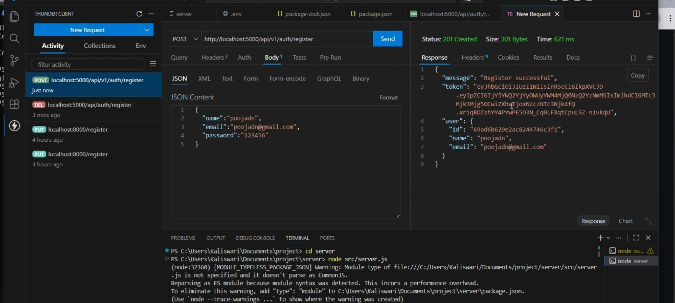

Step 2: User Login
The user logs in using a POST request to:
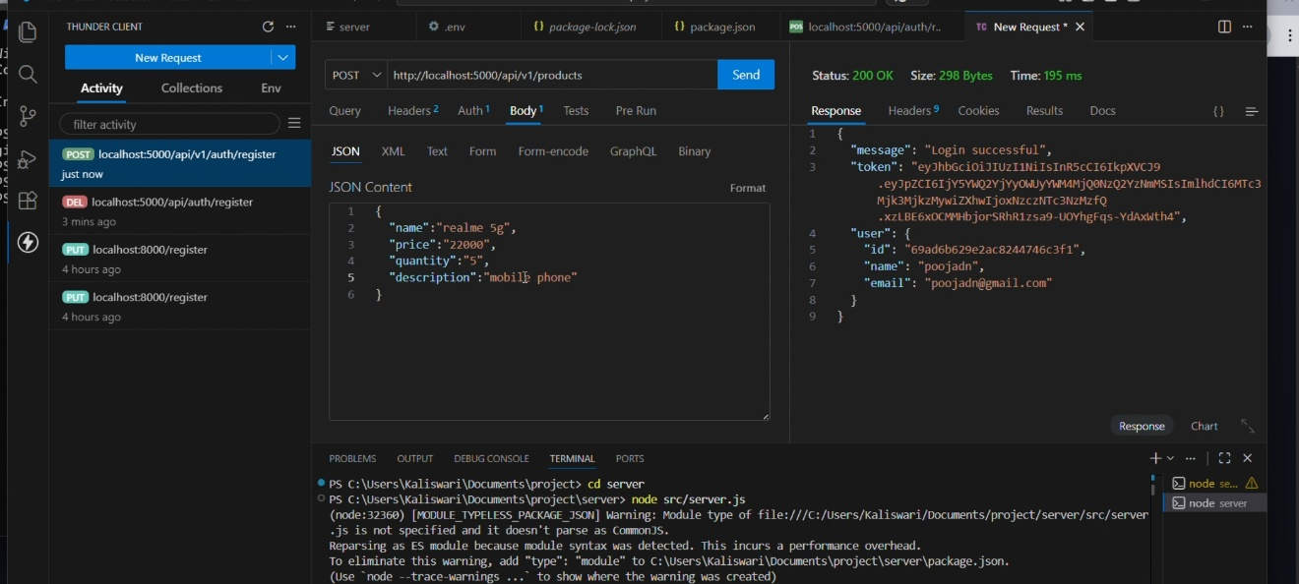
/api/v1/auth/login
After successful authentication, the system returns a login success message and a JWT token.

Step 3: Create Product
A POST request is sent to:
/api/v1/products
Product details include:
- Product Name
- Price
- Quantity
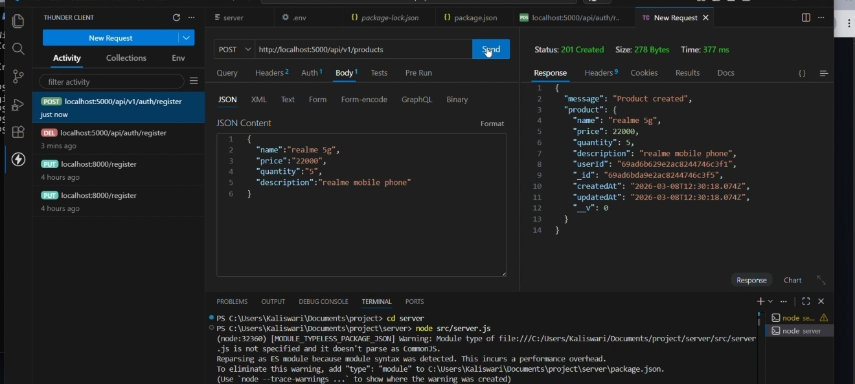
- Descriptions

The product is stored in the database and the server returns “Product created”.

Step 4: Delete Product
A DELETE request is sent to:
/api/v1/products/:id

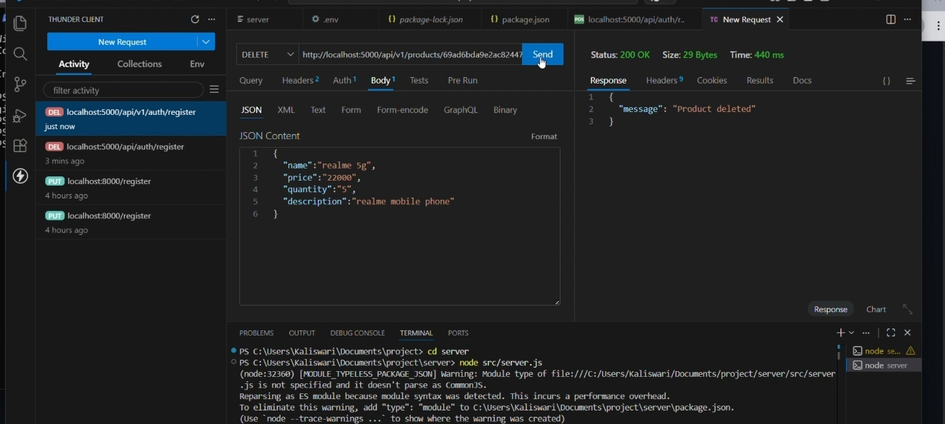

The system deletes the product from the database and returns “Product deleted”.
Step 5: Server Running
The server is started using the command:
Node src/server.js
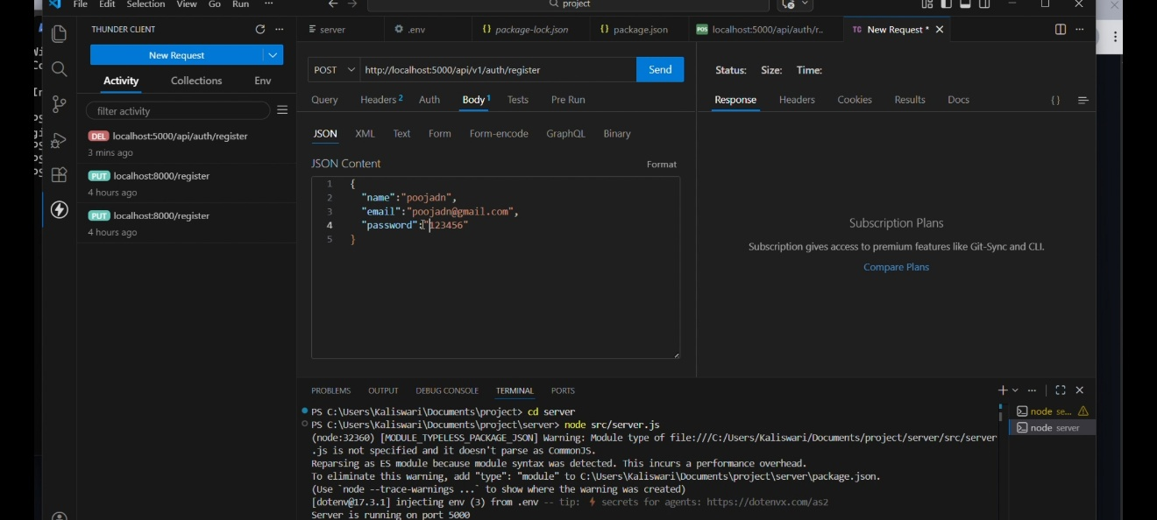

The terminal confirms that the server is running on port 5000.
4. Conclusion
The Product Inventory Management System successfully demonstrates user authentication and product management using REST APIs. Thunder Client is used to test and verify the API responses, ensuring that registration, login, product creation, and deletion work correctly.

