1. Вывести количество преподавателей кафедры “'Кафедра фундаментальной математики и механики”

SELECT COUNT(Teachers.Name) AS [Количество преподавателей]

FROM Departaments, Groups, GroupsLectures, Lectures, Teachers

WHERE Departaments.Name = 'Кафедра фундаментальной математики и механики' and Teachers.Id = Lectures.TeacherId

and Lectures.Id = GroupsLectures.LectureId and GroupsLectures.GroupId=Groups.Id and Departaments.Id = Groups.DepartamentId

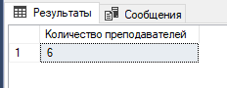

2. Вывести количество лекций, которые читает преподаватель “Владимир Стоумов”

SELECT COUNT(\*) AS [Количество лекций]

FROM Lectures, Teachers

WHERE Teachers.Name = 'Владимир' and Teachers.Surname = 'Стоумов' and Teachers.Id = Lectures.TeacherId

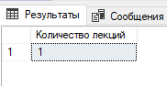

3. Вывести количество занятий, проводимых в аудитории 101.

SELECT COUNT(Subjects.Name) AS [Количество занятий]

FROM Lectures, Subjects

WHERE LectureRoom = 101 and Subjects.Id = Lectures.SubjectId

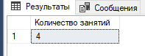

4. Вывести названия аудиторий и количество лекций, проводимых в них.

SELECT LectureRoom, COUNT(Lectures.SubjectId) AS [Количество лекций]

FROM Lectures, Subjects

WHERE Subjects.Id = Lectures.SubjectId group by LectureRoom

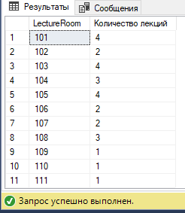

5. Вывести количество студентов, посещающих лекции преподавателя “Александр Калашников”

SELECT COUNT(Students.NameSurname) AS [Количество студентов]

FROM Lectures, Teachers, GroupsLectures, Groups, Students

WHERE Teachers.Name = 'Александр' and Teachers.Surname = 'Калашников' and Teachers.Id = Lectures.TeacherId and Lectures.Id = GroupsLectures.LectureId

and Groups.Id = GroupsLectures.GroupId and Students.GroupId = Groups.Id

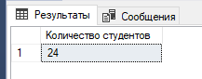

6. Вывести среднюю ставку преподавателей факультета “Факультет психологии”.

SELECT AVG(Salary) as [Средняя ставка преподавателей]

FROM Departaments, Groups, GroupsLectures, Lectures, Teachers, Faculties

WHERE Faculties.Name = 'Факультет психологии' and Teachers.Id = Lectures.TeacherId

and Lectures.Id = GroupsLectures.LectureId and GroupsLectures.GroupId=Groups.Id and Departaments.Id = Groups.DepartamentId

and Faculties.Id = Departaments.FacultyId

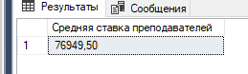

7. Вывести минимальное и максимальное количество студентов среди всех групп.

SELECT min(Gr.Student) AS [Минимальное количество студентов], max (Gr.Student) as [Максимальное количество студентов]

FROM (Select count (Students.GroupId) as [Student]

From Students, Groups

Where Students.GroupId = Groups.Id

Group by Groups.Name) as [Gr]

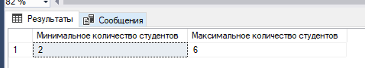

8. Вывести средний фонд финансирования кафедр.

SELECT AVG(Financing) as [Средний фонд]

FROM Departaments

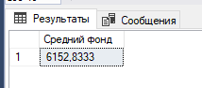

9. Вывести полные имена преподавателей и количество читаемых ими дисциплин

SELECT Teachers.Name+ ' ' +Teachers.Surname AS 'Преподаватели', COUNT(Subjects.Name) as [Количество дисциплин]

FROM Teachers, Subjects, Lectures

Where Teachers.Id = Lectures.TeacherId and Lectures.SubjectId = Subjects.Id group by Teachers.Name, Teachers.Surname

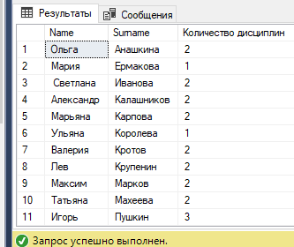

10. Вывести количество лекций в каждый день недели.

SELECT DayOfWeek, COUNT(SubjectId) as [Количество лекций]

FROM Lectures

group by DayOfWeek

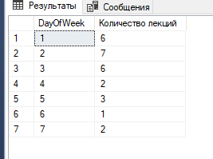

11. Вывести номера аудиторий и количество кафедр, чьи лекции в них читаются.

SELECT LectureRoom, Subjects.Name, Count(DepartamentId) as [Количество кафедр]

FROM Lectures, Departaments, Subjects, Groups, GroupsLectures

Where Subjects.Id = Lectures.SubjectId and Lectures.Id = GroupsLectures.LectureId and Groups.Id = GroupsLectures.GroupId

and Departaments.Id = Groups.DepartamentId

group by LectureRoom, Subjects.Name

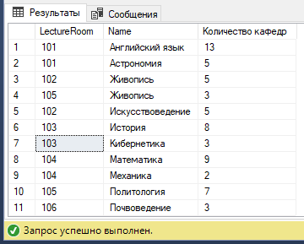

12.Вывести названия факультетов и количество дисциплин, которые на них читаются.

SELECT Faculties.Name, Count(SubjectId) as [Количество дисциплин]

FROM Lectures, Departaments, Subjects, Groups, GroupsLectures, Faculties

Where Subjects.Id = Lectures.SubjectId and Lectures.Id = GroupsLectures.LectureId and Groups.Id = GroupsLectures.GroupId

and Departaments.Id = Groups.DepartamentId and Faculties.Id = Departaments.FacultyId

group by Faculties.Name

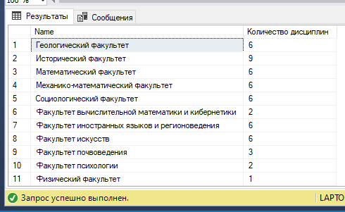

13. Вывести количество лекций для каждой пары преподаватель-аудитория.

SELECT Teachers.Name +' '+ Teachers.Surname +' '+ LectureRoom as [Преподаватель-аудитория], Count(Lectures.Id) as [Количество лекций]

FROM Lectures, Teachers, Groups, GroupsLectures

Where Teachers.Id = Lectures.SubjectId and Lectures.Id = GroupsLectures.LectureId and Groups.Id = GroupsLectures.GroupId

group by Teachers.Name, Teachers.Surname, LectureRoom

