Liz Skerritt

Homework 1

Syllabus Screenshot

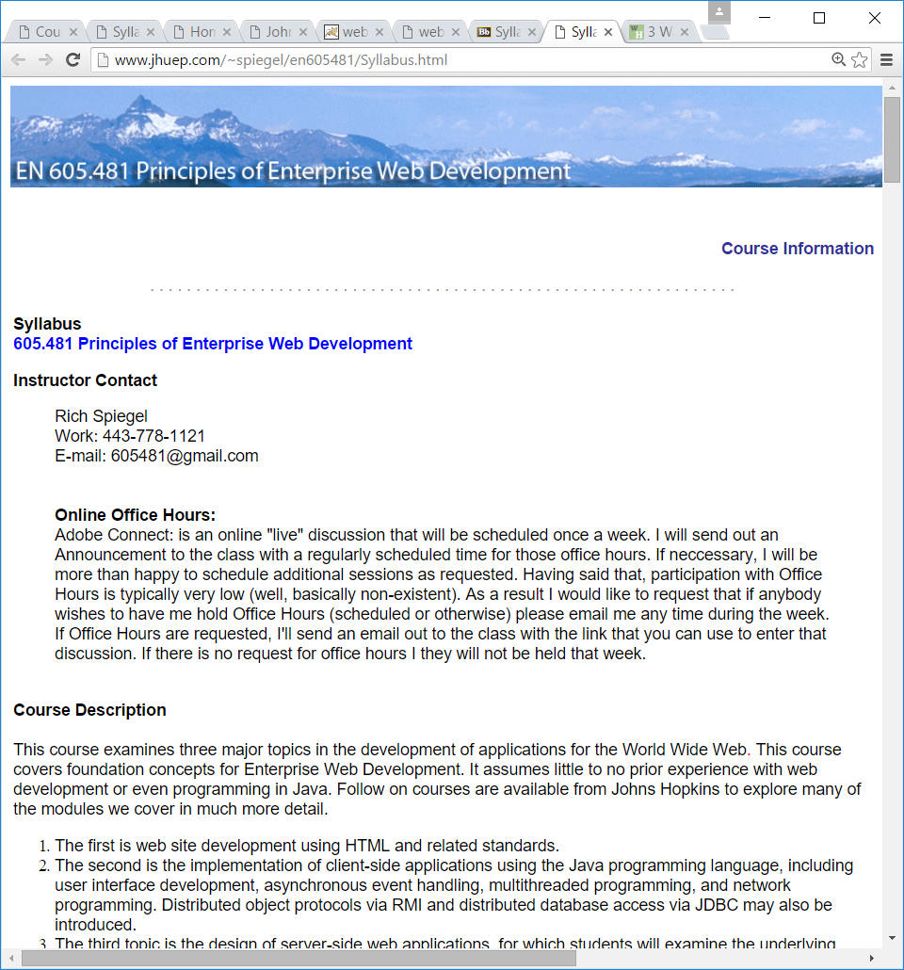

Course Content Screenshot

