Liz Skerritt

Web Development

Module 3, 2/12/16

XHTML Website:

<http://web6.jhuep.com/~eskerri1/HW3/HikingWebsite.xhtml>

Validation:

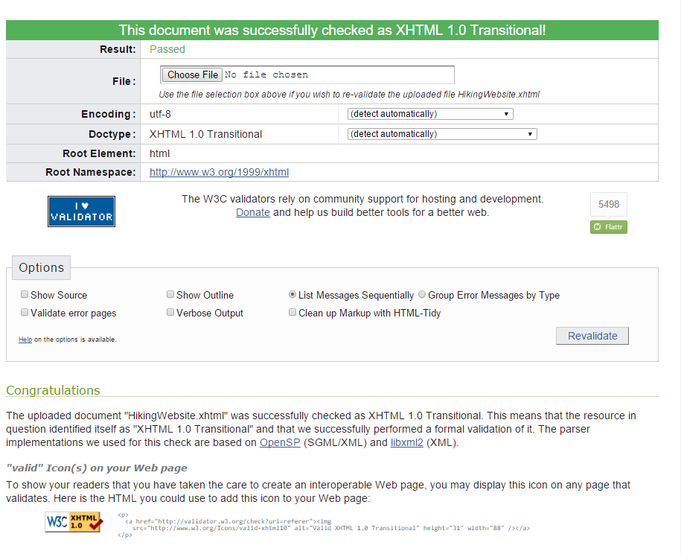

Java Zip File:



Main Class Name:

cplusplus.Module3

Java program in action:

