|  |  |  |
| --- | --- | --- |
| **Student Name** |  | **Student Number** |
| Eliza Gamal |  | 2331425 |

**Portfolio Introduction**

**Workshop Activities 50% Weighting**

**Mini Project 50% Weighting**

**This completed portfolio will need submitting to Canvas by the due date.**

**Questions please email**

**Dr Sarah Slater**

**s.i.slater@wlv.ac.uk**

**Portfolio**

Contents

Workbook 1 4

Activity 1.1: Actual voltage across 5V breadboard pins. 4

Activity 1.2: Actual voltage across 3.3V breadboard pins. 4

Activity 1.3: Potential Divider Calculations 4

Activity 1.4: 3V Calculations from either the 5V supply or 3.3V supply 5

Activity 1.5: Voltage Divider circuit readings from Breadboard circuit. 6

Activity 1.6: LED Circuits 6

Activity 1.7: Current Measurement 7

Activity 1.8: Fritzing for 4 switches & LEDS 9

Activity 1.9: Fritzing for Number 0-7 10

Workbook 2 11

Activity 2.1: LED Flashing to show decimal number 63 as binary. 11

Activity 2.2: 4 LED’s for counting up in binary from 0 to 15. 12

Activity 2.3: Traffic Lights 15

Workbook 3 17

Activity 3.1: Circuit Diagram of Button & LED 17

Activity 3.2: 3 Switches & Led 19

Activity 3.3: 8 Buttons & LEDs (SWITCH STATEMENTS) 21

Workbook 4 23

Activity 4.1: Serial Port 23

Activity 4.2: Serial Port binary to decimal 26

Activity 4.3: Calibrating Analogue Information 28

Activity 4.4: Temperature Sensor & Serial Port 31

Workbook 5 33

Activity 5.1: RGB Led and switches 33

Activity 5.2: Distance Sensor 35

Activity 5.3: 1602 LCD Display 37

Workbook 6 40

Activity 6.1: PWM 40

Workbook 7 42

Activity 7.1: 2 Arduinos – using Digital Pins 42

Activity 7.2: 2 Arduinos – using Serial I/O 44

Workbook 8 46

Activity 8.1: Stepper Motor Circuit Diagram 46

Activity 8.2: 2 Stepper Motors 48

Workbook 9 49

Activity 9.1: Windscreen Wiper Code using Servos & Temperature Sensor 49

Individual Project (50%) 51

Rationale 51

Timescales 51

Equipment 51

The Project 51

Step 1 produce adetailed description of your project. 51

Step 2 Circuit Diagram&Fritzing Schematic 51

Step 3 A Program 52

Step 4 Testing 52

Step 5 Conclusions 52

Layout 52

Marking 52

All sections carry equal marks. 52

If you prefer, you may use Tinkercad to show a component layout, rather than a circuit Diagram in Fritzing or other circuit design software, though a circuit diagram is more useful as this is what you would most likely see if you were working on embedded systems.

# Workbook 1

## Activity 1.1: Actual voltage across 5V breadboard pins.

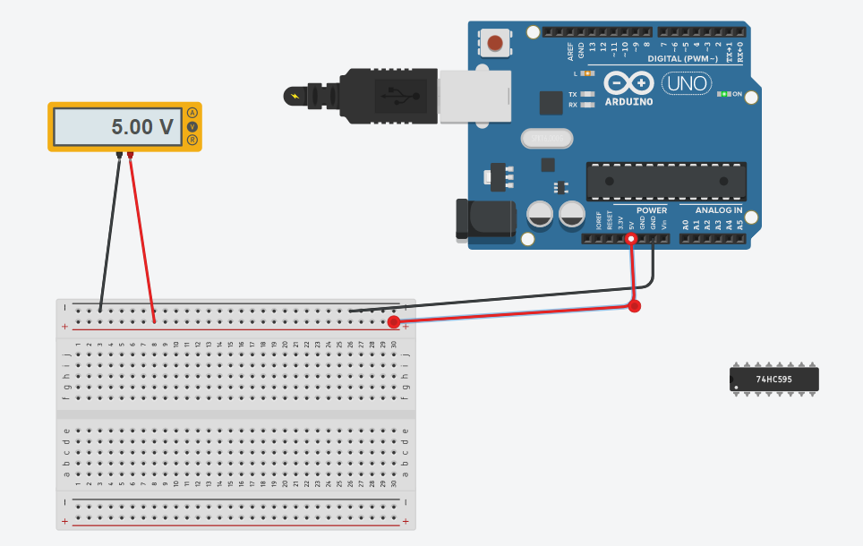

## Activity 1.2: Actual voltage across 3.3V breadboard pins.

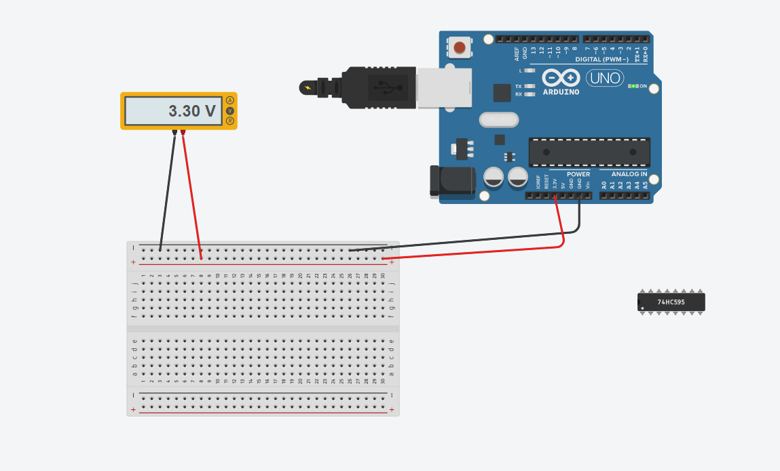

**Explain in around 100 words why you think the value read by a multi meter on a circuit, may be different to a simulator value such as Tinker-Cad.**

Due to the real-world parameters that a Multimeter takes into consideration, the value that it reads may differ from a simulator like TinkerCad. Electrical engineers and professionals utilize two key tools: TinkerCad and the Multimeter. While the TinkerCad computer-aided design program provides a virtual platform for circuit modeling, the Multimeter is a real tool used to measure the voltage, current, and resistance of a circuit. The real readings from a multimeter, which account for elements like wire resistance, voltage drop between components, and interference, may differ from the theoretical numbers produced using TinkerCad. For the best circuit design and analysis, it is crucial to understand the benefits and limits of both tools and employ them effectively.

**If the read value is 4.84V on a 5V supply, what would be a sensible tolerance to quote, explain your answer.**

Depending on how accurate the measurement must be, the proper tolerance for a certain application must be chosen. The variance is 3.2%, for instance, if the target value is 5V and the measured value is 4.84V. For some applications, a tolerance of +/-5% would be enough, and a variance of up to 0.25V would be acceptable. Nevertheless, a tolerance of merely +/-1% may be required in circumstances requiring great accuracy, such as with medical equipment or scientific instruments, allowing for a fluctuation of up to 0.05V. It's critical to take into account the possible repercussions of even little departures from the target value. When choosing a tolerance, it's important to consider the system's unpredictability, the desired accuracy, and the expense of reaching tighter tolerances. Ultimately, it's a balance between accuracy and feasibility.

## 

## Activity 1.3: Potential Divider Calculations

Show the working on how you achieved 2.5V

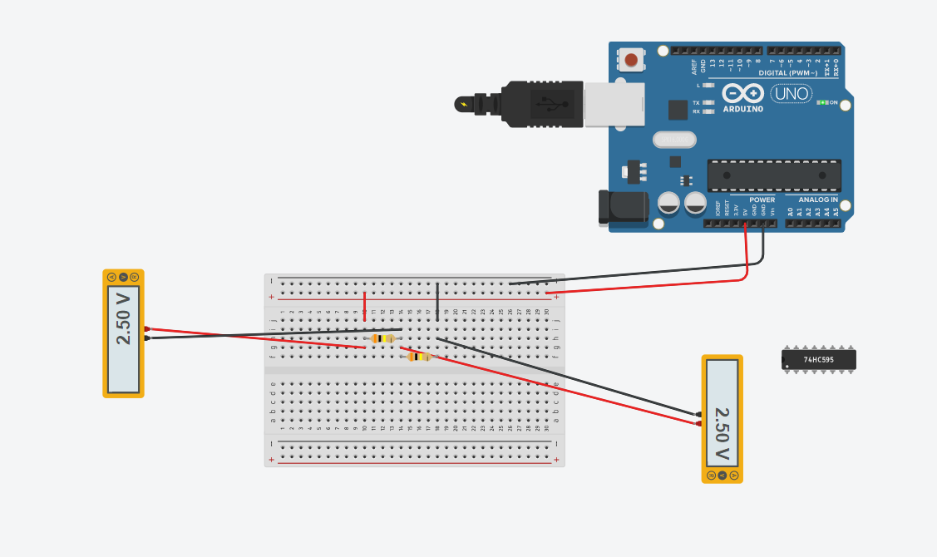

By using two resistors of 2200Ohms in series we can drop the potential difference across

it by 2.5 in 5V Supply

## Activity 1.4: 3V Calculations from either the 5V supply or 3.3V supply

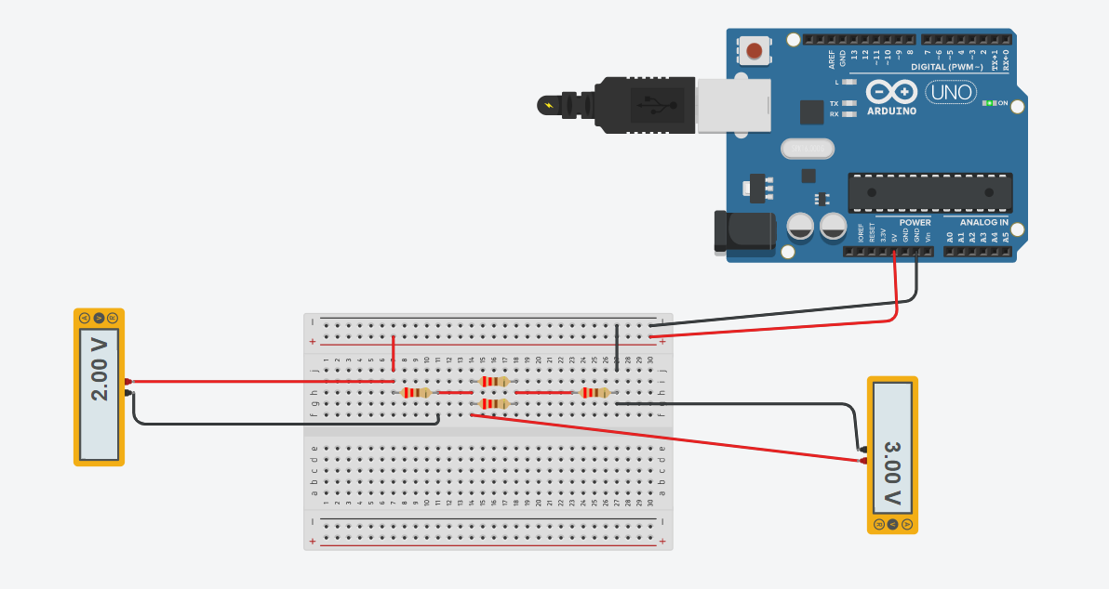

To obtain a voltage of 3V from a 5V supply with a resistor of 330 ohms, the following calculations can be made: Assuming only a 220 ohms resistor is available, the voltage obtained will be 2V using the formula:

Voltage Out = Vin x R1 / (R1 + 220)

To obtain the remaining 1V, a resistor of 110 ohms is needed, which can be achieved by placing two 220 ohms resistors in parallel:

1/Rp = 1/R1 + 1/R2 = 2/220

Rp = 110 ohms

The required total resistance (Rt) can then be obtained by combining the 220 ohms resistor and the 110 ohms resistor in series:

Rt = R1 + Rp = 220 + 110 = 330 ohms

Therefore, to obtain a voltage of 3V from a 5V supply with only a 220 ohms resistor available, a resistor with a value of 110 ohms and the existing 220 ohms resistor can be connected in series to achieve the required total resistance of 330 ohms.

## Activity 1.5: Voltage Divider circuit readings from Breadboard circuit.

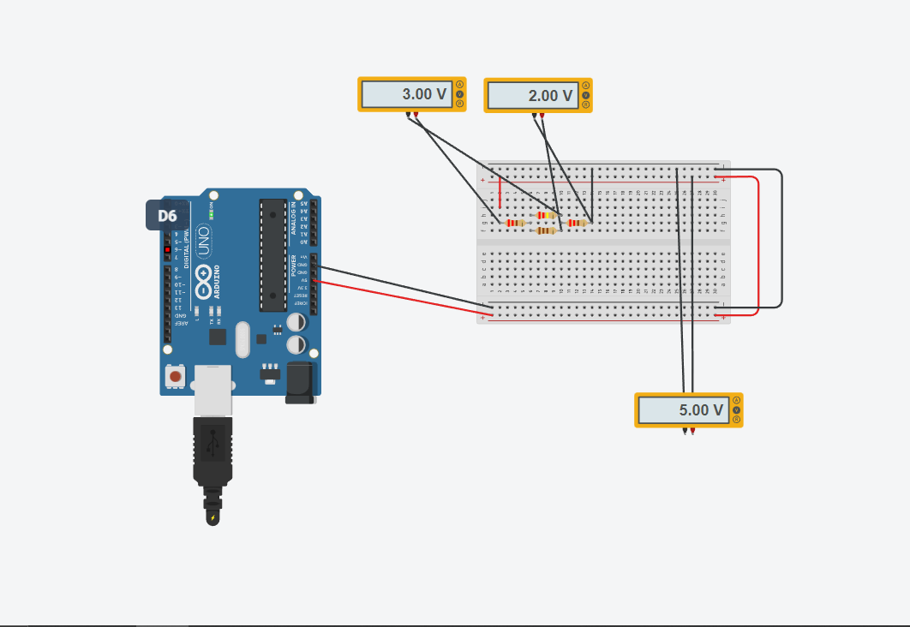

We may create three distinct resistances using a combination of resistors, especially a series connection of a 330-ohm resistor and a 220-ohm resistor, as well as a parallel connection of two 220-ohm resistors. Hence, various voltages may be produced using these resistances. A voltage of 3.6 V is produced by the 330-ohm resistor, whereas a voltage of 2 V is produced by the 220-ohm resistor. By mixing different resistances in series and parallel arrangements, this design offers extra flexibility in attaining desired voltages.

## Activity 1.6: LED Circuits

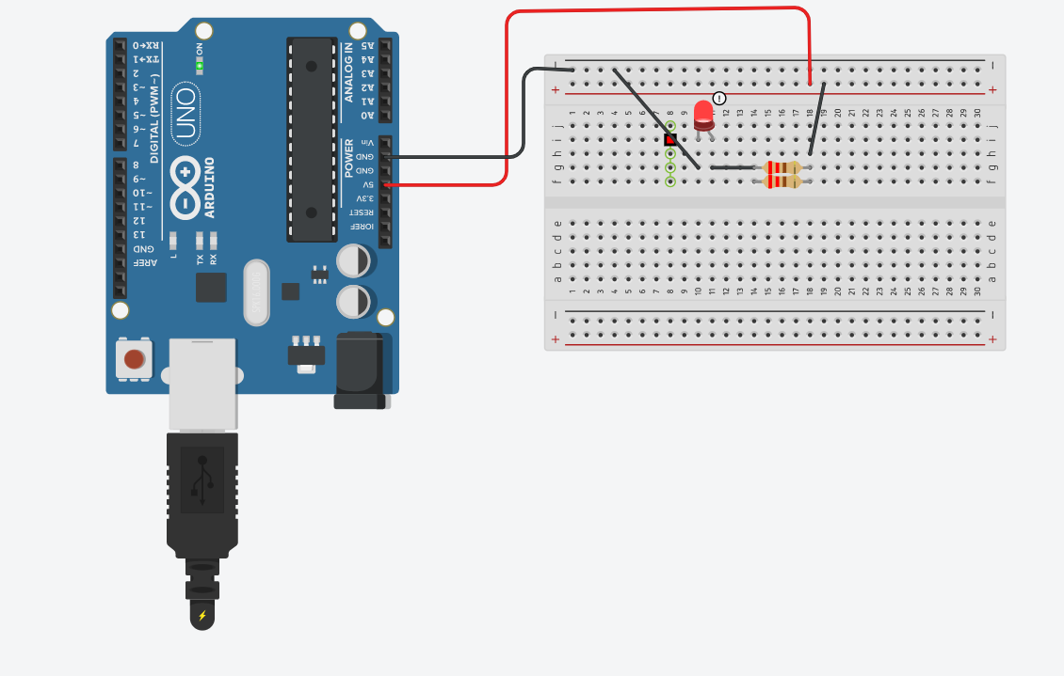

**Each resistor Value**

220 Ohm

220 Ohm

**Total resistance Calculation**

The total resistance (Rt) can be calculated by using the formula:

1/Rt = 1/R1 + 1/R2, where R1 and R2 are the two resistor values.

Substituting the values of R1 and R2 as 220 ohms, we get:

1/Rt = 1/220 + 1/220

Simplifying this equation, we get:

1/Rt = 2/220

1/Rt = 1/110

Therefore, the total resistance (Rt) is equal to 110 ohms.

**Measured Resistance**

211-ohm

**If measured resistance is not the same, why not? If you simulated this, why might the real value be**

**different.**

Due to variations in the wire's length and cross-sectional area, the actual resistance of a resistor may vary. Certain elements could have an impact on the resistance, leading it to vary from its present value.

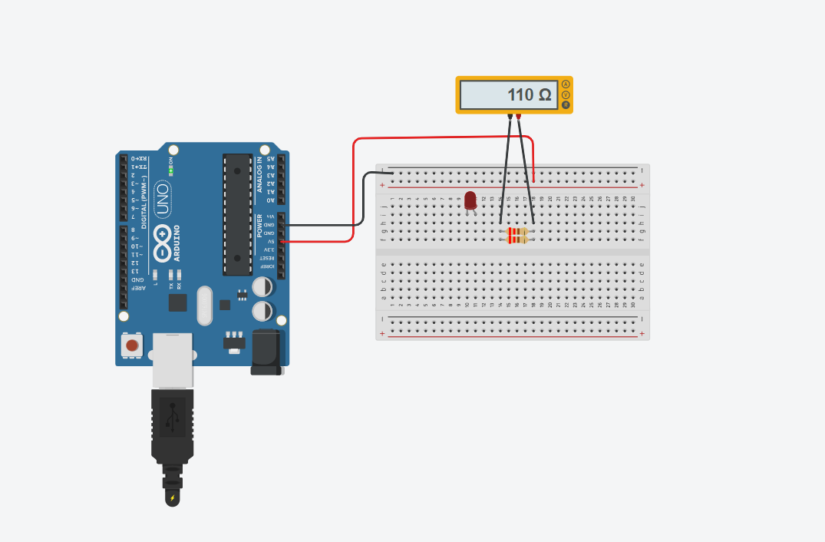

## Activity 1.7: Current Measurement

Calculation of current flowing into LED

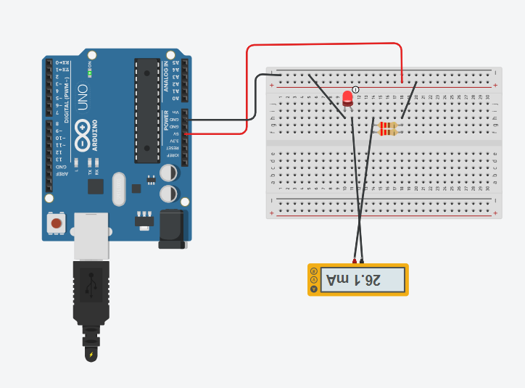

V=5V

R=110ohm

I=?

Now,

I=VR

=5/110

=0.045 A

Actual measured value of current

0.0451 A

Why might they be different?

45.45 mA is current flowing through the circuit

26.1 mA is the current flowing through LED

The recorded result may differ from the real measurement because of the added resistance from several sources, such the breadboard, cables, and even the multimeter itself, which might affect the current flow.

## Activity 1.8: Fritzing for 4 switches & LEDS

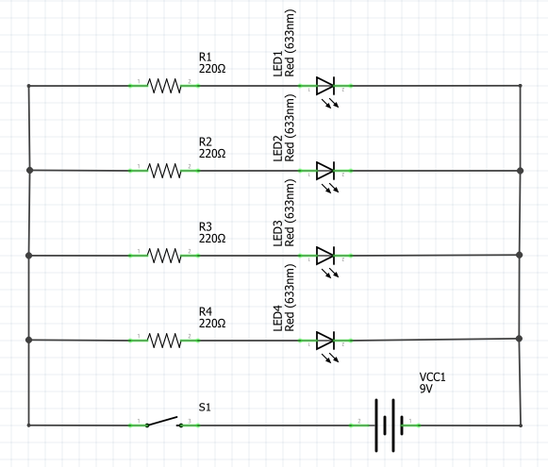

# Activity 1.9: Fritzing for Number 0-7

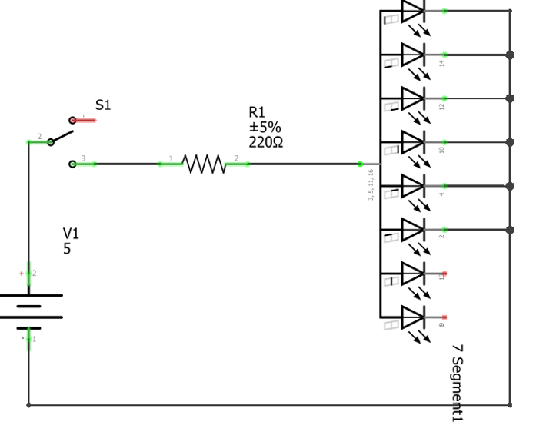

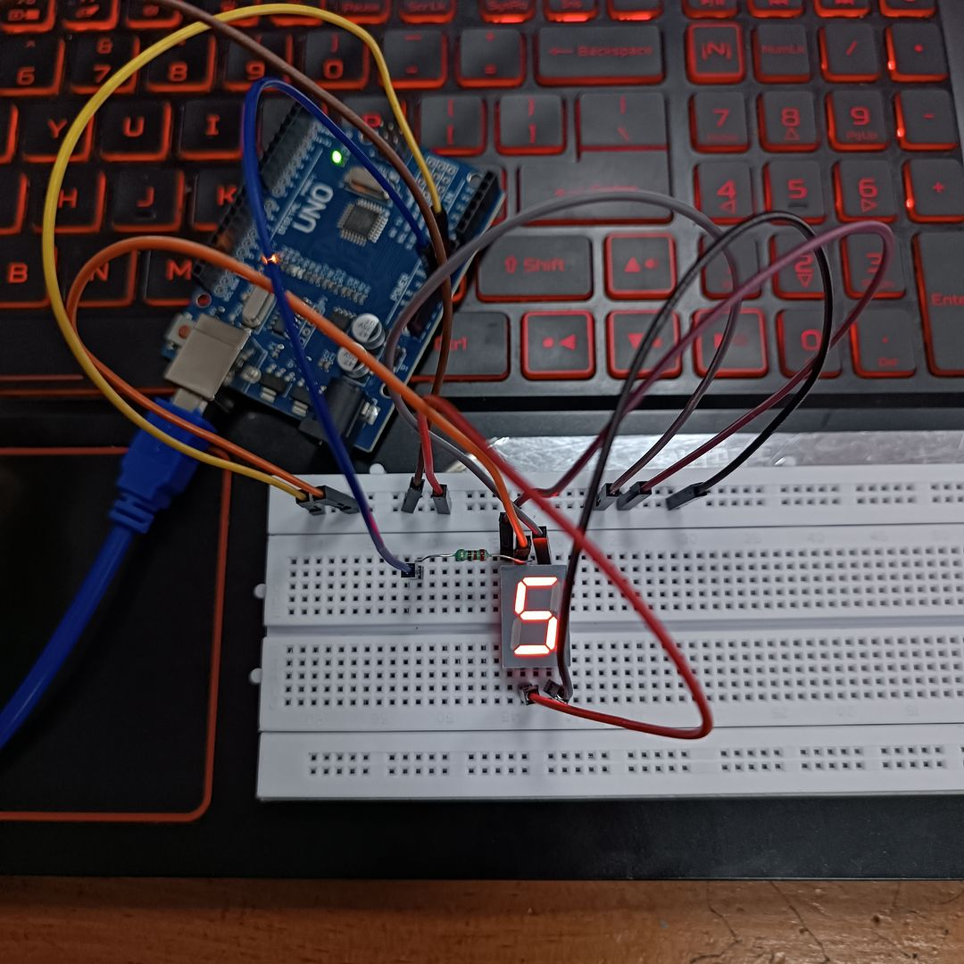

# Workbook 2

## Activity 2.1: LED Flashing to show decimal number 63 as binary.

63 as binary, including working

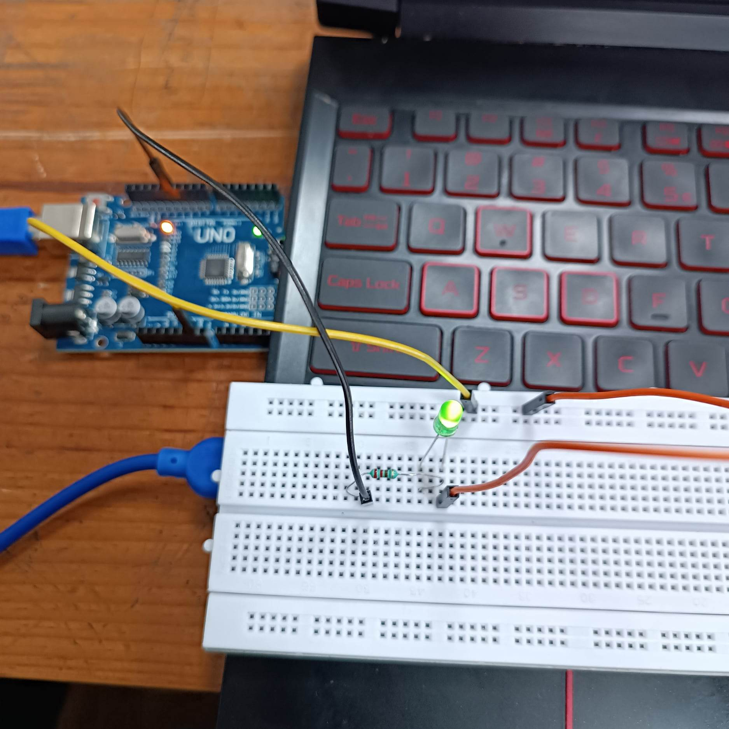

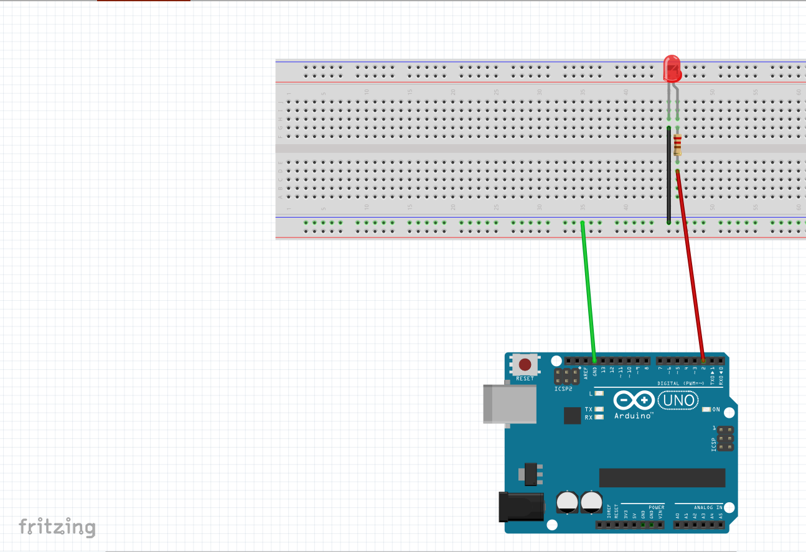

(111111)^2 is the binary representation of the number 63. The first pair occupies rank 63 in this binary value. The cathode is linked to 0V GND to turn on the LED, while the anode is connected to 13V through a resistor to turn it on in state 1. Up until the LED is switched on, the frame will stay on. The LED is repeatedly lit in the example below, with a 5-second internal delay between each occurrence.

Copy & Post your code with a suitable comment at the top of code with your name & student number ☺

// This code display 63 decimal Numbers in binary

// Student Id: 2331425

//Student Name: Eliza Gamal

   // The setup function runs once when you press reset or power the board

   void setup() {

   // initialize digital pin LED_BUILTIN as an output.

   pinMode(4, OUTPUT);

  }

   // the loop function turns the LED on and off in a pattern that represents the binary digits of number 63

  void loop() {

  for(int a=0;a<7;a++){

  digitalWrite(4, HIGH);  // turn the LED on (HIGH is the voltage level)

  delay(1000);                      // wait for a second

  digitalWrite(4, LOW);   // turn the LED off by making the voltage LOW

  delay(1000);     }   // wait for a second

   }

## Activity 2.2: 4 LED’s for counting up in binary from 0 to 15.

Fritzing Circuit diagram for Step 4 i.e. 4 LEDs

iiiiiiiiii

Arduino Program for Step 4 i.e. 4 LEDs

//name:Eliza Gamal

//Student id: 2331425

int ledone = 12; //initializing led 1 in 12

int ledtwo = 11; //initializing led 1 in 11

int ledthree=10; //initializing led 1 in 10

int ledfour=9; //initializing led 1 in 9

void setup() {

// put your setup code here, to run once:

pinMode(ledone, OUTPUT); // setup pin 1 as led one

pinMode(ledtwo, OUTPUT); // setup pin 2 as led two

pinMode(ledthree, OUTPUT); // setup pin 1 as led three

pinMode(ledfour, OUTPUT); // setup pin 1 as led four

}

void loop() {

// put your main code here, to run repeatedly:

binary(0,0,0,0); //all the led will be off

binary(0,0,0,1); // all the led except last one will be off

binary(0,0,1,0); //all the led except third one will be off

binary(0,1,0,0); //all the led except second one will be off

binary(0,1,0,1); // the led will be off and on and repeat the same

binary(0,1,1,0); //the led will be on except first and last

binary(0,1,1,1); //all the led will be on except first

binary(1,0,0,0); //all the led will be off except first one

binary(1,0,0,1); //all led will be off except first and last

binary(1,0,1,0);//the led will be on and off and repeat the same

binary(1,0,1,1); //all led will be on except second one

binary(1,1,0,0);//the first two led will be on

binary(1,1,0,1);//all led except third one will be on

binary(1,1,1,0);//all led except last one will be on

binary(1,1,1,1);//all led will be on

}

void binary(int a, int b, int c , int d)

{

digitalWrite(ledone,a);

digitalWrite(ledtwo,b);

digitalWrite(ledthree,c);

digitalWrite(ledfour,d);

delay(1000);//wait for 1000 milliseconds

}

## Activity 2.3: Traffic Lights

Fritzing Circuit diagram for Step 4 i.e. 4 LEDs

Arduino Program for Step 4 i.e. 4 LEDs

# Workbook 3

## Activity 3.1: Circuit Diagram of Button & LED

Fritzing

## Activity 3.2: 3 Switches & Led

Fritzing Circuit Diagram

Arduino Program

## Activity 3.3: 8 Buttons & LEDs (SWITCH STATEMENTS)

Fritzing

Arduino Program

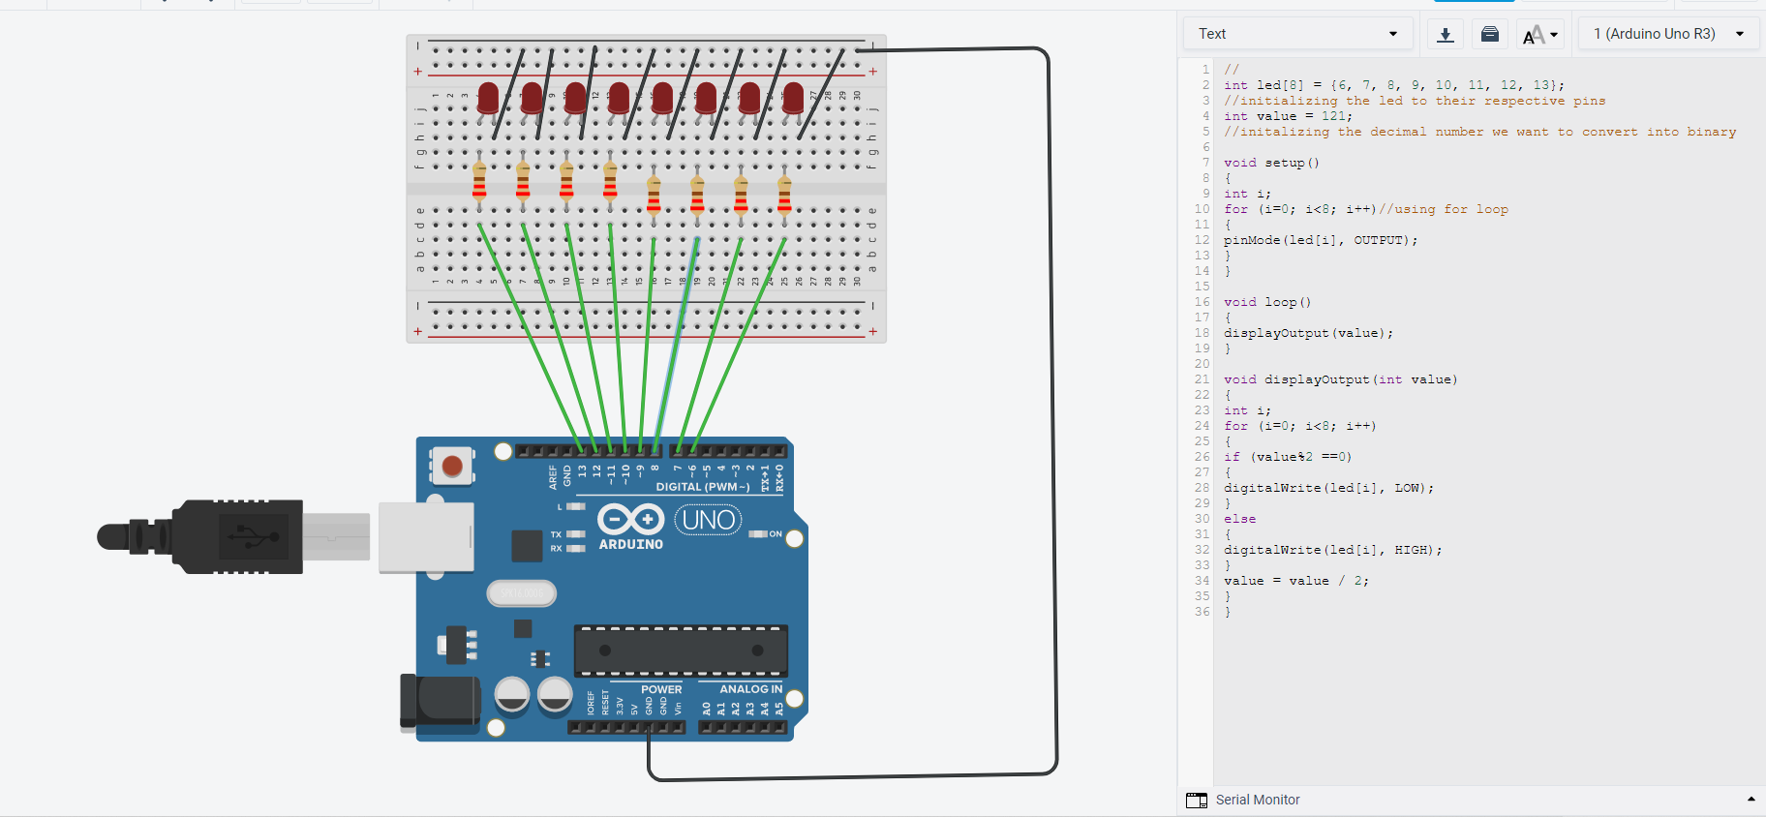

# Workbook 4

## Activity 4.1: Serial Port

Fritzing

Arduino Program

Screen Shot of Serial Port

## Activity 4.2: Serial Port binary to decimal

Code

Screen Shot of Serial Port

## Activity 4.3: Calibrating Analogue Information

Code

Pot Resistance Clockwise

Pot Resistance Anti-clockwise

Sample of Values

Pot Resistance against Voltage change

|  |  |
| --- | --- |
| Pot Resitance | Voltage Measured |
|  |  |
|  |  |
|  |  |
|  |  |
|  |  |

Screen Shot of Meaningful Serial Port Output, not just numbers

## Activity 4.4: Temperature Sensor & Serial Port

Code - Centigrade to Serial port, but when button Pressed Fahrenheit Displayed Instead

Screen Shot of Serial Port

# Workbook 5

## Activity 5.1: RGB Led and switches

Fritzing

Arduino Program

## Activity 5.2: Distance Sensor

Arduino Code

Take a picture of your distance sensor and include it here, please reduce the size and quality as it will be too large else ☺

## Activity 5.3: 1602 LCD Display

Fritzing

Arduino Program

Take a picture of your LCD and include it here, please reduce the size and quality as it will be too large else ☺

# Workbook 6

## Activity 6.1: PWM

Fritzing

Arduino Program

# Workbook 7

## Activity 7.1: 2 Arduinos – using Digital Pins

Fritzing

Arduino Program

## Activity 7.2: 2 Arduinos – using Serial I/O

Fritzing

Arduino Program

# Workbook 8

## Activity 8.1: Stepper Motor Circuit Diagram

Circuit Diagram

Arduino Program

## Activity 8.2: 2 Stepper Motors

Arduino Program

# Workbook 9

## Activity 9.1: Windscreen Wiper Code using Servos & Temperature Sensor

Arduino Code

# Individual Project (50%)

## Rationale

Throughout the module you have used a range of sensors and actuators with an Arduino to complete weekly tasks. For the mini project we would like you to research and create a small embedded project in an area of your choice, such as:

* Games
* Networking
* IT Security
* Systems Engineering
* Smart Technology
* Artificial Intelligence

Previous projects have included a reaction game that gives a score depending on how fast you hit a button, this has buttons to restart the application, and an LCD to show scores, and information.

This project should be your own work, YOU MUST NOT COPY A PROJECT FROM THE INTERNET.

## Timescales

This project should be started around week 5 and continue until the deadline, when it will be submitted in the Portfolio.

## Equipment

You are free to use Tinkercad, or your own kit.

## The Project

### Step 1 produce adetailed description of your project.

This should clearly describe what you are intending to build and may contain some diagrams of how the sensor/switches input is to be processed by the Arduino. Then what kind of output is intended to be seen or heard by the user. Please mention any tools you intend to use.

### Step 2 Circuit Diagram&Fritzing Schematic

You are required to produce a circuit diagram of your work showing any calculations you made, so these might be suitable resistor values for any LED’s you use. These calculations are covered on the module. The circuit diagram should not be hand drawn but should follow the format of circuits from the module.

### Step 3 A Program

You will need to write some software for this project and a listing of the code with suitable comments will need to be included.

### Step 4 Testing

You will be required to produce some suitable test data that you would expect to be able to measure such as voltages, test code.

Once your prototype is complete you will be expected to test your circuit and compare the actual values to your initial test data, and comment on the results.

### Step 5 Conclusions

You are required to write a summary of the work along with a short half page reflection on how you found the work.

### Layout

The report should be suitably laid out for a report, using headings, references if required in Harvard style, and appendices used for any lengthy code. All diagrams should be produced on a PC, and hand-written work is not acceptable.

### Marking

# All sections carry equal marks.