# Data Explanation

The data is an export from Clickhouse in TSV format.

## Column Set for metrics_collector:

account_id, name, point, call_count, total_call_time, total_exclusive_time, min_call_time, max_call_time, sum_of_squares, instances, language, app_name, app_id, scope, host, display_host, pid, agent_version, labels

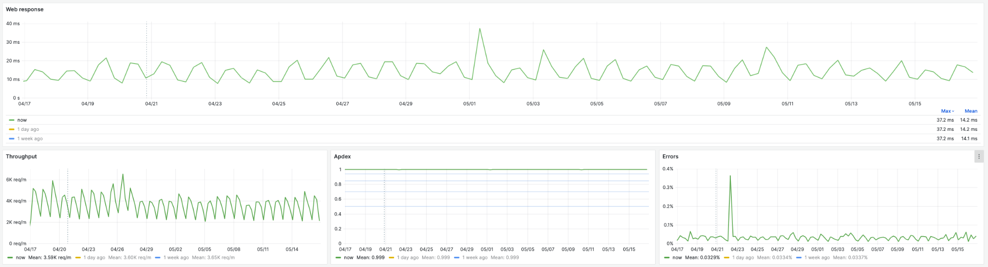

## Key Metrics for Initial Analysis:

### Web Response:

Service response time for external HTTP requests.

select  
 point as time,  
 sumOrNull(total_call_time) / sumOrNull(call_count) as " "  
from metrics_collector  
where  
 language = 'java'  
 and app_name = '[GMonit] Collector'  
 and scope = ''  
 and name = 'HttpDispatcher'  
group by time  
order by time

### Throughput:

Service throughput, measured in requests per minute.

select  
 point as time,  
 sumOrNull(call_count)  
from metrics_collector  
where  
 language = 'java'  
 and app_name = '[GMonit] Collector'  
 and scope = ''  
 and name = 'HttpDispatcher'  
group by time  
order by time

### APDEX:

A synthetic health index for the service, ranging from 0 to 1. The closer to 1, the better.

with  
 sumOrNull(call_count) as s,  
 sumOrNull(total_call_time) as t,  
 sumOrNull(total_exclusive_time) as f  
select  
 point as time,  
 (s + t/2) / (s + t + f) as " "  
from metrics_collector  
where  
 language = 'java'  
 and app_name = '[GMonit] Collector'  
 and scope = ''  
 and name = 'Apdex'  
group by time  
order by time

### Error:

Percentage of errors in processed requests.

select  
 point as time,  
 sumOrNullIf(call_count, name='Errors/allWeb') / sumOrNullIf(call_count, name='HttpDispatcher') as " "  
from metrics_collector  
where  
 language = 'java'  
 and app_name = '[GMonit] Collector'  
 and scope = ''  
 and name in ('HttpDispatcher', 'Errors/allWeb')  
group by time  
order by time

## Examples of Labeled Anomalies

1. Throughput: April 19, 2024, 07:15 - 08:00 UTC

2. Throughput: April 20, 2024, 06:20 - 07:10 UTC, followed by  
 - Web Response: April 20, 2024, 07:20 - 07:40 UTC

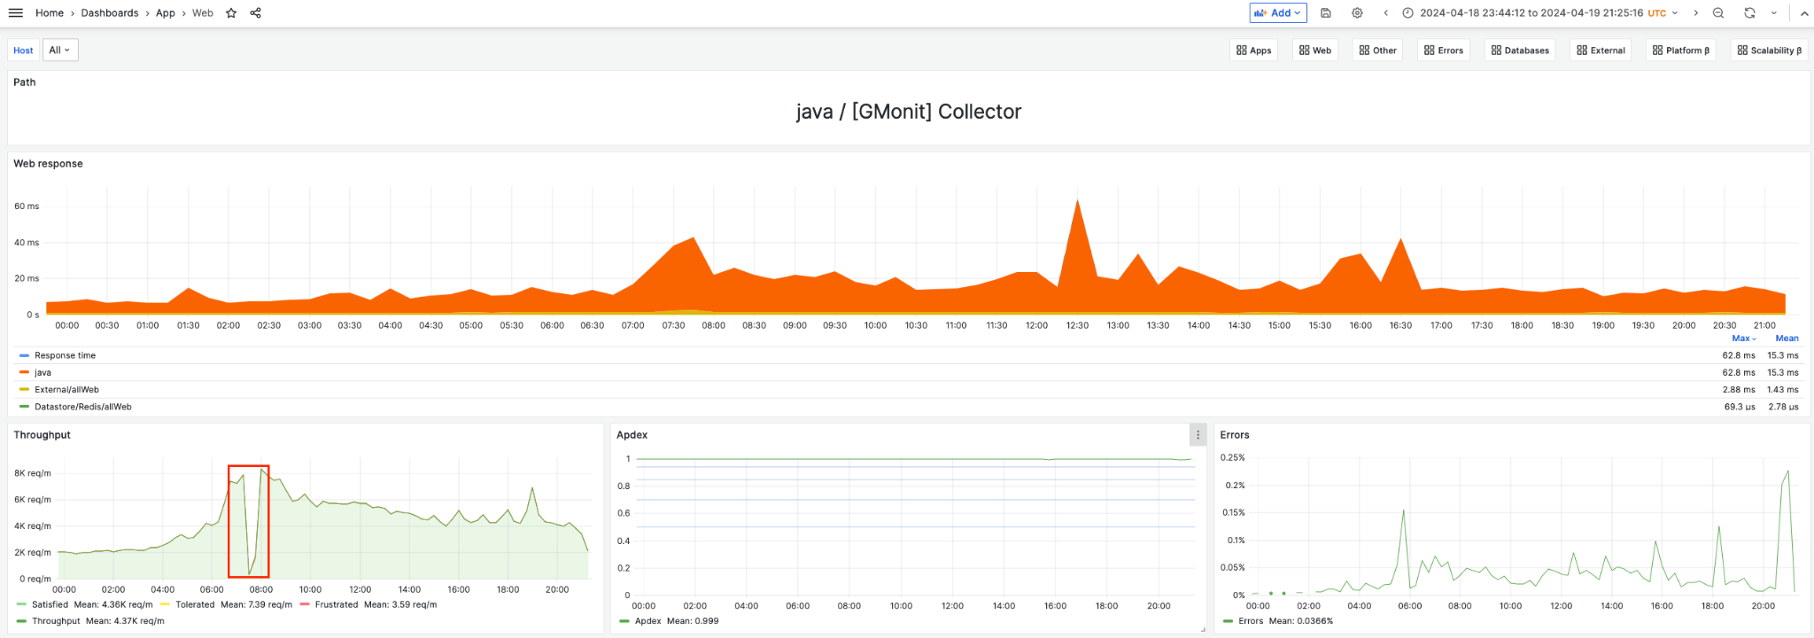

3. Throughput: April 20, 2024, 06:15 - 07:15 UTC

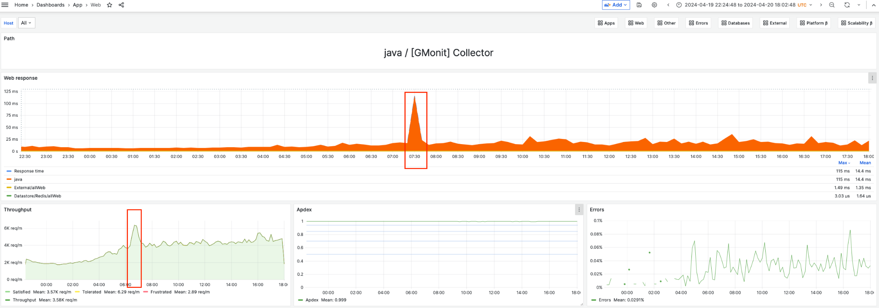

4. Web Response: April 20, 2024, 09:15 - 10:00 UTC

