E-COMMERCE SALES ANALYTICS
& DATA WAREHOUSE PROJECT
MySQL • Power BI • DAX • Power Query
Complete Project Documentation

Table of Contents
1. Project Overview
2. Project Architecture
3. Database and Data Warehouse Design
4. SQL Implementation and Database Logic
5. Connecting MySQL to Power BI
6. Power Query Data Preparation
7. Power BI Data Model and Relationships
8. DAX Measures and Calculated Columns
9. Dashboard Design and Visualizations
10. Business Questions and Insights
11. End-to-End Project Workflow
12. Interview Explanation
13. Common Interview Questions and Answers
14. Portfolio / CV Description
15. Technical Summary

1. Project Overview

1.1 Project Description
This project is an E-Commerce Sales Analytics and Data Warehouse solution. The goal is to organize e-commerce transactional data into a structured relational warehouse using MySQL and then use Microsoft Power BI to transform, model, analyze, and visualize the data.
The solution separates descriptive information such as customers, products, and sellers from measurable business events such as orders, order items, payments, and reviews. This structure makes the data easier to query and allows Power BI to produce reusable business KPIs and interactive visualizations.

1.2 Main Objectives
- Build a structured e-commerce data warehouse in MySQL.
- Separate descriptive dimensions from transactional fact data.
- Create relationships between the tables using primary and foreign keys.
- Connect the MySQL warehouse to Power BI.
- Prepare and clean imported data using Power Query.
- Build a reliable relational data model in Power BI.
- Create DAX measures for revenue, orders, customers, delivery performance, and reviews.
- Build an interactive dashboard for business analysis.
- Document the complete technical workflow for future maintenance and interviews.

1.3 Business Questions
- What is the total revenue?
- How many orders were placed?
- How many customers are represented in the data?
- What is the average order value?
- What percentage of orders were late?
- What is the average customer review score?
- How does revenue change over time?
- Which product categories generate the most revenue?
- What is the distribution of orders by status?
- Which seller cities generate the most revenue?
- How many customers are in each state?
- How does average delivery time differ between late and non-late orders?

2. Project Architecture
The project follows end-to-end analytics architecture in which operational-style e-commerce data is stored in MySQL, prepared and modeled in Power BI, and finally exposed through an interactive dashboard.
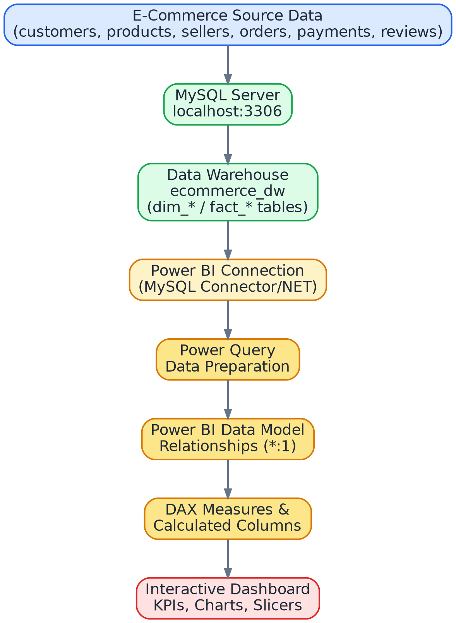
Figure 1. End-to-end data flows, from source data to the interactive dashboard.

2.1 Technology Stack
Technology | Role in the Project
MySQL | Database and data warehouse storage
SQL | Database creation, table design, querying and data manipulation
Power BI | Analytics, modeling and dashboarding
Power Query | Data import, transformation and preparation
DAX | Measures and calculated columns
VS Code | Used as a convenient editor for saving/reviewing project scripts

2.2 Why This Architecture?
Using a separate database layer keeps the source data organized and reusable. Power BI then focuses on analytics rather than acting as the primary data-storage system. The separation also makes it easier to maintain the database and change the reporting layer without redesigning the entire data source.

3. Database and Data Warehouse Design

3.1 Database Name
ecommerce_dw
The database contains seven main tables. The naming convention uses dim_ for dimension tables and fact_ for fact tables.

3.2 Dimension Tables
Table | Purpose | Typical Key
dim_customers | Customer descriptive information | customer_id
dim_products | Product descriptive information | product_id
dim_sellers | Seller descriptive information | seller_id

3.3 Fact Tables
Table | Purpose | Important Fields
fact_orders | Order-level business events | order_id, customer_id, order_status, timestamps, delivery_days, is_late
fact_order_items | Line-item level sales and product/seller links | order_id, product_id, seller_id, item_total
fact_payments | Payment records associated with orders | order_id and payment-related fields
fact_reviews | Customer review records associated with orders | order_id, review_score and review-related fields

3.4 Fact vs Dimension
A dimension describes an entity or context, while a fact records a business event or measurable activity. For example, dim_products describe products, while fact_order_items records products appearing in individual order lines.
Concept | Meaning | Example
Dimension | Descriptive context | Customer state
Fact | Business event / measurable activity | Order item revenue
Dimension Key | Identifier used to connect tables | product_id
Foreign Key | Reference to another table's key | fact_order_items.product_id

3.5 Relationship Concept
The star-schema layout below shows how each dimension connects to the fact tables, and how fact_orders act as the hub linking payments and reviews back to a single order.
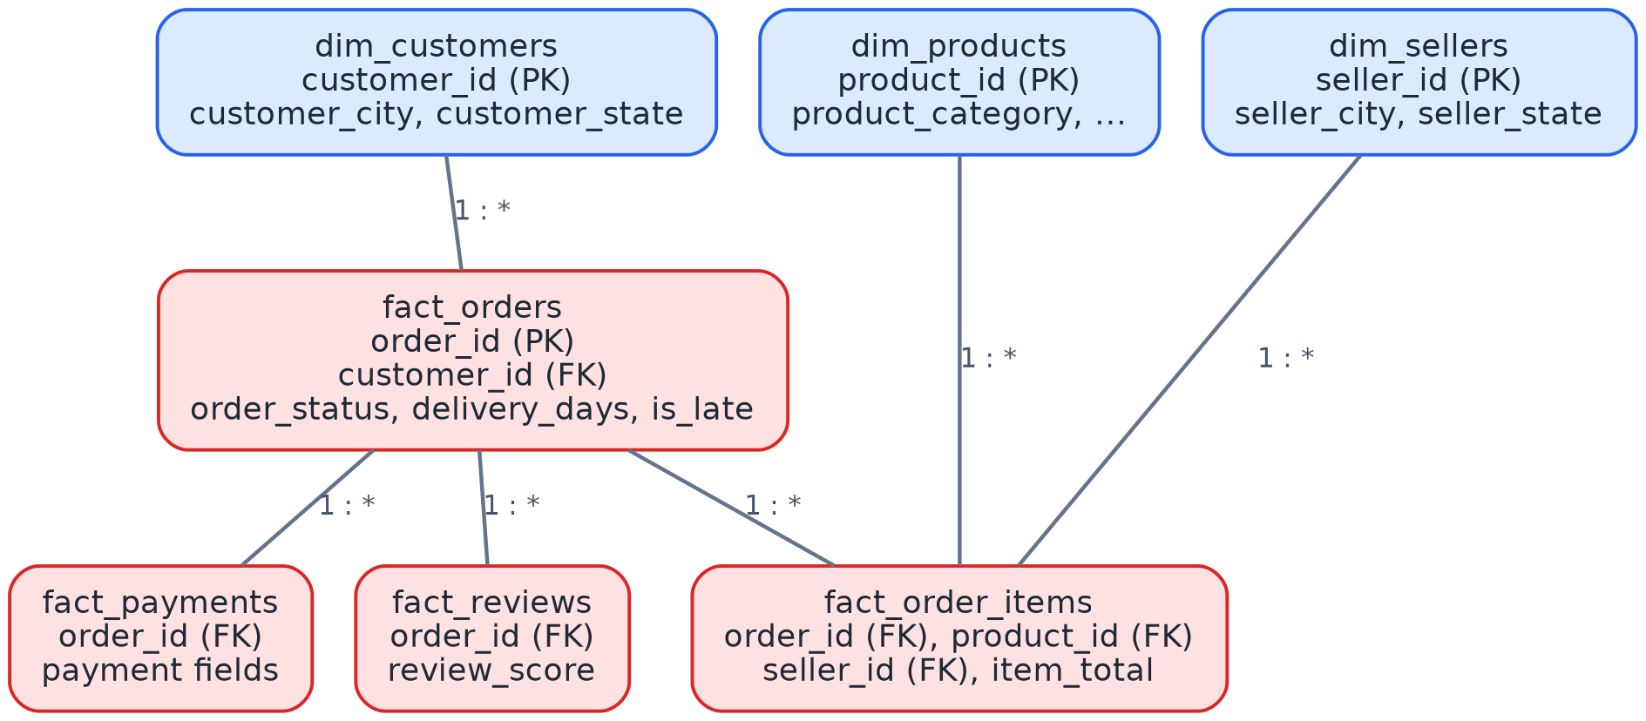
Figure 2. Star-schema relationships between dimension and fact tables.

4. SQL Implementation and Database Logic
The SQL layer creates and prepares the database that Power BI later consumes. The exact original SQL script should be kept with the project source files; the sections below document the SQL logic and the schema used in the finished project.

4.1 Database Creation Concept
CREATE DATABASE ecommerce_dw;
USE ecommerce_dw;
CREATE DATABASE creates logical database containers. USE selects that database so that subsequently CREATE TABLE and query statements operate inside it.

4.2 Table Creation Pattern
CREATE TABLE dim_customers (
customer_id ...,
customer_city ...,
customer_state ...
);
CREATE TABLE defines the structure. Each column is given a name and a data type. The customer identifier is used to uniquely identify a customer and to connect customer information to fact_orders.

4.3 Fact Table Pattern
CREATE TABLE fact_order_items (
order_id ...,
product_id ...,
seller_id ...,
item_total ...
);
The order item table connects an order to the product and seller involved in the transaction and stores the measurable item value used later for revenue calculations.

4.4 SQL Design Principles Used
- Use stable identifiers as keys.
- Keep descriptive attributes in dimensions.
- Keep transactional/measurable information in fact.
- Use foreign keys to represent relationships.
- Choose data types that match the meaning of the values.
- Keep database logic separate from visualization logic.

4.5 Important Note About the Original SQL Script
NOTE
This documentation describes the final database design and SQL logic. It does not invent unseen lines from the original script. When the original SQL file is added to the project documentation, its exact statements can be inserted here and explained line by line.

5. Connecting MySQL to Power BI

5.1 Connection
The finished project uses a local MySQL server at localhost:3306 and the ecommerce_dw database. The MySQL Connector/NET driver was installed so Power BI could establish the connection.
Setting | Project Value
Server | localhost:3306
Database | ecommerce_dw
Source | MySQL
Destination | Power BI

5.2 Imported Queries
- dim_customers
- dim_products
- dim_sellers
- fact_order_items
- fact_orders
- fact_payments
- fact_reviews

5.3 Why Power Query Appeared
Power BI uses Power Query as the preparation layer between the external source and the model. During import, relationships and navigation information can expose additional nested table columns. Those unnecessary nested columns were removed so each query contains the intended table fields.

6. Power Query Data Preparation

6.1 Main Preparation Actions
- Connect to the MySQL database.
- Navigate to the required e-commerce tables.
- Rename queries to the final table names.
- Remove unnecessary nested Table columns created by the navigation/relationship expansion.
- Review data types.
- Keep intentionally null values where they represent missing business information.
- Close & apply to load the prepared data into the Power BI model.

6.2 Query Cleanup
Query | Preparation
dim_customers | Removed unnecessary fact_orders nested column
dim_products | Removed unnecessary fact_order_items nested column
dim_sellers | Reviewed and retained the intended seller fields
fact_order_items | Removed unnecessary dim_products, dim_sellers and fact_orders nested columns
fact_orders | Removed unnecessary dim_customers, fact_order_items, fact_payments and fact_reviews nested columns
fact_payments | Reviewed and retained the intended payment fields
fact_reviews | Reviewed and retained the intended review fields

6.3 Why Nulls Were Not Automatically Deleted
Some values such as delivery_days and is_late can legitimately be unavailable for certain records. Deleting all rows containing nulls without understanding their business meaning could remove valid orders. Therefore, these values were reviewed rather than blindly removed.

7. Power BI Data Model and Relationships
The data model connects the fact tables with the appropriate dimensions and with fact_orders where an order identifier is shared. The completed relationships use Many-to-One (*:1) cardinality, Single cross-filter direction, and Active status.
From | To | Cardinality | Filter | Status
fact_orders.customer_id | dim_customers.customer_id | *:1 | Single | Active
fact_order_items.order_id | fact_orders.order_id | *:1 | Single | Active
fact_order_items.product_id | dim_products.product_id | *:1 | Single | Active
fact_order_items.seller_id | dim_sellers.seller_id | *:1 | Single | Active
fact_payments.order_id | fact_orders.order_id | *:1 | Single | Active
fact_reviews.order_id | fact_orders.order_id | *:1 | Single | Active

7.1 Why Many-to-One?
A single dimension entity can be associated with many fact records. For example, one customer can place many orders, and one product can appear in many order items. Therefore, the fact side is the many sides, and the dimension/key side is the one side.

7.2 Why Single-Direction Filtering?
Single-direction filtering provides a predictable analytical flow and reduces ambiguity in the model. Filters normally propagate from the dimension/key side toward the related fact data.

8. DAX Measures and Calculated Columns
DAX was used to create reusable business calculations. Measures are evaluated according to the current filter context, which is why the same KPI can respond to slicers and visual selections.

Total Orders
Table: fact_orders
Total Orders =
DISTINCTCOUNT(fact_orders[order_id])
Explanation: Counts unique orders rather than counting rows. DISTINCTCOUNT prevents duplicate order rows from being counted as separate orders.

Total Revenue
Table: fact_order_items
Total Revenue =
SUM(fact_order_items[item_total])
Explanation: Adds the item-level monetary values to calculate total revenue.

Total Customers
Table: dim_customers
Total Customers =
DISTINCTCOUNT(dim_customers[customer_id])
Explanation: Counts unique customers in the customer dimension.

Average Order Value
Table: fact_orders
Average Order Value =
DIVIDE(
[Total Revenue],
[Total Orders]
)
Explanation: Divides revenue by the number of orders. DIVIDE is used instead of the / operator because it safely handles a zero denominator.

Late Orders
Table: fact_orders
Late Orders =
CALCULATE(
[Total Orders],
fact_orders[is_late] = TRUE()
)
Explanation: Recalculates Total Orders under a filter where is_late is TRUE.

Late Order %
Table: fact_orders
Late Order % =
DIVIDE(
[Late Orders],
[Total Orders]
)
Explanation: Calculates the proportion of orders that are late.

Average Review Score
Table: fact_reviews
Average Review Score =
AVERAGE(fact_reviews[review_score])
Explanation: Calculates the arithmetic average of review scores.

8.1 Formatting Used
Measure | Format
Total Orders | Whole number
Total Revenue | Decimal number, 2 decimals
Total Customers | Whole number
Average Order Value | Decimal number, 2 decimals
Late Orders | Whole number
Late Order % | Percentage, 2 decimals
Average Review Score | Decimal number, 2 decimals

8.2 State Full Name Calculated Column
State Full Name =
SWITCH(
dim_customers[customer_state],
"SP", "São Paulo", "RJ", "Rio de Janeiro",
"MG", "Minas Gerais", "RS", "Rio Grande do Sul",
"PR", "Paraná", "SC", "Santa Catarina",
"BA", "Bahia", "ES", "Espírito Santo",
"GO", "Goiás", "PE", "Pernambuco",
"CE", "Ceará", "PA", "Pará",
"MA", "Maranhão", "PB", "Paraíba",
"RN", "Rio Grande do Norte", "AL", "Alagoas",
"PI", "Piauí", "SE", "Sergipe",
"MT", "Mato Grosso", "MS", "Mato Grosso do Sul",
"DF", "Distrito Federal", "AM", "Amazonas",
"RO", "Rondônia", "AC", "Acre",
"AP", "Amapá", "RR", "Roraima",
"TO", "Tocantins",
BLANK()
)
This calculated column converts Brazilian state abbreviations into full state names. It was introduced because short abbreviations could be incorrectly interpreted by geographic visuals. The full names also make the dashboard easier to read.

9. Dashboard Design and Visualizations

9.1 Dashboard Title
E-Commerce Sales Dashboard
The page was organized into KPI cards, trend analysis, category analysis, order status, seller geography, customer geography, delivery performance, and an order-status slicer.
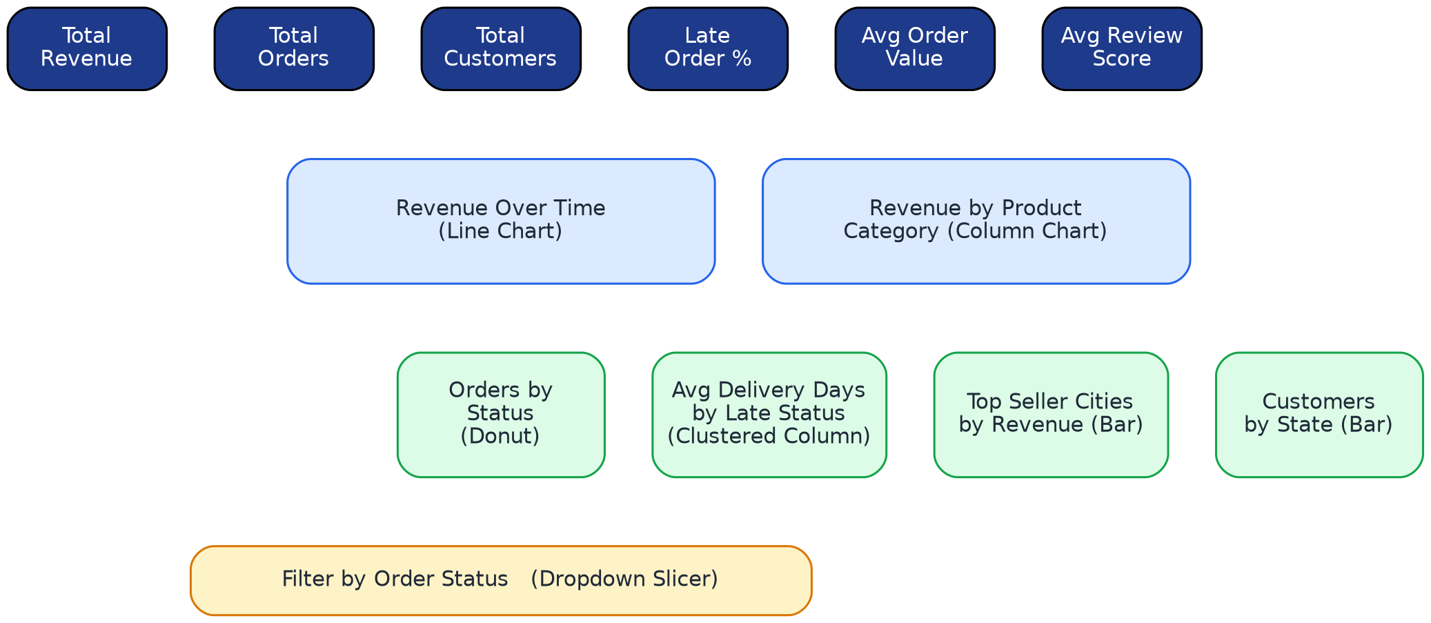
Figure 3. Wireframe layout of the E-Commerce Sales Dashboard page.
Visual | Type | Main Fields | Purpose
Total Revenue | KPI Card | [Total Revenue] | Shows the overall revenue generated by the dataset.
Total Orders | KPI Card | [Total Orders] | Shows the number of unique orders.
Total Customers | KPI Card | [Total Customers] | Shows the number of unique customers.
Late Order % | KPI Card | [Late Order %] | Shows the percentage of orders classified as late.
Average Order Value | KPI Card | [Average Order Value] | Shows revenue per average order.
Average Review Score | KPI Card | [Average Review Score] | Shows the average customer review score.
Revenue Over Time | Line Chart | Date hierarchy + [Total Revenue] | Shows how revenue changes over time.
Revenue by Product Category | Column Chart | Product category + [Total Revenue] | Compares revenue generated by product categories.
Orders by Status | Donut Chart | Order status + Count of order_id | Shows the distribution of order statuses.
Average Delivery Days by Late Status | Clustered Column Chart | is_late + Average delivery_days | Compares average delivery time for late and non-late orders.
Top Seller Cities by Revenue | Bar Chart | seller_city + [Total Revenue] | Shows the top 10 seller cities by revenue.
Customers by State | Bar/Column Chart | State Full Name + [Total Customers] | Compares the customer population across Brazilian states.
Filter by Order Status | Dropdown Slicer | order_status | Allows interactive filtering by order status.

9.2 Revenue Over Time
The line chart uses order_purchase_timestamp as the time axis and Total Revenue as the value. The date hierarchy was reduced to Year and Month to keep the trend readable.
NOTE
A very small September 2018 point is still a real value rather than a missing or zero value. It appears visually close to zero because the earlier monthly values are much larger.

9.3 Revenue by Product Category
The product category is placed on the axis, and Total Revenue is used as the value. This allows categories to be compared by their contribution to revenue.

9.4 Orders by Status
The donut chart uses order_status as the legend and a count of order_id as the value. It provides a compact view of how orders are distributed among statutes.

9.5 Average Delivery Days by Late Status
The chart uses is_late as the category and the average of delivery_days as the metric. This allows the dashboard user to compare delivery duration between the two late-status groups.

9.6 Top Seller Cities by Revenue
seller_city is used as the category and Total Revenue as the value. A Top N filter limits the visual to the ten cities with the highest revenue contribution.

9.7 Customers by State
The original geographic approach using state abbreviations was not reliable because the geocoding could interpret abbreviations as locations in another country. The final solution uses full Brazilian state names and a regular chart instead of depending on ambiguous map geocoding.

9.8 Order Status Slicer
The order_status slicer was converted to a dropdown and titled Filter by Order Status. Selecting a status filters the dashboard visuals. Selecting a data point in another visual can also cross-filter the page; clearing the visual selection restores the full dataset.

10. Business Questions and Insights
The dashboard is designed to answer business questions rather than only display numbers. The following are the intended analytical interpretations.
Question | Dashboard Element | Interpretation
How much revenue was generated? | Total Revenue | Overall monetary performance
How many orders were placed? | Total Orders | Transaction volume
How large is the customer base? | Total Customers | Unique customer reach
What is the average order value? | Average Order Value | Average revenue per order
How many orders are late? | Late Order % | Delivery performance indicator
How do customers rate orders? | Average Review Score | Customer satisfaction indicator
When is revenue highest? | Revenue Over Time | Temporal sales pattern
Which categories generate more revenue? | Revenue by Product Category | Category contribution
What are the order statuses? | Orders by Status | Order lifecycle distribution
Where are major sellers located? | Top Seller Cities | Seller geographic concentration
Where are customers located? | Customers by State | Customer geographic distribution

11. End-to-End Project Workflow
The diagram below groups the eighteen build steps into five practical phases, from initial design through to the final saved report.
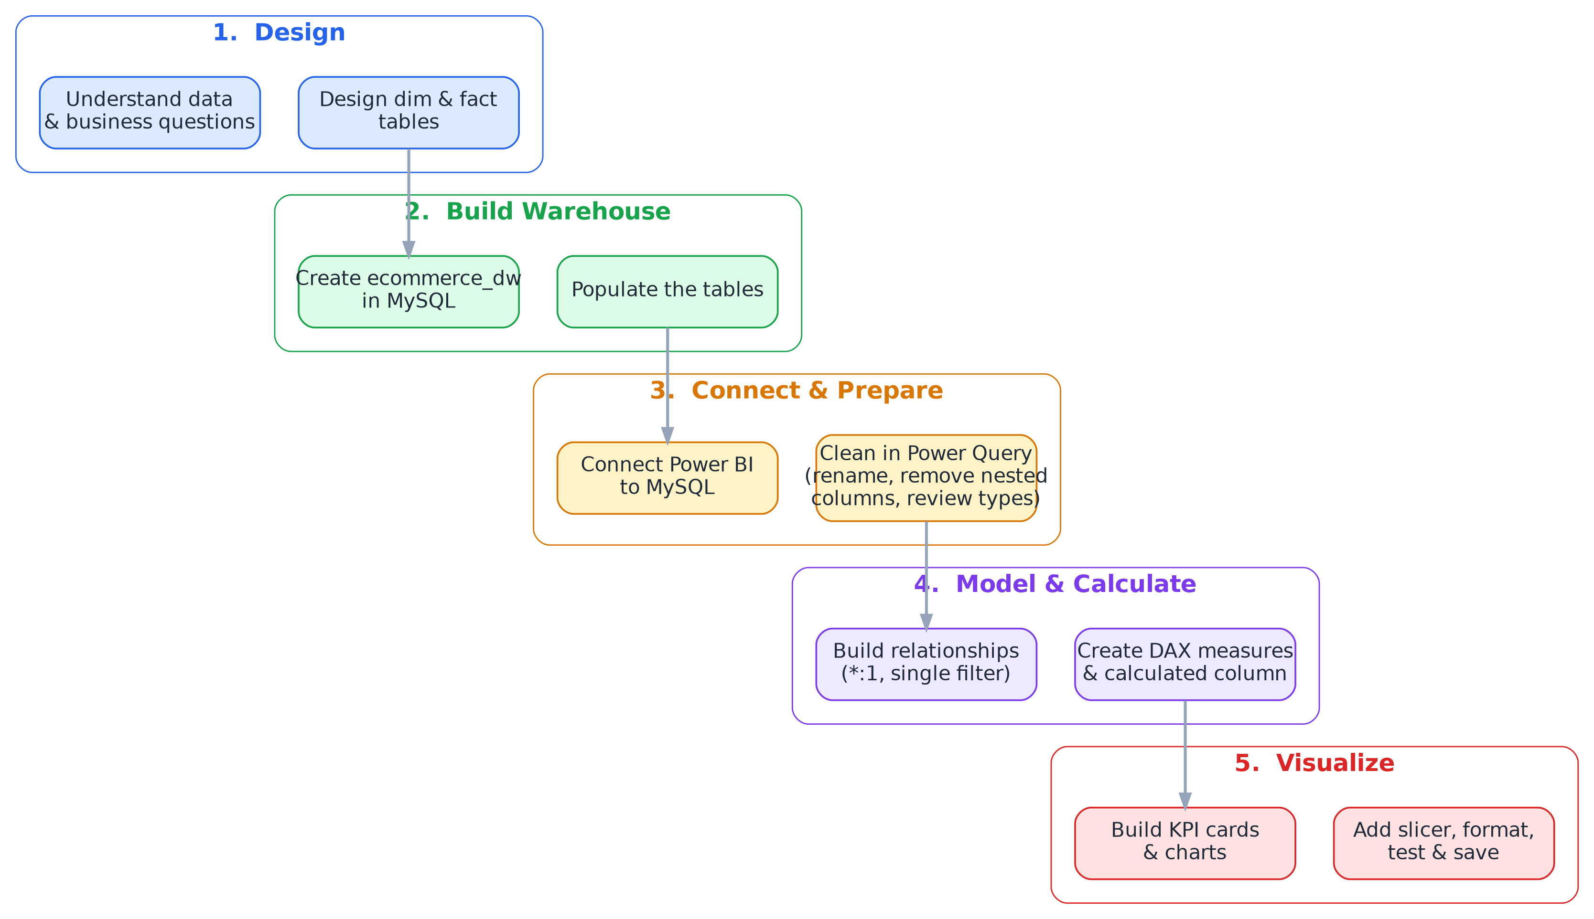
Figure 4. Five-phase build workflow, from data design to the saved Power BI report.
- Understand the e-commerce dataset and business questions.
- Create the ecommerce_dw MySQL database.
- Design dimension and fact tables.
- Populate the tables with the available e-commerce data.
- Install the MySQL Connector/NET required by Power BI.
- Connect Power BI to MySQL at localhost:3306.
- Import seven project tables.
- Rename and clean the Power Query queries.
- Remove unnecessary nested Table columns.
- Review data types and intentional nulls.
- Close & Apply the Power Query changes.
- Build and verify the Power BI relationships.
- Create DAX measures and the State Full Name calculated column.
- Format the measures according to their business meaning.
- Build KPI cards and analytical visuals.
- Add the order-status slicer.
- Format titles, backgrounds, alignment, and layout.
- Test filtering and cross-filtering behavior.
- Save the final Power BI report.

12. Interview Explanation

12.1 Short Version
I built an e-commerce sales analytics solution using MySQL and Power BI. I designed the data warehouse using fact and dimension tables, connected the database to Power BI, prepared the data with Power Query, created a relational data model, developed DAX measures for key KPIs, and built an interactive dashboard for revenue, orders, customers, products, sellers, delivery performance, and reviews.

12.2 Two-to-Three-Minute Version
The project started with an e-commerce dataset containing customers, products, sellers, orders, order items, payments, and reviews. I organized the data into a MySQL data warehouse using fact and dimension tables. The main dimensions were customers, products, and sellers, while orders, order items, payments, and reviews were represented as fact tables.
After preparing the database, I connected MySQL to Power BI. In Power Query, I cleaned the imported queries, removed unnecessary nested table columns, reviewed data types, and kept meaningful missing values where appropriate. I then created a relational Power BI model using many-to-one relationships with single-direction filtering.
For analytics, I created DAX measures such as Total Revenue, Total Orders, Total Customers, Average Order Value, Late Orders, Late Order Percentage, and Average Review Score. I also created a calculated column that converts Brazilian state abbreviations into full state names.
Finally, I built an interactive dashboard containing KPI cards, a revenue trend, product-category revenue, order status distribution, delivery performance, top seller cities, customers by state, and an order-status slicer. The dashboard provides a single place for analyzing the main sales and operational KPIs.

13. Common Interview Questions and Answers
Q: Why did you use a data warehouse?
A: To organize analytical data in a structured way and separate measurable business events from descriptive dimensions, making reporting and analysis easier.
Q: What is the difference between fact and a dimension?
A: A dimension describes business entities or context, while a fact records business events and measurable values.
Q: Why is fact_order_items important for revenue?
A: Because revenue is stored at item level through item_total, so summing item_total provides total revenue.
Q: Why did you use DISTINCTCOUNT for orders?
A: Because an order can be represented by multiple related records, unique order IDs are required to avoid double counting.
Q: Why use a measure instead of a fixed number?
A: A measure is recalculated according to the current filter context, making it dynamic across visuals and slicers.
Q: Why use DIVIDE in DAX?
A: DIVIDE safely handles a zero denominator and is clearer for ratio calculations.
Q: Why did you use Many-to-One relationships?
A: Because many fact records can refer to one dimension entity, such as many orders belonging to one customer.
Q: Why did you use single-direction filtering?
A: It keeps filter propagation predictable and reduces ambiguity in the model.
Q: Why did you create State Full Name?
A: Because state abbreviations could be interpreted ambiguously by geographic visuals; full names provide clearer labels and reduce geocoding ambiguity.
Q: What is Power Query used for?
A: It is the data preparation layer used to import, clean, transform, and shape source data before it enters the Power BI model.
Q: What is DAX used for?
A: DAX is used to create analytical calculations such as measures and calculated columns in the Power BI model.
Q: What happens when a slicer is changed?
A: The filter context changes and compatible measures and visuals recalculate according to the selected value.

14. Portfolio / CV Description

14.1 Portfolio Description
E-Commerce Sales Analytics & Data Warehouse — Built a MySQL-based analytical data warehouse using fact and dimension tables and connected it to Power BI for business intelligence reporting. Performed data preparation with Power Query, developed DAX KPIs for revenue, orders, customers, average order value, late-order performance and reviews, and designed an interactive dashboard covering sales trends, product categories, order status, seller cities and customer geography.

14.2 CV Bullet Points
- Designed an e-commerce analytical data warehouse in MySQL using fact and dimension tables.
- Connected MySQL data to Power BI and performed data preparation with Power Query.
- Built a relational Power BI data model using active many-to-one relationships.
- Developed DAX measures for revenue, orders, customers, average order value, late-order percentage and review score.
- Created an interactive Power BI dashboard for sales, products, customer, seller and delivery analysis.

14.3 Technologies
MySQL • SQL • Power BI • Power Query • DAX • Data Modeling • Data Visualization

15. Technical Summary
Layer | Technology | Deliverable
Storage | MySQL | ecommerce_dw database
Schema | SQL | Fact and dimension tables
Transformation | Power Query | Clean Power BI queries
Modeling | Power BI | Relationships and semantic model
Calculation | DAX | KPIs and calculated column
Visualization | Power BI | Interactive dashboard
Documentation | Word | Complete project reference

15.1 Final KPI Results
KPI | Final Result
Total Revenue | 15.84M
Total Orders | 99.441K (approximately 99K)
Total Customers | 99K
Average Order Value | 159.33
Late Order % | 7.87%
Average Review Score | 4.09

15.2 Final Project Status
STATUS
The MySQL-to-Power BI pipeline, Power Query preparation, data model, DAX calculations, dashboard visuals, slicer, formatting, and final report save were completed. This document serves as the consolidated technical explanation and interview reference for the finished project.

