ROBOTICS LAB 4 - MOBILE ROBOT URDF

NAME - ELKAN QUADROS REG NO - 200929162 SECTION - A2 ROLL NO - 45

Exercise - Equip robot with obstacle avoidance capabilities and spawn a four wheeled robot

#!/usr/bin/env python3

from sensor_msgs.msg import LaserScan from geometry_msgs.msg import Twist import rclpy

from rclpy.node import Node import numpy as np

class ObstacleAvoidance(Node): def init (self):

super(). init ('avoid') self.subscriber =

self.create_subscription(LaserScan,'/gazebo_lidar/out',self.listener_callb ack,10)

self.publisher = self.create_publisher(Twist,'cmd_vel',10)

def listener_callback(self,msg): vel = Twist()

if float(min(msg.ranges))>0.2 and float(min(msg.ranges))<0.8: print(float(min(msg.ranges[288:431])))

vel.linear.x=0.0 vel.angular.z=0.5 self.publisher.publish(vel) print('obstacle detected')

else:

print(float(min(msg.ranges[288:431]))) vel.linear.x=0.3

vel.angular.z=0.0 self.publisher.publish(vel) print('safe now')

def main(args=None): rclpy.init(args=args)

obsav = ObstacleAvoidance() rclpy.spin(obsav) obsav.destroy_node() rclpy.shutdown()

if name == ' main ': main()

Subscribe to laser scan data and avoid obstacles when distance is less than threshold by continuously rotating by a particular angle till its safe.

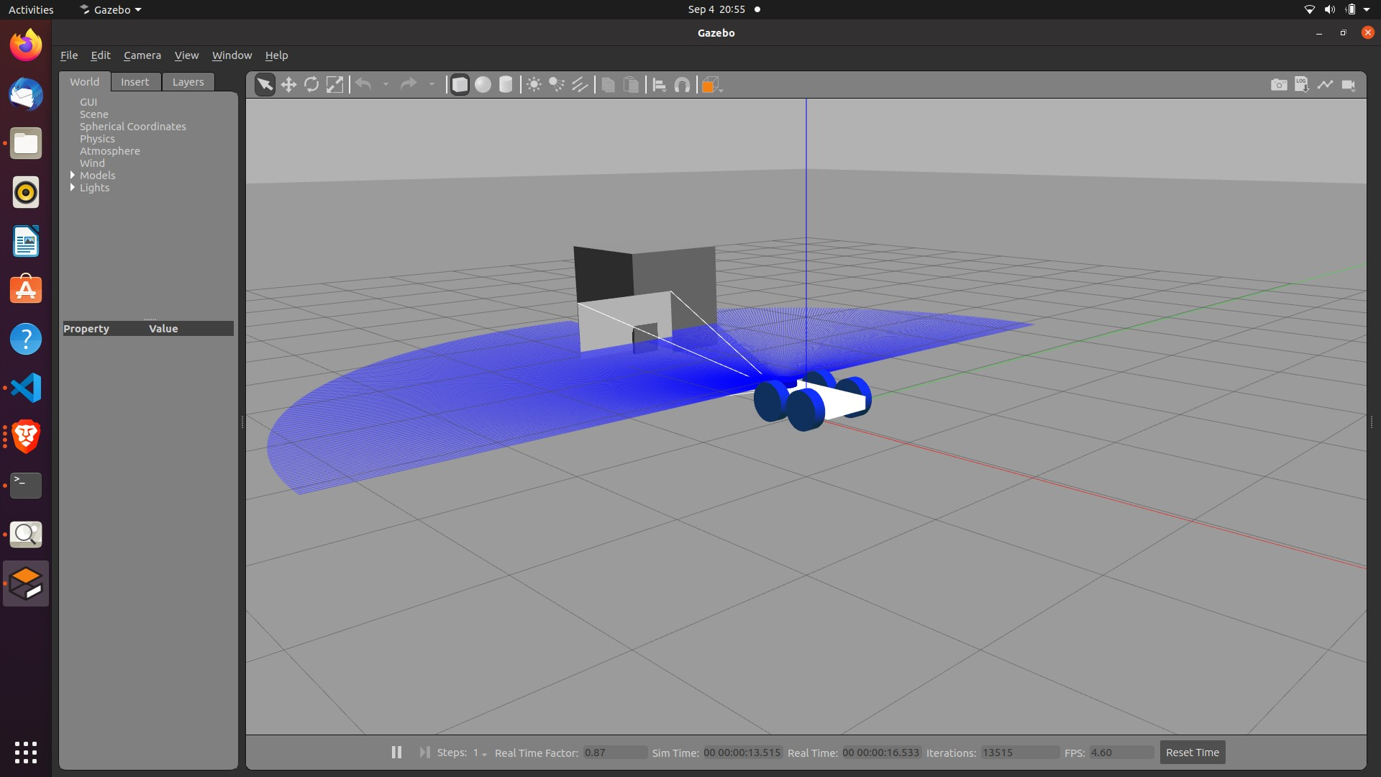

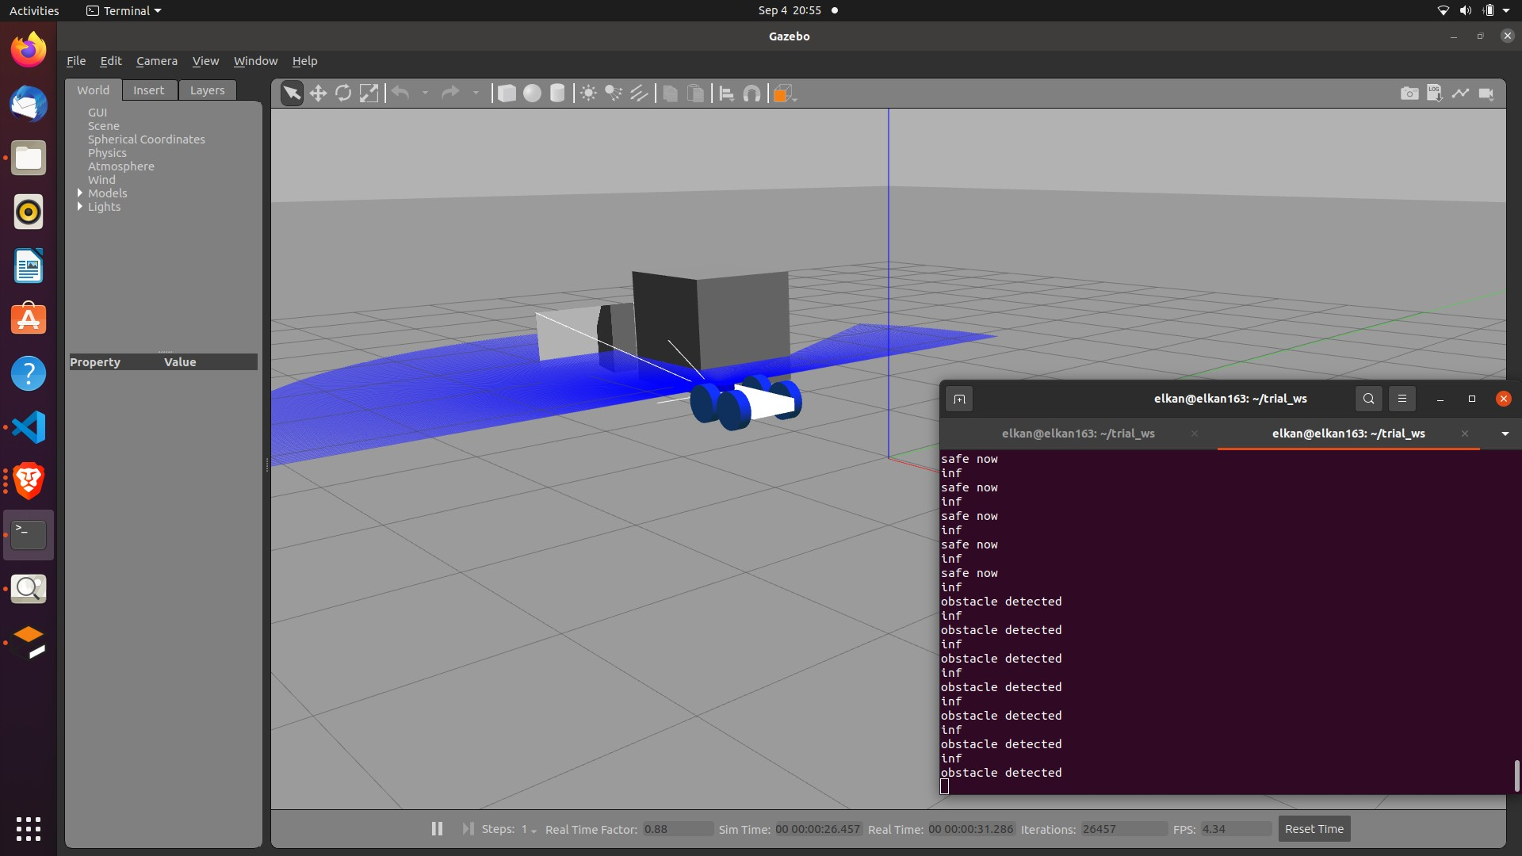

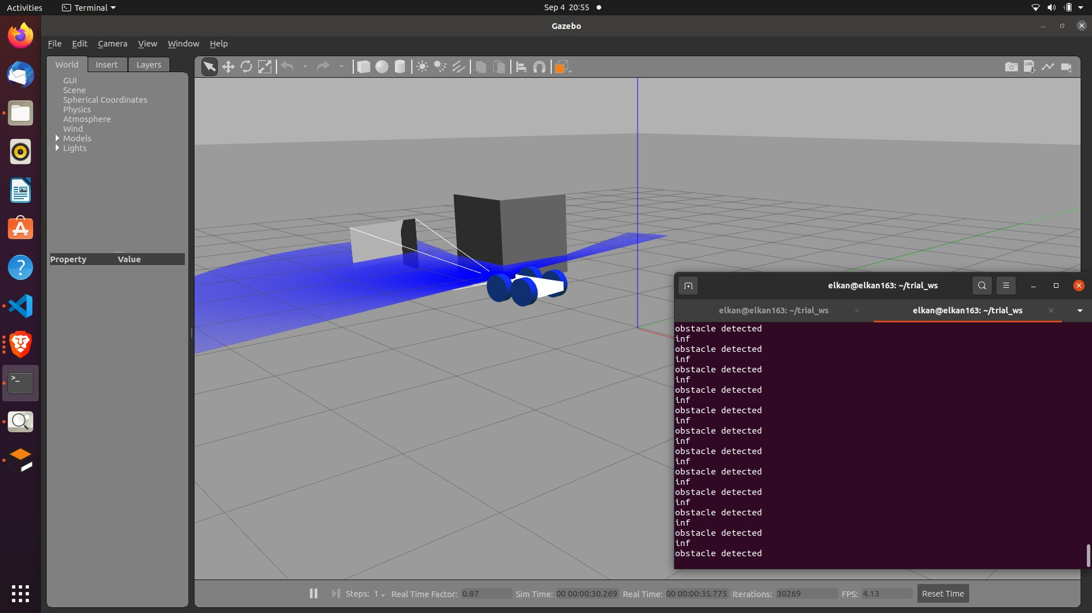

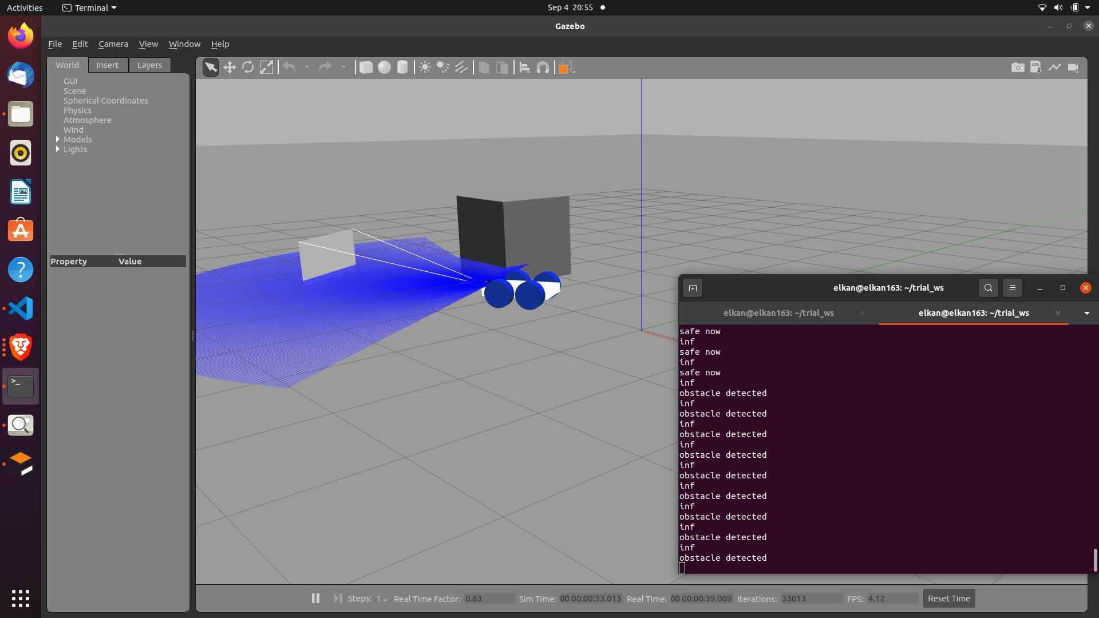

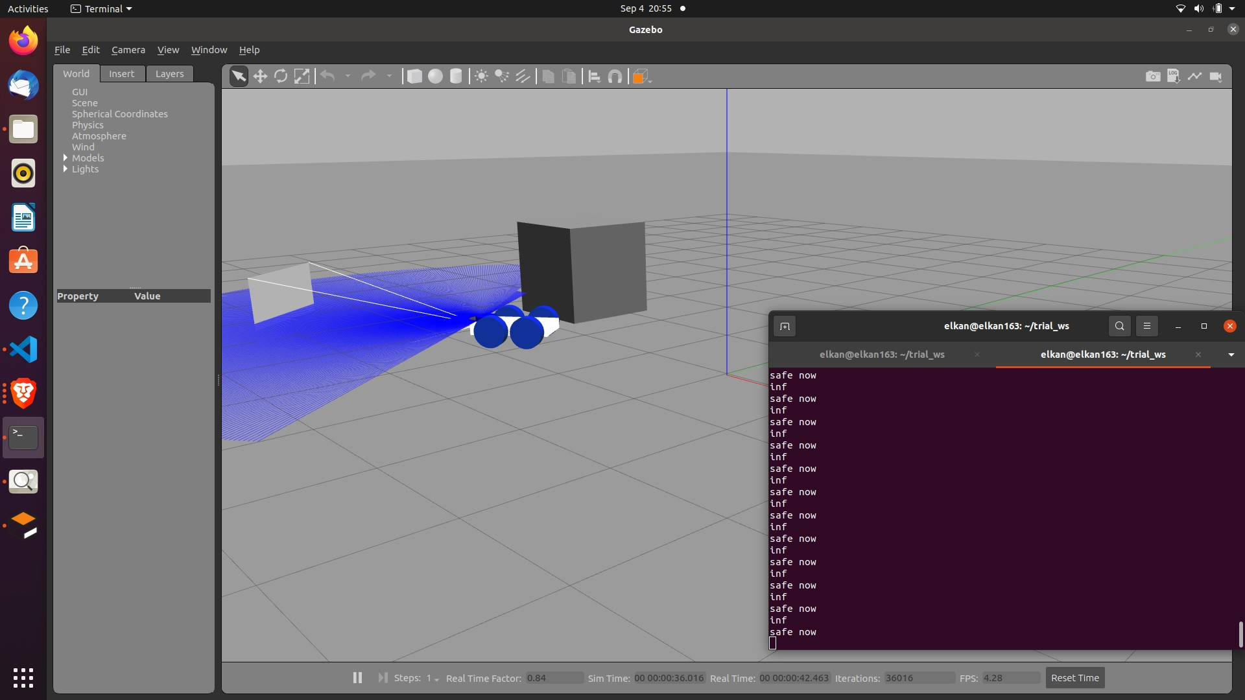

To make the robot four wheeled add two more links and just change their joint position along a particular axis.

LAB WORK

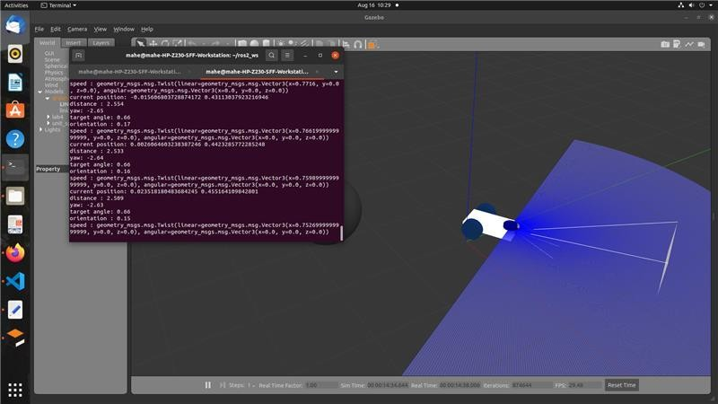Controlling using Python script

Teleop control

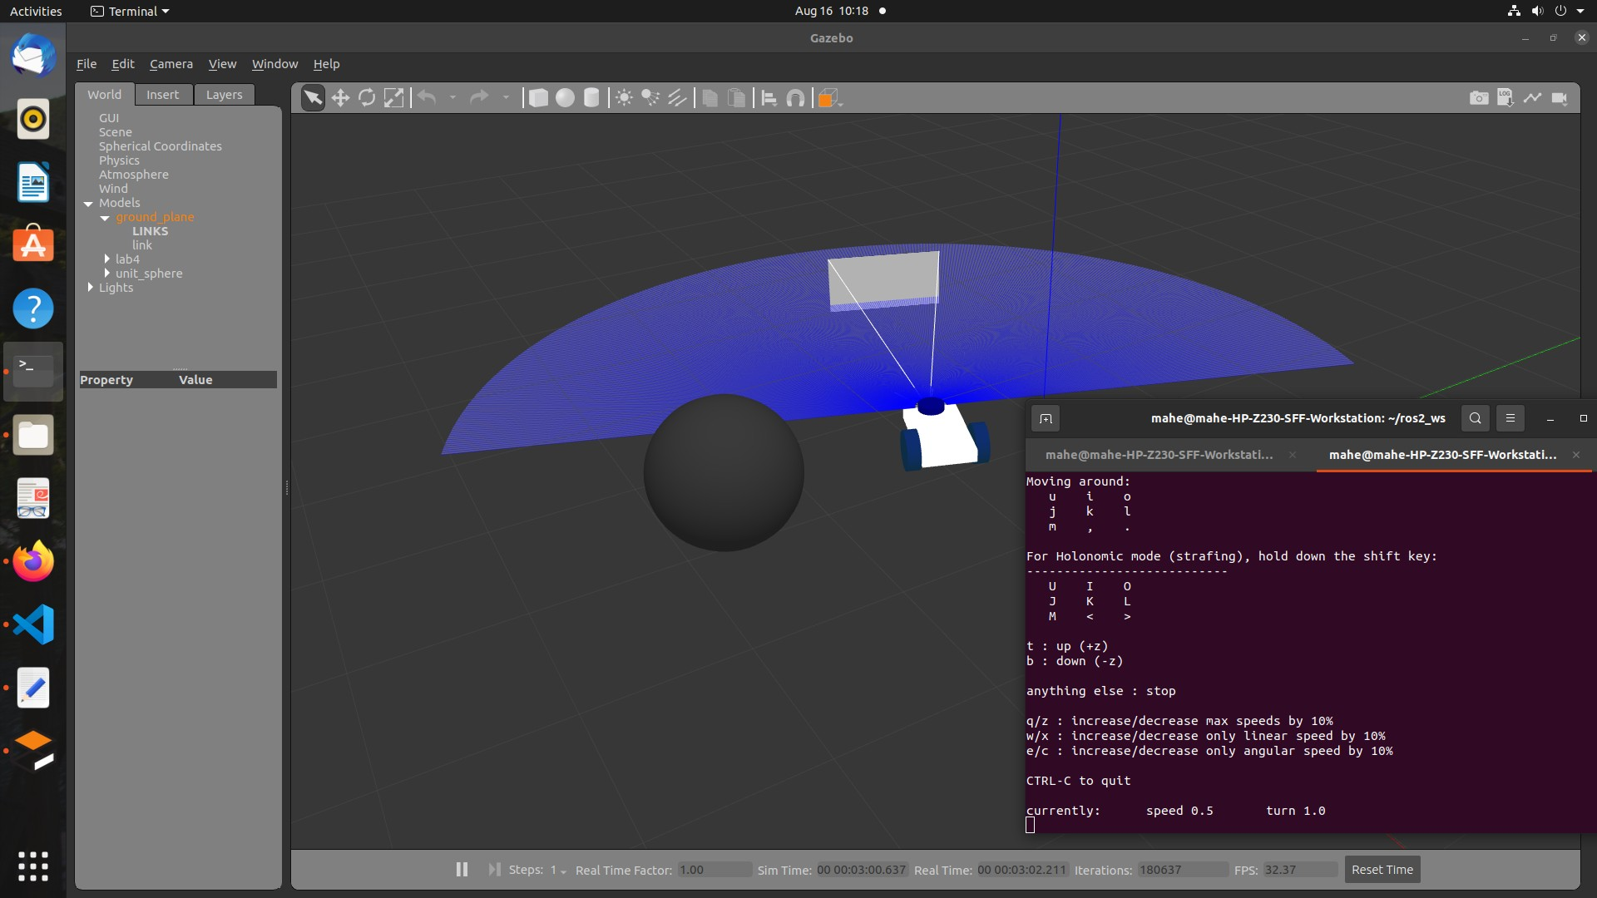

Visualize in rviz and joint state publisher gui

