Elliot Higgs

16434619

<https://ellh.github.io/csy1018-assign1/index.html>

Assignment 1: Web Development

13/01/2017

Contents

Getting Started 3

Designs 3

Wireframes 4

Desktop 4

Mobile 6

Images 10

Favicon 10

Models of Good Practice 10

Visual Appeal 10

Colour Scheme 10

Page Load Speed 10

Progression of Website 11

Week 1 11

Week 2 12

Week 4 12

Week 6 13

Week 8 13

Final Designs 16

Homepage 16

Bio 16

Contact 17

CV 17

Getting Started –

Before I started developing my CV website I research other sites that could give me inspiration for the design of my website. I noted from google plus that it had a darker background colour and was using white for the text area, I really liked this idea so I carried it into the designs phase. I also found Thalida which gave me inspiration on how I wanted to layout my content this would come into the development later in the project. The last website that I researched was Metro on this website I really liked the navigation bar and how it changed colour when hovered on and i decided to carry this onto my website.

The website that I investigated were the following:

<http://thalida.com/>

<https://plus.google.com/>

<http://metro.co.uk/>

Designs –

Wireframes –

Desktop –

Homepage –

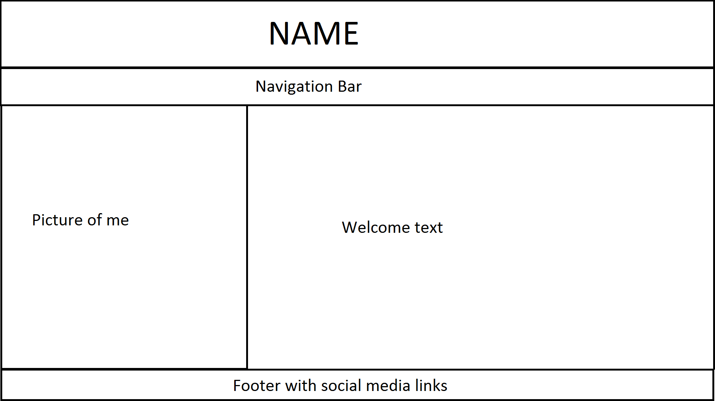

Bio –

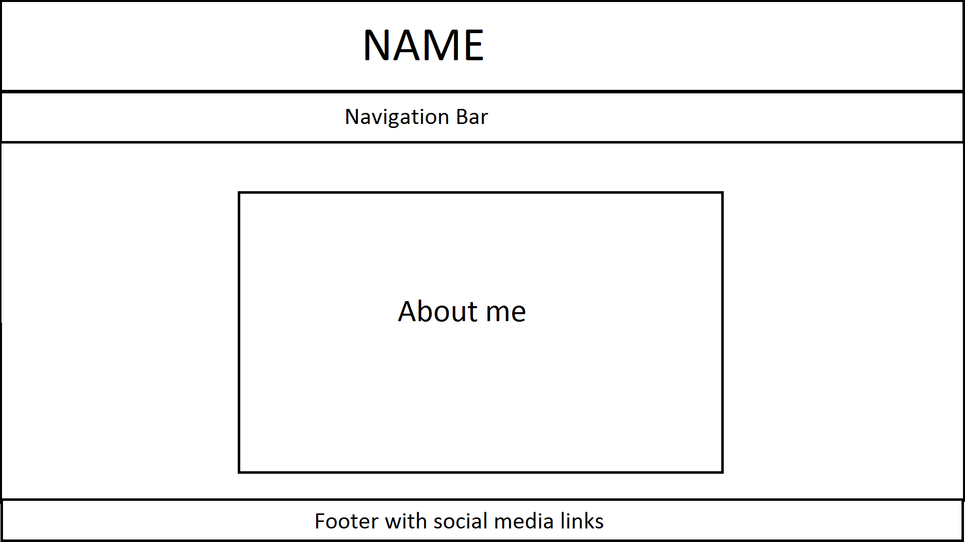

Contact –

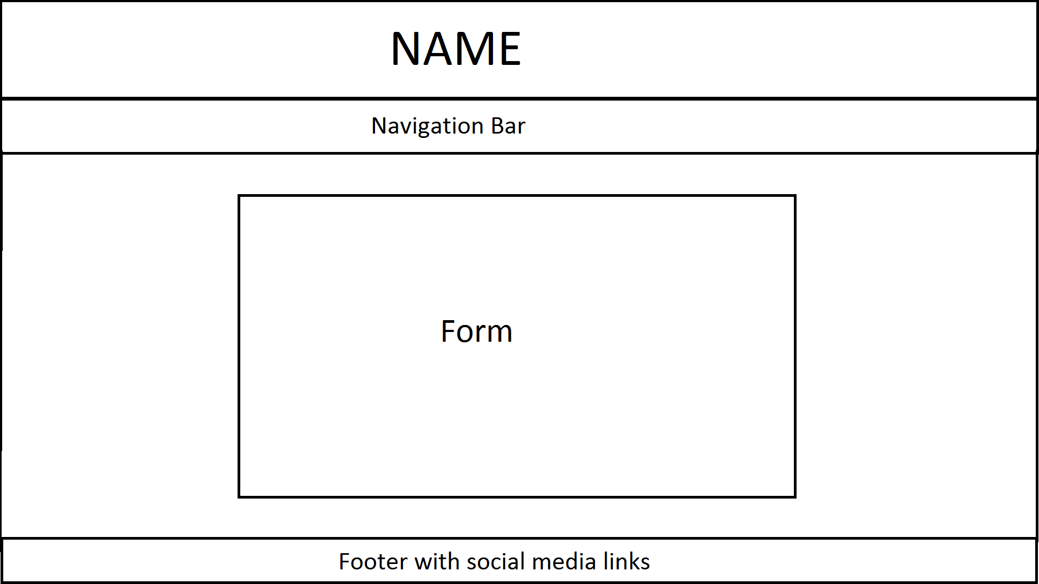

CV –

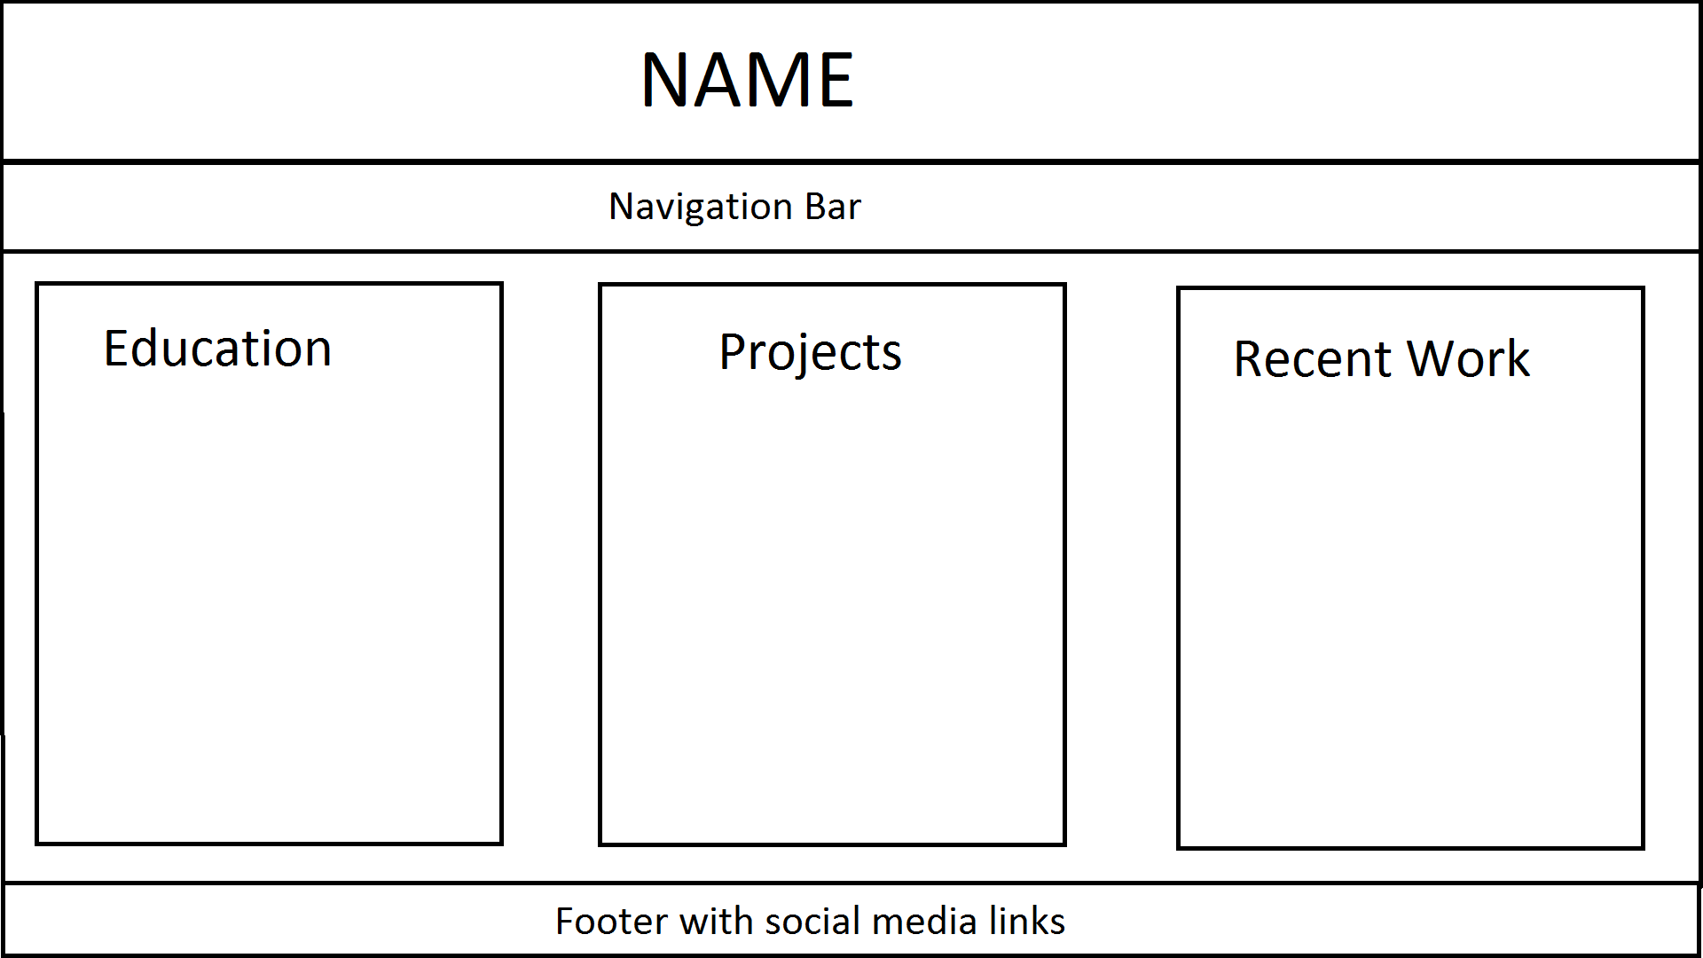

Mobile –

On most of these pages the page will overflow allowing more space for each section. An example of this would be on the cv page each heading will have a lot more space than shown because of overflowing.

Homepage –

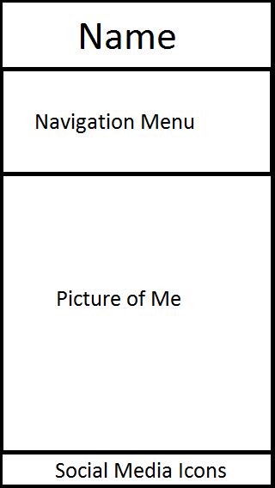

Bio –

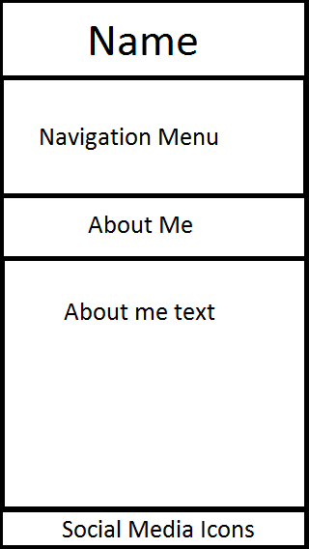

Contact –

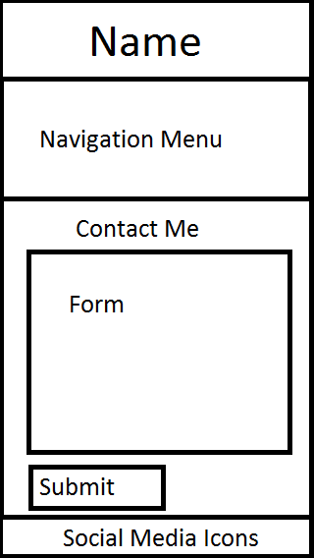

CV –

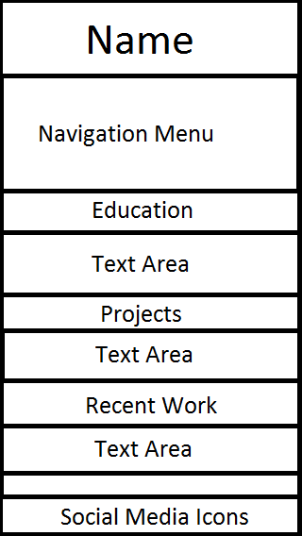

Images –

Favicon –

This is the favicon that I have created, I decided to make it a 16x16 image to minimize the sites size thus increasing the load speed. I also chose to use my initials as the favicon because of this 16px by 16px limit.



Models of Good Practice –

Visual Appeal –

While I looked at other sites I ended up deciding to just have a simple theme for the website and not to over complicate the colour scheme. In the end I decided to use the background design from google plus with the greyish background and white area for text.

Colour Scheme –

When choosing which colours I would use for my website I looked into googles material design and found a website called Material Palette from this website I decided to choose grey and purple for the colour scheme.

Page Load Speed –

One of the most important aspects of making a site is the load speed. This is a reason I decided to test my site using two well-known sites. As you can see from the results google is showing the speed as good on desktop and fair for mobile, while Pingdom showed that it loads faster than 99% of sites tested using this source and took 188ms to load.

This figure can be further improved upon by eliminating render-blocking css and further reducing the image sizes.

I used the following sites to test the load speed of my site:

<https://testmysite.thinkwithgoogle.com/>

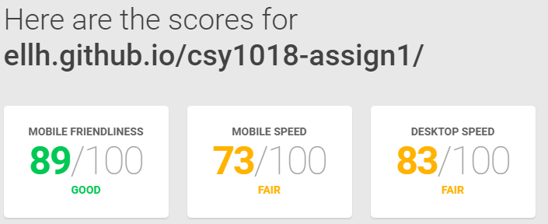

<https://tools.pingdom.com/#!/dOd2x6/https://ellh.github.io/csy1018-assign1/>

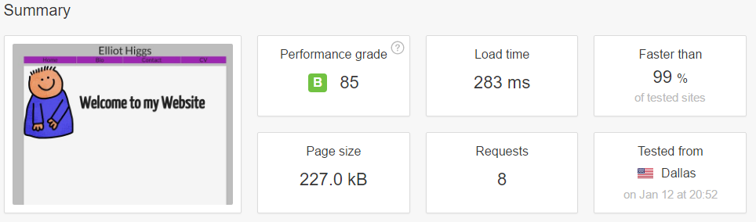

Progression of Website –

Week 1 –

During the first week of working on my website, I started off with the basic layout of the page. I have added a title, navigation bar, main and footer. I have only worked on the index page but the layout once finished will be copied to the other pages. Additionally, I added media queries to the navigation bar so I could test the website on my mobile and ipad to see how the website was working on smaller devices.

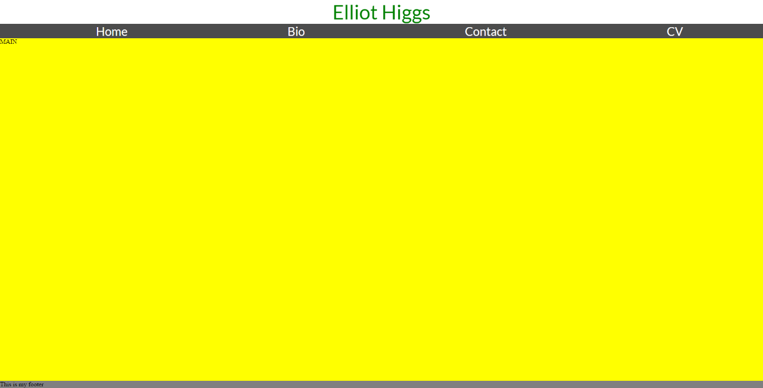

Week 2 –

During the second week, I was still deciding on the final colour scheme so there is a mix of background colour. I also ran into from problems during this week such as my footer becoming unattached to the bottom of the page.

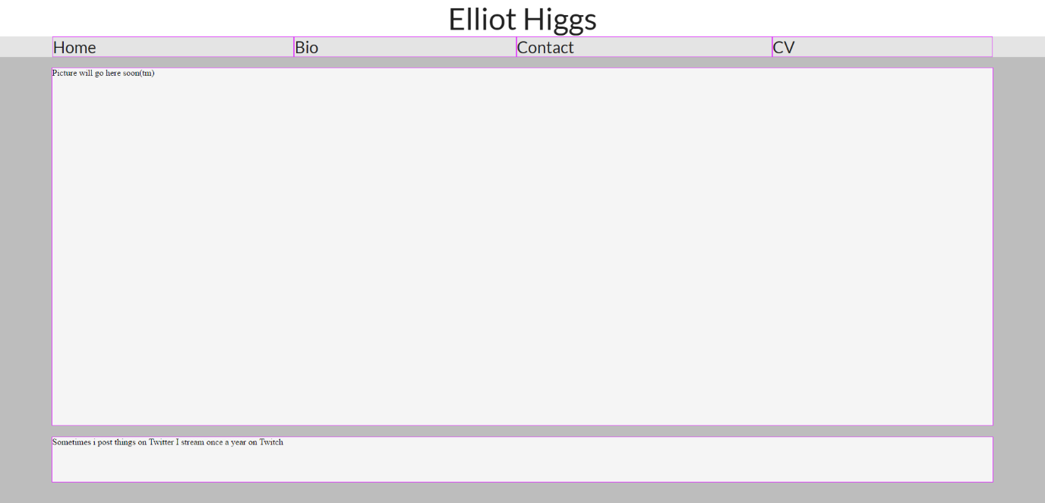

Week 4 –

During these two weeks, I finalised my colour scheme and layout, I copied the layout over to the other pages so I could start finalising the layout on them pages. During this, I also added the contact form and tested how it was working on different devices. I also added animation to my navigation bar during so when the user hovers over the navigation bar it will go to a deeper colour purple and back to original and it will loop this until the user changes what they have hovering over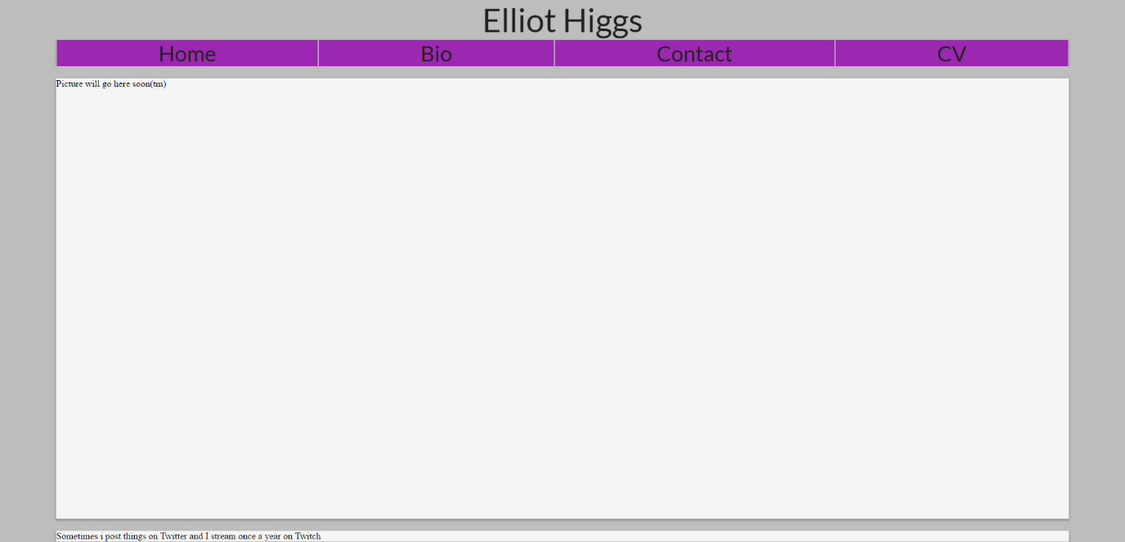

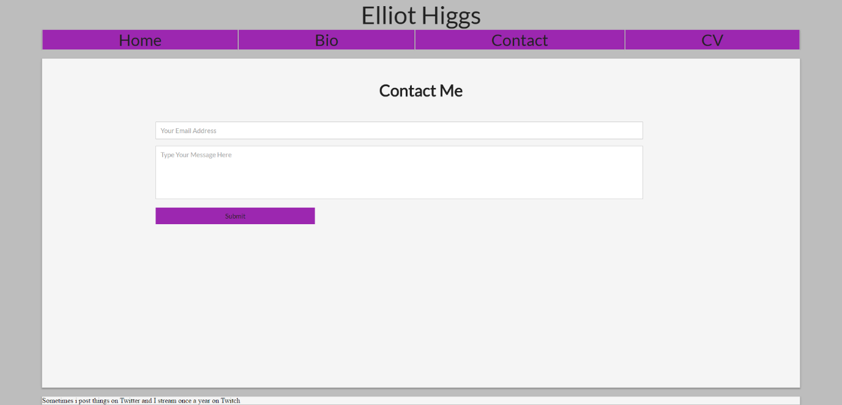

Week 6 –

During these two weeks, I added content to the home page, added icons to the footer, I was mainly working on the footer and favicon. A problem I ran into during this was the image I was going to use was 923kb so I spent time investigating the best way to optimise the image for mobile devices, in the end, I managed to get the file down to 77kb.

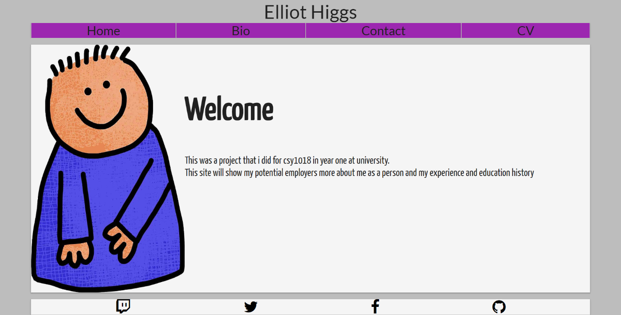

Week 8 –

During these two weeks, most of my time was spent modifying the layouts on Bio and CV page as when I added the content I had an idea of how I wanted to lay it out. During this stage, I also decided to use another font as the one I was currently using I didn’t think would fit the style of this layout, but I kept the old font as I thought it was suited to the contact form. During this I decided to simplify my homepage so now it only says ‘Welcome to my Website’ I decided that I would do this as the text when the media query happens it removes the text and only the image is visible during this stage when the image is clicked the image width gets changed.

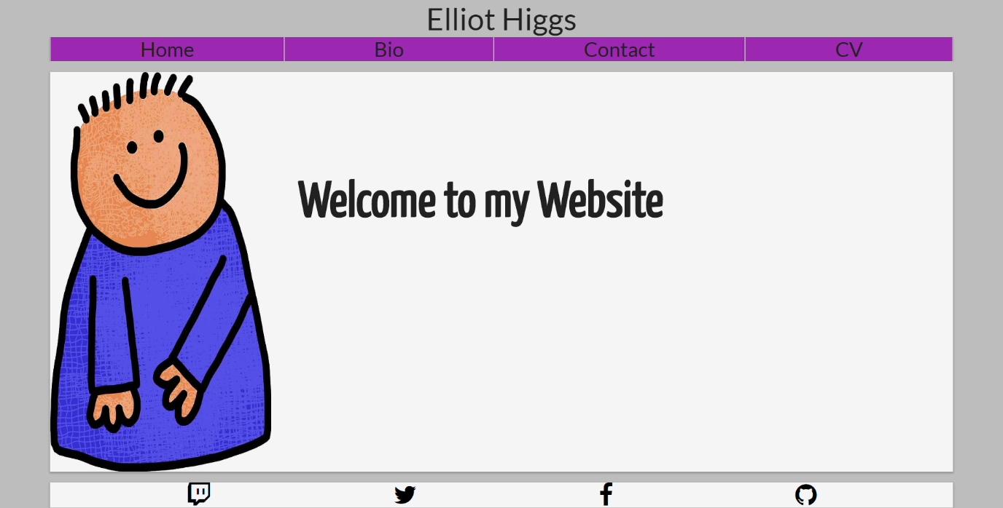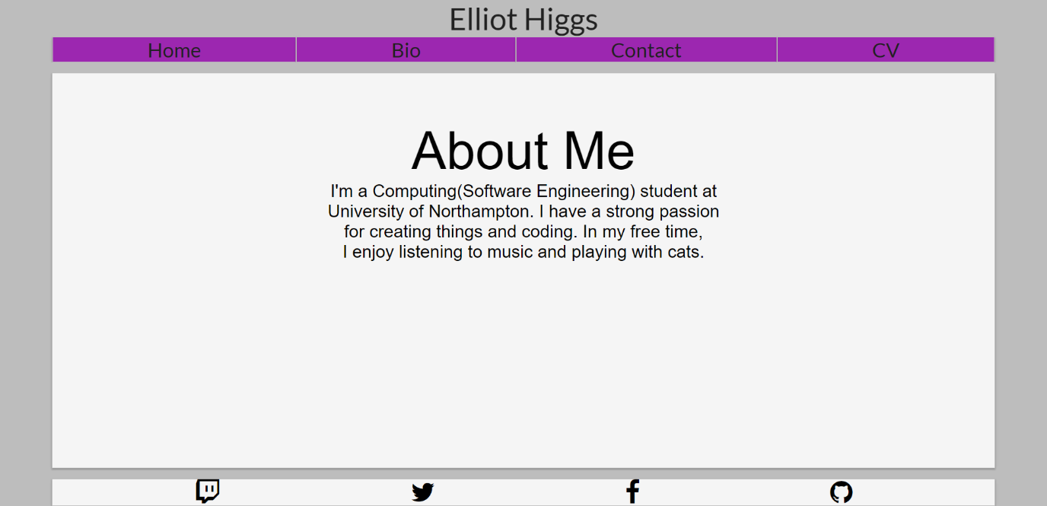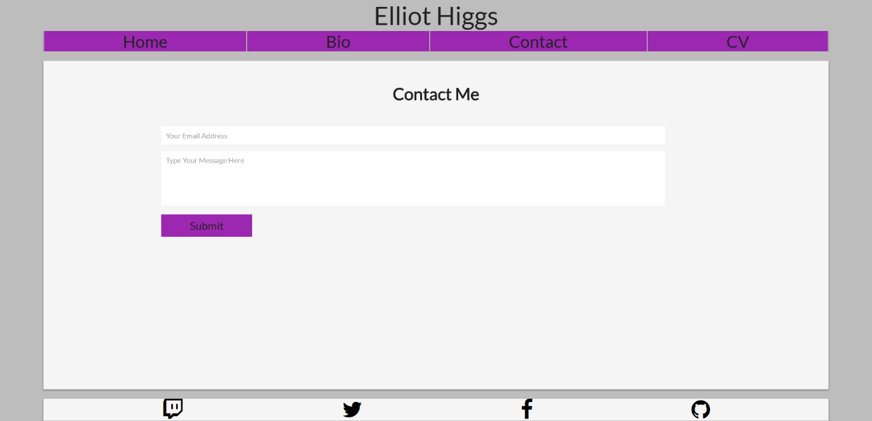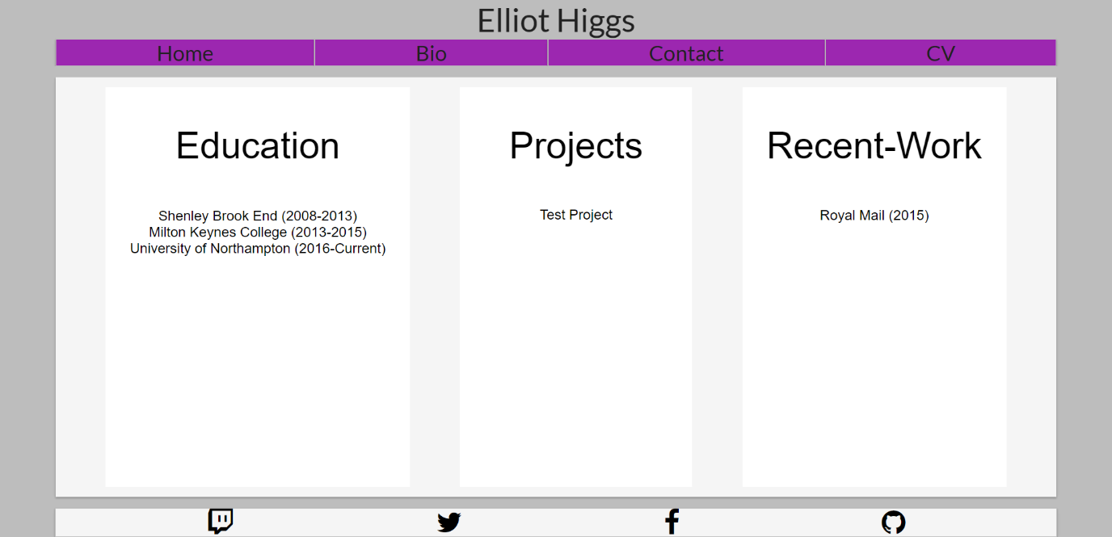

Final Designs –

For my designs, I decided that I would keep the same layout throughout all of the pages, consisting of a header, navigation bar, content and footer, the header, navigation bar and footer will stay the same on all pages. Whereas the content on each page will change the layout depending on the type of content, such as the cv page will need multiple content sections so the layout has been modified to allow it.

Homepage -

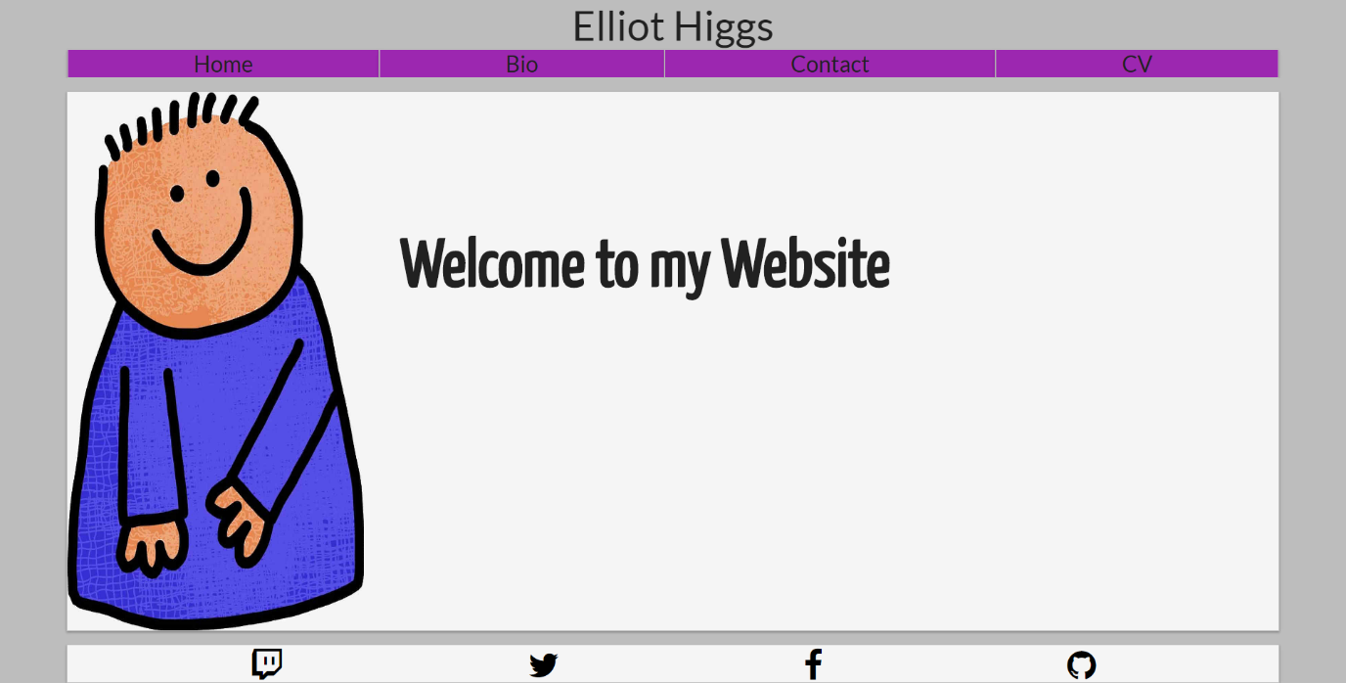

Bio –

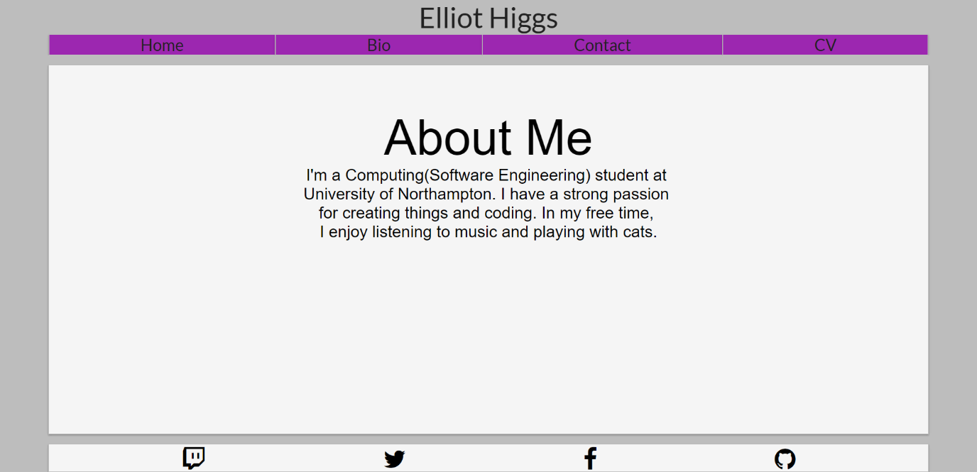

Contact – 

CV –

