# 20/10/2020

## FOMOD

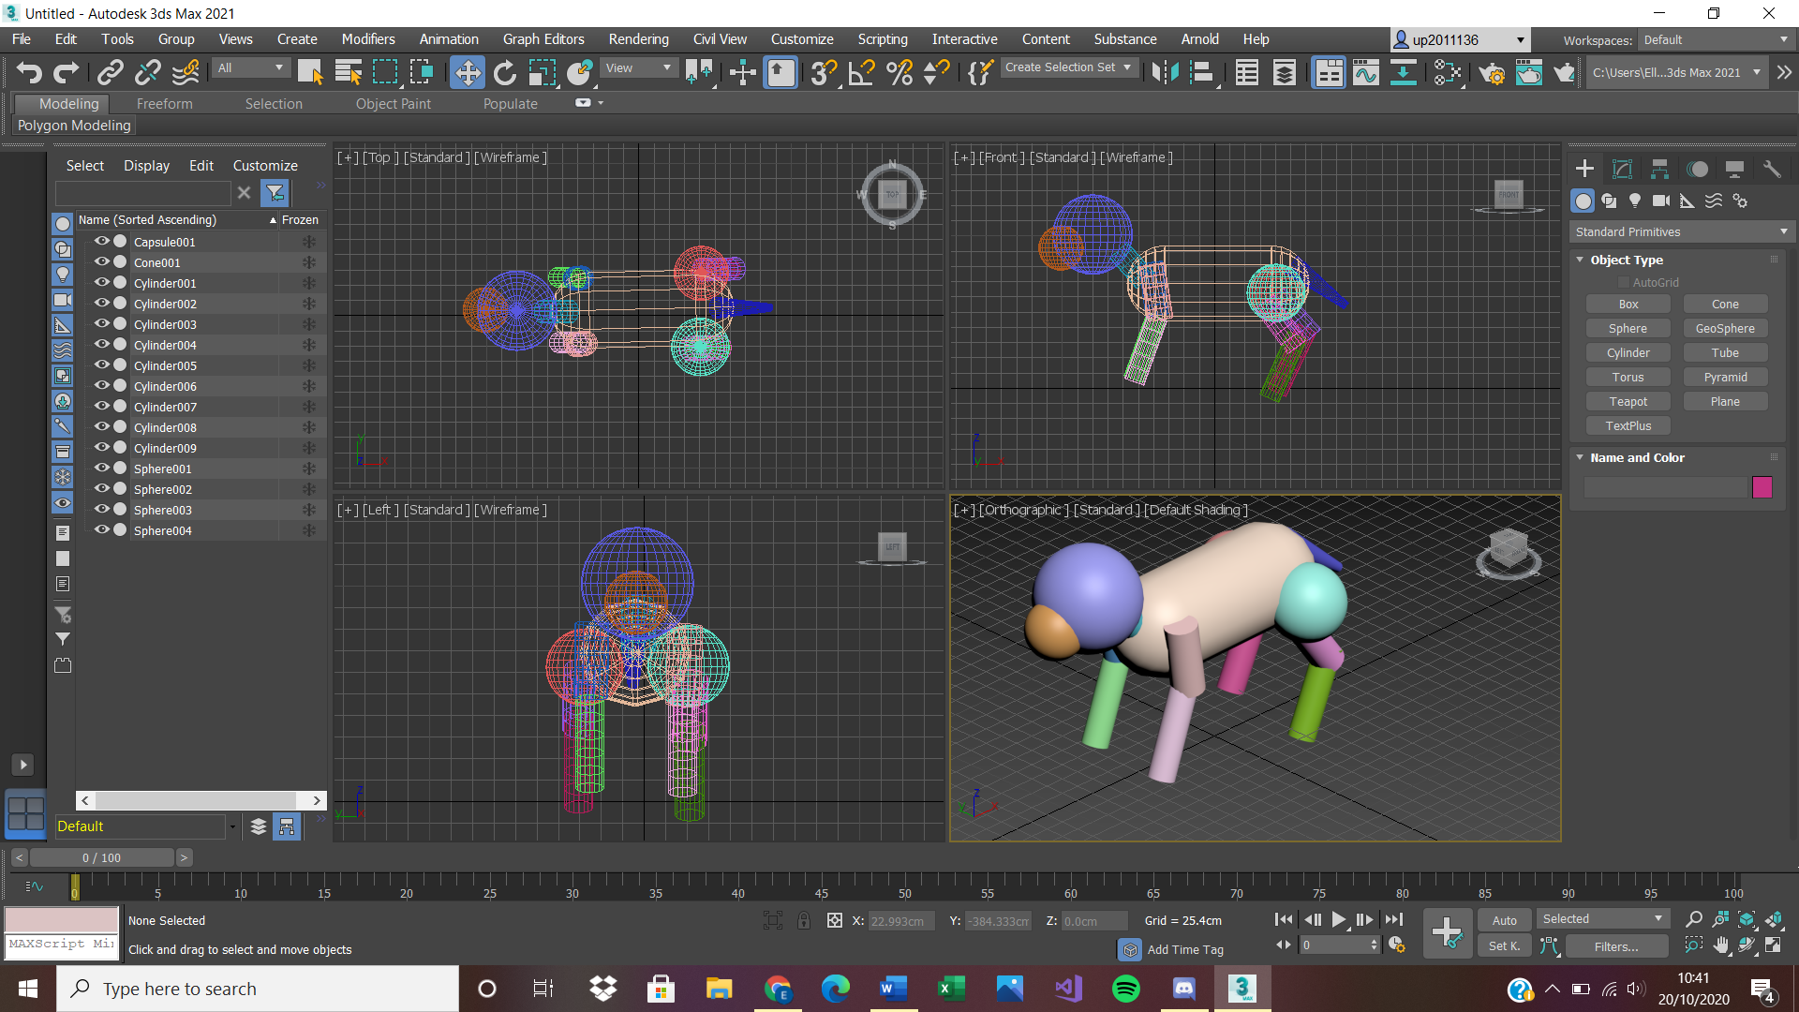

Working on creating a Quadrupedal animal out of standard primitives to practice using 3Ds max. I used a dog skeleton as a reference

# 29/10/2020

## FOMOD

Today I completed tasks for 3d modelling and image tasks creative observational drawings of a full model. I had a lot of fun creating the drawings as I previously practiced drawing the human form this way.

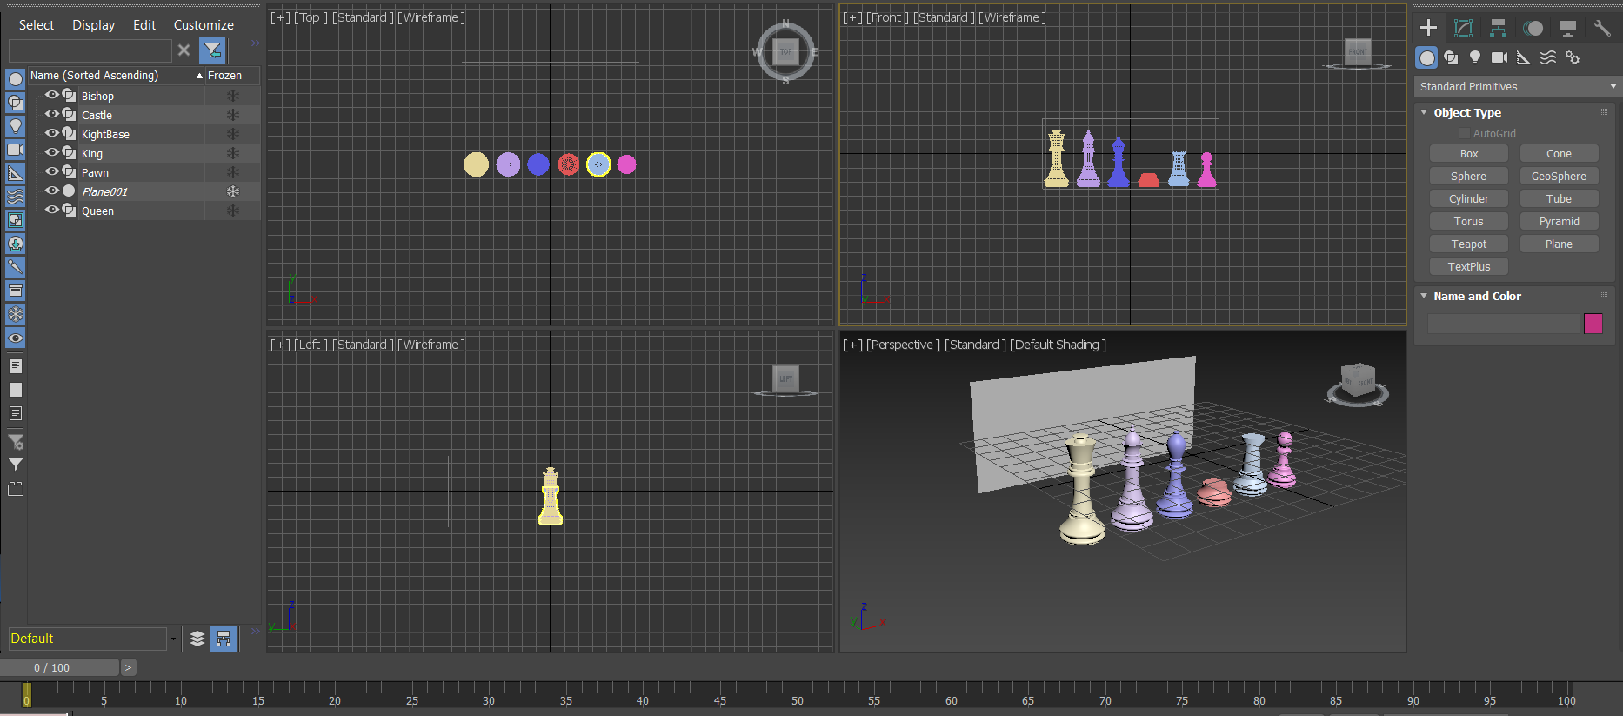

# 03/11/2020

## FOMOD

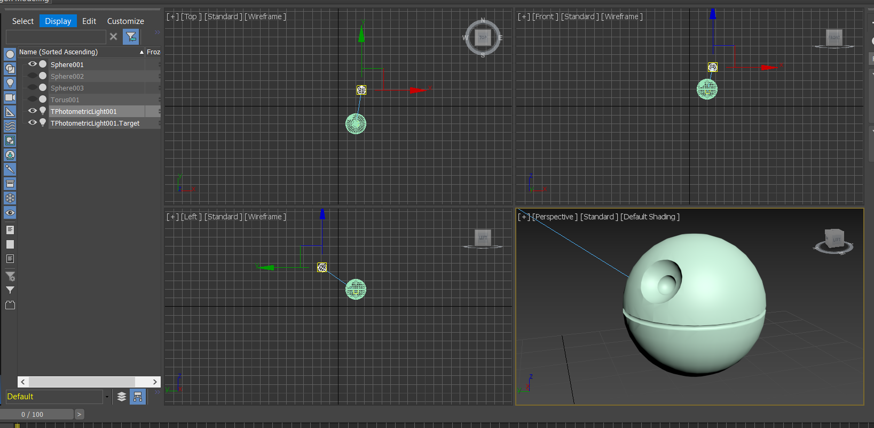

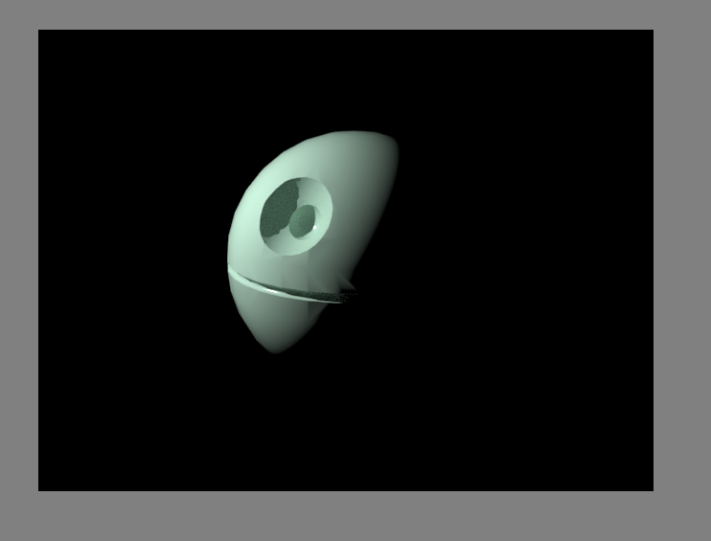

I started using basic shapes set up a scene for a treehouse.

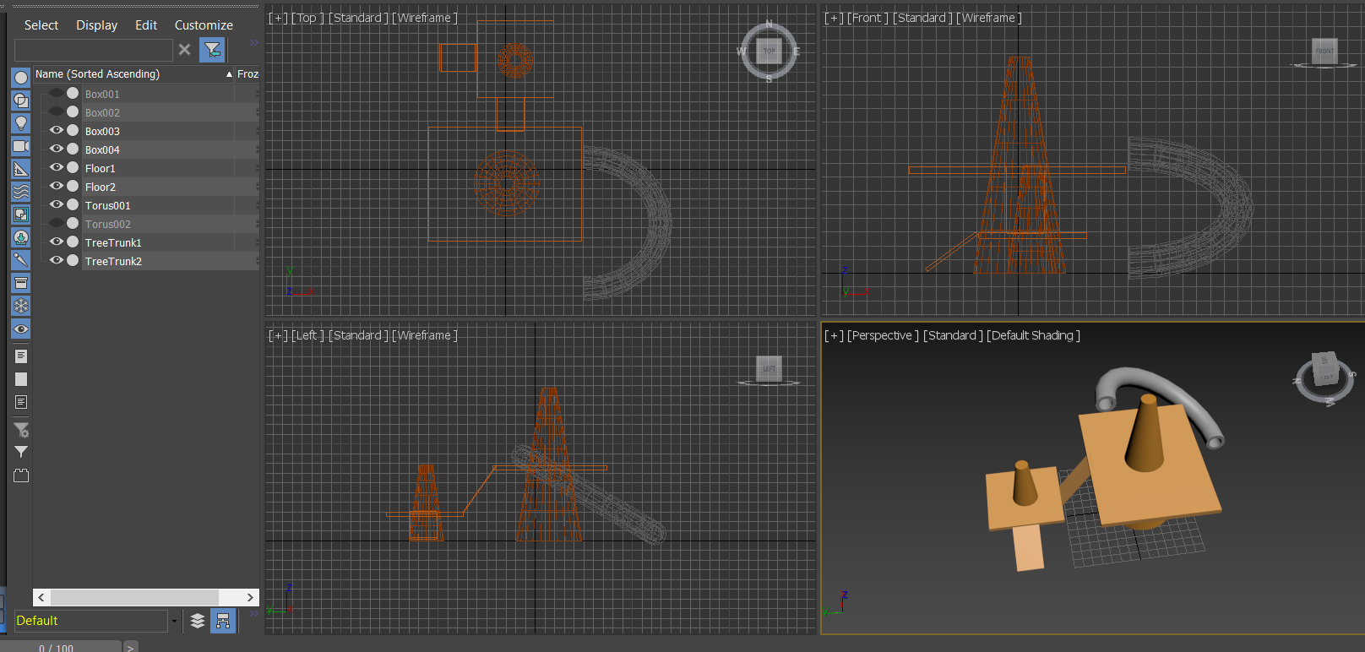

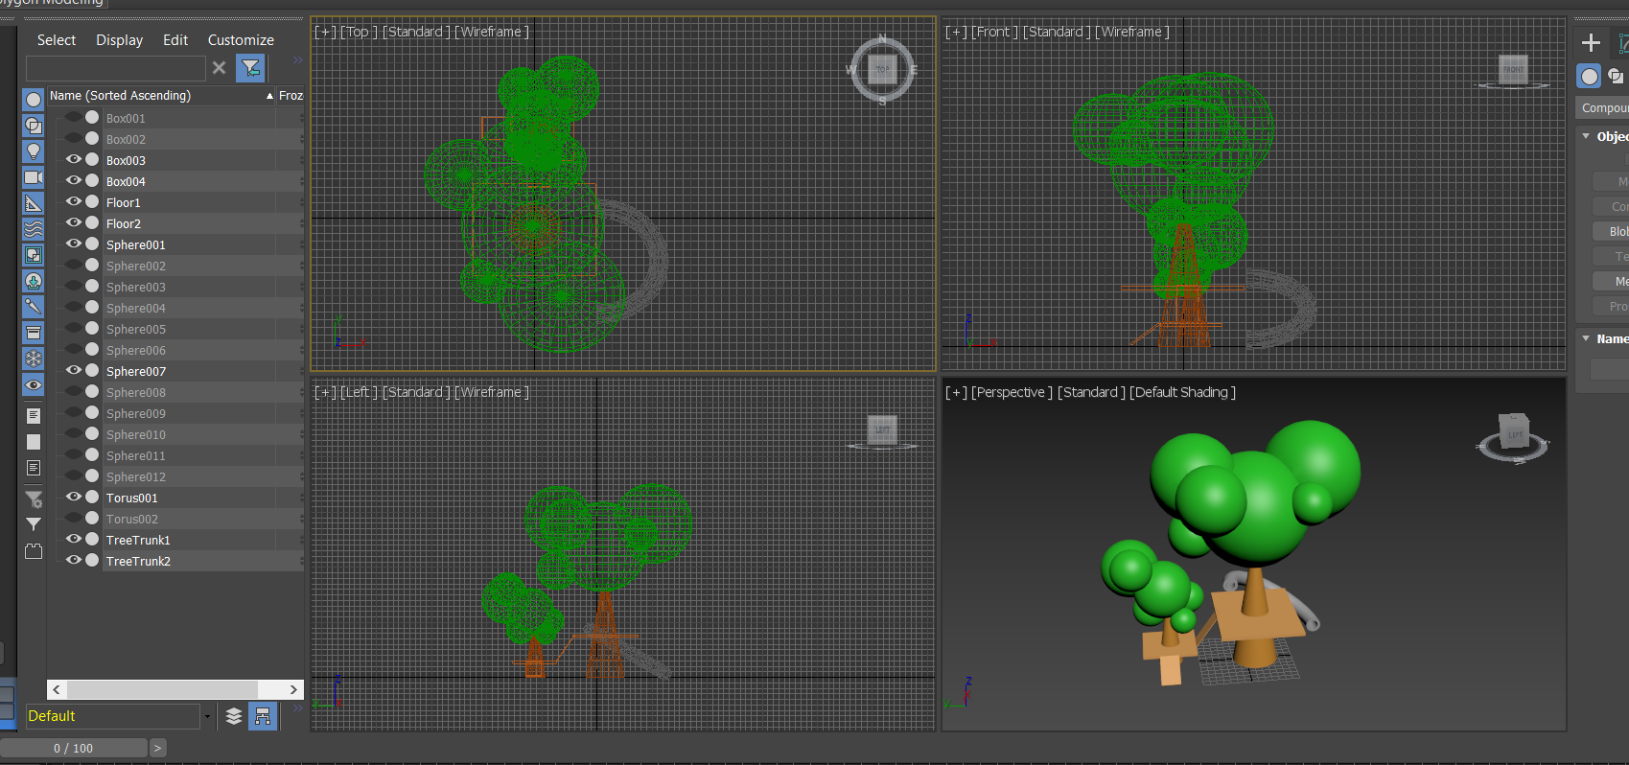

# 04/11/2020

## FOMOD

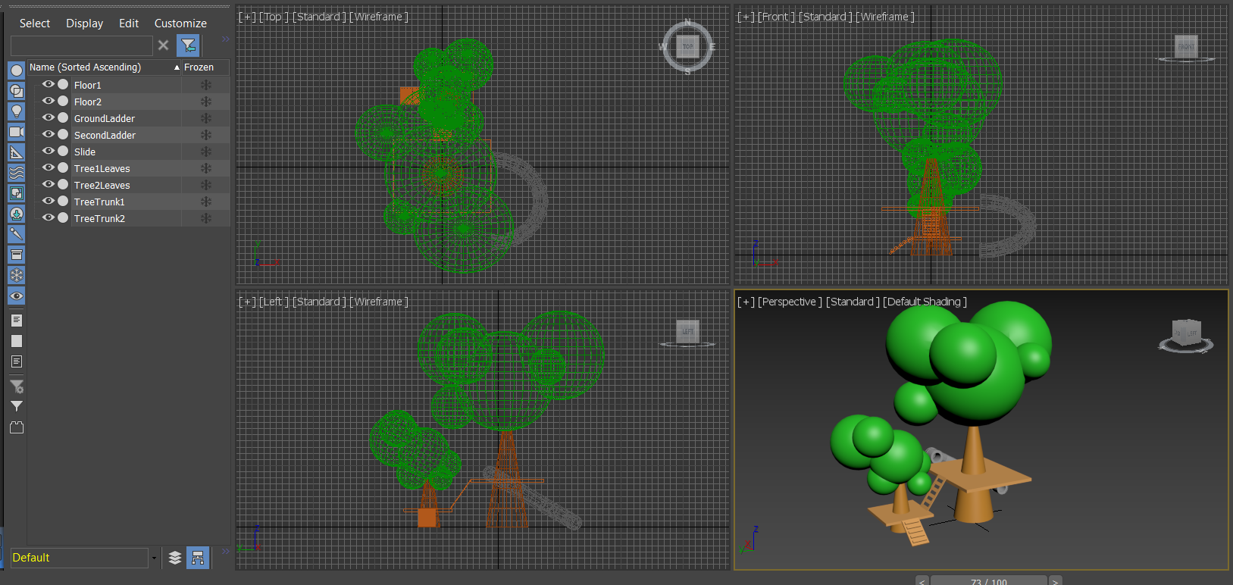

I added details to the slide and the ladders up to the platform.

# 10/11/2020

## FOMOD

I worked on creating a blender for my consolidation week task.

# 11/11/2020

## FOMOD

I finished the blender I was making for consolidation week

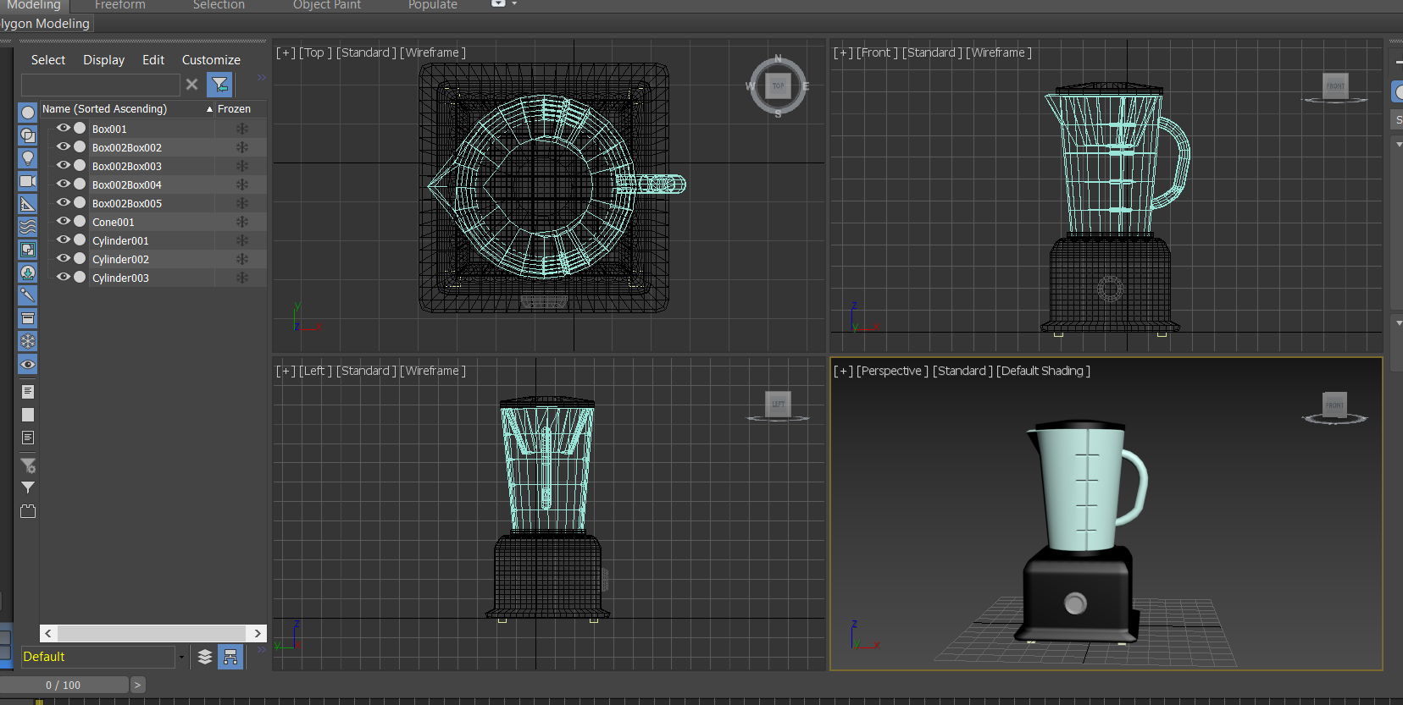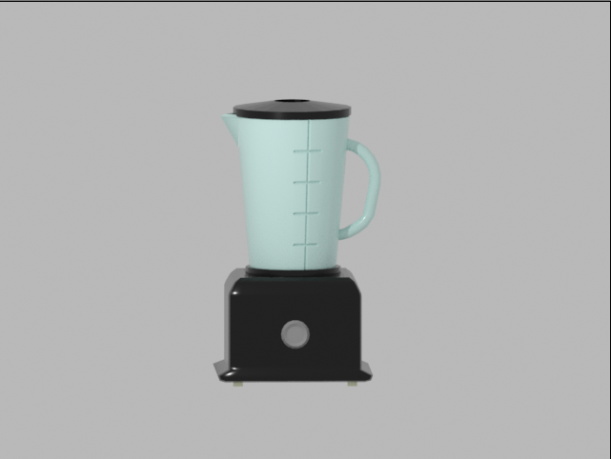

# 26/11/2020

## FOMOD

I did the workshops however forgot to take screenshots however I need to complete the 3rd workshop.

# 31/12/2020

## FOMOD

I started the Christmas break challenge making a Christmas sleigh

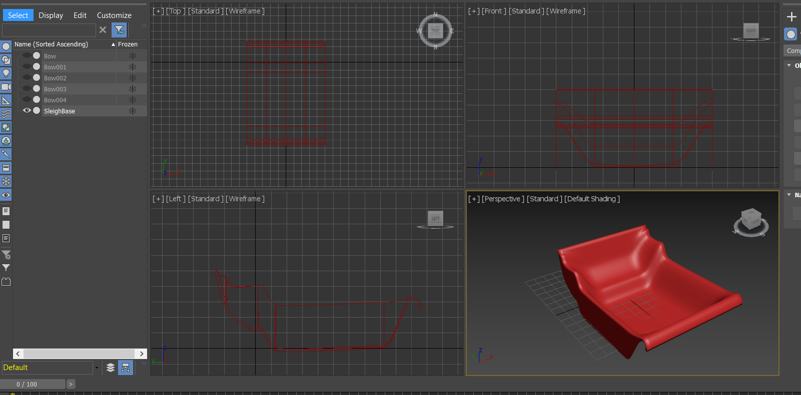

Using nurbs I created the base of the sleigh

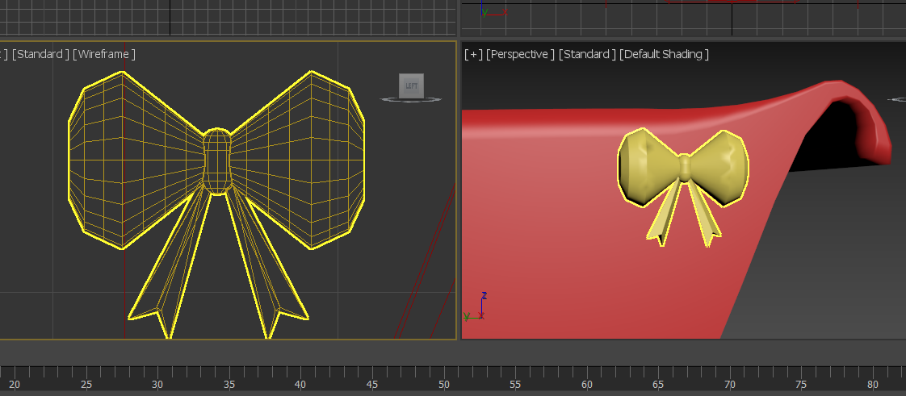

I created bows using simple shapes and using the Boolean so I can copy and repeat them for decoration.

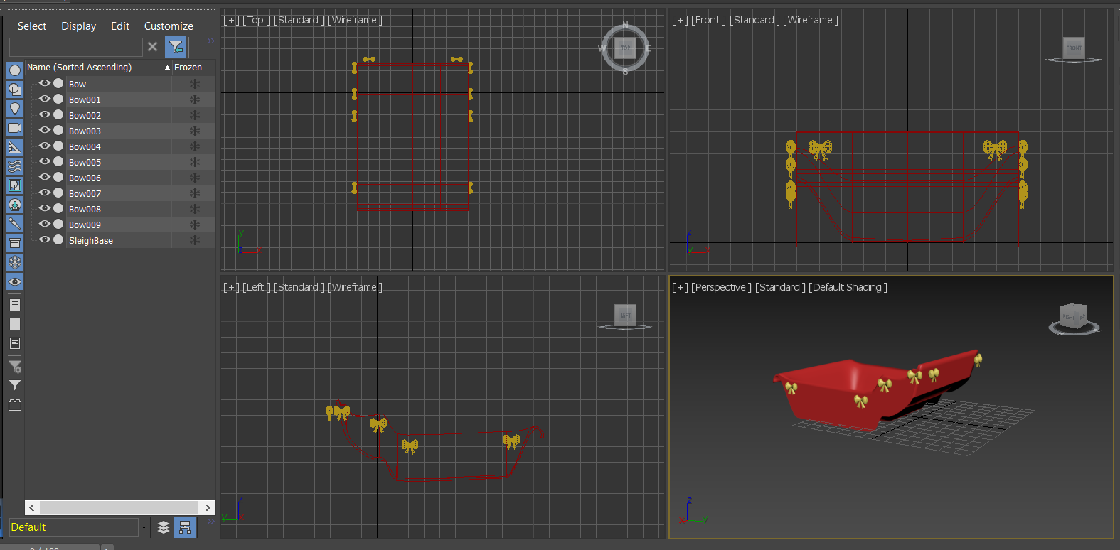

I created a line and lofted a circle onto it for the skis.

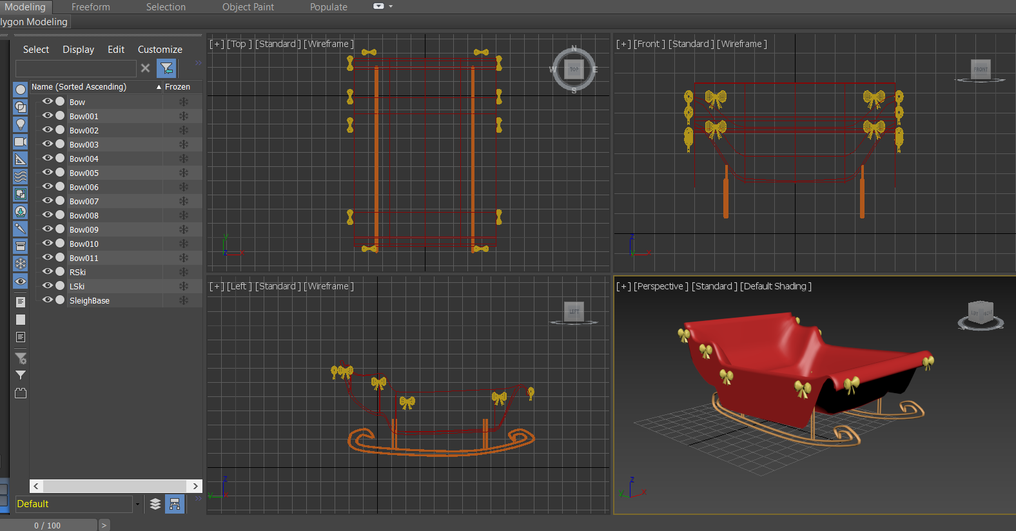

Using another nurb patch I tidy up the underneath of the sleigh

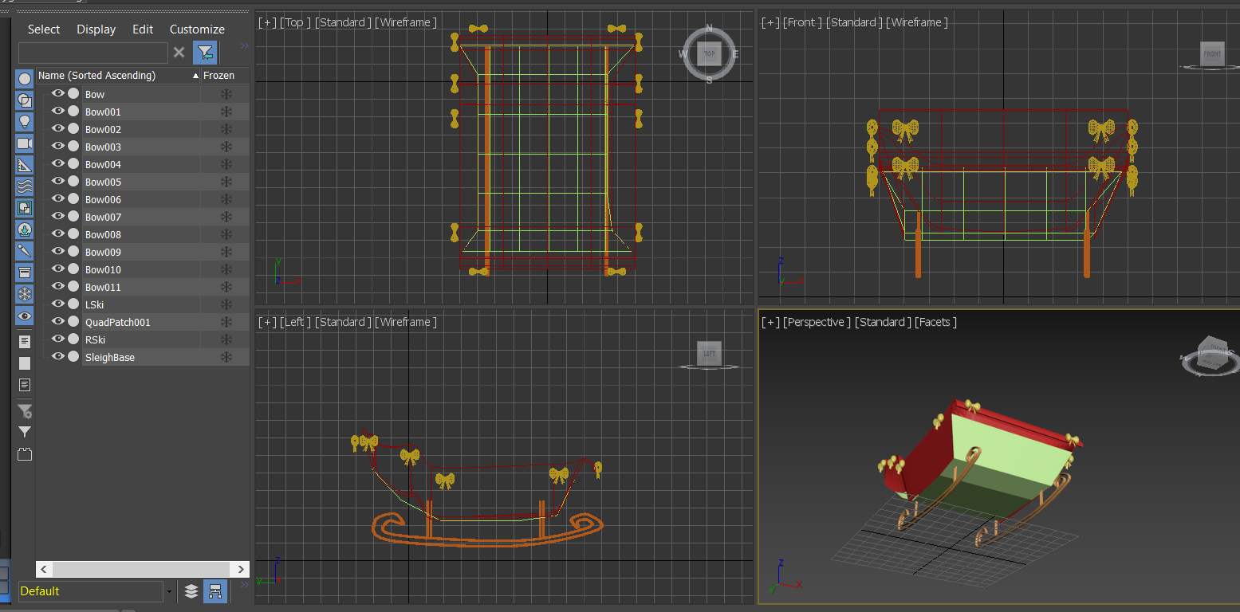

# 01/01/2021

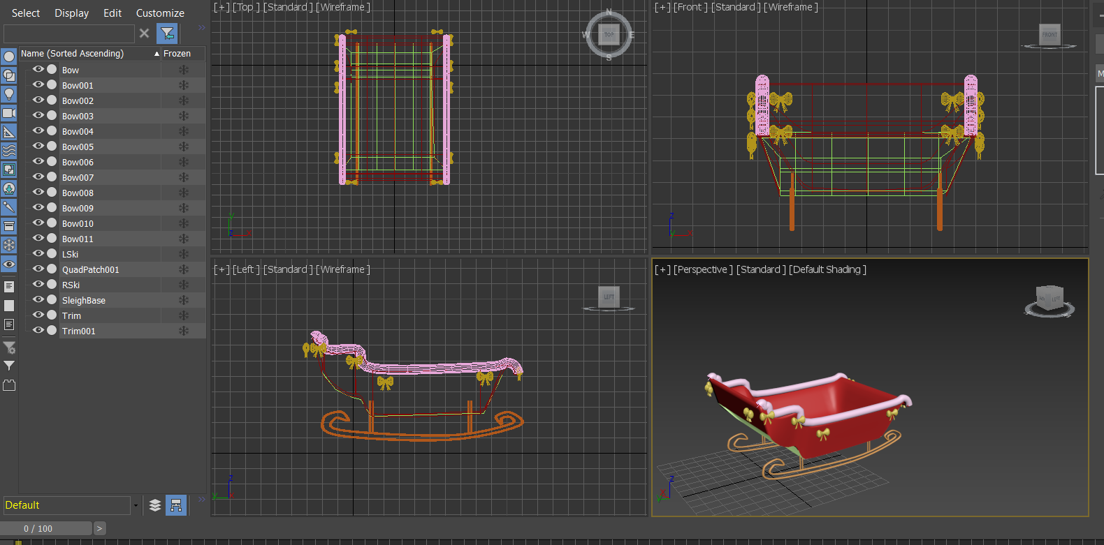

I used lofting to create a trim around the outside of the sleigh

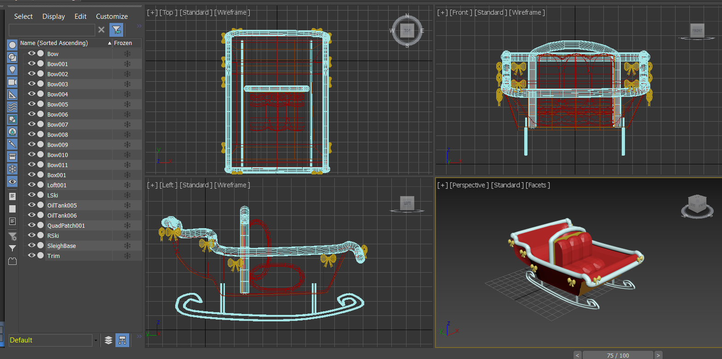

I created the seats in the middle using basic oil tank shapes booleaned together with the edges subtracted to make the edges sharp. I used a cube for the back with a lofted trim.

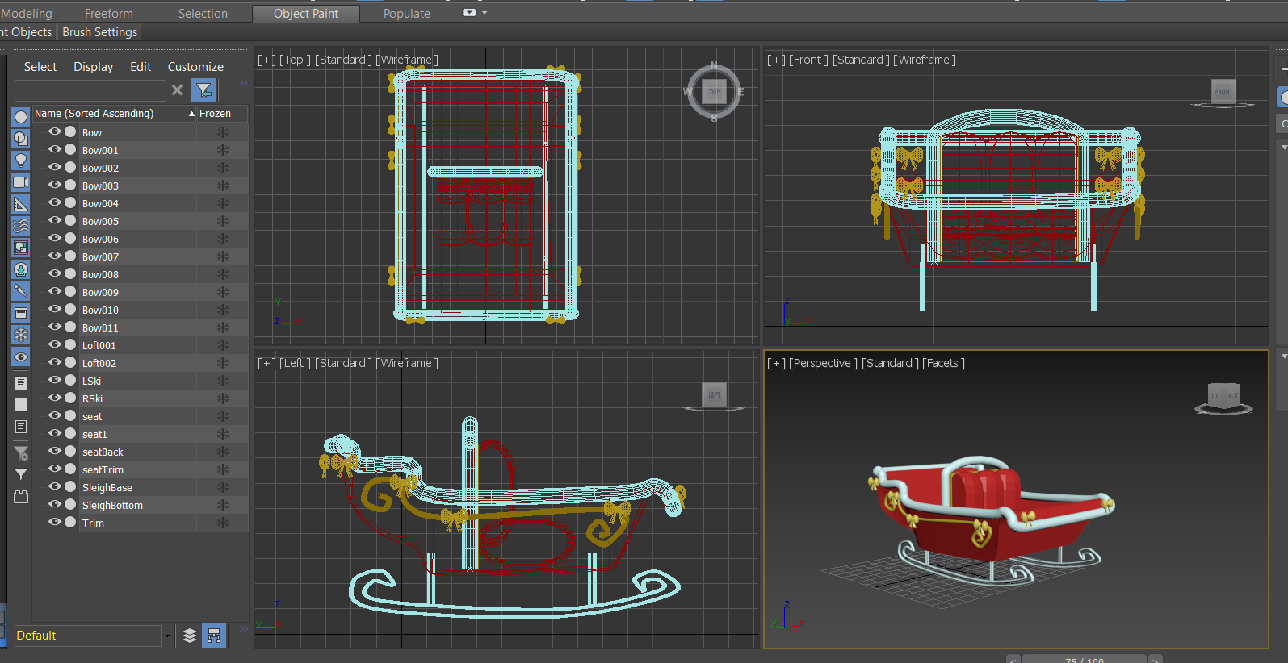

I used lofting to add detail on the outside.

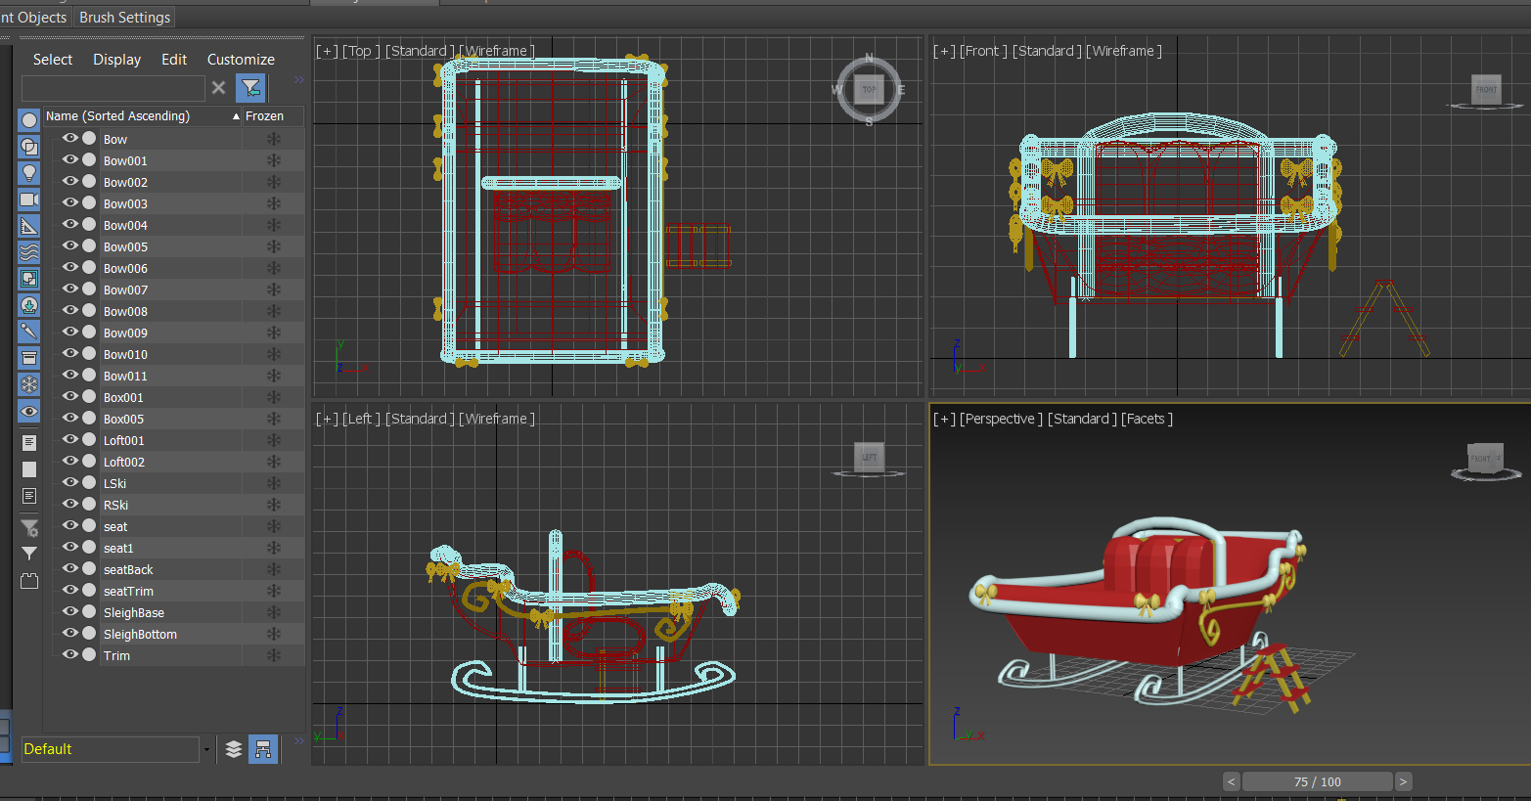

I added a step ladder next to the sleigh.

# 12/01/2021