# 15/10/2020

## IMAGE

I sent my portraits that I drew for image to my lecturer and got feedback on my work

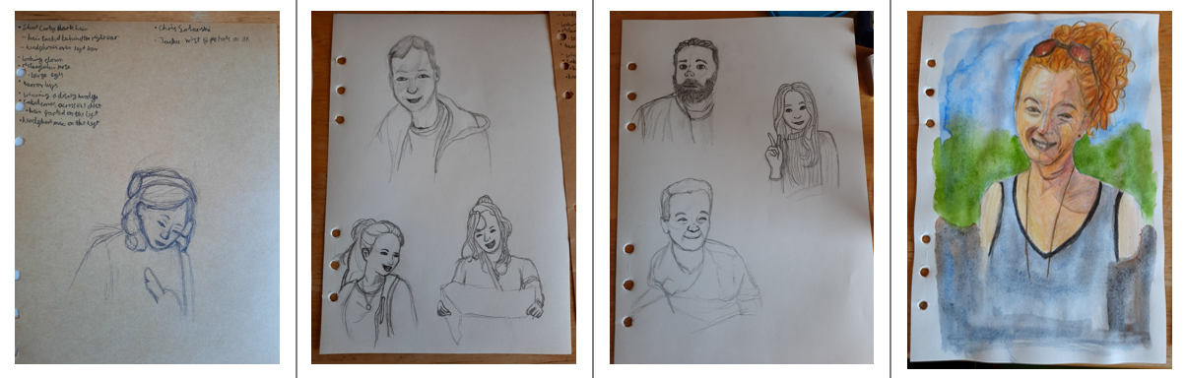

Feedback:

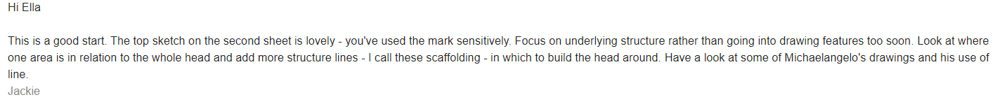

# 29/10/2020

## IMAGE

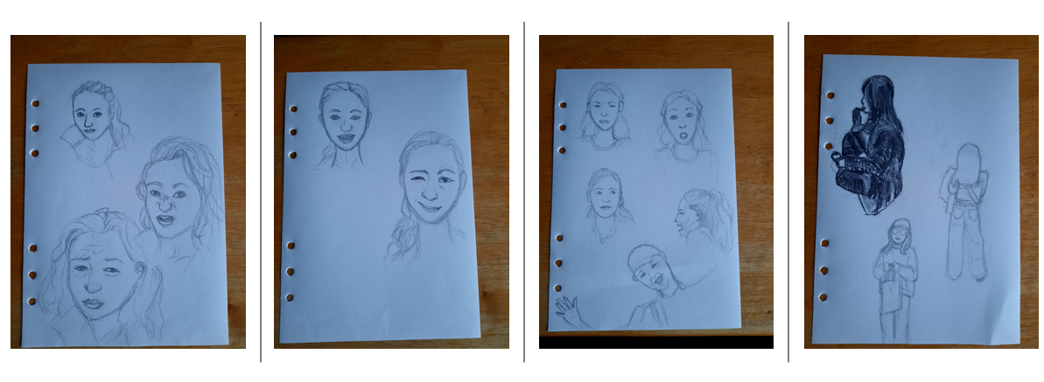

Feedback:

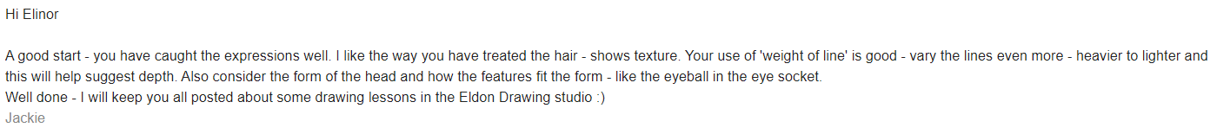

# 04/11/2020

## IMAGE

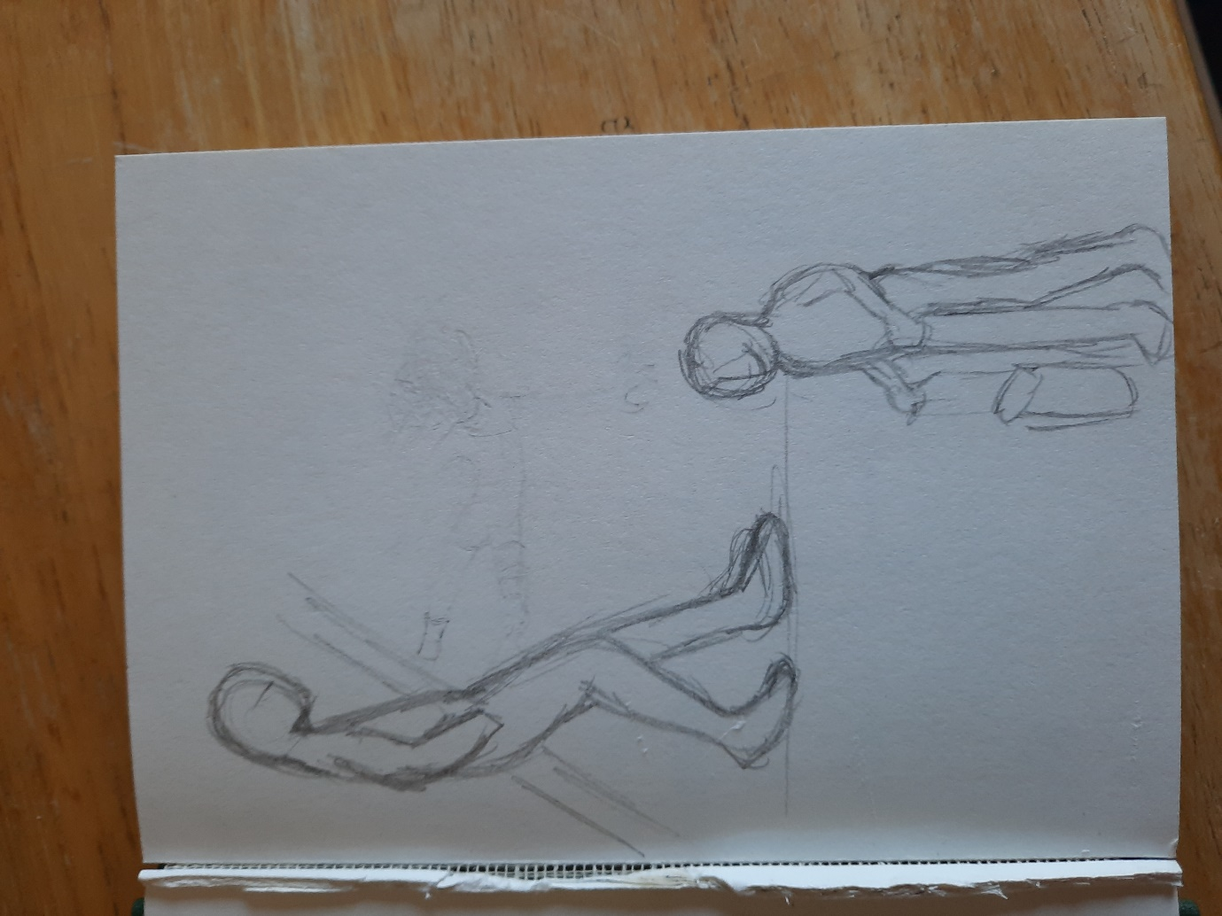

# 05/11/2020

## IMAGE

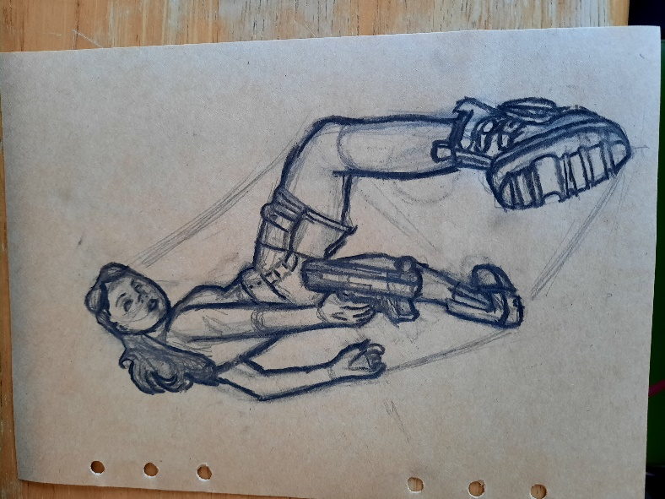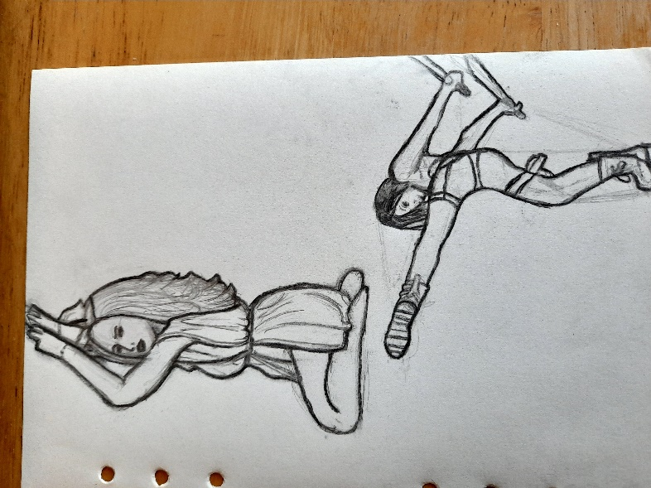

# 06/11/2020

## IMAGE

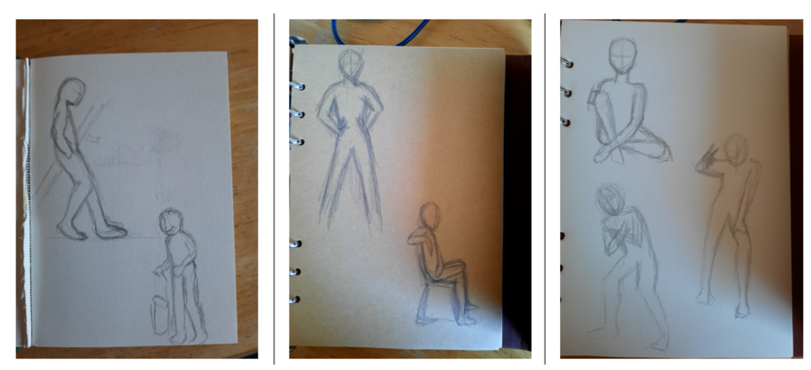

Feedback

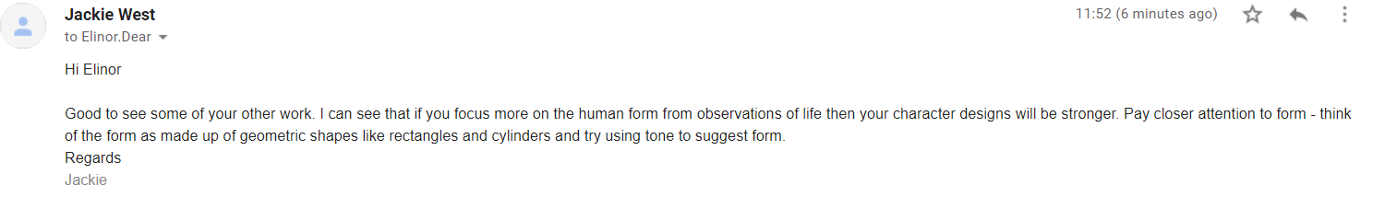

# 03/12/2020

## IMAGE

I started practicing with colour in acrylic and water colour paint

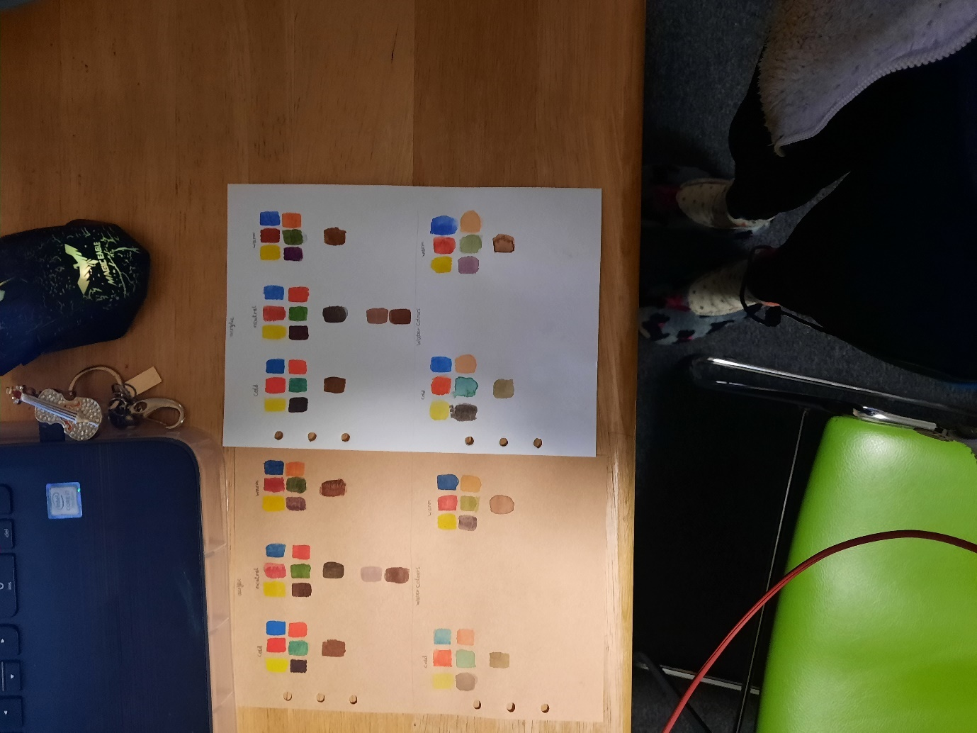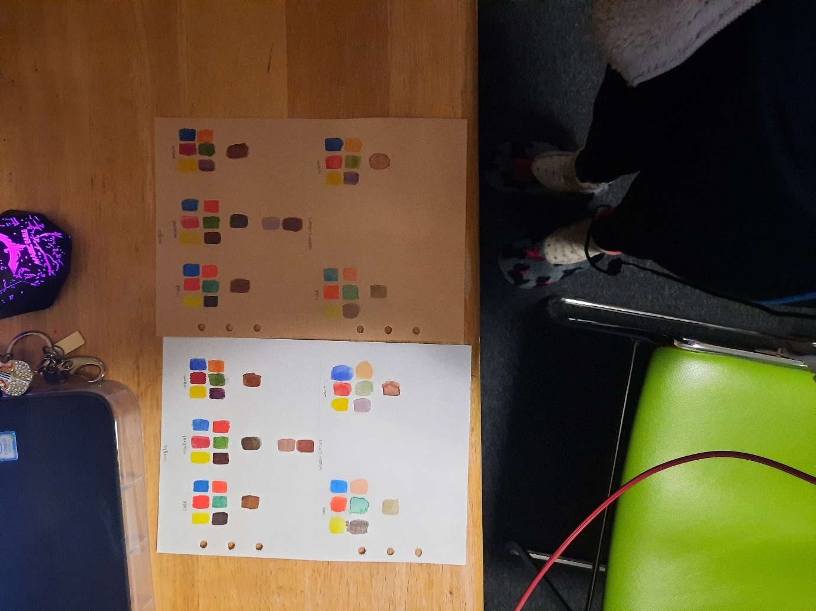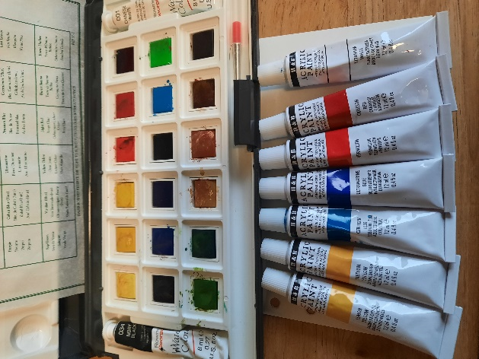

# 04/02/2021

On the 25th of January I handed in my power point containing all my work I hadn’t updated my dev diaries after the Christmas holidays.