# 16/10/2020

## TOGA

My code using what I learnt from the first topic workshop.

[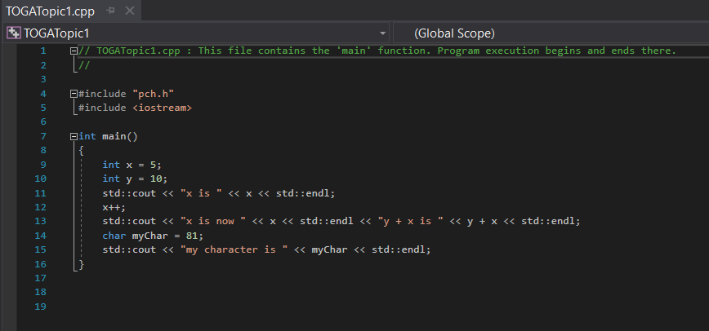](https://jhnhertsschuk-my.sharepoint.com/personal/stevensond_jhn_herts_sch_uk/Documents/Networks%201_3.xlsx?web=1)

This my code using what I learnt from the topic 2 workshop

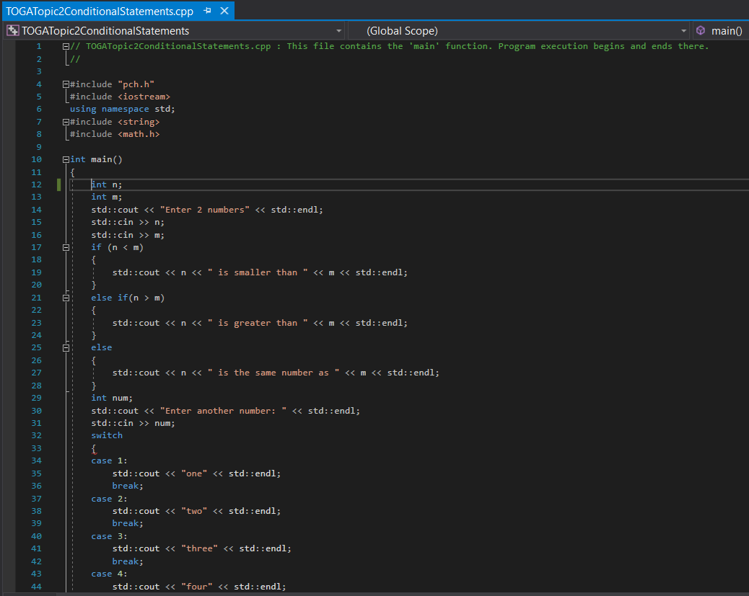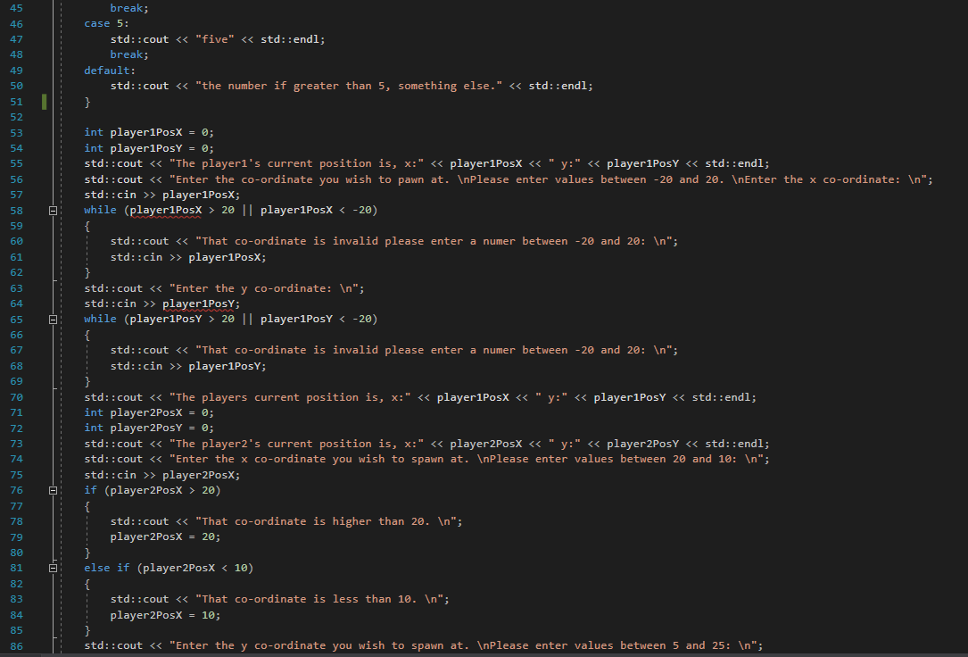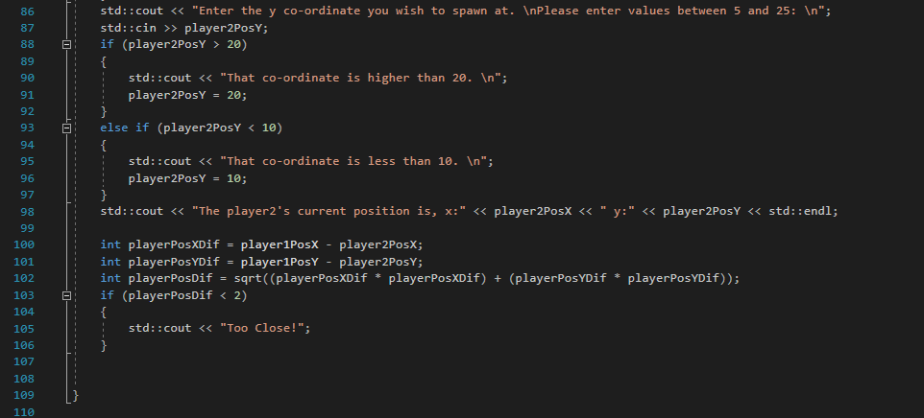

# 02/11/2020

## TOGA

### Crocodile simulator

I started looking though the consolidation week crocodile simulator game. From looking through the code I can see that to win the game and not get eaten by the crocodiles you must start the game with over 1000 crocodile food. The only chance to meet this end condition and survive exiting the safe zone is at the start when the player is asked to enter their name and how much food they are carrying, this information is stored in the player1 object that is initialised at the start. The player then spends the rest of the game wondering around the safe zone by entering what direction they wish to travel.

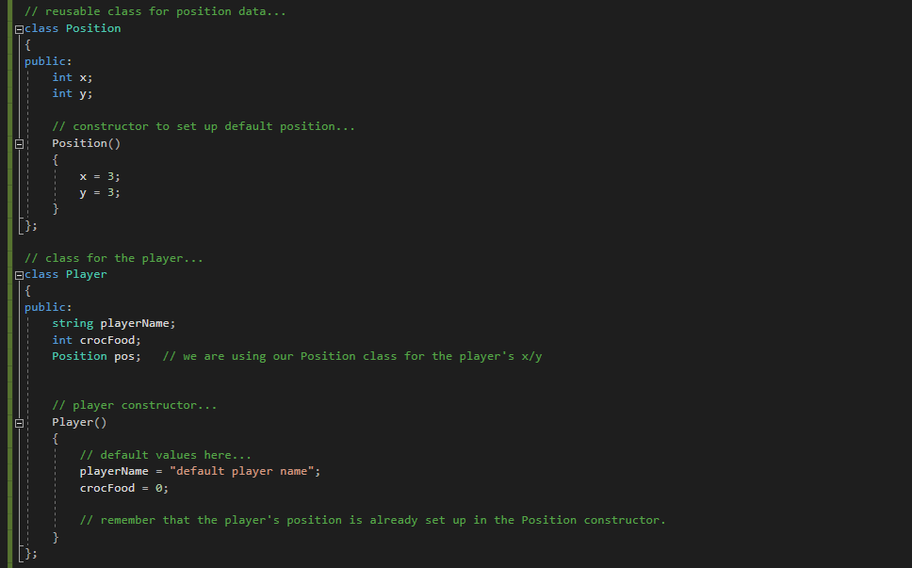

The game has 2 classes the position class and the player class, which makes use of the position class. The position class stores the x and y co-ordinates of the player and has the default spawn co-ordinates of 3,3. The player class stores the players name and the amount of food the player has. I wonder why they would create a separate class for the players position and not store that data in the player class.

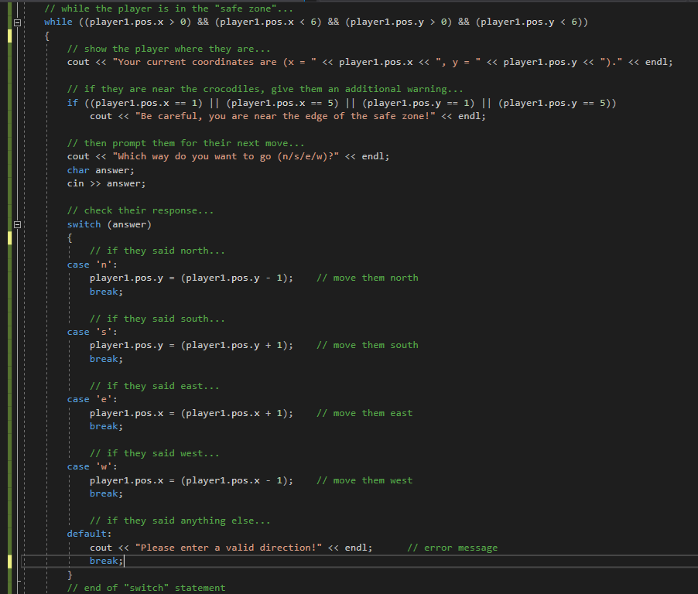

The majority of the game takes place inside a while loop where the player is told their current co-ordinates and asked which direction they wish to move in. If the players co-ordinates are ever greater than 6 or less than 0 the while loop will end as the player has left the safe zone.

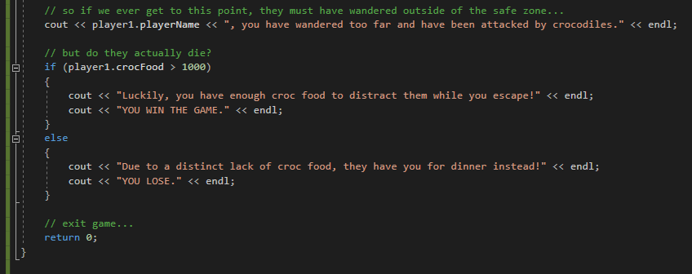

When the while loop ends the game will check how much croc food the player entered at the beginning of the game if it is more then 1000 then the player is told they have survived however if it is less then the player is eaten by crocodiles and the game then ends.

### Island adventure

I have started looking at the island adventure code which is an example of using 2D arrays like co-ordinates. In this game the player can explore the island and in specific positions there is text which will appear giving the player messages.

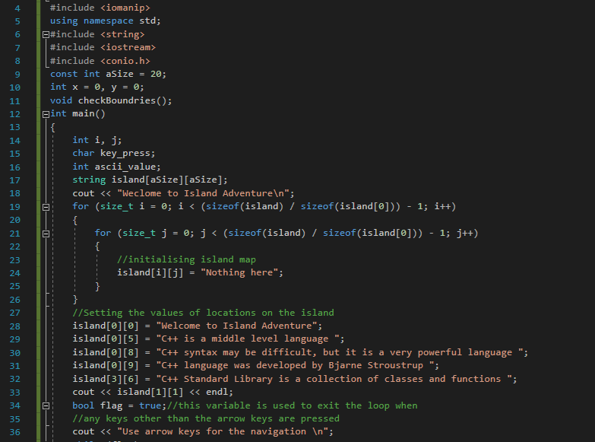

This is the codes set up where the array island is created and populated. A for loop is used to fill all the spaces on the island with the words “Nothing here” and then the data in the specific locations in the array is overridden with the new phrases.

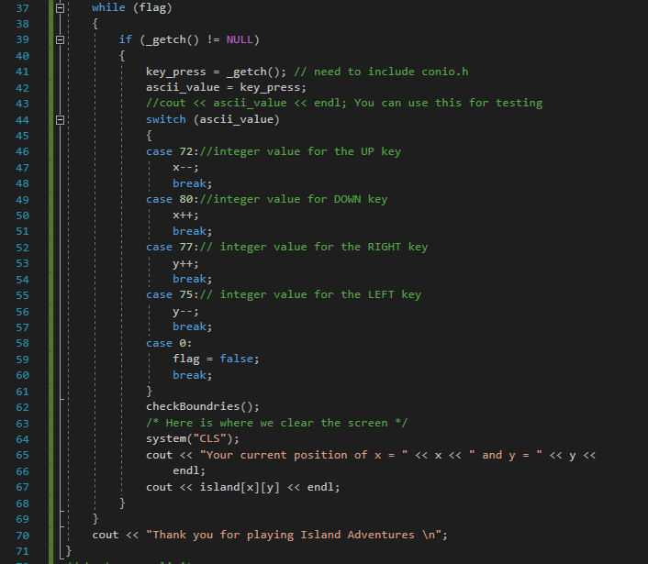

There is then a while loop where the main game is played. This program checks if the flag value is true, if so it checks if the key pressed. If a key was pressed then it stores the key in the variable name key_press and then finds the ascii value of that key so the switch statement can check if it was an arrow key pressed. If an arrow key was pressed then it changes the values of x and y having the player move through the array. If it was not an arrow key that was pressed then the flag variable is made false which causes the while loop to stop, the message “Thank you for playing Island Adventures ” is printed and the game ends.

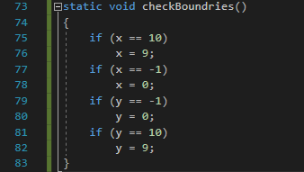

Underneath this is the code for the function checkBoundries which is called after the switch statement.

# 15/11/2020

## TOGA

Using what I have learnt from the first few lessons I started to create a map for a mining game.

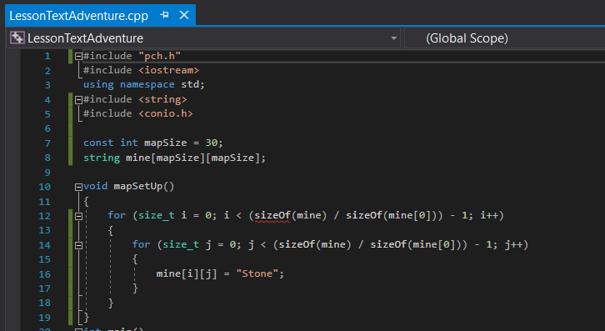

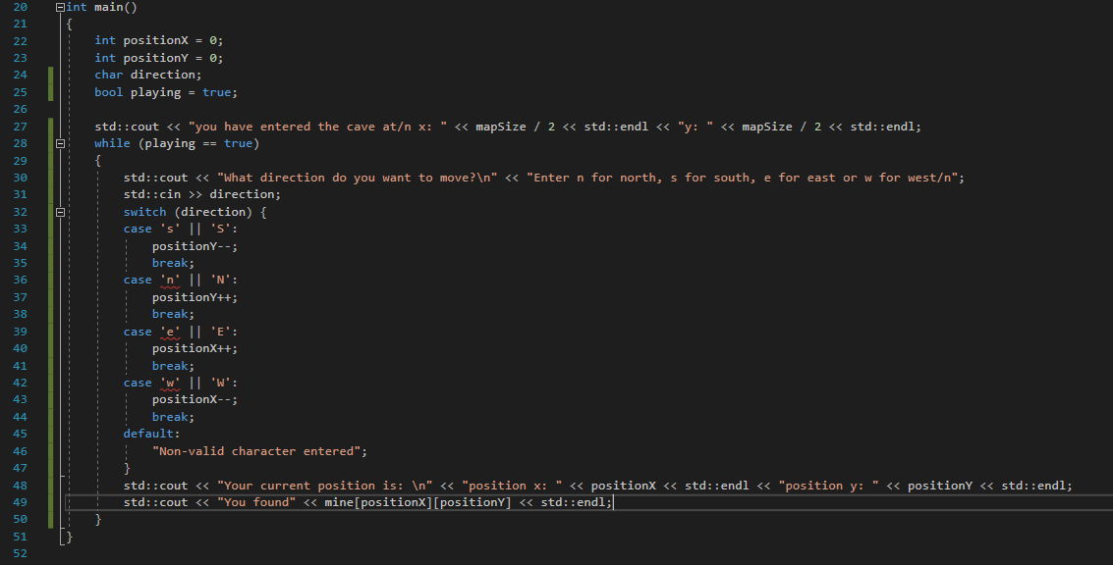

I started to create original code setting up classes for the player and items they could collect or purchase.

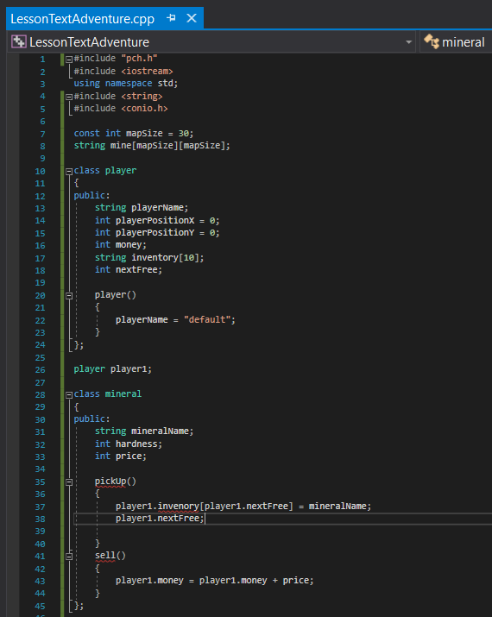

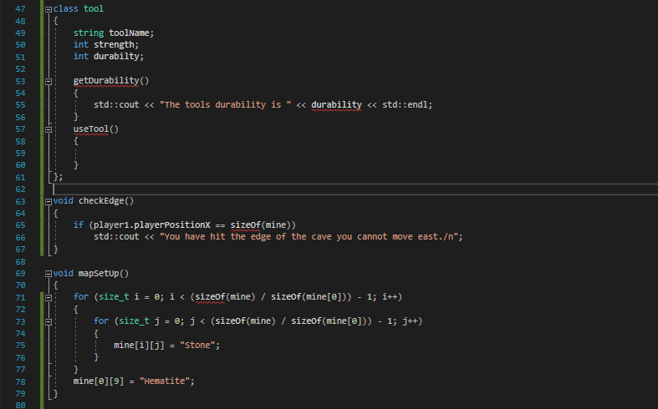

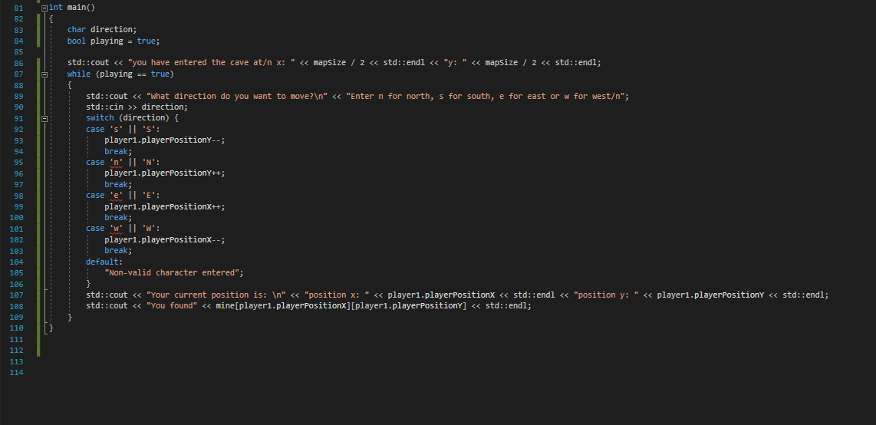

I spent 2 hours setting up the classes and main loop

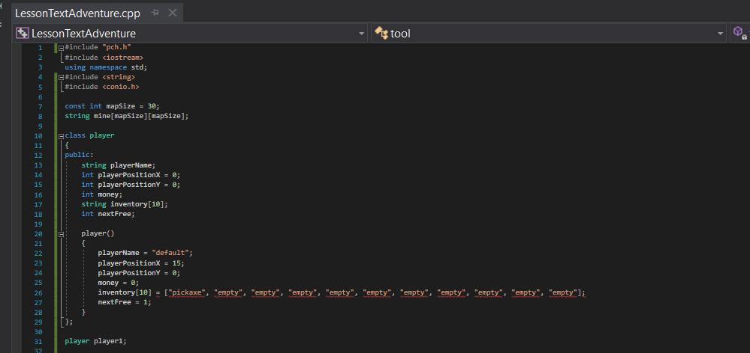

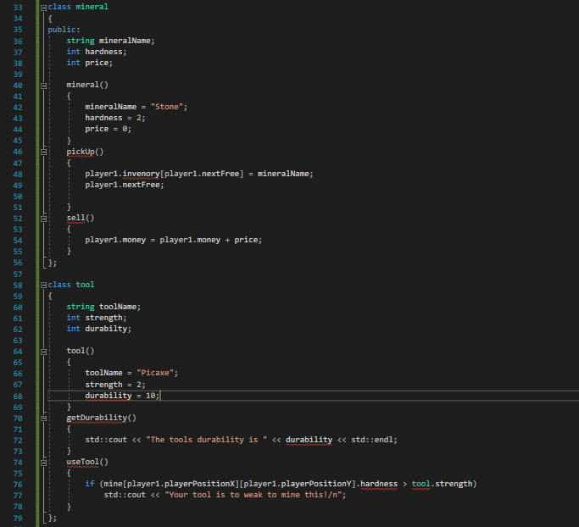

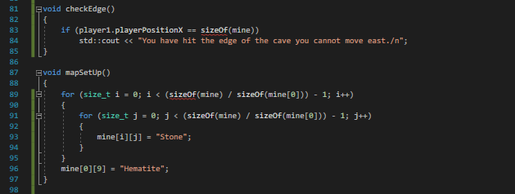

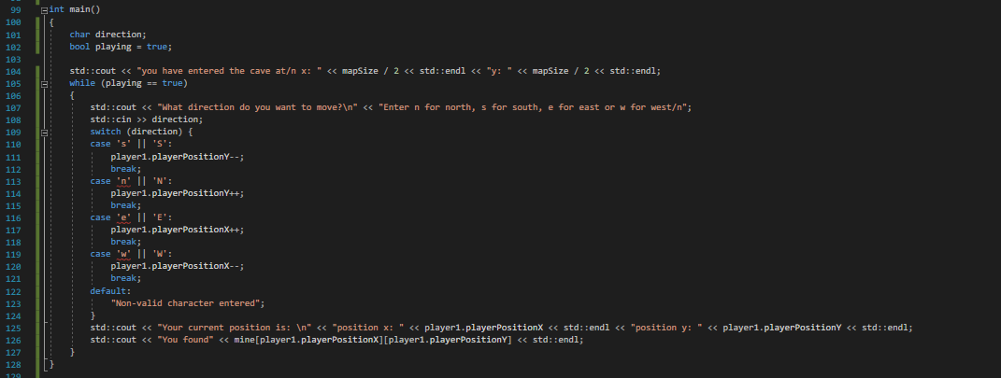

# 16/11/2020

## TOGA

I started the topic 3 workshop

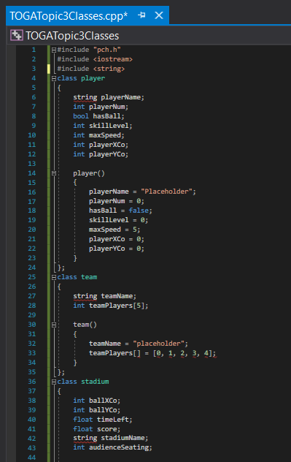

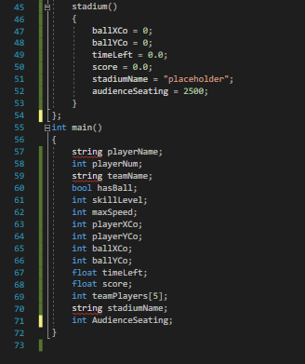

# 23/11/2020

## TOGA

Step 1 of the loops workshop

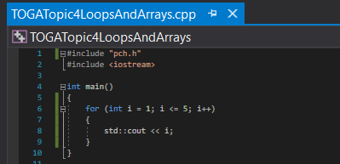

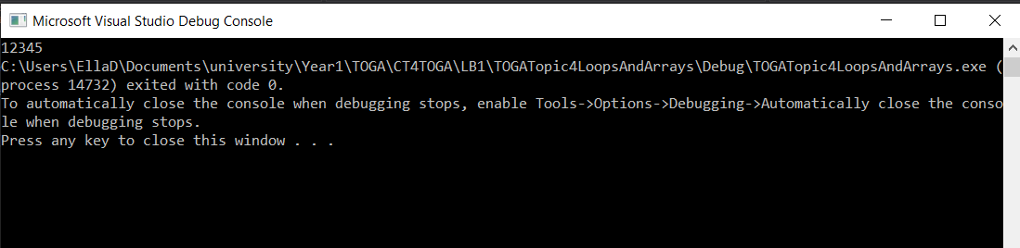

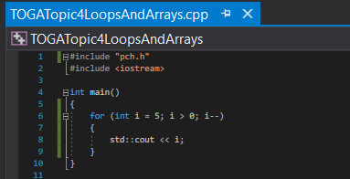

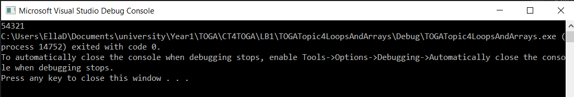

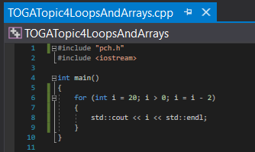

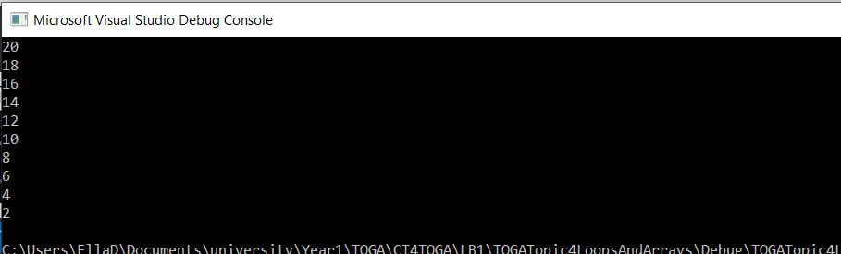

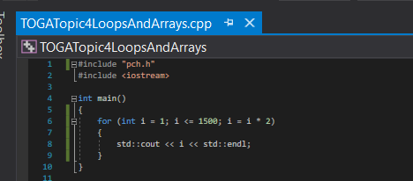

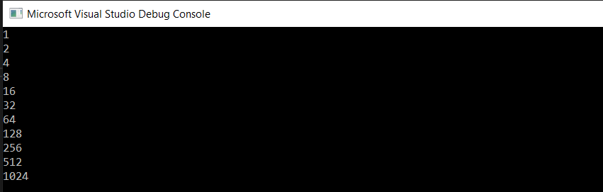

Step 2 of the topic 4 workshop

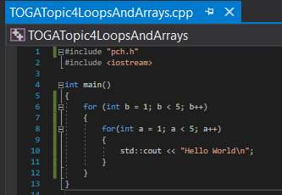

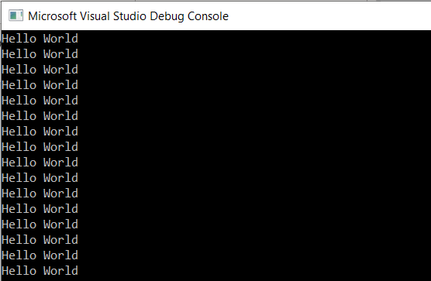

# 30/11/2020

## TOGA

Workshop for topic 4 working through step 3

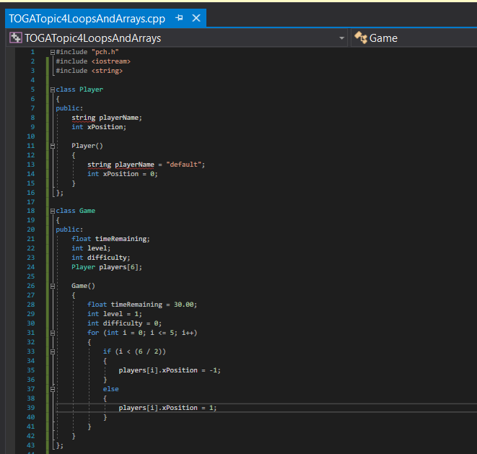

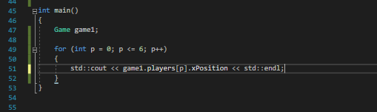

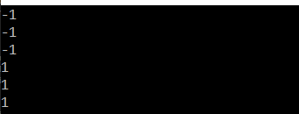

Step 4

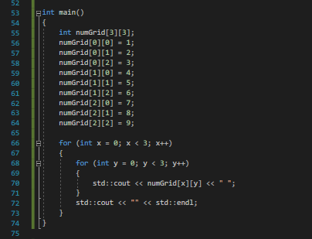

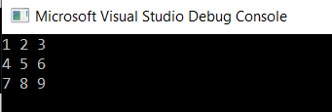

# 19/12/2020

## TOGA

Step 1:

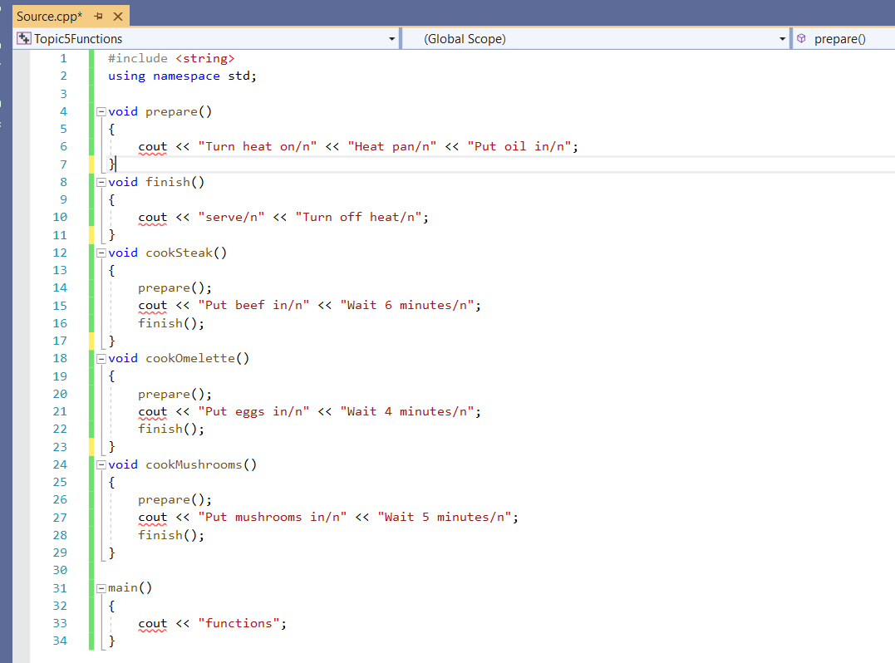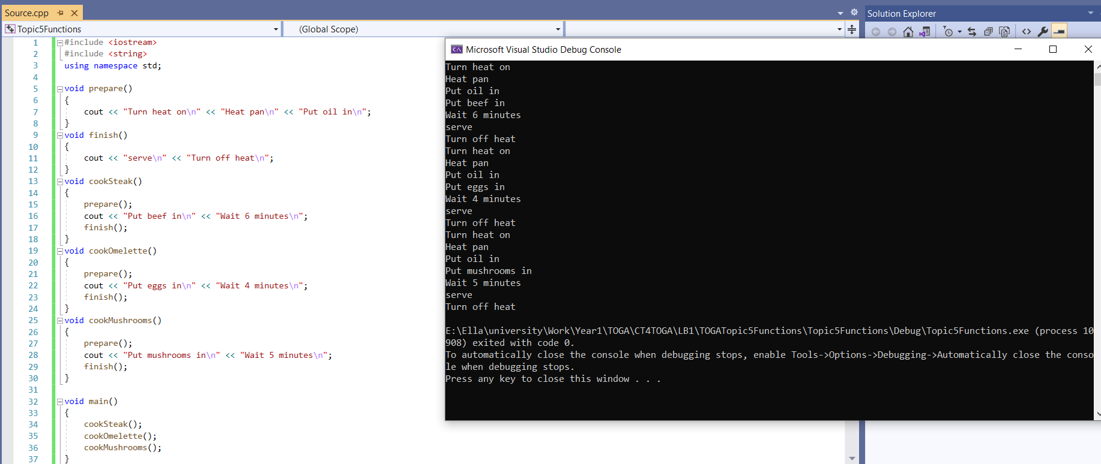

Step 2:

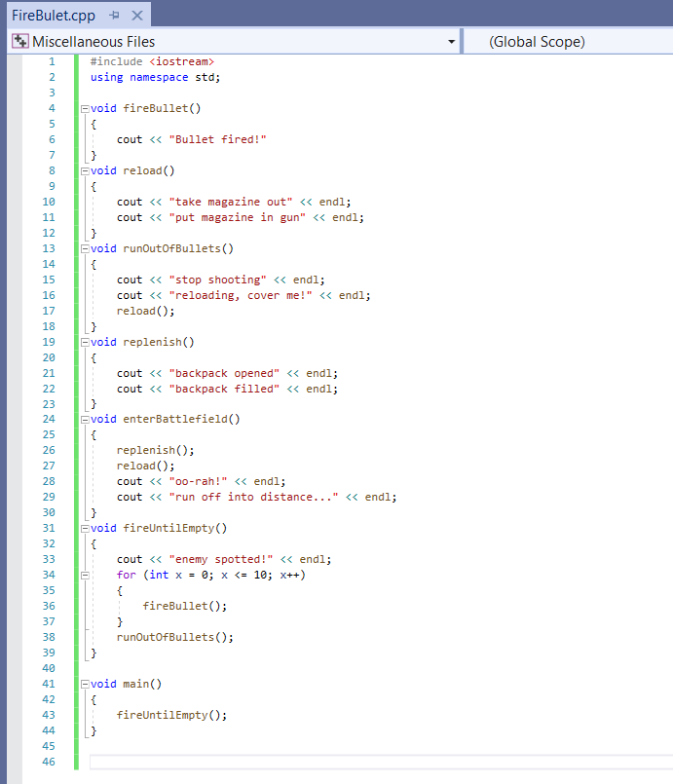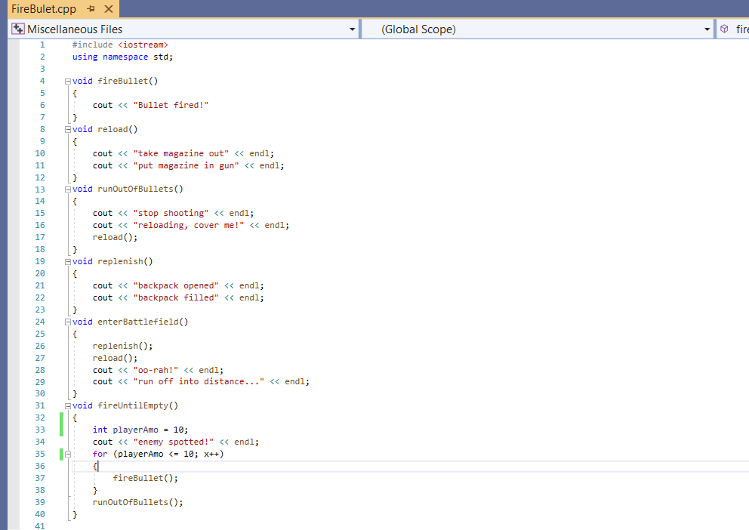

# 22/12/2020

## TOGA

Step 3:

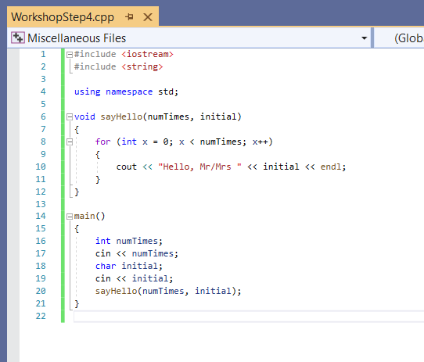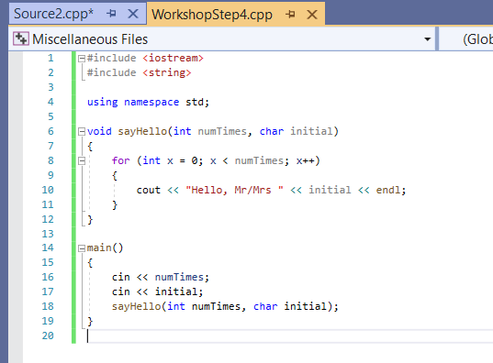

Step 5:

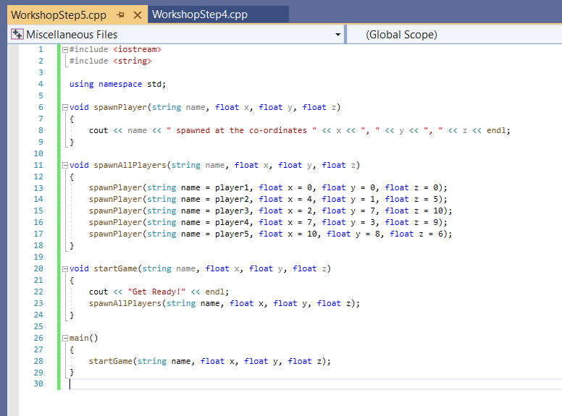

# 30/12/2020

## TOGA

Step 6:

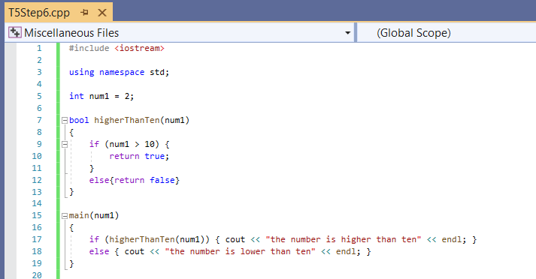

# 04/01/2021