**Title: Parallax Mapping – Assignment 2**

**1.0 Purpose**

This assignment required me to produce a working C++, OpenGL, and GLSL to demonstrate Parallax Mapping. I will consider two varieties of parallax mapping; Normal Parallax Mapping and Steep Parallax Mapping.

I have to implement and test a shader for each variety.

Parallax mapping is similar to normal mapping, it boosts a textured surface’s detail and gives an illusion of depth. (i)

Steep Mapping is similar to parallax but is much more accurate, it uses a ray tracer in order to pinpoint positions, however, it is slower than Parallax Mapping. (ii)

**2.0 Method/Results**

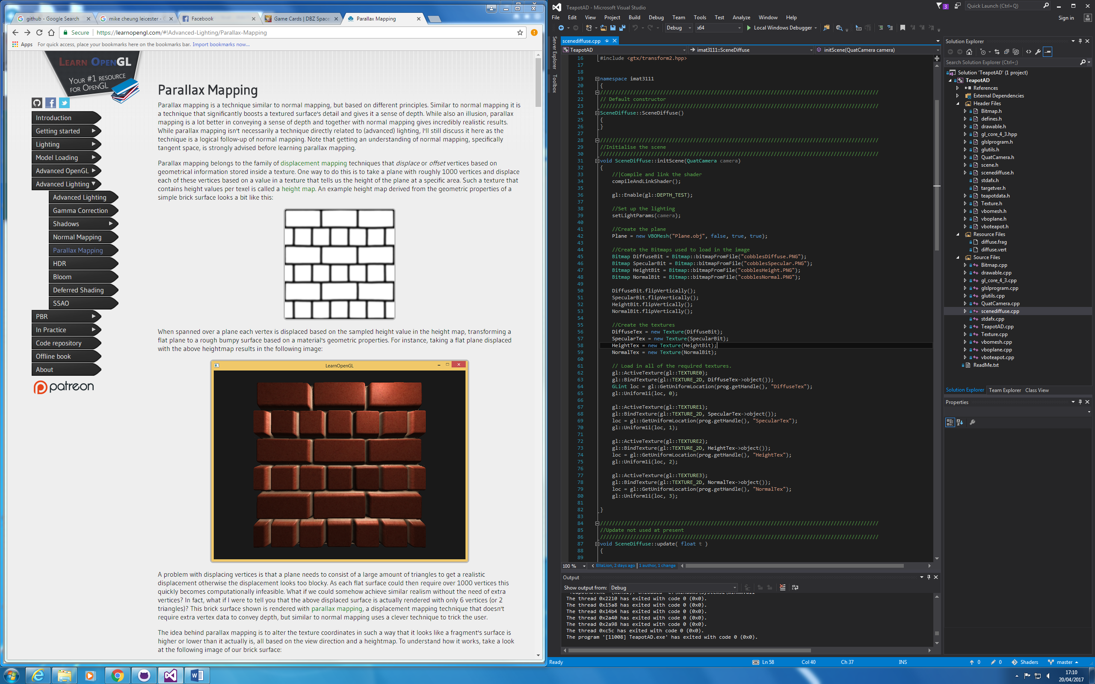I started this project by inputting all four images into my scene;

I then started to create textures for the images and load in all the information for the textures;

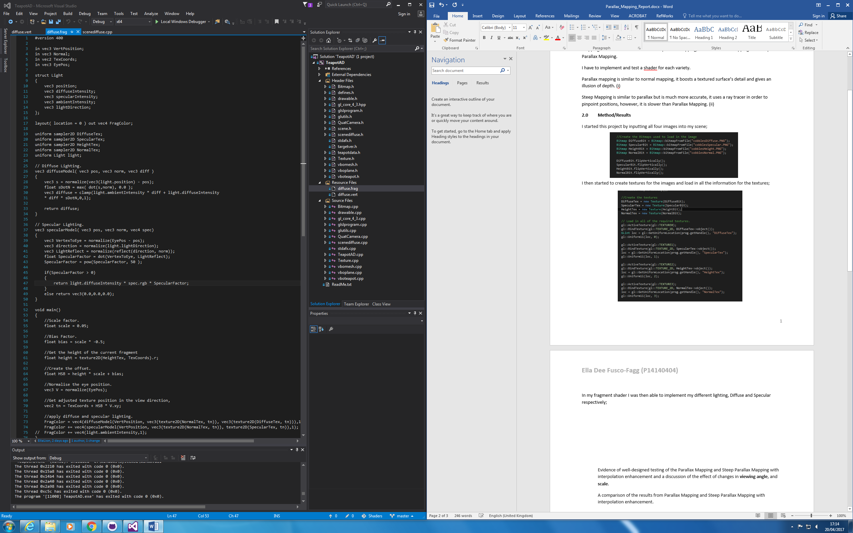In my fragment shader I was then able to implement my different lighting, Diffuse and Specular respectively;

In the main for my shader I set the different factors like scale, Bias etc and added a few more calculations that were needed;

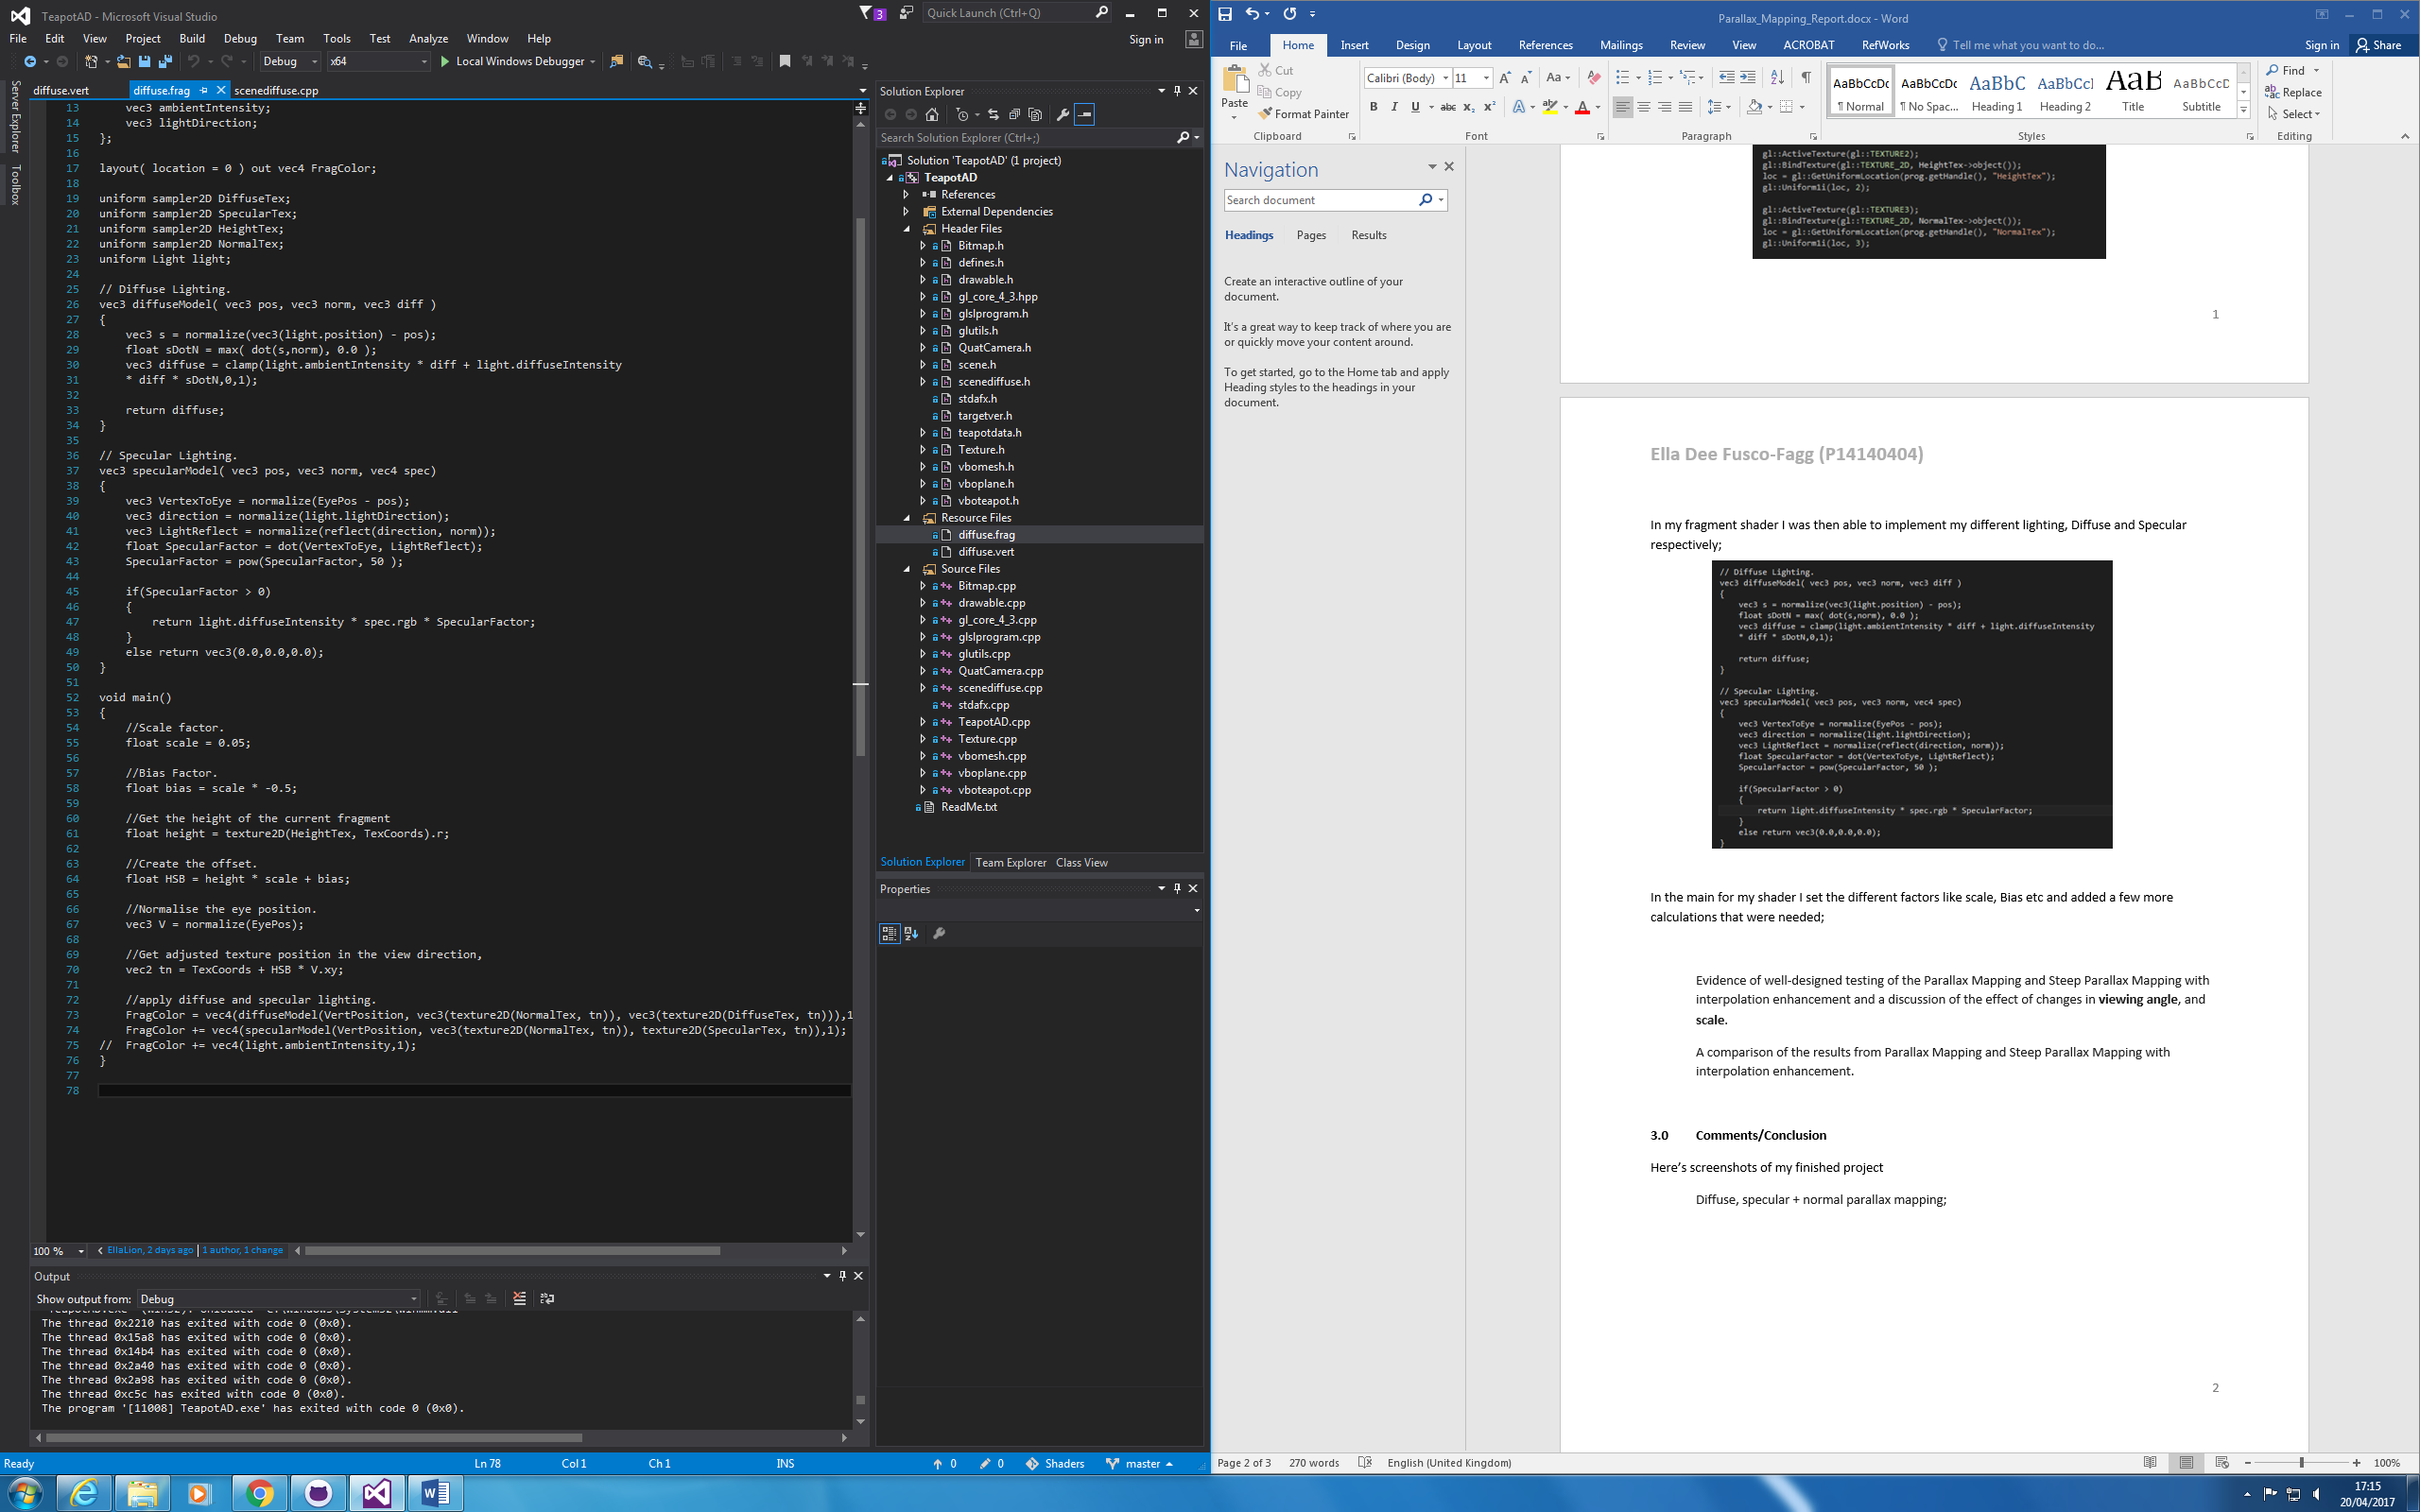

I then simply applied the diffuse and specular lighting as seen in the code.

**2.5 Testing**

**3.0 Comments/Conclusion**

Here’s screenshots of my finished project

Diffuse, specular + normal parallax mapping;

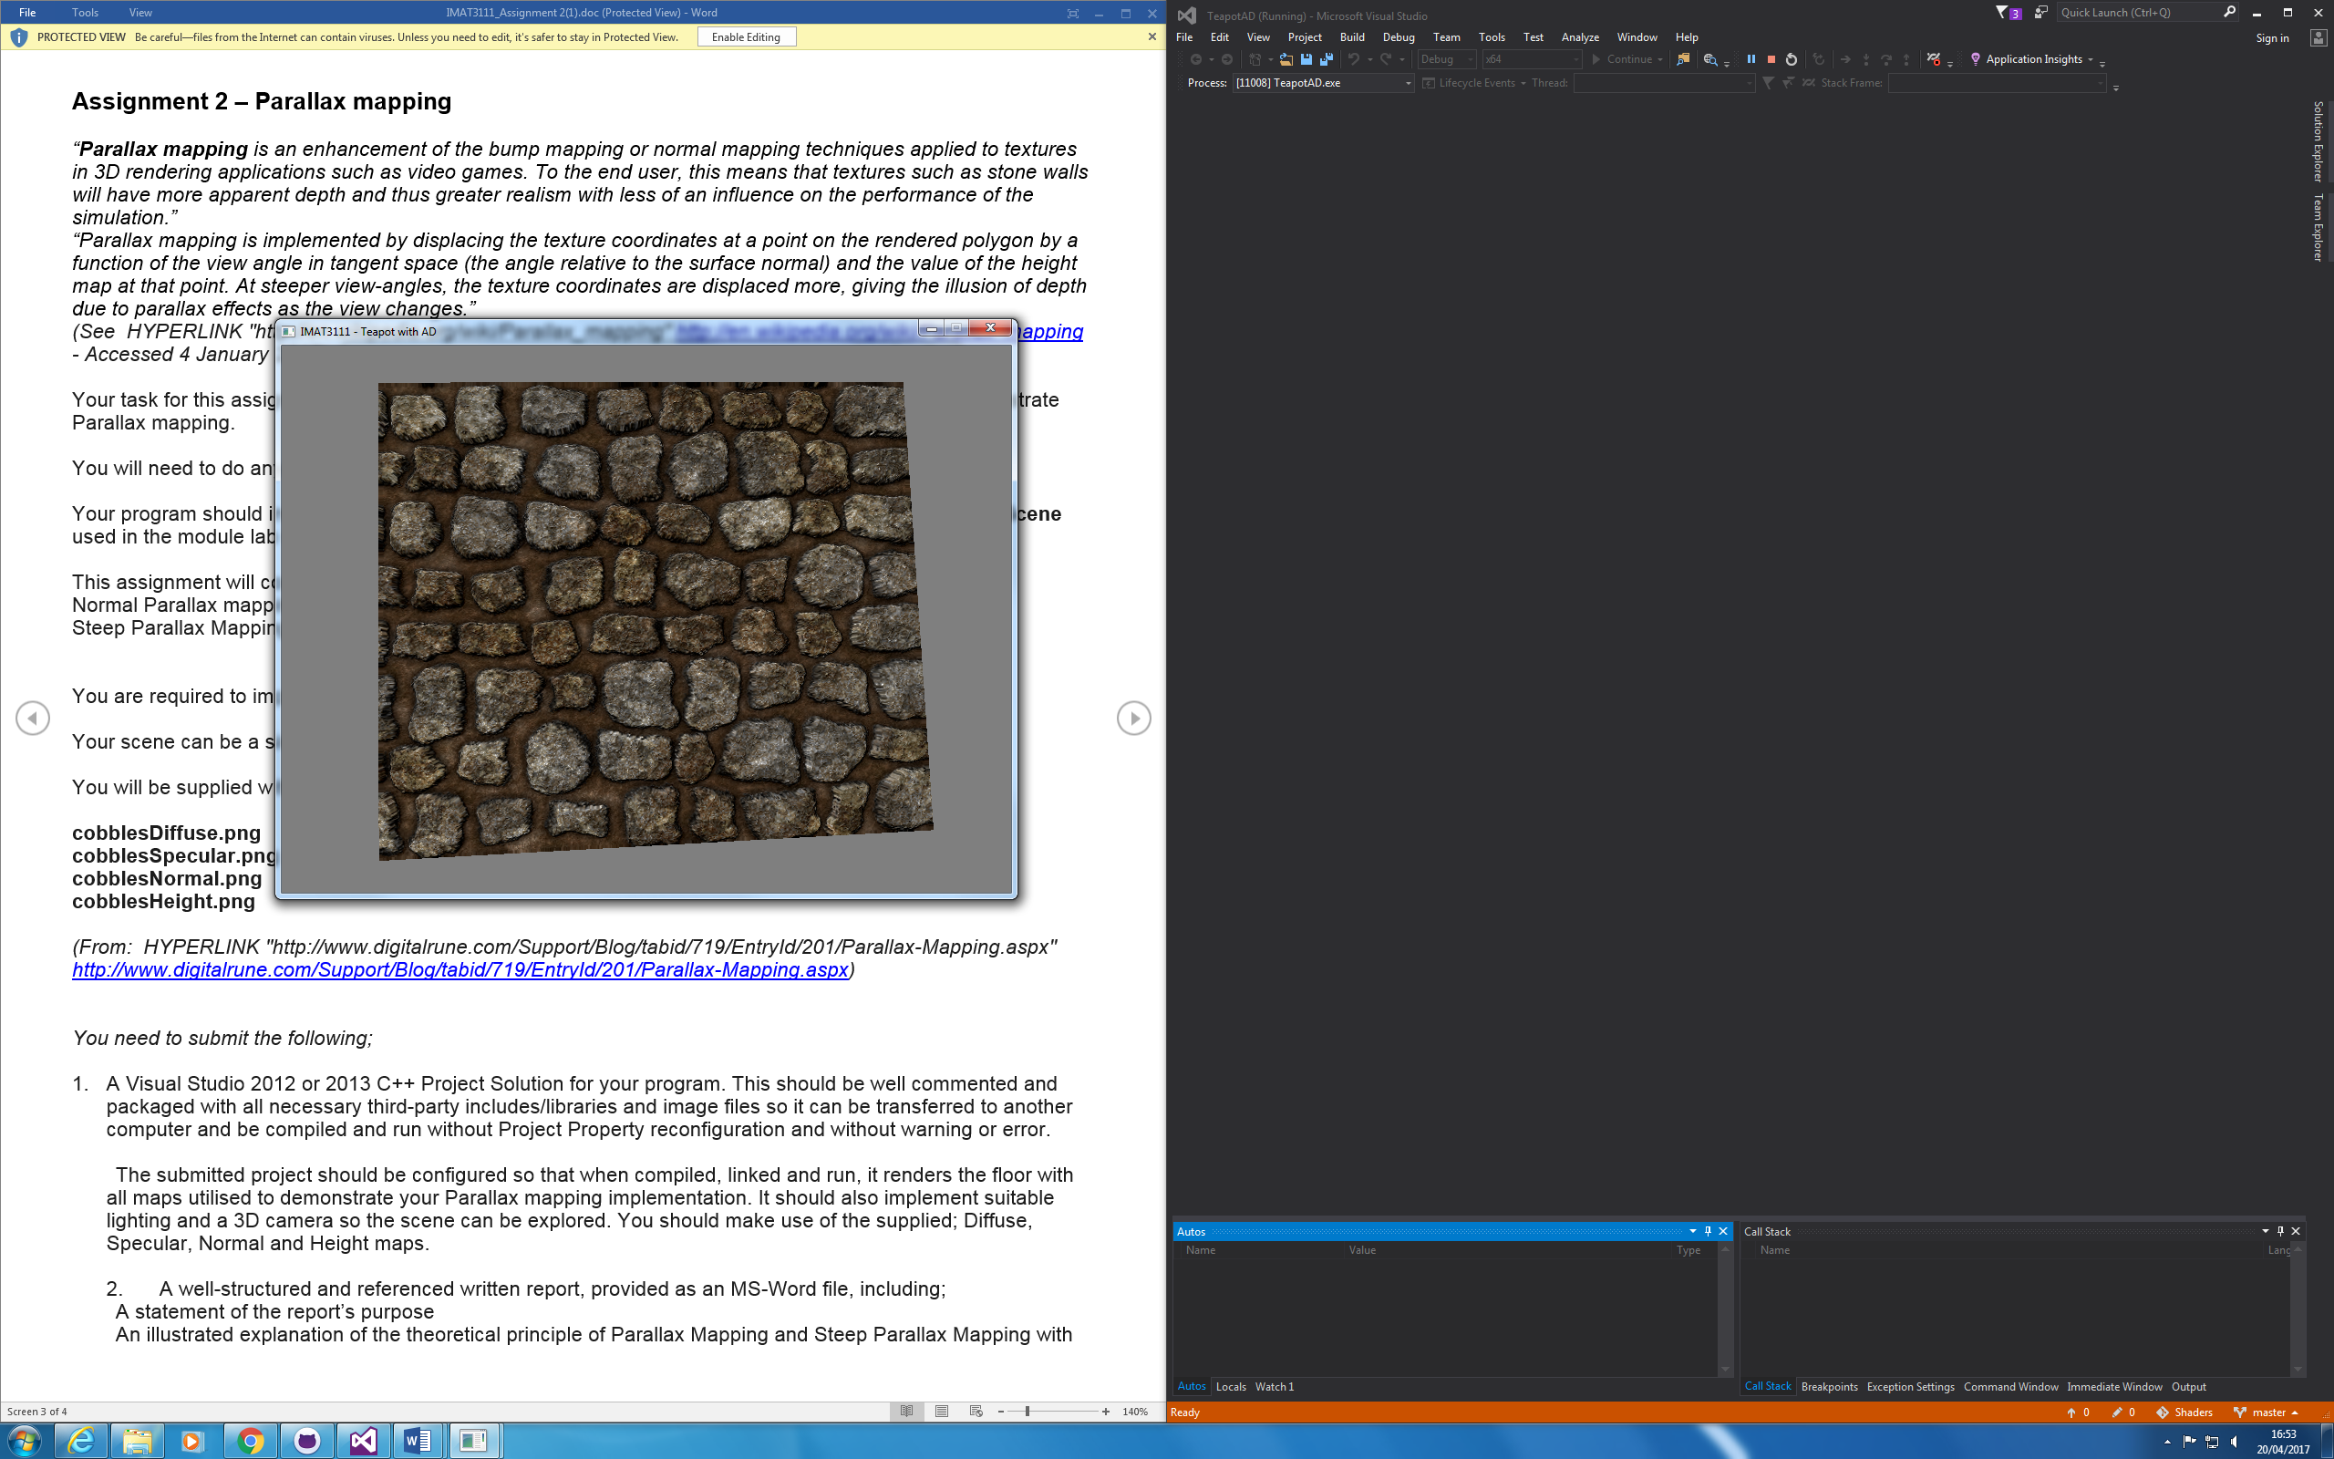

Diffuse and specular colour maps only;

Diffuse, specular + normal map;

Diffuse, specular + steep parallax mapping;

I attempted to include height and depth, however came into a lot of problems doing so, in the process of this I lost my previous working shader. If I was to do it again I would try to get the depth working.

**4.0 References**

(i) https://learnopengl.com/#!Advanced-Lighting/Parallax-Mapping

(ii) https://www.gamedev.net/topic/414744-difference-between-parallax-and-steep-parallax-mapping/