**Title: Parallax Mapping – Assignment 2**

**1.0 Purpose**

This assignment required me to produce a working C++, OpenGL, and GLSL to demonstrate Parallax Mapping. I will consider two varieties of parallax mapping; Normal Parallax Mapping and Steep Parallax Mapping.

I have to implement and test a shader for each variety.

Parallax mapping is similar to normal mapping, it boosts a textured surface’s detail and gives an illusion of depth. (i)

Steep Mapping is similar to parallax but is much more accurate, it uses a ray tracer in order to pinpoint positions, however, it is slower than Parallax Mapping. (ii)

**2.0 Method/Results**

Evidence of well-designed testing of the Parallax Mapping and Steep Parallax Mapping with interpolation enhancement and a discussion of the effect of changes in **viewing angle**, and **scale**.

A comparison of the results from Parallax Mapping and Steep Parallax Mapping with interpolation enhancement.

**3.0 Comments/Conclusion**

Here’s screenshots of my finished project

Diffuse, specular + normal parallax mapping;

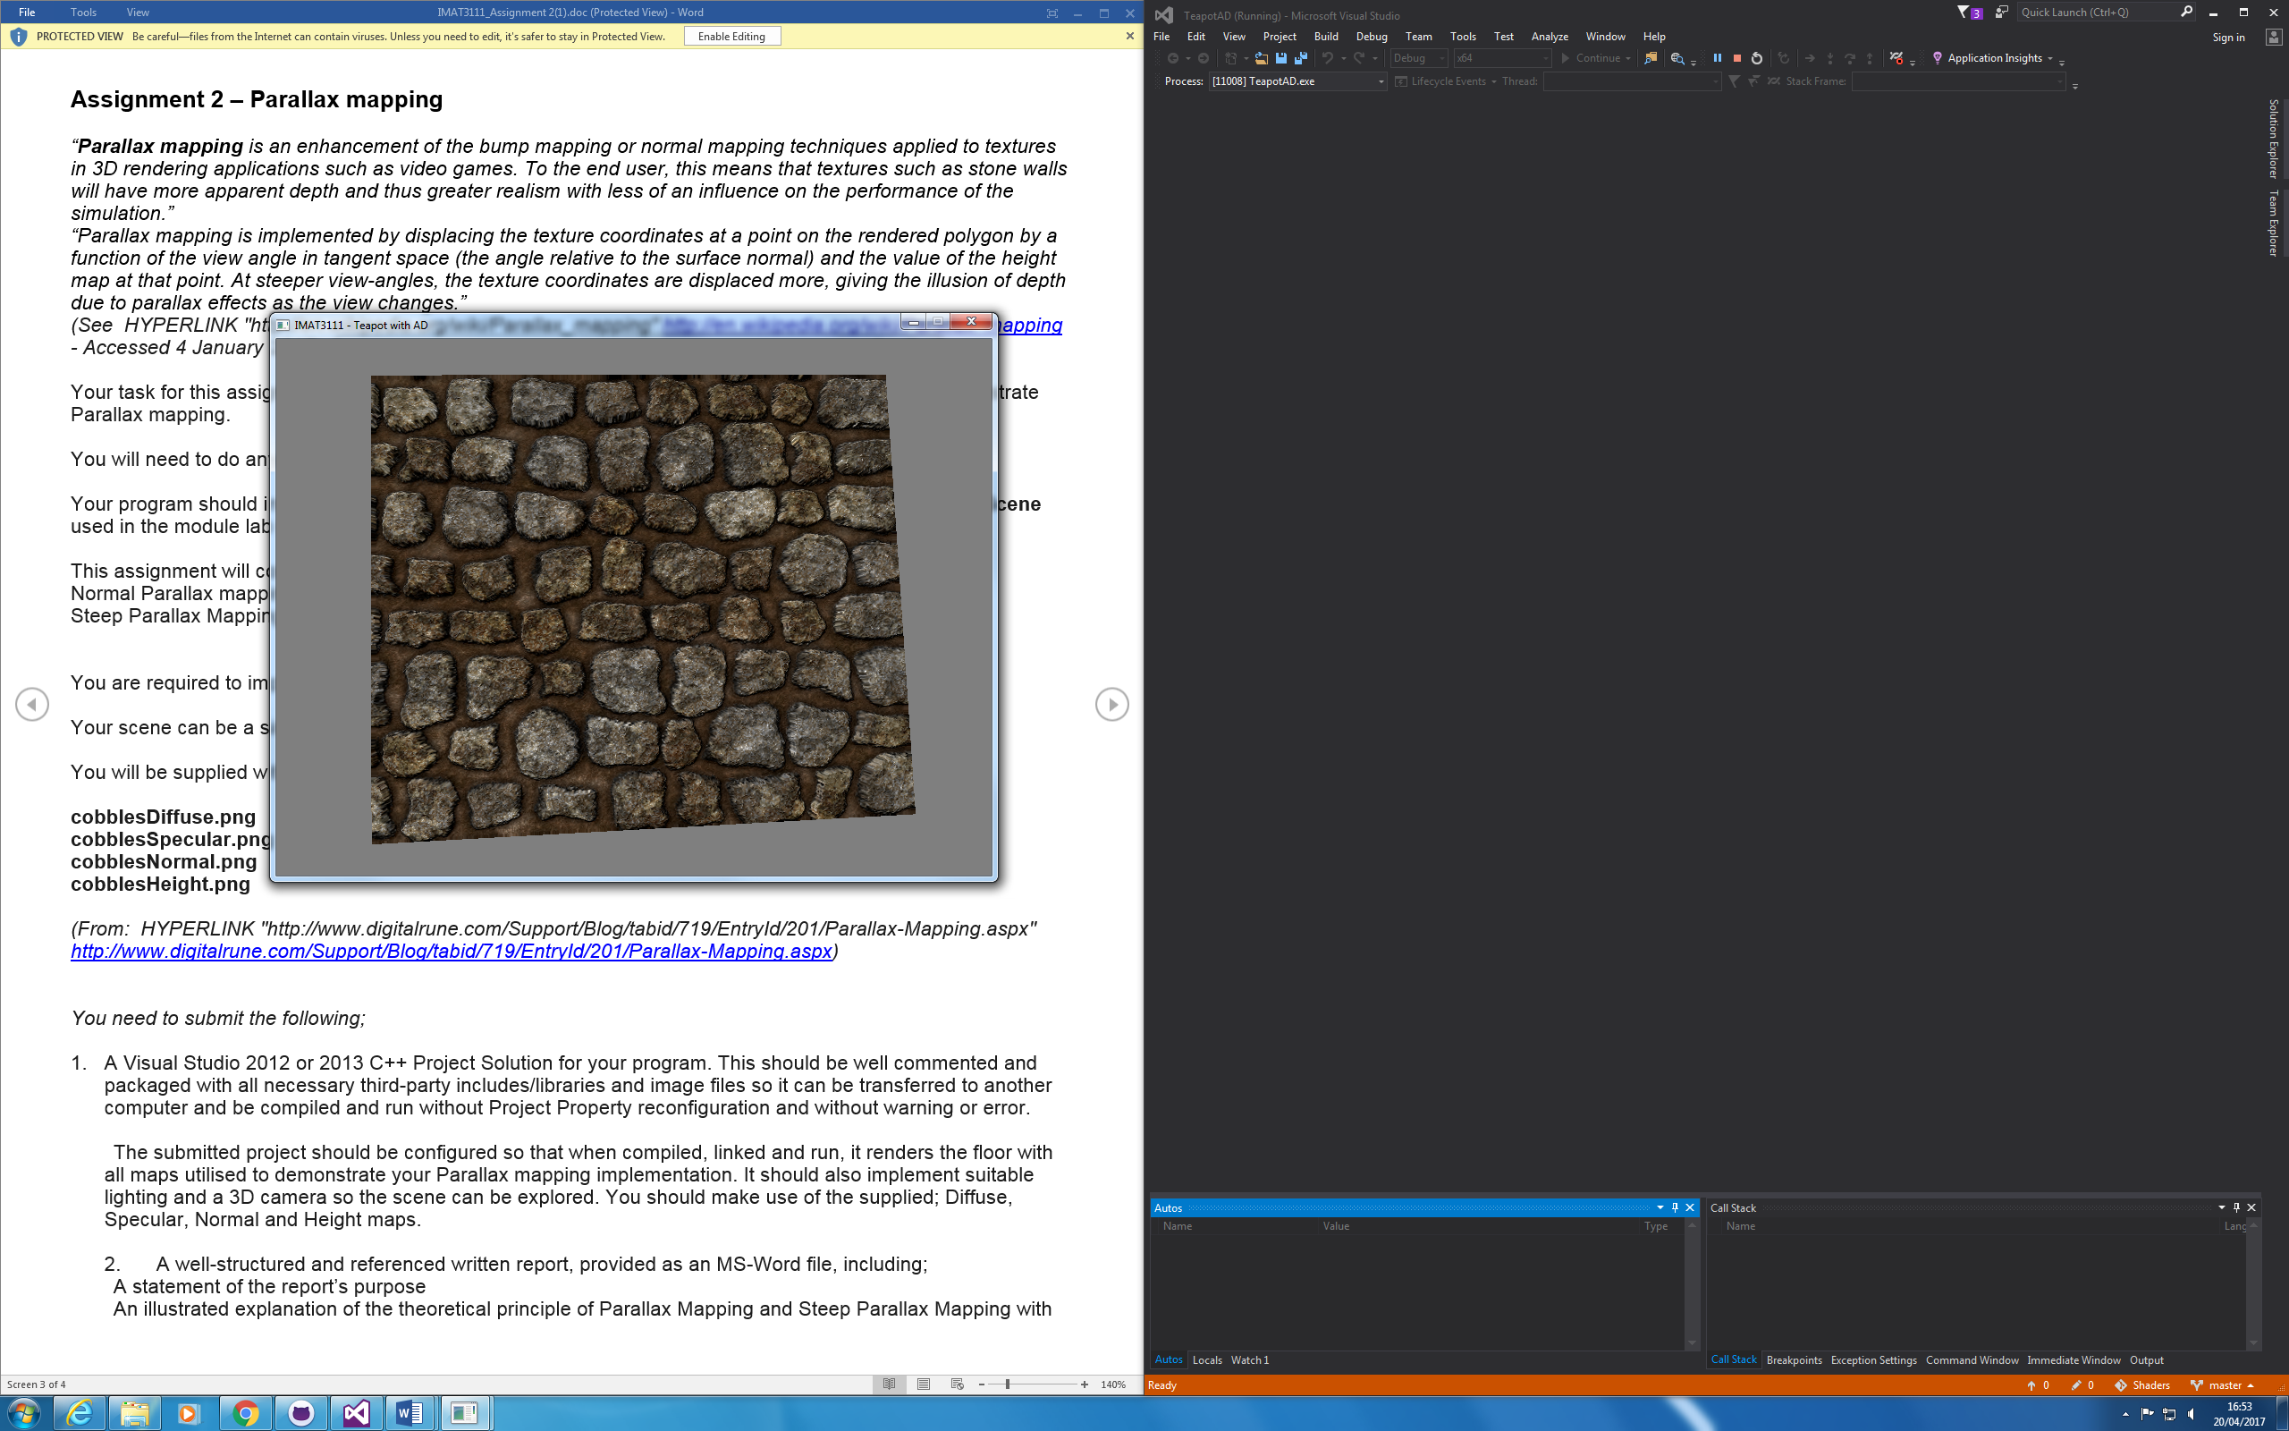

Output screen captures showing the floor/cube with;

Diffuse and specular colour maps only

Diffuse, specular + normal map

Diffuse, specular + steep parallax mapping

A conclusion including enhancements that could be made to improve the result.

**4.0 References**

(i) https://learnopengl.com/#!Advanced-Lighting/Parallax-Mapping

(ii) https://www.gamedev.net/topic/414744-difference-between-parallax-and-steep-parallax-mapping/