The Relationship Between Cryptos and Stablecoins?

1 Overview
We used 5 years of daily stablecoin and crypto data (2020-2024) to assess the relationship between cryptos and stablecoins

1.1 Metrics
We used the following data and metrics:
Coin Type | Coins Used | Metrics Used
Stablecoin | - USDT  - USDC  - DAI | - Delta Log Garman-Klass  - Log Volume % Change
Major Crypto | - BTC  - ETH  - XRP  - BNB | - Delta Log Garman-Klass  - Log Returns

Our volume and returns metrics are common choices so require no justification. We choose Garman-Klass volatility as it gives us the best ‘pointwise’ volatility for a given day by considering the high, low, open and close prices for that day. Realised Volatility (RV) is a common choice but is usually calculated using a rolling window on intra-day data. Unfortunately, we do not have this data and so opt for Garman-Klass. Moreover, we could calculate a rolling window RV using our daily data, but this will give us a very smoothed picture of volatility and will not capture and react well to instances of high volatility.
We test the predictive power of Stablecoins and Cryptos in both directions:
- Stablecoin predicts crypto
- Crypto predicts Stablecoin
We do this to capture their relationship, how they move with one another, and any cyclical structure in the market.

1.2 Principle Component Analysis (PCA)
The naive approach, that many papers seem to use, is to test every stablecoin/crypto metric pair individually. For example, with 3 stablecoins, 2 stablecoin metrics, 4 cryptos, and 2 crypto metrics, we would have to run 48 individual tests in each direction. This creates two issues:
- Stablecoin metrics are highly correlated with each other, and crypto metrics are highly correlated with each other. For example, seeing if USDT volatility predicts BTC returns is an extremely similar test to seeing if USDC volatility predicts BTC returns. Most of the 48 tests would essentially be repeats and give us no new information
- With 48 tests at significant level 0.05, we are guaranteed to find false positives
(48*0.05 = 2.4, so expect at least 2 false positives)
To overcome this, we use Principal Component Analysis (PCA). PCA is a dimensionality reduction technique that can convert multiple time series into a single series that captures the maximum shared variance across all time series (PC1). Using PCA, we convert all our time series into 4 time series:
- Stablecoin Volume
- Stablecoin Volatility
- Crypto Volatility
- Crypto Returns
This means we now must only perform 8 tests:
- Stablecoin Volume -> Crypto Volatility
- Stablecoin Volatility -> Crypto Volatility
- Stablecoin Volume -> Crypto Returns
- Stablecoin Volatility -> Crypto Returns
(The other 4 tests are the reverse of the above)
Each time series of a single coin is made of two parts:
- The systemic signal that affects the market as a whole (Captured by PCA)
- The idiosyncratic noise for that specific coin (could be a specific event for that coin)
PCA helps us strip the noise and leave us with the true, systemic signals.
Lastly, PCA helps to avoid multicollinearity. For example, in the case of a ML model, if we used each individual coin metric as a feature, the model would not know which one was important, causing its feature importance and coefficients to become unstable. PCA also offers interpretability by allowing us to examine the factor loadings to see which coins are most influential
In practice, we use Expanding Window PCA to prevent data leakage. In an OOS back test, we recalculate the PCA after every day to include the new day.
When performing PCA, we must select which principle components to use. To help us select which Principle Components to use, we employ Horn’s analysis which analyses which principle components are statistically distinguishable form random noise. We find that every one of our PCA results only has the first principle component as statistically significant.
For example, the principle components of crypto volatility:
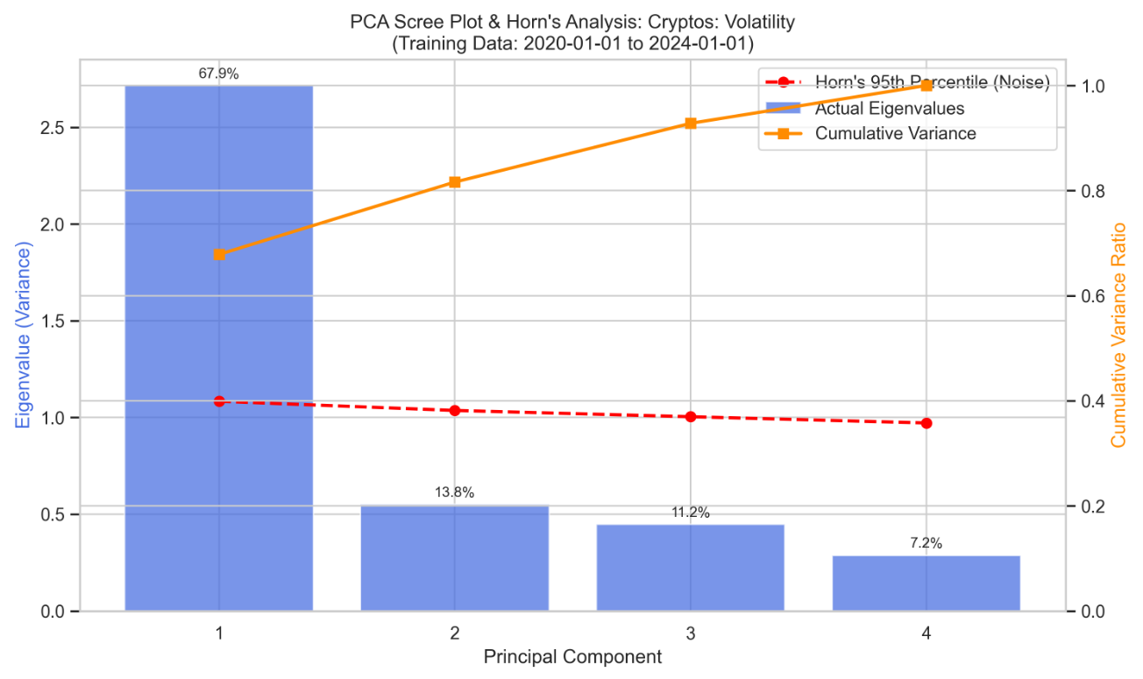

1.3 Winsorisation
We also use Winsorisation to mitigate the effects of extreme outliers in crypto markets. Winsorisation is the idea of capping extreme outliers at a given quantile. In this research, we winsorise at the 0.01 and 0.99 quantiles, which is common practice. This means any value outside of the 0.01 and 0.99 quantiles will be set to the value at the 0.01 and 0.99 quantiles respectively. This prevents black swan events from skewing our models. These events include:
- Terra Luna Collapse
- FTX Collapse
- There are others but cannot remember right now
These huge outliers are normally caused my macro event where there are is no way of predicting them from time series data alone

2 Methodology
In this section, we discuss the tests we run and models we construct to capture the relationship between Stablecoins and Cryptos. We are asking the following questions:
- Does a relationship exist?
- What is the horizon of the relationship (Daily, Weekly, Monthly)
- Soes the relationship change with regimes/time?
- If the relationship exists, Is it a relationship that affects the assets on ‘average’ or only in parts of the distributions (tails)?
- IS there a cyclical/bidirectional relationship?

2.1 Stationarity Testing
First, we test for stationarity in each of our time series. We do this before PCA as otherwise the generated Principal Component series would tell us very little.
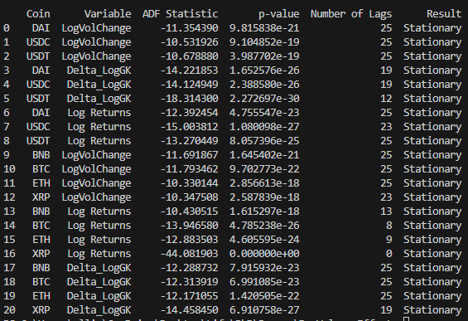

2.2 Causality Testing
We use Time-Varying Copula Granger Causality for in-sample testing. This offers numerous benefits over typical granger causality:
- Standard granger causality can only capture linear relationships; copula granger can capture nonlinear
- Standard granger only looks at the mean/average effect from one asset to another. Copula granger allows us to capture effects across the whole distribution. This includes mean, variance, skewness, tails, etc.
When we get significant p values in this test, it simply says that their significant causality on average, and we can look closer to see where the causality lies in the distribution. For now, we just use the p value to show nonlinear causality.
We also introduce the use of time-varying copula. This is because crypto and stablecoin markets are evolving and so their relationships will change over time. Currently, we use a rolling copula that we fit (NOT SURE YET, 6 months? 12 months?).
Use a rolling copula instead of expanding copula to mitigate old information from past regimes.
We also want to see the causality across different horizons, we use our daily data and transform it into weekly and monthly data to see if causality lies at these different horizons.
From these tests, we are able to inform our feature selection in the OOS backtest.

2.3 OOS Backtest
We use a GARCH-XGBoost model where we fit egarch models to our PCAs then use their shocks and volatility as features in an XGboost model.
We run 2 models:
- A benchmark model that only uses the target variables past data
- A challenger model that uses the targets variable and predictor past data
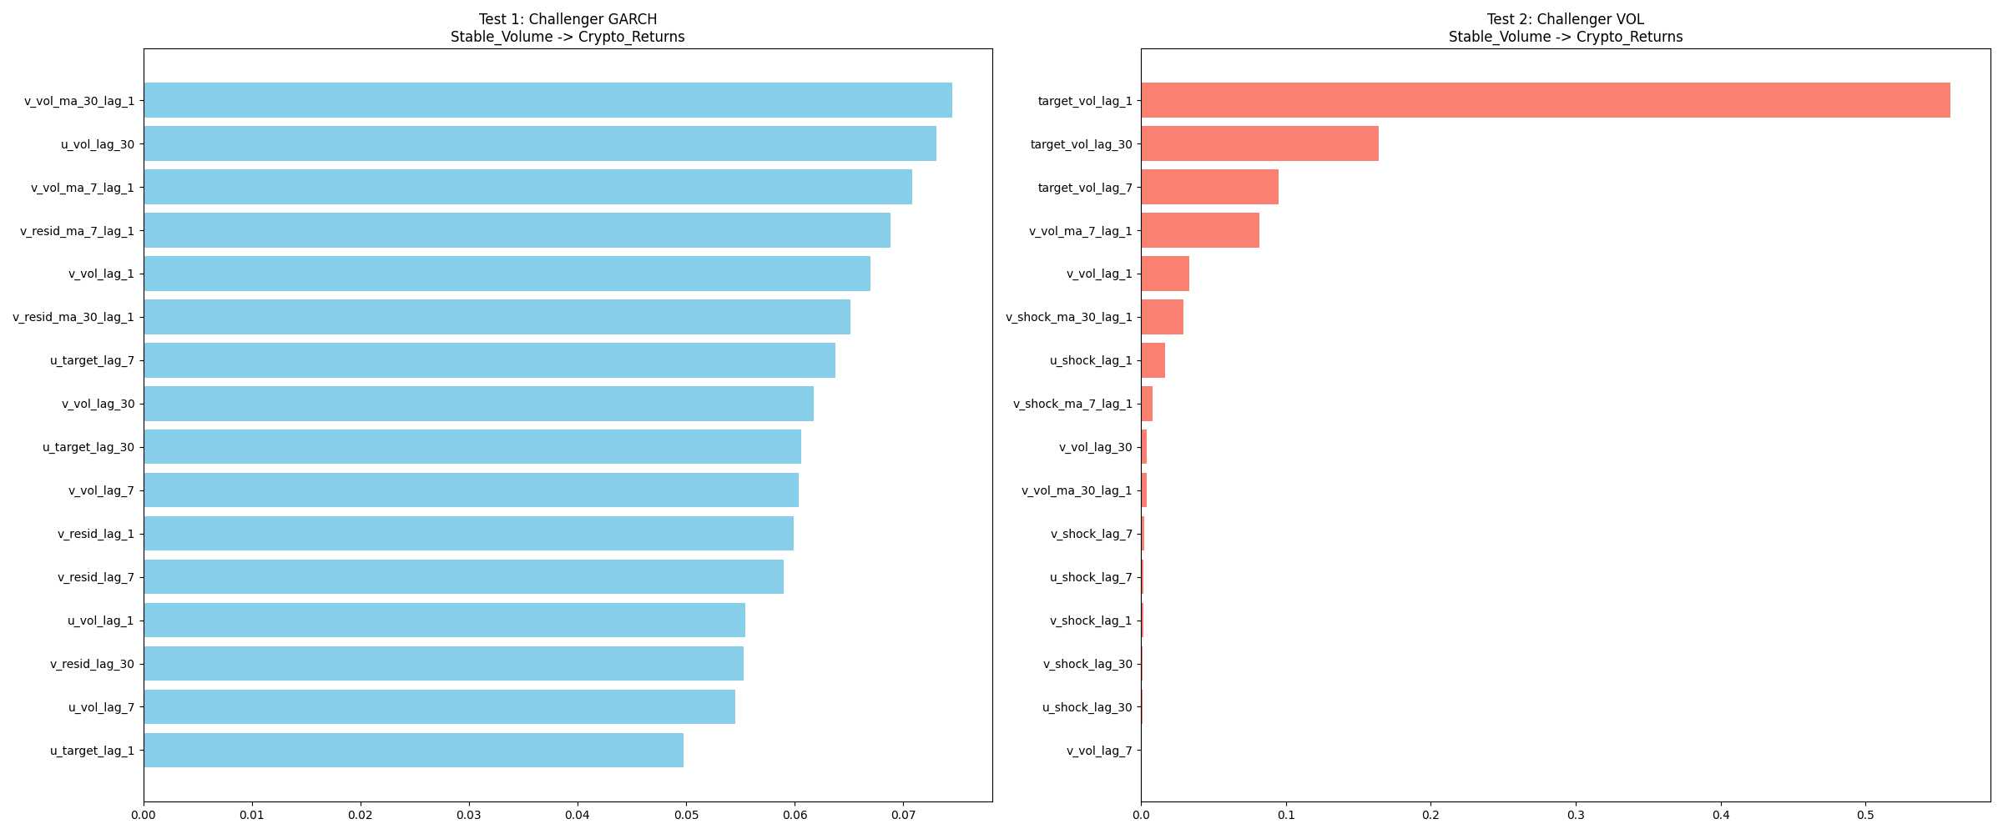
We compare these models using MSE (testing significant changes using Diebold Mariano) and Sign Test (To see if it predicts the correct direction negative or positive). This gives us a complete picture on whether the stablecoin data gives information on the direction (sign change) and magnitude/error (MSE).

Significant MSE reduction Results:
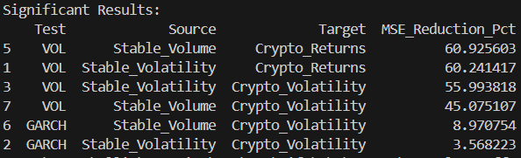
Positive Directional Accuracy Results:
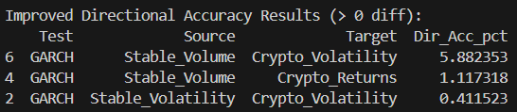

2.4 OOS Trading With actual Asset
Now we have shown the general predictive power across markets, We use our PCs of the stablecoin data to predict a specific asset’s returns (For example, Bitcoin)
We should use the Sortino Ratio as this does not penalise increased volatility in the upside (Where we make more money!)

