Do Stablecoins Predict Cryptos? A Copula-based approach
Overview
We used 5 years of daily stablecoin and crypto data (2020-2024) to assess if stablecoins carry predictive power for major crypto market dynamics.
We used the following data and metrics:
Coin Type | Coins Used | Metrics Used
Stablecoin | - USDT  - USDC  - DAI | - Delta Log RV  - Log Volume % Change
Major Crypto | - BTC  - ETH  - XRP  - BNB | - Delta Log RV  - Log Returns

The first thing to consider is how we determine which stablecoin metrics have predictive power for which crypto metrics
The naive approach, that many papers seem to use, is to test every stablecoin/crypto metric pair individually. For example, with 3 stablecoins, 2 stablecoin metrics, 4 cryptos, and 2 crypto metrics, we would have to run 48 individual tests. This creates two issues:
- Stablecoin metrics are highly correlated with each other, and crypto metrics are highly correlated with each other. For example, seeing if USDT volatility predicts BTC returns is an extremely similar test to seeing if USDC volatility predicts BTC returns. Most of the 48 tests would essentially be repeats and give us no new information
- With 48 tests at significant level 0.05, we are guaranteed to fine false positives
(48*0.05 = 2.4, so expect at least 2 false positives)
To overcome this, we use Principal Component Analysis (PCA). PCA is a dimensionality reduction technique that can convert multiple time series into a single series that captures the maximum shared variance across all time series (PC1). Using PCA, we convert all our time series into 4 time series:
- Stablecoin Volume
- Stablecoin Volatility
- Crypto Volatility
- Crypto Returns
This means we now must only perform 4 tests:
- Stablecoin Volume -> Crypto Volatility
- Stablecoin Volatility -> Crypto Volatility
- Stablecoin Volume -> Crypto Returns
- Stablecoin Volatility -> Crypto Returns
Each time series of a single coin is made of two parts:
- The systemic signal that affects the market as a whole (Captured by PCA)
- The idiosyncratic noise for that specific coin (could be a specific event for that coin)
PCA helps us strip the noise and leave us with the true, systemic signals.
Lastly, PCA helps to avoid multicollinearity. For example, in the case of a ML model, if we used each individual coin metric as a feature, the model would not know which one was important, causing its feature importance and coefficients to become unstable. PCA also offers interpretability by allowing us to examine the factor loadings to see which coins are most influential
Methodology
First, we test for stationarity in each of our time series. We do this before PCA as otherwise the generated PC1 series would tell us very little.
We conduct 3 main tests:
- Copula Granger Causality (In Sample)
- Copula – GARCH forecasting (OOS, LogLikelihood and VaR)
- Copula – ML forecasting (OOS, XGBoost, MSE and Sharpe)
The theme across each of these tests is the copula. A copula allows us to separate the dependence structure of a set of variables from their individual behaviours. In other words, it allows us to see how variables move together without considering their individual behaviours. In practice, this is creating a joint distribution between variables. A copula can capture non-linear relationships.
Using a copula moves the focus of the study from looking at average relationships to ‘shock-based’ relationships. Again, it does this by removing the ‘noise’ of coin’s individual behaviours and capturing their hidden dependencies on one another. This allows us to look at extreme/unexpected events. This is a far more realistic model as these unexpected events are often what drive risk analysis and potential trading opportunities.
For the OOS forecasting, we use the first 4 years of our dataset (2020-2023) to train the model and the final year (2024) to test it.
We now breakdown the purpose of each test and why we use a copula:
Test | In/Out of Sample? | Purpose | Result (If significant) | Why Copula?
Granger Causality | In sample | To first establish if a predictive link exists at all | Can show lagged stablecoin data has a relationship with current crypto data | Standard Granger Causality is linear; copula introduces non-linearity  Copula also makes it ‘shock-based’ – testing if unexpected movements in stablecoins predicts unexpected movements in cryptos
GARCH | OOS | Parametric Test  Forecasts a full distribution | Statistical Proof (LogLik AG test) and  Economic Proof (VaR backtest) that Stablecoin carries predictive power | Standard method of incorporating Stablecoin data would be GARCH-X style model where you add it as an exogenous variable. Assumes a linear relationship and ignores tail-dependence  Using a copula again allows for non-linear relationships and a ‘shock-based’ prediction model:  “given yesterday’s stablecoin shock, what is the new adjust risk model for crypto today?”
ML (XGBoost) | OOS | Non-parametric test  Forecasts a single value/point | Can show  Statistical Proof (MSE) and  Economic Proof (Sharpe backtest) that Stablecoin carries predictive power | Filtering our features through a GARCH model then fitting a copula to the resulting shocks gives us very ‘clean’ features to add  The copula strips away the ‘noise’ between the features and captures their true relationship.  (Still a WIP)

In the following table, we explain the specific methodologies of each test:

Test | Approach
Granger Causality | Follow the methodology outlined in the paper  “A copula approach to assessing Granger causality”  - Create systemic series using PCA  - Select optimal lag for each series (informed by ADF lags)  - Use Kernel Density Estimation to obtain the shocks of the two variables Stablecoin Predictor, Crypto Target)  - Use Bernstein Estimation to estimate the dependence structure between the two variables  - Calculates a granger causality statistic for the copula  - Use bootstrapping to create 1000 synthetic datasets, calculating the granger causality statistic for each  - Construct a null distribution of these 1000 statistics.  - If our statistic for the true dataset is stronger than 95% of these values, we have a significant result!
GARCH | Follow the methodology outlined in the paper  “The Copula-GARCH model of conditional dependencies: An international stock market application  ”  This paper only covers the construction of the copula GARCH model, the forecasting is of our own design  - Create systemic series using PCA  - Fit a AR – GARCH model to each PCA series. The AR part models the autocorrelation in the PCA’s mean then the GARCH part models the shocks from the AR model. This ensures the shocks are ‘clean’ and uncorrelated  - Train a copula on the shocks of the stablecoin and crypto data  - Generate a 1-day-ahead distribution forecast for day t  - Move to day t+1, storing the true value for day t and retrain  - Compare our copula model with the standard GARCH model for total log likelihood over the 1 year test set. Use an Amisano-Giacomini (AG) test to see if the difference between models is statistically significant  - Compare our copula model with the standard GARCH model for VaR breach rates at the 1% and 5% levels. See which model was closer to the true breach rate.
ML (XGBoost) | - Create systemic series using PCA  - Fit a AR – GARCH model to each PCA series to be left with the shocks (As in GARCH above)  - Feed these shocks to the ML model (XGBoost). The model then learns the dependence structure (copula) between these shocks.  - Generate a 1-day-ahead point forecast for day t  - Move to day t+1, storing the true value for day t and retrain  - Compare our copula model with the standard XGBoost model by comparing MSE values  - Compare our copula model with the standard XGBoost model by comparing Sharpe Ratios for a simple portfolio/strategy

Results
ADF:
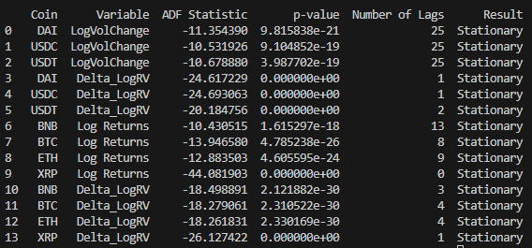
Copula Granger Causality:
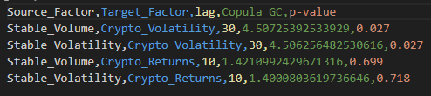
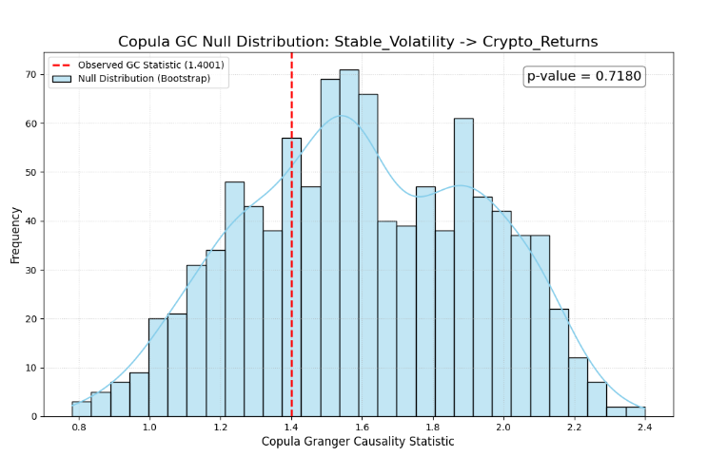
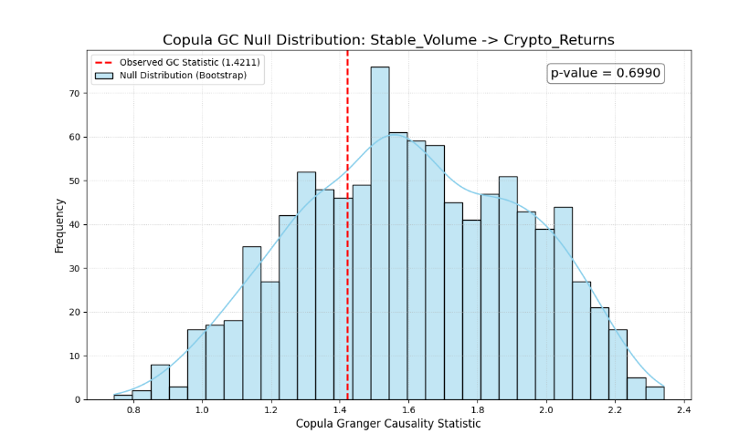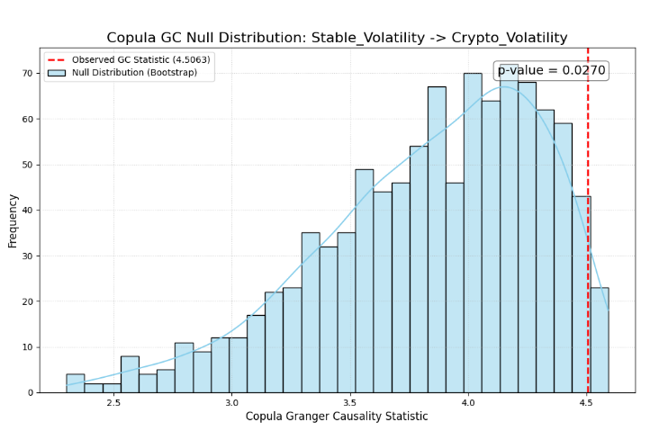
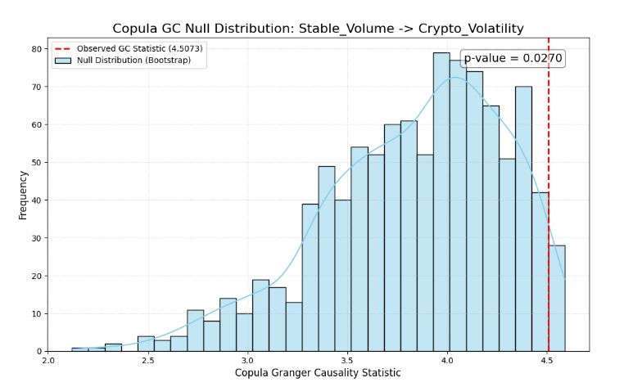

GARCH (Log Likelihood):
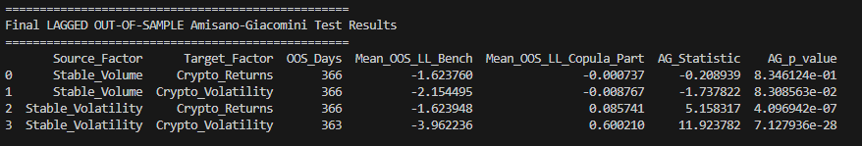
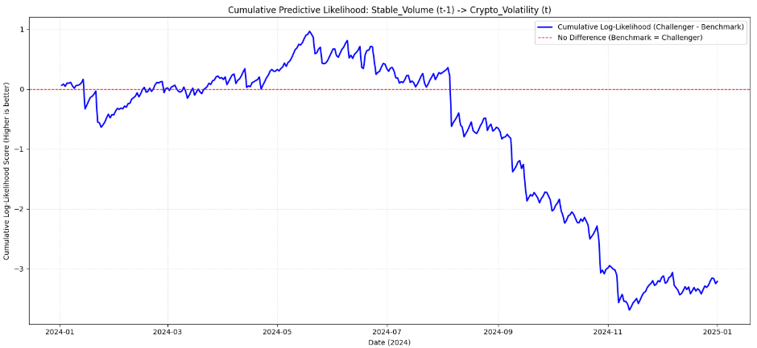
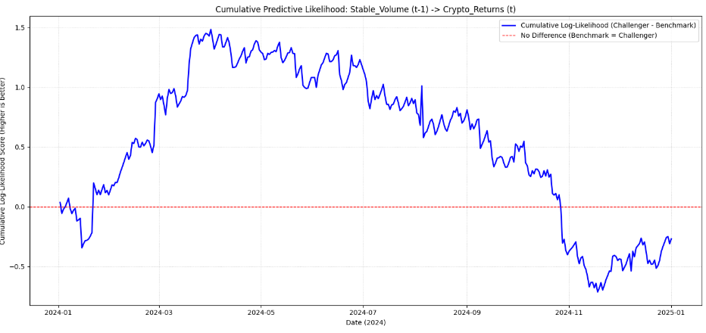
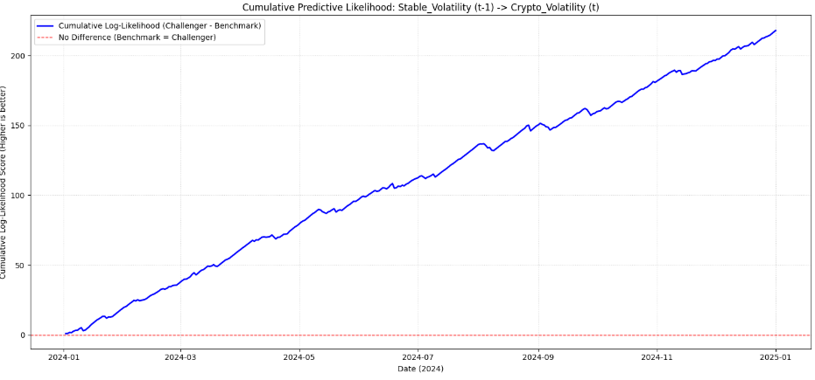
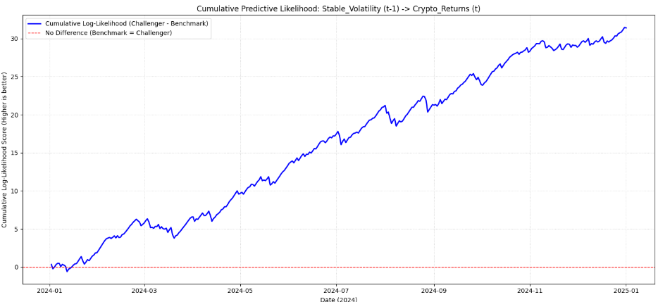

GARCH (VaR):
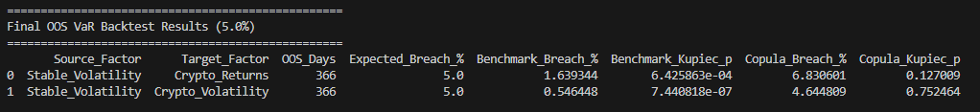
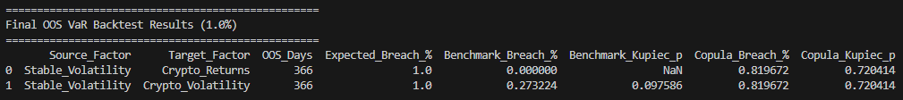
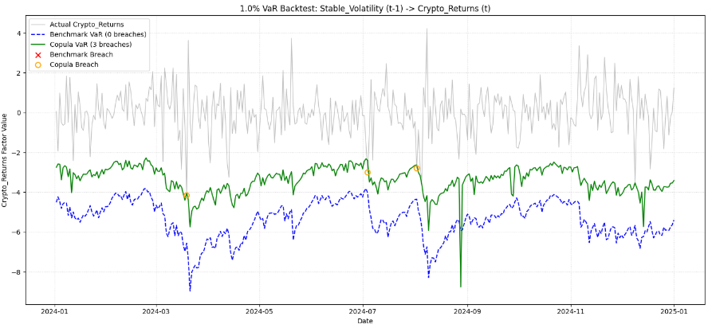
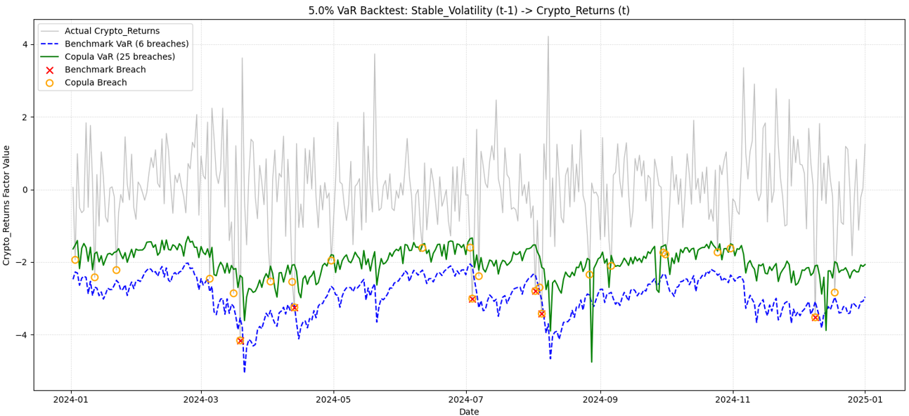

XGBoost:
