# Load required libraries  
library(readxl)

## Warning: package 'readxl' was built under R version 4.4.1

library(dplyr)

##   
## Attaching package: 'dplyr'

## The following objects are masked from 'package:stats':  
##   
## filter, lag

## The following objects are masked from 'package:base':  
##   
## intersect, setdiff, setequal, union

library(ggplot2)

## Warning: package 'ggplot2' was built under R version 4.4.1

# Load the Excel file  
file_path <- "D:\\sheba r program.xlsx"  
data <- read_excel(file_path)  
  
# View the first few rows of the data  
head(data)

## # A tibble: 6 × 9  
## S.No Motorcycle_Name Price City Kms_Driven Owner Age `Engine Power` Brand  
## <dbl> <chr> <dbl> <chr> <dbl> <chr> <dbl> <dbl> <chr>  
## 1 1 TVS Star City … 35000 Ahme… 17654 Firs… 3 110 TVS   
## 2 2 Royal Enfield … 119900 Delhi 11000 Firs… 4 350 Roya…  
## 3 3 Triumph Dayton… 600000 Delhi 110 Firs… 8 675 Triu…  
## 4 4 TVS Apache RTR… 65000 Bang… 16329 Firs… 4 180 TVS   
## 5 5 Yamaha FZ S V … 80000 Bang… 10000 Firs… 3 150 Yama…  
## 6 6 Yamaha FZs 150… 53499 Delhi 25000 Firs… 6 150 Yama…

# Summary statistics of the data  
summary(data)

## S.No Motorcycle_Name Price City   
## Min. : 1.0 Length:1099 Min. : 9350 Length:1099   
## 1st Qu.: 275.5 Class :character 1st Qu.: 40000 Class :character   
## Median : 550.0 Mode :character Median : 70000 Mode :character   
## Mean : 550.0 Mean : 101910   
## 3rd Qu.: 824.5 3rd Qu.: 114000   
## Max. :1099.0 Max. :1900000   
## Kms_Driven Owner Age Engine Power   
## Min. : 3 Length:1099 Min. : 1.000 Min. : 100.0   
## 1st Qu.: 8000 Class :character 1st Qu.: 4.000 1st Qu.: 150.0   
## Median : 15059 Mode :character Median : 5.000 Median : 200.0   
## Mean : 19367 Mean : 5.585 Mean : 246.6   
## 3rd Qu.: 25934 3rd Qu.: 7.000 3rd Qu.: 350.0   
## Max. :357000 Max. :39.000 Max. :1800.0   
## Brand   
## Length:1099   
## Class :character   
## Mode :character   
##   
##   
##

# Plotting  
  
# Scatter plot of Price vs. Kms_Driven  
ggplot(data, aes(x = Kms_Driven, y = Price)) +  
 geom_point() +  
 labs(title = "Price vs. Kms Driven", x = "Kms Driven", y = "Price")

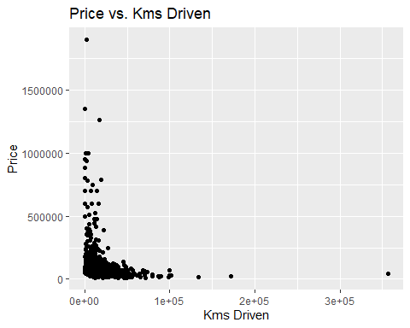

# Bar plot of average price by brand  
avg_price_by_brand <- data %>%  
 group_by(Brand) %>%  
 summarize(AveragePrice = mean(Price, na.rm = TRUE))  
  
ggplot(avg_price_by_brand, aes(x = Brand, y = AveragePrice)) +  
 geom_bar(stat = "identity") +  
 labs(title = "Average Price by Brand", x = "Brand", y = "Average Price") +  
 theme(axis.text.x = element_text(angle = 45, hjust = 1))

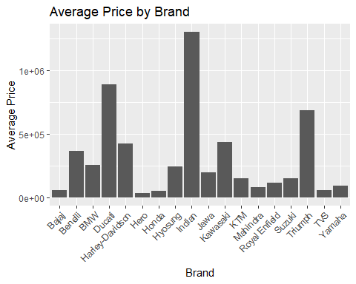

# Histogram of Prices  
ggplot(data, aes(x = Price)) +  
 geom_histogram(binwidth = 5000, fill = "blue", color = "black") +  
 labs(title = "Distribution of Prices", x = "Price", y = "Count")

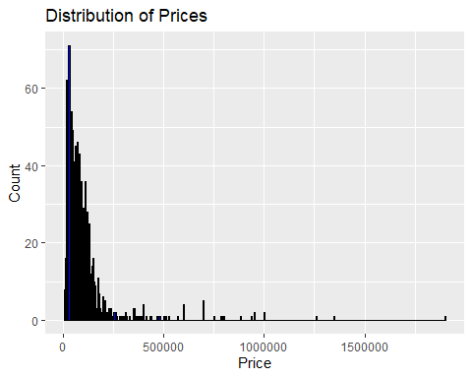

# Scatter plot of Price vs. Age with color representing Brand  
ggplot(data, aes(x = Age, y = Price, color = Brand)) +  
 geom_point() +  
 labs(title = "Price vs. Age", x = "Age", y = "Price")

